Weekly Updates
July 5, 2013
Test | Description of Change(s) | Affected Individuals
New ESR Vacuum Tubes | Starting Monday July 8th we will begin using the ESR Auto Plus for sed rates. With that, we will also begin to use ESR Vacuum tubes.  See pasted section from procedure regarding collection:  Collect a venous specimen following the NorthPoint venipuncture specimen collection procedures. The blood may be collected in the ESR-Vacuum Tube - (1.2mL) which contains 3.2% Sodium Citrate as an anticoagulant -- preferred container. The test may also be collected in an EDTA tube. When drawing the ESR Vacuum tube using a butterfly, it is necessary to use a lead tube to ensure proper tube filling. The draw order for the ESR Vacuum tube is the same position as a coagulation tube. When drawing a patient using the ESR-Vacuum tube, mix the blood with the sodium citrate solution immediately after drawing the patient sample by inverting the tube at least 6 to 8 times. The air bubble in the tube must reach the opposite end of the tube between every inversion. Hold the tube at an angle of about 35° to enhance mixing. The mixing procedure is very important! If the sodium citrate is not properly mixed with the blood, microscopic clots/aggregates may form and cause results to appear higher than they actually are.  See pasted section from procedure regarding labeling:  The ESR-Auto Plus reads the sample using infrared light. This light is very strong and can read through one layer of most commonly used labels. Label the tube vertically as close to the cap as possible. Do not allow bubbles or gaps in label or tube will not fit into measuring chamber. See image below.  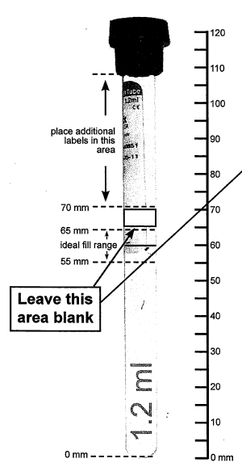  Place Cerner label vertically. Make sure label is smoothly applied as close to the cap as possible.  Alternately, a peon label or label sleeve may be used, though the Cerner barcode label is preferred. | All Staff
Daily Start Up Change | Each day perform a system check is performed. Successful completion is marked on the daily startup log.  See process pasted from procedure below.  Although no calibration is required, a system check will be performed each day using the test rack. Follow procedure below.  Step Action  1 From Standby (time is shown on the display), press and hold ‘NOT OK’ . The main menu will be shown in a scrolling manner.  2 Enter 5, ‘RUN TEST RACK,’ from the Main Menu. You will be prompted: RUN TEST RACK Insert Rack {Ok}  3 Insert the test rack and press ‘OK’ to start the verification procedure.  4 After the test rack has been read, the results will be reported on the printout.  5 If the printout indicates TEST OK, mark task as completed on daily start-up check list.  6 If the printout indicated FAILED TEST, the instrument will ask if you want to retry.  7 Press ‘OK’ to retry. Press ‘NOT OK’ to exit. Retry the test rack once. If the test rack fails a second time, re-register the rest rack. Refer to the ESR-Auto Plus Quick Reference Guide for instructions, or contact Streck Technical Services at 800-843-0912 for further assistance. | All Staff
aPTT reminder | When PTT’s are drawn, they need to be spun and frozen. Though, we have four hours to get it to HCMC unprocessed, we rarely make that time frame. So always spin, take off plasma and freeze this test. | Sendouts
Wet Preps Result Change | Trich are now resulted as:  TP -- Trich Present  NTP -- No Trich Present | Bench Techs
Computers | At the end of your workday, please shutdown (restart) your computer. | All Staff
Procedure Additions, Updates and Changes:

