Weekly Updates
July 18, 2013
Test | Description of Change(s) | Affected Individuals
NPH Weekly Comparison | Reminder: Performed on Thursdays by the Chem Bench Tech. | All Staff
T Spot TB Test | I have updated the processing instructions.  DO NOT SPIN TUBES. Send at RT to HCMC. Test must be performed within 24 hours. Specimens must arrive before 12 noon on M-Th and arrive before 5pm on Friday. Send with couriers accordingly. If drawn after regular evening courier on M-Th, leave out at RT and call courier first thing next day. Do not draw on Sat or Sun. | Phlebs/All Staff
Hettich Centrifuge  Adapters | 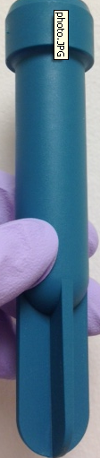  This adapter is used in the centrifuge with short tubes, such as coag tubes. | All Staff
Hazardous Waste Update | FYI: The hazardous waste picture chart has been updated.  ALP Substrate is no longer hazardous  Stromatolyser 4DS (from the Sysmex) is hazardous waste | Bench Techs
Procedure Additions, Updates and Changes:

