Weekly Updates
September 13, 2013
Test | Description of Change(s) | Affected Individuals
Preparing Fecal Occult Bloods | Do not label outside envelope with EPIC label. This EPIC label contains privileged information and using it is a HIPAA violation.See scanned image:  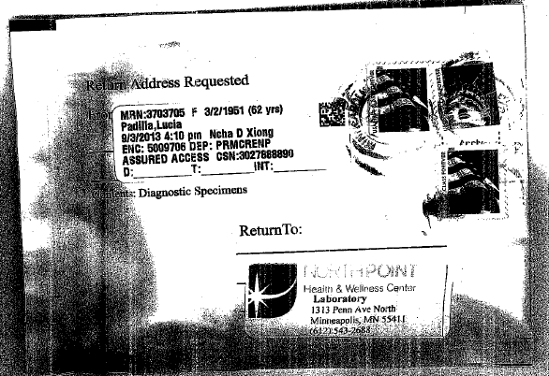  NO | All Staff
Flu Shots Clinic | Next week – September 16-20th from 12-4pm  Please fill out paperwork (see hyperlinks) and bring insurance card.  All staff should fill out this paperwork even if you choose not to get flu shot at NP or got your flu shot somewhere else.  If you do use the NP Shot Clinic – please fill out your insurance information. | All Staff
UA Reflex | This test is not orderable by lab staff. If you have to reorder this because a patient was unable to void – see Denelle. | All Staff
UAC – issue | We have identified an issue where if we have to reorder a UAC, the UC may have pop-up errors and require an ABN. We are actively working to find a solution. See Denelle if this occurs. | All Staff
Procedure Additions, Updates and Changes:

