Weekly Updates
February 14, 2014
Test | Description of Changes |  | Affected Individuals
Ctrl+Alt+del | Please get in the habit of locking your computer when you step away.  Why does this matter?  - After 15 minutes, a screen saver will lock your computer.  - A secondary timer starts where at 60 minutes of no activity, the computer will reboot  - If multiple users are logged on to one computer when you go to restart, a pop-up message will display warning about logging of all the users. Select ok. | All Staff
Multi-user computers | When a computer is locked, you can choose to switch the user and log on even if the original user is still logged on and locked. | All Staff
Cerner desktop Shortcut | Under start, all programs right click on the Cerner icon and choose send to desktop. This will create a shortcut on the desktop for the logged on user. You will need to do this on each computer as you log on to them. | All Staff
Windows 7 Help | Here is a link to training options for Windows 7.  The video indicated below is short and recommended by Jackie. Feel free to follow through with the training resources as you feel necessary.  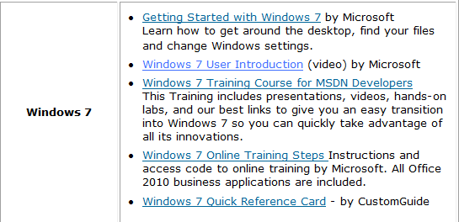  Select this video | All Staff
FIT Testing | Just a reminder that FIT testing is next Wed & Thurs (Feb 19 & 20). See schedule below --  - Kim West – Feb 19th 0820  - Leah Atkins – Feb 19th 0900  - Sondra Brooks-Retic – Feb 19th 1120  - Sue Seim – Feb 20th 0820  - Deb Jaakola – Feb 20th 0920  - Heather Labs – Feb 20th 1140  - Hilina Berhe – Feb 20th 1220  - Sue Johnson – Feb 20th 1240 | All Staff

Procedure Additions, Updates and Changes:

