Weekly Updates
March 4, 2016
Test | Description of Changes | Affected Individuals
Invalid A1C | 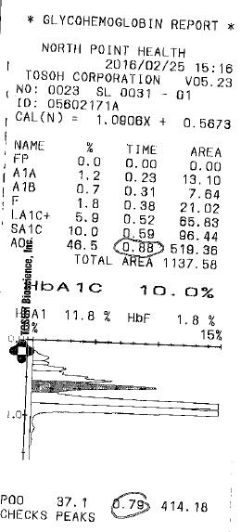  This test result is INVALID because the POO peak eluted before AO. See the circled times on the printout. | Bench Techs
Employee of the Year | It is time again to nominate an Employee of the Year. There are nomination forms behind the time clock. Please complete no later than Friday March 11th by 3pm. | All Staff
Phrazer | We are live with Phrazer, but the workflow is a work in progress. Please check out this workflow diagram – or look upfront at the laminated workflow at the front desk.  We are helping uninsured individuals with FIT (iFOB) tests fill out the SAGE Scopes paperwork. It is a front/back registration form that they complete. We check that they have answered the questions appropriately and signed on the back side. Then we will highlight their FIT test orange to notify the techs that this patient is a part of SAGE Scopes.  SAGE Scopes Log: When you have a patient complete the paperwork for registration – place an EPIC label on the SAGE Scopes log in the 3-ring binder.  Resulting FIT tests: The bench techs will complete an orange result sheet when this test is returned to the lab.  Paperwork:  Place the original on the clipboard hanging on the post in the island. Bench techs will make a copy of the SAGE Scopes registration form and place that in the back folder for HIM to copy to their record. The original will go in basket. Completed orange results sheets go in the results basket.  Original registration forms and result forms will be send to MDH weekly. | All Staff
CDC | Please check out the brochures about the history of the CDC. Sherry visited the CDC and brought back these for our nerdy little brains. They are in the hanging folder just outside the lab office. | All Staff
Lab Meeting Potluck | Next week on March 8 we will have a taco potluck. Please see the sign-up sheet on the refrigerator. | All Staff

Procedure Additions, Updates and Changes:
- Messaging in EPIC
- DocumentingTelephoneEncounterinEPIC
- OrderingExtraTubesinCerner
- TransfersPendingList
- CheckingtheTigrisList
- SysmexProcedure
- ESR Auto Plus Sed Rate
- Sickle Cell Screen
- Wet Preps

