Weekly Updates
March 11, 2016
Test | Description of Changes | Affected Individuals
TJC Requirement for specimen identification | 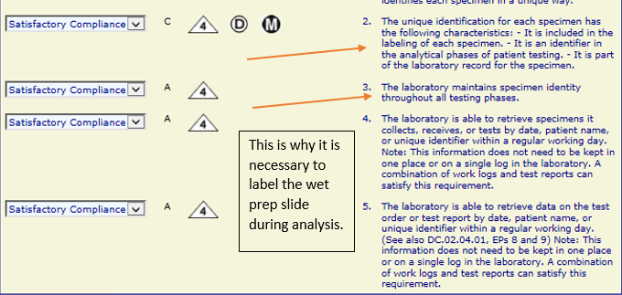  This requirement is the reason that specimens need to be labeled during all phases of testing. | All Staff
New gloves trial | Please try out the blue Amitex gloves – size medium. We will get a sample small box next week for trial. Leave me your feedback. | All Staff
Hennepin County Survey | County Employees - Please look for the survey from Hennepin County coming next week. Your input is valued – please complete the survey with your opinions! | All Staff
New results options for Flu | Group Responses:  Enter this code in the ‘Entry’ field:  - NIVOIA – Negative for Flu A & Flu B, & TPB  - PIVAOIA – Positive for Flu A & Negative for Flu B, & TPB  - PIVBOIA – Positive for Flu B & Negative for Flu A, & TPB  This information has been updated on the clipboard, as well
Phrazer headphone pairing | Hints for pairing the headphones:  - Make sure headphones are powered ON before pairing or unpairing – it will remember automatically so this step should be unnecessary  - To get into pairing mode – the headphones should be OFF, then hold down power key for 10 seconds and red and blue lights start flashing  - You can only have 1 device paired at a time to patient mode  Charging:  - It will have a red light when plugged in and successfully charging | All Staff
Phrazer at the end of the night | Please make sure phrazers are plugged in at the end of the night. We will ONLY ‘log’ them off on Saturday nights. Then on Monday morning we can power them back up. | All Staff
Bukky | Please join me in welcoming Bukky, our new phlebotomist. She joins us with much experience from Memorial Blood Centers. | All Staff

Procedure Additions, Updates and Changes:
- Messaging in EPIC
- DocumentingTelephoneEncounterinEPIC
- OrderingExtraTubesinCerner
- TransfersPendingList
- CheckingtheTigrisList
- SysmexProcedure
- ESR Auto Plus Sed Rate
- Sickle Cell Screen
- Wet Preps

