Weekly Updates
March 18, 2016
Test | Description of Changes | Affected Individuals
New gloves trial | Please try out the blue Amitex gloves – size small. Leave me your feedback. | All Staff
SAGE Scopes Insurance | Please remember to attach SAGE Scopes insurance coverage when a participating patient returns a FIT kit. If you need assistance, please see me and I can assist you. | All Staff
Doorbell & Team response | The doorbell will be used by the Front Desk to notify the lab that assistance of any type is needed at the front desk. The order of response will be as follows:  - Sendouts  - T2  - Chem  - T1  Please offer your help if the doorbell goes off. Notify your fellow workers that you are responding and ask them to help cover your bench. | All Staff
Sed Rates | When drawing sed rates, here are few tips to help you:  - If you are using a butterfly, you need a lead tube  - You can also draw an EDTA tube, and the techs can perform off of that as well, if sed rate tube over or underfills | All Staff
New Walkies | 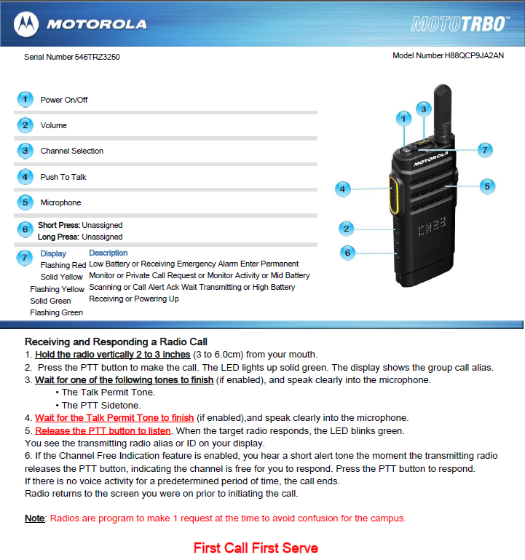
Tosoh and variant Hgb | Providers only need to be notified if the patient is < 50 years and a Hgb S is identified. | Bench Techs
Student | Starting next Monday, March 21st please welcome our student from Rasmussen. Sadee Eberly will be with us for 1 week working on her phlebotomy skills. | All Staff
SharePoint | There is a graphic on the office door of things I plan to put on the Sharepoint site for the lab. Please take a look and add things if you feel something was overlooked. I am also happy to share with you how sharepoint will work. | All Staff
Urine | What does everyone think about not releasing urine orders, rather print EPIC labels, label cup and then give the yellow slips to T1. T1 tech will release and log in the orders when the urine arrives. Please share your thoughts, pros and cons of how this might work. | All Staff
Phrazer headphone pairing | Hints for pairing the headphones:  - Make sure headphones are powered ON before pairing or unpairing – it will remember automatically so this step should be unnecessary  - To get into pairing mode – the headphones should be OFF, then hold down power key for 10 seconds and red and blue lights start flashing  - You can only have 1 device paired at a time to patient mode  Charging:  - It will have a red light when plugged in and successfully charging | All Staff
Phrazer at the end of the night | Please make sure phrazers are plugged in at the end of the night. We will ONLY ‘log’ them off on Saturday nights. Then on Monday morning we can power them back up.  How is this going…? | All Staff
Survey | Just a reminder for Hennepin County employees to complete the survey. You will find it in your email. | All Staff
Employee Appreciation | Please plan to attend the employee appreciation luncheon at the Earle Brown Heritage Center from 1:30-4:30 on Friday April 1st. This is paid time where you will have food and entertainment. I can give rides to anyone that may need a ride. | All Staff
Clean Catch Urine Directions for patients | Directions for a Clean Catch Urine and using Aidet  In the back we are seeing about 80-90% of our urines are very “dirty” meaning they have a lot of contamination and skin cells in them. When these urines are cultured there may be interferences with normal flora obscuring the results and making them unreadable. It may also give us false positive results on the testing we do here in the lab. I have made directions that are in each of the patient bathrooms on orange paper in English, Spanish, and Hmong. It is important that we start giving our patients more directions on how to catch a clean, midstream, urine. It will also help us use AIDET in on urine only patients.  My suggestion is that when you bring a patient back to the bathroom, after you greet the patient, introduce yourself, and identify the patient, tell them that you need to give them some directions on how to collect a clean catch, midstream urine and that it will only take a minute.  Women should be instructed to use the wipe and wipe their area front to back, start voiding in the toilet then catch the mid-stream urine, and finish voiding in the toilet. Then direct them to the directions on the back wall for more reinforcement.  We are not seeing evidence of contamination in male urines. | All Staff

Procedure Additions, Updates and Changes:
- Messaging in EPIC
- DocumentingTelephoneEncounterinEPIC
- OrderingExtraTubesinCerner
- TransfersPendingList
- CheckingtheTigrisList
- SysmexProcedure
- ESR Auto Plus Sed Rate
- Sickle Cell Screen
- Wet Preps

