Weekly Updates
April 1, 2016
Test | Description of Changes | Affected Individuals
GCT orders | Medical will put in when the Glucola drink was given to patients in the EPIC GCT order to help prevent confusion. Look in the order for this information. | All Staff
Resource to help providers with orders | FYI – we should offer to help providers place orders in EPIC, because as you know there are often multiple names for lab tests. We can use ARUP as a resource or call HCMC. If you are unsure or unable to figure out how to order the lab tests, ask the provider when the patient will be coming to have labs collected. If you are unable to get the orders placed immediately, coordinate with the provider and patient to come back for collection another day. Leave the orders for me or contact HCMC for assistance. | All Staff
Example of outside orders | Here is a copy of a fax that a provider received. The provider was expected to figure out how to order these in EPIC…  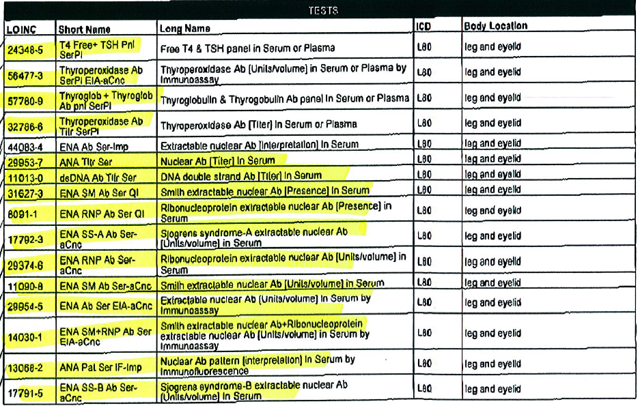
Headset | We now have a headset attached to the chemistry phone. Anyone can use it and answer the phone ‘on the fly.’ Put the headset on and then press the small silver button. This will turn on, answer or hang up the phone. Please see me if you have questions. I encourage y’all to use this awesome tool, especially for troubleshooting instruments. | All Staff
Survey Extended | Hennepin County employees – the survey has been extended until April 8th. Please complete the survey so your voice is heard. | All Staff

Procedure Additions, Updates and Changes:
- Messaging in EPIC
- DocumentingTelephoneEncounterinEPIC
- OrderingExtraTubesinCerner
- TransfersPendingList
- CheckingtheTigrisList
- SysmexProcedure
- ESR Auto Plus Sed Rate
- Sickle Cell Screen
- Wet Preps

