Weekly Updates
April 15, 2016
Test | Description of Changes | Affected Individuals
IFOB Procedure Update | Updated the procedure to add a section on handling specimens that may arrive overfilled. Please reference the IFOB procedure for details. Changes are highlighted in yellow. | Bench Techs
Proficiency Testing | Our proficiency testing from AAFP will be shipping next Monday.  - Please be aware it may be arriving on Tuesday or Wednesday evening.  - Open the box  - Check that contents are in satisfactory condition  - Remove paperwork from box  - Refrigerate entire box  I will hand out the assignments for proficiency testing next week. | All Staff
Stocking draw rooms | Remember to always put new stock supplies so that it is used after the older stock. For example, this will mean stocking blood tubes with the newest tubes at the bottom, because everyone pulls blood tubes from the top. | Phlebs
Outdates | Please check outdates in the draw rooms for specialty tubes, including but not limited to:  - Coag tubes  - Red, no gel  - Pediatric tubes  - Green, no gel | Phlebs
HCL 24 hour urine container | HCMC test menu has a hyperlink for directions for using this collection container – follow this link to see it. I am working to get this translated to Spanish.  Important details:  - Patients should never collect directly into 24 hour containers with preservative because of splash risk  - Turn plastic HCL container a quarter turn counter clockwise to release HCL into container when distributing to a patient for collection | All Staff
RSVP to Lab Luncheon | Please check your email and RSVP to the lab luncheon invite on 4/28/2016. | All Staff
Heritage Park chemistry samples | Please make a copy of the next 5 chemistry sample result printouts from Heritage Park samples. Give to Heather or Denelle. | Bench Techs
Phrazer | On Monday, we will be getting a condensed version of IFOB directions in English and Spanish on the Phrazer. | All Staff
Competencies | Competency folders and grids have been updated. Directions for performing competencies were printed on yellow paper and placed in your mailbox. It is time to show that you are competent in all of the required ways.  **New employees don’t begin competency documentation until after they have been here 6 months. | All Staff
Sofia Updates | We have another Sofia in T2. The Sofias are now connected to Virena, a device which will send de-identified information to the MDH about our results to track Influenza, RSV and strep trends. Because of this change, you will need to enter the following when performing any tests:  - Patient age – this will show up after you log-on  - Also have a choice for age in [Month] or [Years] or [Weeks]  - Patient status – has a proficiency test choice, for non-patient testing, otherwise leave as defaulted blank status  - Scan barcode to log-on as user  ** We are still only using Flu and RSV on the Sofia at this time.  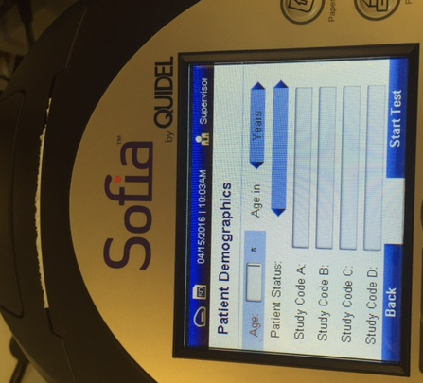  Use this button to toggle between YEARS, MONTHS OR WEEKS  Changed only for proficiency testing | All Staff
New Swabs | Starting on 4/26/16 – we will begin using e-swabs. These will be collected for Group B strep, wound cultures or miscellaneous cultures.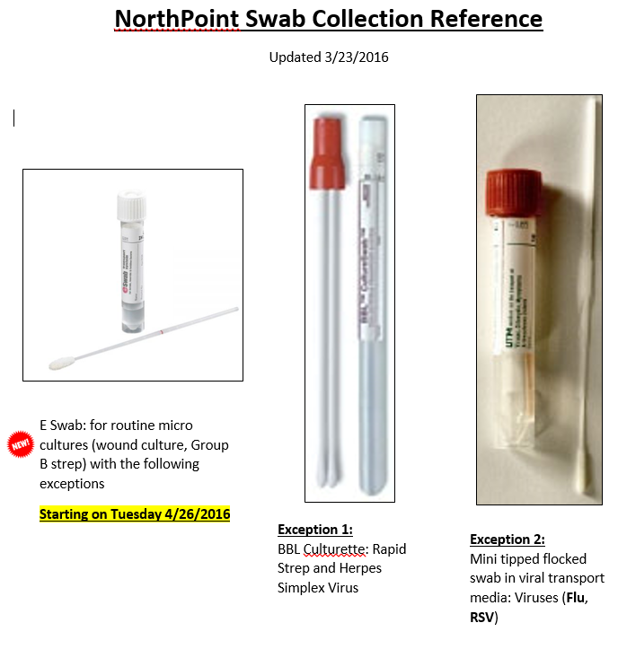
Biannual Correlations | This procedure has been updated to include A1C correlations – link to procedure. Techs please read and sign procedure attestation. Turn in completed attestations. | Bench Techs

Procedure Additions, Updates and Changes:
- Messaging in EPIC
- DocumentingTelephoneEncounterinEPIC
- OrderingExtraTubesinCerner
- TransfersPendingList
- CheckingtheTigrisList
- SysmexProcedure
- ESR Auto Plus Sed Rate
- Sickle Cell Screen
- Wet Preps

