Weekly Updates
April 22, 2016
Test | Description of Changes | Affected Individuals
ESR Procedure Update | The test procedure was edited to remove information about looking for lipemia. | Bench Techs
SAGE Scopes Paperwork | We can now print off a copy of the patient’s snapshot from EPIC and attach that to the paperwork in lieu of filling out all of the demographic information on the paperwork. We still need either an EPIC sticker just at the name/birthdate section or the patient to fill out their name. | All Staff
New Coverage Exception | United Behavioral Health is not an insurance that we can bill. Use corporate account if this the only insurance they have. See image below  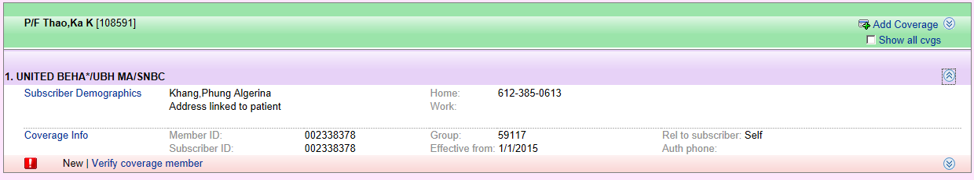 | All Staff
Phrazer | The Phrazer has the new shorter version of FIT directions. It is about 5 minutes long in English. We also have the Spanish version. To choose the language, it is the last option under patient set up. African American – is English. | All Staff
Sofia Updates | We have another Sofia in T2. The Sofias are now connected to Virena, a device which will send de-identified information to the MDH about our results to track Influenza, RSV and strep trends. Because of this change, you will need to enter the following when performing any tests:  - Patient age – this will show up after you log-on  - Also have a choice for age in [Month] or [Years] or [Weeks]  - Patient status – has a proficiency test choice, for non-patient testing, otherwise leave as defaulted blank status  - Scan barcode to log-on as user  ** We are still only using Flu and RSV on the Sofia at this time.  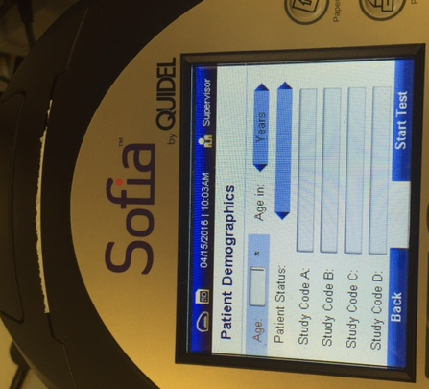  Use this button to toggle between YEARS, MONTHS OR WEEKS  Changed only for proficiency testing | All Staff
New Swabs | Starting on 4/26/16 – we will begin using e-swabs. These will be collected for Group B strep, wound cultures or miscellaneous cultures.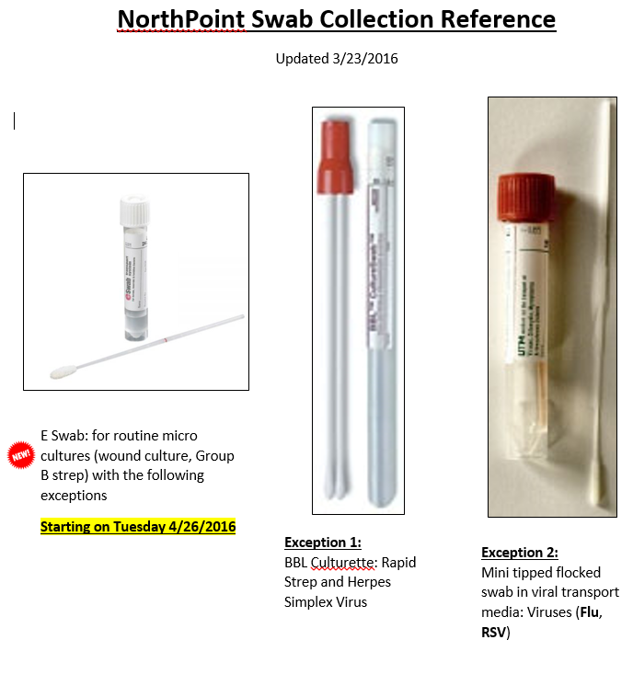
Moved Supplies | The Sofia Flu and strep containers have been mounted on the wall to increase working counter space in T2. See Denelle or Tech specialists if you have questions or concerns. | All Staff

Procedure Additions, Updates and Changes:
- Messaging in EPIC
- DocumentingTelephoneEncounterinEPIC
- OrderingExtraTubesinCerner
- TransfersPendingList
- CheckingtheTigrisList
- SysmexProcedure
- ESR Auto Plus Sed Rate
- Sickle Cell Screen
- Wet Preps

