Weekly Updates
May 13, 2016
Test | Description of Changes | Affected Individuals
Update Job Aid for MALBs | Please see the updated flip chart job aids for MALBs and flags on the center island. | Bench Techs
Checking Insurance | Just a reminder, that you can see the patient’s insurance status when you are releasing their labs in the primary care visit. Choose patient from schedule, select show orders. This is the top bar that you will see for the patient. This is relevant when screening our IFOB patients for insurance status. See the screen shot example: (insurance is boxed in red) | All Staff
Proficiency Testing | We are getting our proficiency testing in phases. Please complete all testing that has been assigned to you and turn in. The next testing should arrive on or around May 16th. I will give you back your worksheets when the next phase arrives. | All Staff
System Check | Please make sure all instrument flags are address prior to leaving at the end of each day. Several days, the Dimension did not have sufficient Check reagent. | Bench Techs
Yellow Slips | Note: yellow slips may have additional information written on them to communicate with the lab. This may include things like – draw extra tubes or STAT next to a certain test. Please follow through on these notes from the providers or call them to clarify their intent. | All Staff
H Pylori Administration Charges | Each patient who has a breath test, must also have an H Pylori Breath Admin charge. This is ordered under their Primary Care visit or Lab visit. Search H Pylori Breath admin in the orders field. (PF H Pylori Drug Admin 183014001) Attach the same diagnosis code as was used for the breath test. Once you sign the order it will disappear. It is a code that bills for the administration of the test. If we don’t order it, we can’t get reimbursed. | All Staff
2 patient Identifiers | Please use two identifiers (name, date of birth, MRN # - if you have labels to compare to) when identifying EVERY step of lab work.  For example:  - Collecting the specimen  - Identifying specimen before beginning UA/scope/strep/manual work  - Identify specimen and match to Cerner labels when aliquotting for sendout testing
Name Alert Stickers | We have name alert stickers at the front desk and in sendouts. These stickers should be placed on yellow sheets or Cerner labels to help staff recognize that they may need to use a third identifier to correctly identify patients with similar names. | All Staff
New Swabs | Starting on 4/26/16 – we will begin using e-swabs. These will be collected for Group B strep, wound cultures or miscellaneous cultures.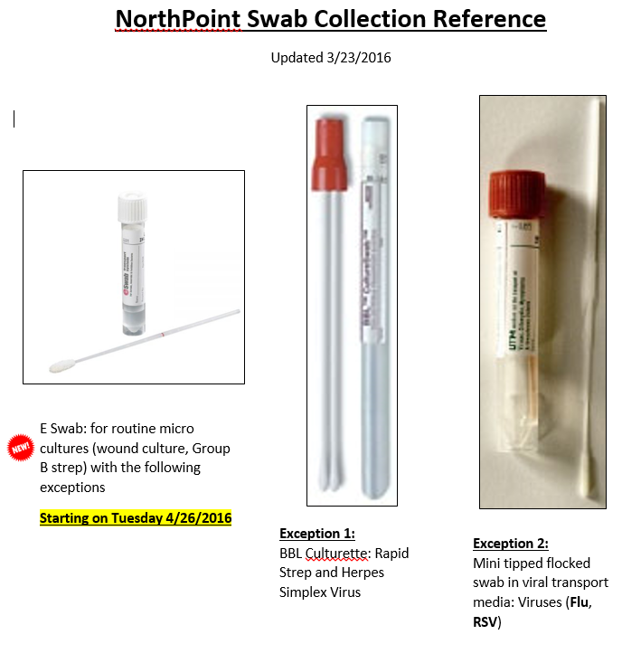

Procedure Additions, Updates and Changes:

