 | LABORATORY DEPARTMENT  POLICIES AND PROCEDURES | Department: HEMATOLOGY
 | LABORATORY DEPARTMENT  POLICIES AND PROCEDURES | Number:  226.1-Hema-gu-rev03/2013

HEMATOLOGY DOWNTIME PROCEDURE

POLICY: The Hematology Department has a manual backup system in place in case of computer downtime to ensure continuity of care for our patients.

PROCEDURE

A. In the event of a planned downtime, where Cerner labels are available, specimens will be processed as follows.

1. Change report on DxH to downtime (chartable report).

a. From System Status screen click menu, then setup, then reporting.

b. At bottom of screen you will see tabs, click on Auto report. This is where we will

make the changes for Downtime and to return from Downtime.

c. Under the heading “Automatically report when results final released” nothing needs to be changed. The only checked item should be Transmit report.

d. Under the heading “Automatically report when results held” click in the box

for Chartable report - when done a check mark should be present.

e. On the upper right side of screen you will see a marked circle for “only print lab

report for abnormal results containing one or more of the following”. You will click

in the above box which labeled “Print lab report for all results”.

f. Do not change anything else. See screen prints for before Downtime and

Downtime. Remember you must have a barcode to run in automatic mode.

g. If you have no bar code you can run in single aspiration mode. Remember in

this mode that you have your default test selected from System Status.

h. The DxH will print two reports; one with ranges for the patient chart and one for our

purposes.

i. Remember during the Downtime patient name will not appear, make sure you label

each report with correct patient name.

2. Once Cerner is up you can re-transmit to Cerner: Only the ones with cerner IDs.

a. From main menu click on the icon at top of screen Worklist

b. Here you have several tabs; pending, not processed, review, released and custom. Choose released. Here you can highlight as many as you need to transmit. The Transmit tab is at the bottom left.
c. Look at the review tab to see if anything is not released. Click on the specimen in
question, click the released tab – it will now be in released file.
d. Scrutinize before you release to see why it was not released.

PROCEDURAL NOTES
1. Remember when Cerner comes up to change your reporting back on the DxH.
2. You must write your results for ESR and manual differentials.

ATTACHMENTS
1. See DxH screen prints

REFERENCES

1. UniCel DxH 800 Coulter Cellular Analysis System Instructions for Use, Beckman
Coulter, Inc, Fullerton, CA 92835.
2. Unicel DxH 800 Procedures, Willis McKnighton Laboratory Services, 2/20/2010.

Prepared by/Title/Date:  Gary Sauer MT 4/28/2010  Approved by/Title/Date:  signature on file in Lab | Committee Approval/Date:  Policy & Procedure ______ | Dates Reviewed/Revised:  5/16/2011  3/5/2013
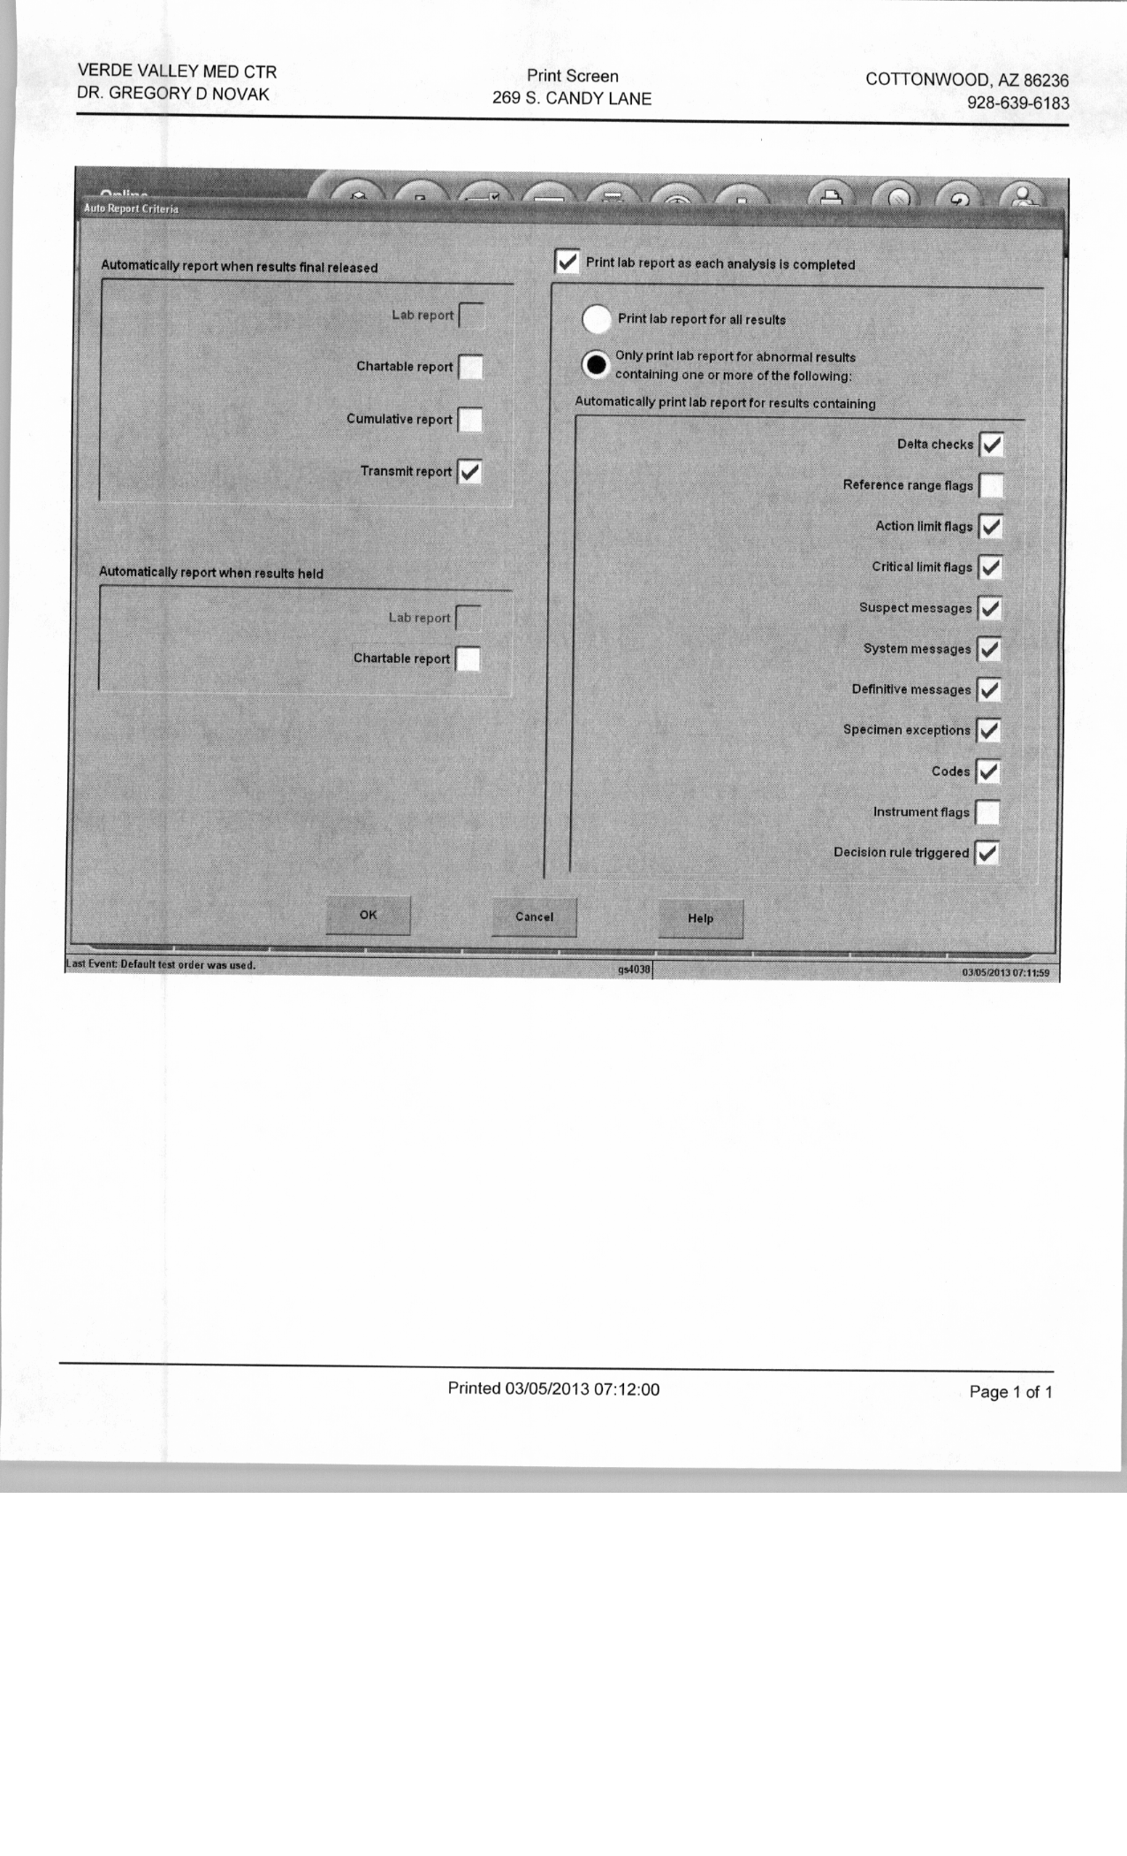

SETTINGS BEFORE DOWNTIME

SETTINGS FOR DOWNTIME

