POLICY

Specimens for coagulation tests must meet the following criteria or be redrawn.

PROCEDURE

General Drawing Instructions
- Only citrated plasma is the acceptable sample type. All other anticoagulants (heparin, EDTA, oxalate, etc.) are NOT acceptable.
- The proper blood to anticoagulant ratio is required. Currently we see 4.5ml glass, 3.0ml plastic, 2.7ml plastic and pediatric 1.8ml.
Pictures (actual size) are representative of the types of Coagulation tubes used for testing. Ensure proper draw volume by holding tube up to this guide for overfilling and underfilling. Check visually for clots as well.

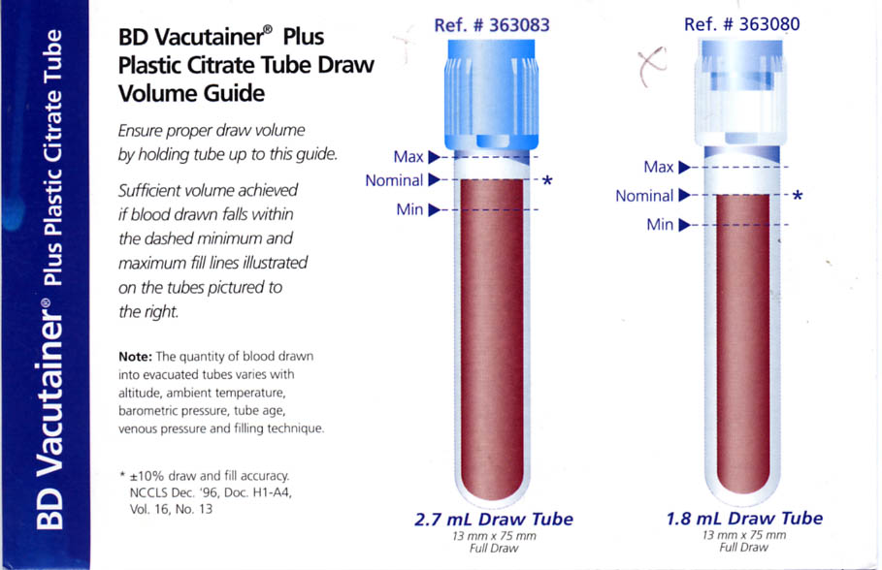

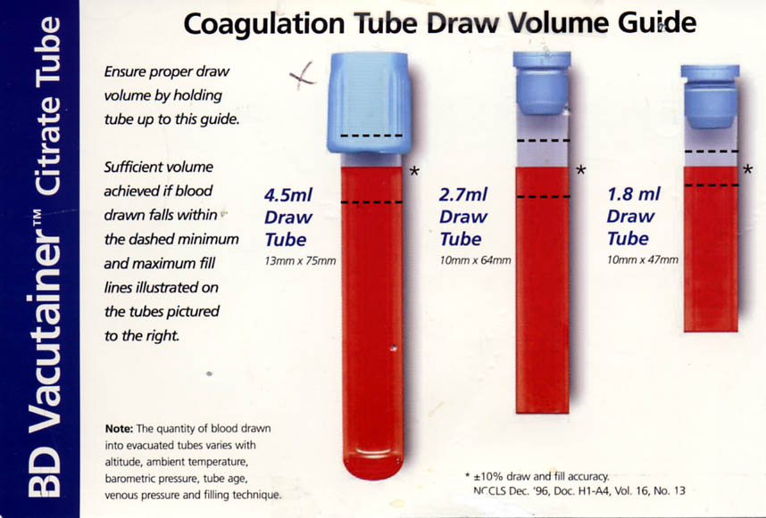

a. Vacutainer tubes must be completely filled to ensure the proper 9:1 blood to sodium citrate (3.2% Na citrate in water) ratio.
b. Routine collection requires 2.7 ml blood added to 0.3 ml sodium citrate or pediatric 1.8ml of blood added to 0.2ml of sodium citrate. For patients with normal hematocrits, no adjustment is necessary. If the patient has a known hematocrit above 55%, adjust the amount of anticoagulant in the collection tube before drawing the blood, according to these NCCLS guidelines:

Anticoagulant vol. = 100 - hematocrit X total vol. of
595 - hematocrit blood required*

*2.7 ml standard or 1.8 ml for
pediatric
Example: Patient hematocrit = 60%

100 - 60 x 2.7 = 0.2 ml sodium citrate
595 - 60

- Certain substances such as tissue thromboplastin or heparin may alter the results. To avoid contaminating the sample.
  - The venipuncture must be clean, with no trauma.
  - Hemolyzed samples are not acceptable.
  - The first 4 ml of blood drawn from a patient should not be used for coagulation testing.
  - If the specimen is drawn through an indwelling catheter, the first 20 mL of blood must be discarded or used for other laboratory tests before the specimen for coagulation testing can be obtained.
- Mix the sample gently by inverting the tube several times immediately after filling. Do not shake the tube, as this will break down the fibrinogen in the sample.
- Complete testing within 60min, (if stored at room temperature) or within 4h, (if stored at 2-8°C). See individual procedures.
- Centrifuge the specimen to obtain plasma with a low platelet count (3500 RPM for 5 min). Transfer plasma into a plastic cup/tube using a plastic Pasteur pipette, or analyze in the primary Vacutainer tube. Refer to Procedural notes coagulation centrifuge for platelet poor plasma.
- Any specimen that does not meet the above requirements will be logged onto the Specimen Rejection Log (refer to Specimen Rejection Procedure in the General Laboratory Manual).
Appropriate Department is called for redraw.
- Pipette calibrations are performed on a regular maintenance schedule, refer to Pipette Calibration procedure in the General laboratory Manual.
- Check for mislabeled specimens from the Emergency Dept. (ED).
- If the specimen is lipemic answer the test as “See Note”, and put a note in Result Comment
stating that “Specimen too Lipemic to Obtain a Result”.
- If a specimen cannot be assayed in this lab due to lipemia refer the specimen to a reference laboratory.

POST ANALYTIC
1. Refer to Critical Values Procedure in the General lab Manual.
2. Refer to Validation of Patient Results in the General Lab Manual.
3. Refer to Amended Result Policy in the General Lab Manual.
4. When verifying results in the LIS review the analyzer printout to match the results in the LIS before verifying.

QUALITY ASSURANCE (QA)
- Tracking of specimen rejections is an ongoing process, refer to QA Manual 2005.
- Tracking mislabeled specimens by ED (Emergency Department) is an ongoing process, refer to QA manual 2005.
- Read Back Verification documentation is an ongoing process, refer to QA manual 2005.
- Quality Improvement Plan, refer to Laboratory General Policies and Procedures Manual.
- Review QC data monthly.

SENDOUTS
- Ship samples for testing on dry ice. Samples must remain frozen in transit
- Quick freezing the sample is the best way to keep the coagulation factors intact. This can be achieved by one of the following methods:
  - Freeze in a mixture of dry ice and methanol.
  - Freeze in a -70°C freezer.
Procedural Notes
1. To avoid spurious coagulation results, it’s important that the centrifuge used to process the coagulation specimens produce platelet poor plasma, with a platelet count not exceeding 10,000 per microliter. The centrifuge will be checked twice a year by sampling the plasma from five citrated tubes, averaging the results, and determining the centrifuge’s suitability. If the platelet count is not acceptable, not any corrective action, or check a different centrifuge and use that one. Currently one in processing is labeled as suitable for blue tops to spin down and the stat spin in hematology. Form used for checking attached.
2. Regarding clearing (flushing) of the volume of intravenous lines before drawing samples of hemostasis testing- refer to nursing policy 200.12.
3. Delay in coagulation testing is as follows: Prothrombin times are stable for 24 hours at 18-24°C spun or unspun. APTT’s are stable for 4 hours at 2-4°C or 18-24°C.Fibrinogens are stable for 4 hours at 18-24°C.
D-Dimer HS is stable for 4 hour at 18-24°C. If testing cannot to performed within the these times, platelet-poor plasma should be removed from the cells and frozen at -20°C for up to 2 weeks or -70°C for up to 6 months. A frost-free freezer should not be used.

REFERENCES
- NCCLS Document H21-A2, Vol. 11, #23, 2nd Ed. (1991). Collection, Transport and Processing of Blood Specimens for Coagulation Testing and performance of Coagulation. Villanova, PA: NCCLS.
- ACL™ TOP On-Line Help Manual Rev 2.0, Instrumentation laboratory.
- NCCLS Document H1-A4, (Dec. 1996). 16(13).
- Laboratory General Policies and Procedures:
  - Specimen Rejection Procedure
  - Pipette Calibration
  - Aliquot Labeling
  - Validation of Patients Results
  - Critical Values
  - Amended Result Policy
  - Quality Improvement Plan
- Hematology Policy and Procedure Manual:
  - Schedule of Hematology Instrument Maintenance
  - Specimen Collection and Preparation for Coagulation Tests, December 6, 2005.
  - Protimes
- Quality Assurance manual 2005:
  - Mislabeling of tubes ED
  - Read Back Verification document

