Radiometer Patient Testing Training Document

Analyzer Basics

The elements of the ABL90 FLEX PLUS main screen are as follows:

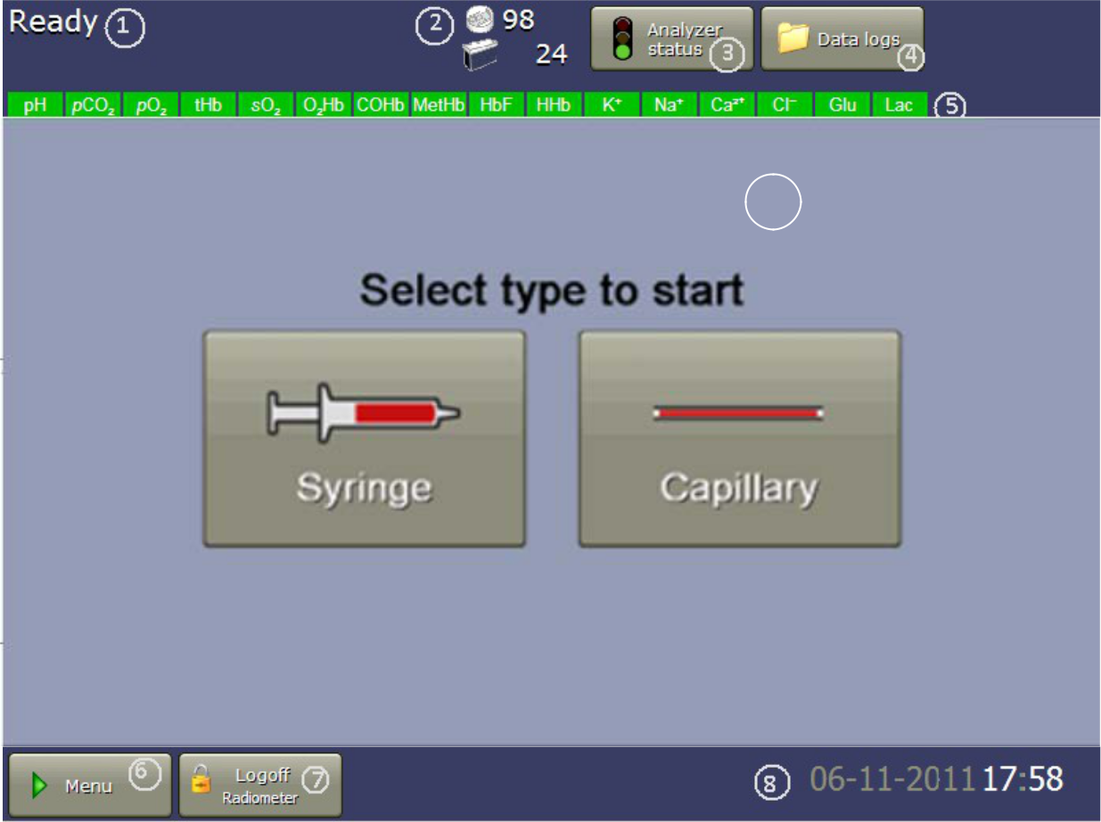

9

* + - 1. Analyzer status: The overall status of the analyzer. If the analyzer is not available for sampling; the task and the time remaining will be displayed.
      2. Replacement status: the status of the consumables is displayed.
      3. Analyzer status traffic signal: the status of the calibrations, quality control, replacements, activities, and system messages.
      4. Data logs: Access to historical data
      5. Parameter status: The status and availability of each parameter.
      6. Menu: Access to all ABL90 FLEX functions and setup.
      7. Logoff: user Logoff
      8. Date/Time: Current system date and time display
      9. Sample type analysis buttons for initiating analysis.

Quality Procedures

Quality control management is important as it evaluates the performance of the analyzer to make sure that patient results are accurate and precise.

* 1. Built-in QC: automatic QC test sequences that are done with each measurement and at other times to make sure that all parts of the analyzer operate within specifications.
  2. External QC: external QC may also be performed per regulatory and individual laboratory guidelines. See Appendix A for specific laboratory QC guidelines.
  3. System checks: Automatic test sequences done with each measurement and at other times to make sure that all parts of the analyzer operate within specifications. The analyzer automatically takes action to correct a problem it finds. If the action fails, a message is shown and the analyzer goes into the Operator Action Needed, Troubleshooting needed or Intervention Required mode. In these modes operators are given instructions about what to do. Results of failed system checks are recorded in the Activity log.

Quality control management is important as it evaluates the performance of the analyzer to make sure that patient results are accurate and precise. The analyzer performs QC automatically, but external QC may also be performed per regulatory and individual laboratory guidelines.

* 1. External QC - Qualitcheck + QC ampoules Level 1, 2 and 3 will be used to monitor instrument performance at specific intervals.
  2. Frequency of External QC
     1. After replacement of solution Pack
     2. After replacement of Sensor Cassette Replacements
     3. Whenever instrument performance is in question

Requirements for Patient Testing

Patient preparation

* + 1. There is no specific patient preparation prior to collecting samples for testing.
    2. If samples are collected from an artery, appropriate Allen's testing or circulation should be performed prior to arterial puncture. Follow site-specific procedures.

Specimen Collection

* The collection of arterial blood samples for blood gas analysis is performed primarily by the Respiratory Care staff. Policies and procedures related to the collection of blood for blood gas analysis are determined and written by Respiratory Care. The Department of Nursing defines blood collection procedures for nursing staff.
  + - * To ensure quality blood gas results and to avoid contamination by air, place an airtight cap on the end of the syringe, immediately after collection. Excess air in the sample should be expelled prior to mixing the sample and prior to capping the sample. **Needles should not be recapped**
      * Collection containers should be filled to correct sample fill capacity to avoid binding of ionized calcium by heparin.
      * Incomplete filling/ under filling of the sample collection container causes higher heparin to blood ratio, which will falsely decrease ionized calcium results and may affect other results.
      * Minimum volume for ABG testing by syringe is 1mL
      * Minimum volume for Lithium Heparin tubes is 3.5 mL.
      * Effective mixing of samples is essential to quality results. Samples should be well mixed to prevent clotting. Avoid shaking as this may cause hemolysis of the sample. Syringes should be mixed by gently rolling while rocking the sample between the hands for a minimum of 10 seconds. Mix all samples using consistent technique. Evacuated tubes should be gently inverted until the sample is homogenous. Capillary samples must be thoroughly mixed until homogenous.

Acceptable Specimen Types

* Each facility will need to ID and document the sample types that have been validated and will be accepted for testing. The following are general acceptable sample types for the Radiometer ABL 90 FLEX PLUS Analyzer.
* Arterial blood - procured by arterial puncture or arterial line is recommended as it accurately reflects acid-base physiology and oxygenation status.
* Venous blood - obtained by syringe can also be used to provide satisfactory pH and pCO2 however venous pO2 levels may not be significant in routine clinical studies without simultaneous study of arterial pO2. Evacuated tubes (Li Heparin vacutainer) are not recommended for collecting blood gases.
* Mixed venous – Obtained from a pulmonary artery catheter after carefully clearing the catheter of infusion fluid.
* Capillary blood – Closely resembles arterial blood and may be used for blood gas analysis. Care should be taken to avoid hemolysis as it would falsely elevate K+ levels. Tubes should be capped with rubber caps (clay not recommended). Avoid use of mixing fleas to mix capillary tubes to avoid hemolysis.
* Li Heparin evacuated tubes may be used for Na, K, Glu, and Lactate testing. Note: With the exception of autopsy samples, evacuated tubes should not be used for venous Co-Ox testing. The O2Sat results from evacuated tubes are considerably higher due to air contamination from this collection method.
* Anticoagulants - Electrolyte balanced lithium heparin or lithium heparin is the only acceptable anticoagulant suitable for blood gases, ISE and tHb. Other anticoagulants such as EDTA, citrate, oxalate and fluoride have significant effects on blood pH and ionized calcium and should not be used. EDTA will also decrease the lifetime of the calcium sensor.
* When using blood gas syringes with liquid heparin, extreme care should be taken to avoid sample dilution/contamination from the liquid heparin.
* Different types of anticoagulant may change the concentration of some parameters and give false patient results.
  + - 1. Anticoagulant Possible effect on patient results
      2. Heparin in liquid form - Biased results on all parameters
      3. Anticoagulants with sodium cations (Na+) - Falsely high cNa+ results
      4. Anticoagulants with sodium and potassium cations (Na+ and K+) - False cNa+, cK+ results
      5. Anticoagulants with Lithium/Zinc heparin - False cCa2+ results
      6. Anticoagulants with ammonium heparin - False cCl– results
      7. Disodium oxalate with sodium fluoride - Falsely high cNa+, falsely low cCa2+ and false cGlu and cLac results
      8. Trisodium citrate - False cNa+, cK+, cCa2+, pH, cGlu, and cLac results
      9. EDTA - False pH, pCO2, cNa+, cK+ and cCa2+ results. False cCa2+ results in subsequent patient samples

Specimen Storage and Preservation

Sample storage should be kept to a minimum. When the sample cannot be analyzed immediately the following guidelines are recommended.

|  |  |
| --- | --- |
| **Containment** | **Storage recommendations** |
| Plastic syringe | If it is not possible to analyze the sample immediately, analyze it within 30 minutes.  Recommended sample storage temperature is room temperature. |
| Glass syringe | If it is not possible to analyze the sample immediately, analyze it within 30 minutes when stored at room temperature.  Alternatively, store the sample in ice water (0-4 °C). The storage time should not exceed 1 hour |
| Plastic capillary  tube | If it is not possible to analyze the sample immediately, analyze the sample within 10 minutes. Keep the sample at room temperature. |
| Glass capillary  tube | If it is not possible to analyze the sample immediately, either analyze the sample within 10 minutes when stored at room temperature or store the sample horizontally at 0-4 °C for maximum 30 minutes. |

* + 1. Note**:** Samples with expected high*p*O2 values or for special studies like shunt studies should be analyzed immediatelyor within 5 minutes.

Specimen Acceptability and Rejection

* Good pre-analytical sample handling techniques are essential for ensuring accurate results for tests performed at the blood gas lab. The following specimens should be rejected and an order for recollection placed.
  + - 1. Specimens that have clotted
      2. Specimens collected in an improper tube for analyte requested
      3. Specimens that have been mislabeled, unlabeled or are missing required patient identifiers.
      4. Specimens mixed with requisitions that do not correspond to the same patient
      5. Bio-hazard bags containing specimens from multiple patients.
      6. Specimens that have exceeded sample stability
      7. Improperly filled specimens
      8. Specimens that indicate improper collection due to physiologically improbable results that are not consistent with clinical observation i.e. Samples that appear to have been diluted by IV fluid
      9. Specimens with a needle still attached
      10. Specimens that are leaking
      11. Specimens submitted on Ice

Patient Orders and Reports

* Orders will be documented by a respiratory paper order. All paper orders are considered an official provider requisition order and must have the appropriate patient information. Testing will not be performed for requisition orders with incomplete information.
* Perform only the tests that have been ordered by the provider. Temperature corrected tests are only performed at the request of the provider.
* The paper printout from the instrument may be used as the report form or results may be manually entered on a downtime report form. Two copies of the report must be printed.
* If the incorrect orders were chosen or incorrect patient information was entered at the time of testing, go to ID Button > Parameters button. Choose the correct tests to be reported. Once you hit the Back button, the results will print automatically.
* Call all critical values to the appropriate clinical staff member. This must be documented on the report form according to departmental policies.
* One copy of the report form will be tubed to the appropriate location and one will be saved in the lab.
* Report forms will be scanned into Media Manager and become a permanent document for the patient’s chart.

Limitations of Procedure

* Hemolysis: hemolysis can falsely elevate potassium levels. Samples with an elevated potassium (defined as > 5.0 mmol/L) must be spun and the plasma portion evaluated for hemolysis.
  + - 1. Inject some of the well-mixed whole blood sample into a micro-centrifuge tube labeled with the patient’s MR# or last 4 digits of the patient’s CSN# or a taglet from a Beaker label.
      2. Be gentle to avoid mechanical hemolysis of the sample.
      3. Spin the sample.
      4. Remove the tube from the centrifuge and examine for hemolysis.
         1. Comment on the report:
         2. No visible Hemolysis (NVH - the plasma layer has no visual pink or red coloration)
         3. Slight Hemolsysis (SLTH -the plasma layer has a pale pink to red tinge)
         4. Moderate Hemolysis (MODH -the plasma layer has a definite red color but is lighter than the red cells)
         5. Marked Hemolysis (MKDH - the plasma layer is a dark red color)
* Lactate samples should be analyzed within 30 minutes after collection. Normal values depend on the sample type and must be appropriately assigned.
* Any substance that absorbs light in the same regions as whole blood could potentially cause an interference.
* Hyperlipemia can result in artificially increased methemoglobin values.
* High bilirubin concentrations can falsely increase oxyhemoglobin values.
* Hyperlipemia and administration of fat emulsions can increase total hemoglobin values.
* Samples frozen with liquid nitrogen can have decreased total hemoglobin levels.
* Samples from patients receiving blood substitutes yield unreliable results for oxygen content because of the different oxygen solubility of the blood substitutes.
* Contamination of the sample by room air should be avoided. Air should be expelled from the syringe which should be capped securely. Corks should never be used as capping devices. Rubber stoppers and caps should be used to prevent gas exchange with the sample.

Troubleshooting

* To troubleshoot **Consumables** or **System messages**
  + Select the message.
  + Tap the **Troubleshoot** button.
  + Follow the instructions on the screen.
* **NOTE:** If reagent or sensor was recently changed or if you suspect the sensor or reagent pack is not the problem but the Troubleshooting is telling you to change them. Try removing and re-inserting the current reagent pack or sensor before replacing with a new one.
* **Anytime a reagent pack or sensor is replaced as part of troubleshooting efforts, staff are to print the credit form and submit to the supervisor**.
  + Radiometer Services Hotline
    - 1-800-736-0600