On August 18th, orders and collection information for Blood Gas testing will change with a new workflow.

What is new and how does this affect us?

**NEW**

Beginning August 18th, the FIO2, Temperature, and specimen type will auto-fill in Beaker for you.

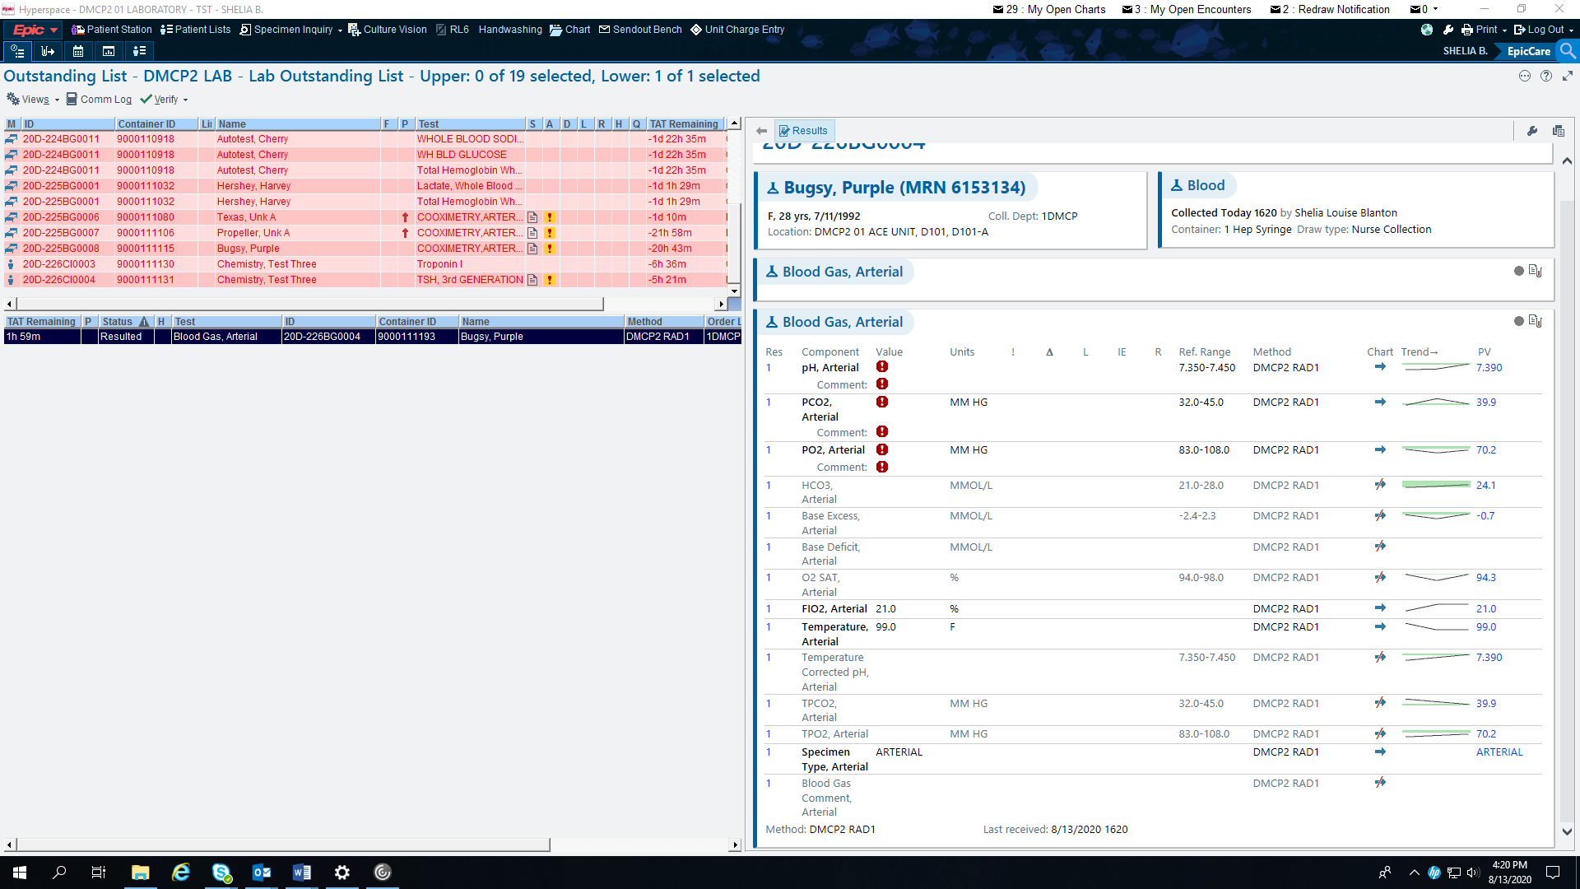

What do I need to do?

1. Always check the outstanding screen to look for Temp, FIO2, and specimen type (It MUST match the specimen type on the order!)

* REMEMBER: The FIO2 and Temperature are OPTIONAL. If the information isn’t there it is OK. The specimen type is a HARD STOP at collection. This should always be there.
* When testing, enter into Radiometer the information that has been provided to you.

** NEW **

The orders will specify the specimen type, but it also is a hard stop at collection. The specimen type drives the reference ranges.

* **IF THERE IS A DISCREPANCY WITH THE SPECIMEN TYPE AND THE ORDER IT MUST BE VERIFIED AND THE ORDER CORRECTED PRIOR TO TESTING!**

**Example of order and specimen type matching:**

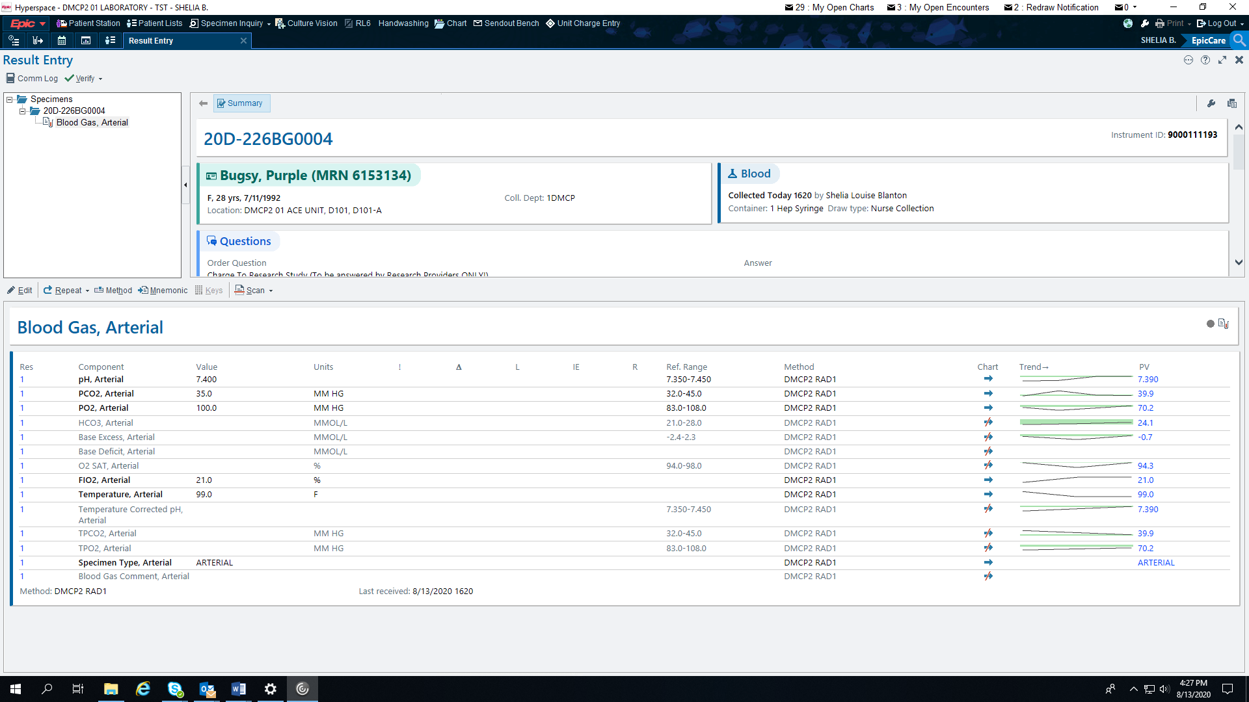

**NOTE: reference ranges have filled in for arterial blood gas.**

**Example of order and specimen type NOT matching**

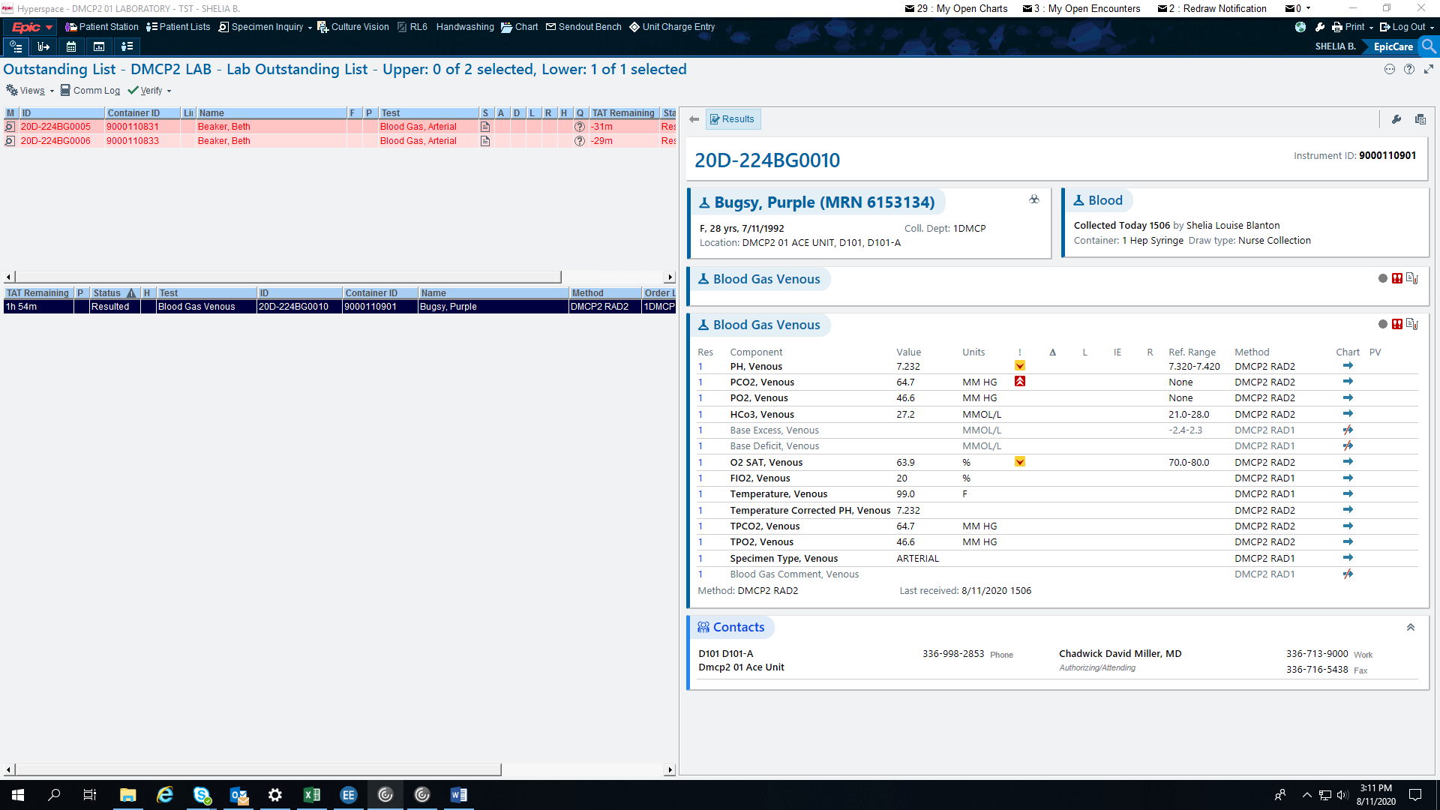

NOTE: The specimen type was entered as ARTERIAL, but the order is for VENOUS. Look at the reference ranges – these are venous reference ranges!

What do I need to do?

* This should not be reported out. The order needs corrected.
* Pay attention to the specimen types PRIOR to performing the test to catch errors BEFORE results are posted

Ugh-Oh – the orders are correct but after running the respiratory therapist says it is wrong. What do I do now?

* If after running the specimen type is noticed to be incorrect or it is expected to be ABG but the results show it is venous, you will need to follow what the RT / Nurse instructions are. (Whoever collected will make the decision)
* If they want the results: you will need to correct the order.
* If the specimen is still OK for a re-run, you can re-run the specimen.
* If the specimen is NOT OK for a re-run, correct the order and manually enter the results. Leave the report for review.
* If they do NOT want the results, place the order back for redraw with appropriate documentation.

Questions? PLEASE ASK!