New Urinalysis Orders and Workflow

Go-Live: July 21, 2021

Situation: As of July 21, 2021, a new Urine Analyses/Urine Culture (UA/UC) reflex process for in- and outpatients will be introduced systemwide.

Background: The diagnosis of a Urinary Tract Infection (UTI) remains difficult with non-specific signs and symptoms (1). Asymptomatic bacteriuria and urine culture contamination are frequently mistaken for UTI and are major drivers of inappropriate antimicrobial treatment (1-5). We currently perform over 143,000 Urine Analyses (UA) and 83,000 Urine Cultures (UC), annually. Only 34% of all out- and inpatient UC render a positive microbial result. The new UA/UC reflex process uses a threshold of White Blood Cell (WBC) of greater than 6/ul in the UA to trigger a UC. This will improve the identification and treatment of UTI and reduce the number of UC tests per year by over 66,000 with a false negative rate of <0.4% (missed positive UC).

Assessment: All providers should be aware of the changes ordering UA and UC in WakeOne for in- and outpatients.

Recommendations: The new UA/UC reflex process for in- and outpatients includes the following changes:

* There will be no changes to ordering UA
* Orders of the UA/UC combination will activate the new UA/UC reflex process (exemptions below)
* The following patients and departments listed below are exempt:
  + Patients exempt from the UA/UC reflex process:
    - Children <5 years old
    - Pregnant women
    - Neutropenic patients
  + Departments exempt from the UA/UC reflex process (peds and adult services):
    - Infectious Disease
    - Urology
    - Hem/Onc
    - OB/GYN
    - Nephrology

For questions regarding the new UA/UC reflex process please contact [Clin Micro].

References:

1. Claeys KC, Blanco N, Morgan DJ, Leekha S, Sullivan KV. Advances and Challenges in the Diagnosis and Treatment of Urinary Tract Infections: the Need for Diagnostic Stewardship. Curr Infect Dis Rep. 2019;21:11
2. Sullivan KV, Morgan DJ, Leekha S. Use of diagnostic stewardship practices to improve urine culturing among SHEA Research Network hospitals. Infect Control Hosp Epidemiol. 2019;40:228-231.
3. Flokas ME, Andreatos N, Alevizakos M, Kalbasi A, Onur P, Mylonakis E. Inappropriate management of asymptomatic patients with positive urine cultures: a systematic review and meta-analysis. Open Forum Infect Dis. 2017;4(4). Available from: https://www.ncbi.nlm.nih.gov/pmc/articles/PMC5714225/ .
4. Apisarnthanarak A, Rutjanawech S, Wichansawakun S, Ratanabunjerdkul H, Patthranitima P, Thongphubeth K, et al. Initial inappropriate urinary catheters use in a tertiary-care center: incidence, risk factors, and outcomes. Am J Infect Control. 2007;35(9):594–9.
5. Klausing BT, Tillman SD,Wright PW, Talbot TR. The influence of contaminated urine cultures in inpatient and emergency department settings. Am J Infect Control. 2016;44(10):1166–7.

So, what does this new order mean for you?

* You will no longer need to manually add the urine culture. Beaker will do this for you.
* Nursing and physicians will receive education about this new process.
* Nursing will no longer collect a Urine Culture tube, unless they have the new order for a Hold for Culture.

We have a new requirement for culture: New Culture Criteria is Microscopic WBC ≥ 6 (none seen and <0-5 results will NOT generate a culture).

**This is the ONLY criteria for a urine culture.**

New Order Process:

* New Order name: Urinalysis with Urine Culture if Indicated
* This order will generate two lab orders (The UA order and the Hold for Urine Culture order) and will apply to the following Urine tests:

1. Urinalysis with microscopic (UAMR)

2. Urinalysis with Microscopic if Indicated

* For the UA the physician will choose the appropriate test. The new order “Hold for Urine Culture” will also automatically order.
* Urinalysis only (No microscopic) Will NOT have the option for the Hold for Culture, as no microscopic exam will be performed.

What is the “Hold for Urine Culture” Order?

* These are place holders for the Culture to reflex. There will NEVER be a need to “add-on” a test to this order. Once you have received this specimen in, you will not need to see these orders again.

For inpatients and ED:

* Nursing will continue to collect the UA tube and the Culture tube ONLY if there is an order for the “Hold for Urine Culture”
* Lab staff will need to receive in BOTH tubes.

For Outpatients:

* Lab staff collecting UA samples will only send the culture tube if there is an order for the “Hold for Culture”
* EXCEPTION: We will continue to collect the culture tube for the ortho and pre-op patients as a courtesy until they get used to the new orders. I will establish a cut-off for this and let you know when you can stop.
* If a culture is needed, a new order for a culture will auto-process.

**Do not** use this order for extra urine culture tubes received that does not have this order.

If a UA is ordered without the reflex order, a culture will NOT be automatically ordered.

**We will NOT manually reflex the order. The physician will need to order the culture if they want it.**

New Culture Criteria is Microscopic WBC ≥ 6 WBCs.

Inpatient orders instructions:

New Order: urinalysis / urine Culture.

This will automatically pop up anytime the physician enters any order for a UA, no matter how they search (UA, Urine, Urinalysis etc.)

See the new order:

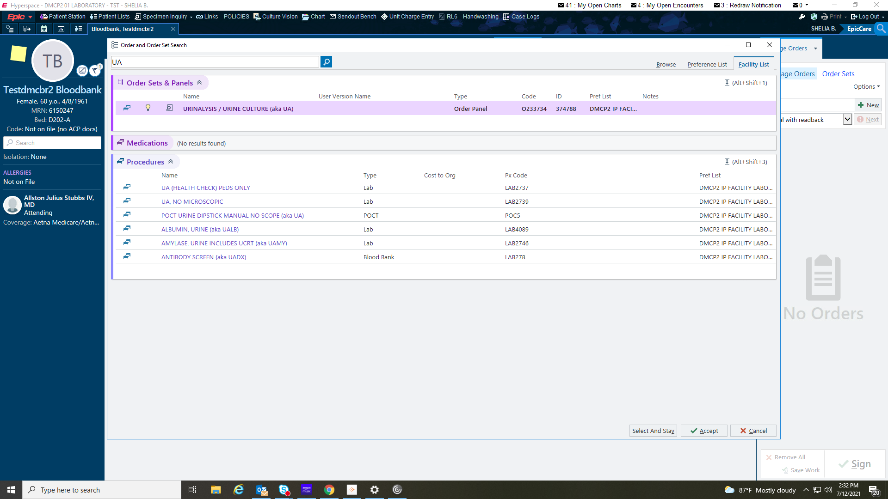

When the clinician clicks on the new order, a pop up box comes up. Here they will choose the correct orders. We want to direct clinicians to the CORRECT order – Urinalysis with urine culture if indicated.

NOTE: A decision is being made about what tests are in the pop-up box. Labs(and Dr. Palavecino) has requested the order for the Urine culture NOT be available in the order sets here. I will keep you posted if this changes.

See the order options here:

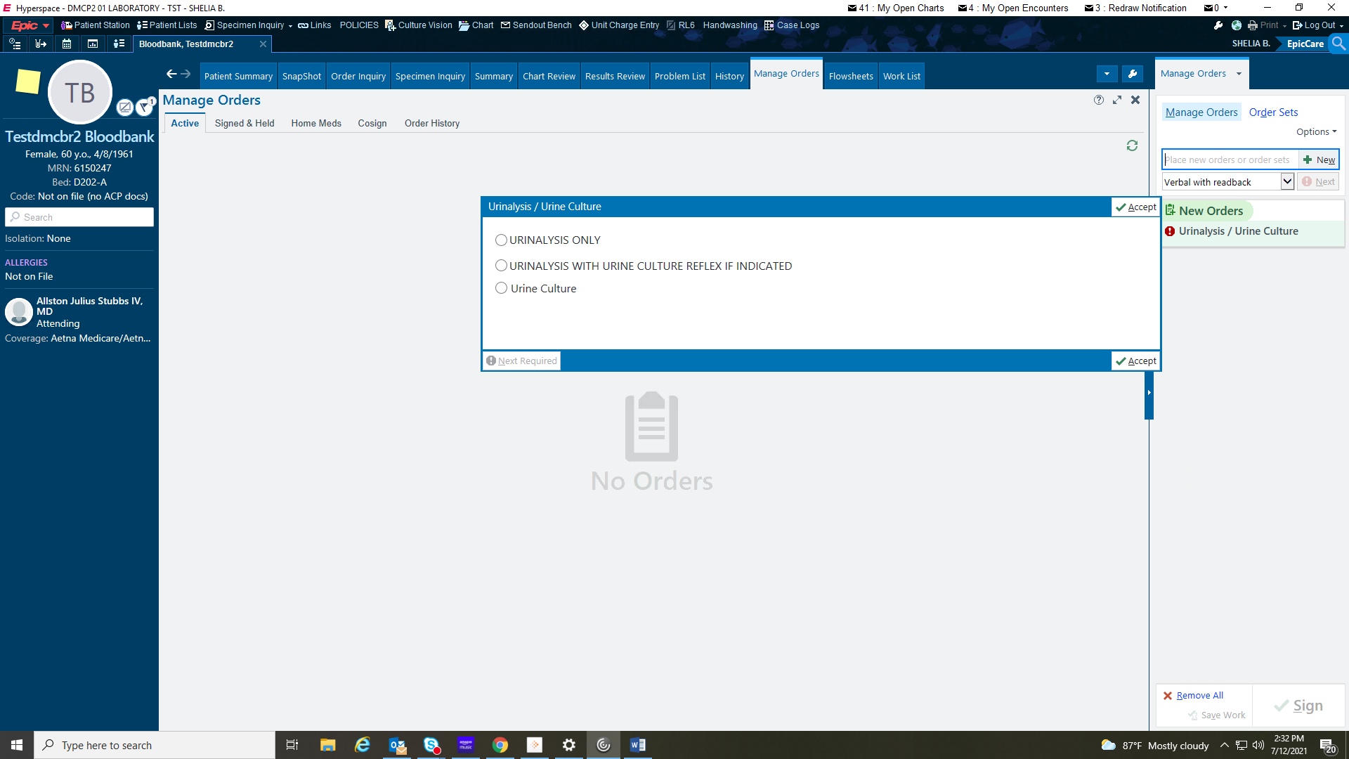

Another pop-up box comes up with the appropriate UA orders once the new order is selected.

Clinicians will choose which UA they want.

IF the physician ONLY wants a UA and not microscopic, they would choose the Urinalysis ONLY option (seen in the screenshot above)

NOTE: You see the “Hold for Urine Culture” is automatically ordered.

See the UA options here:

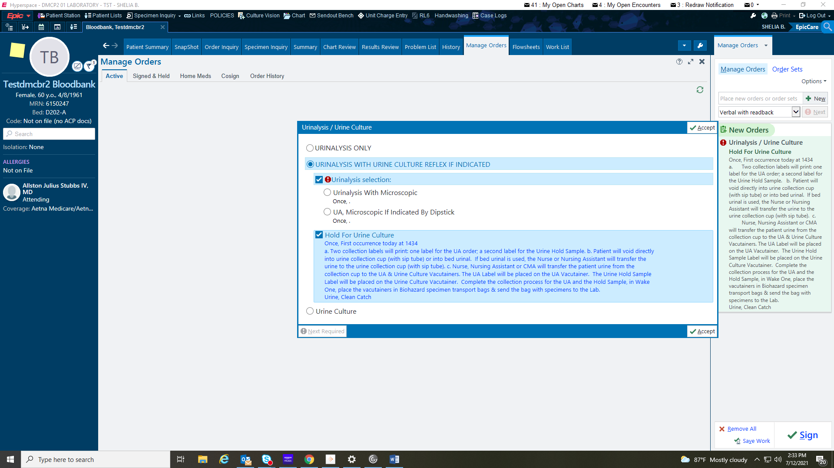

Once the orders are signed, they are viewable in order inquiry.

BOTH orders must be selected for collection.

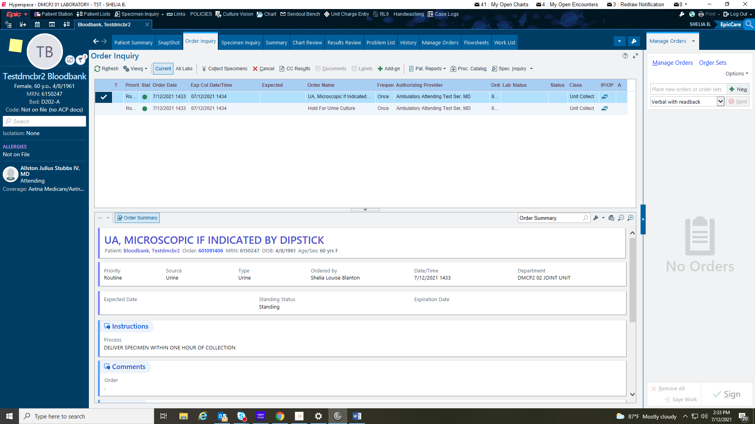

Unless you change your preferences, you will see both the UA and the Hold for culture order in your outstanding list.

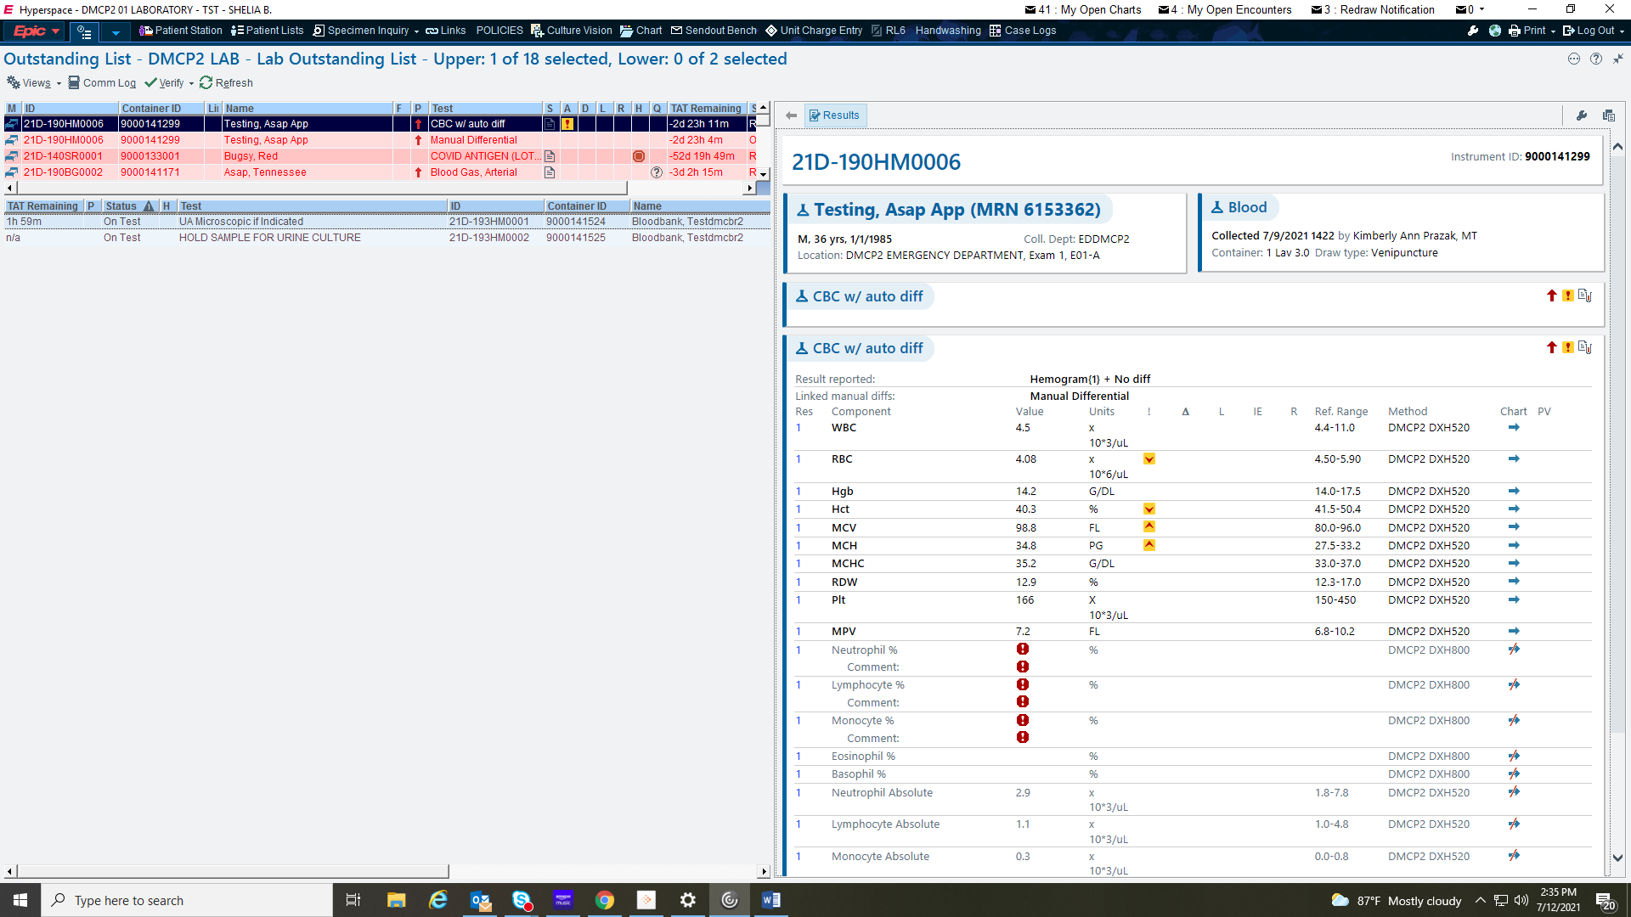

Go into views and select DMCP2 Outstanding list to prevent from seeing the Hold for Culture order.

The ONLY time you will need to go into the Hold for Culture outstanding is to see if the order is there for some unknown reason.

Otherwise, there is NO reason to need to see this information. We will not do anything with the order, even if a culture is needed.

Beaker will auto-cancel the order throughout the day.

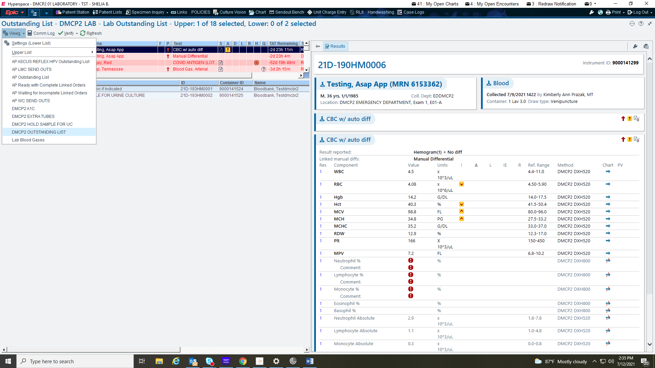

This urine will NOT need a culture.

Microscopic WBC is < 0-5.

No culture was ordered for this UA.

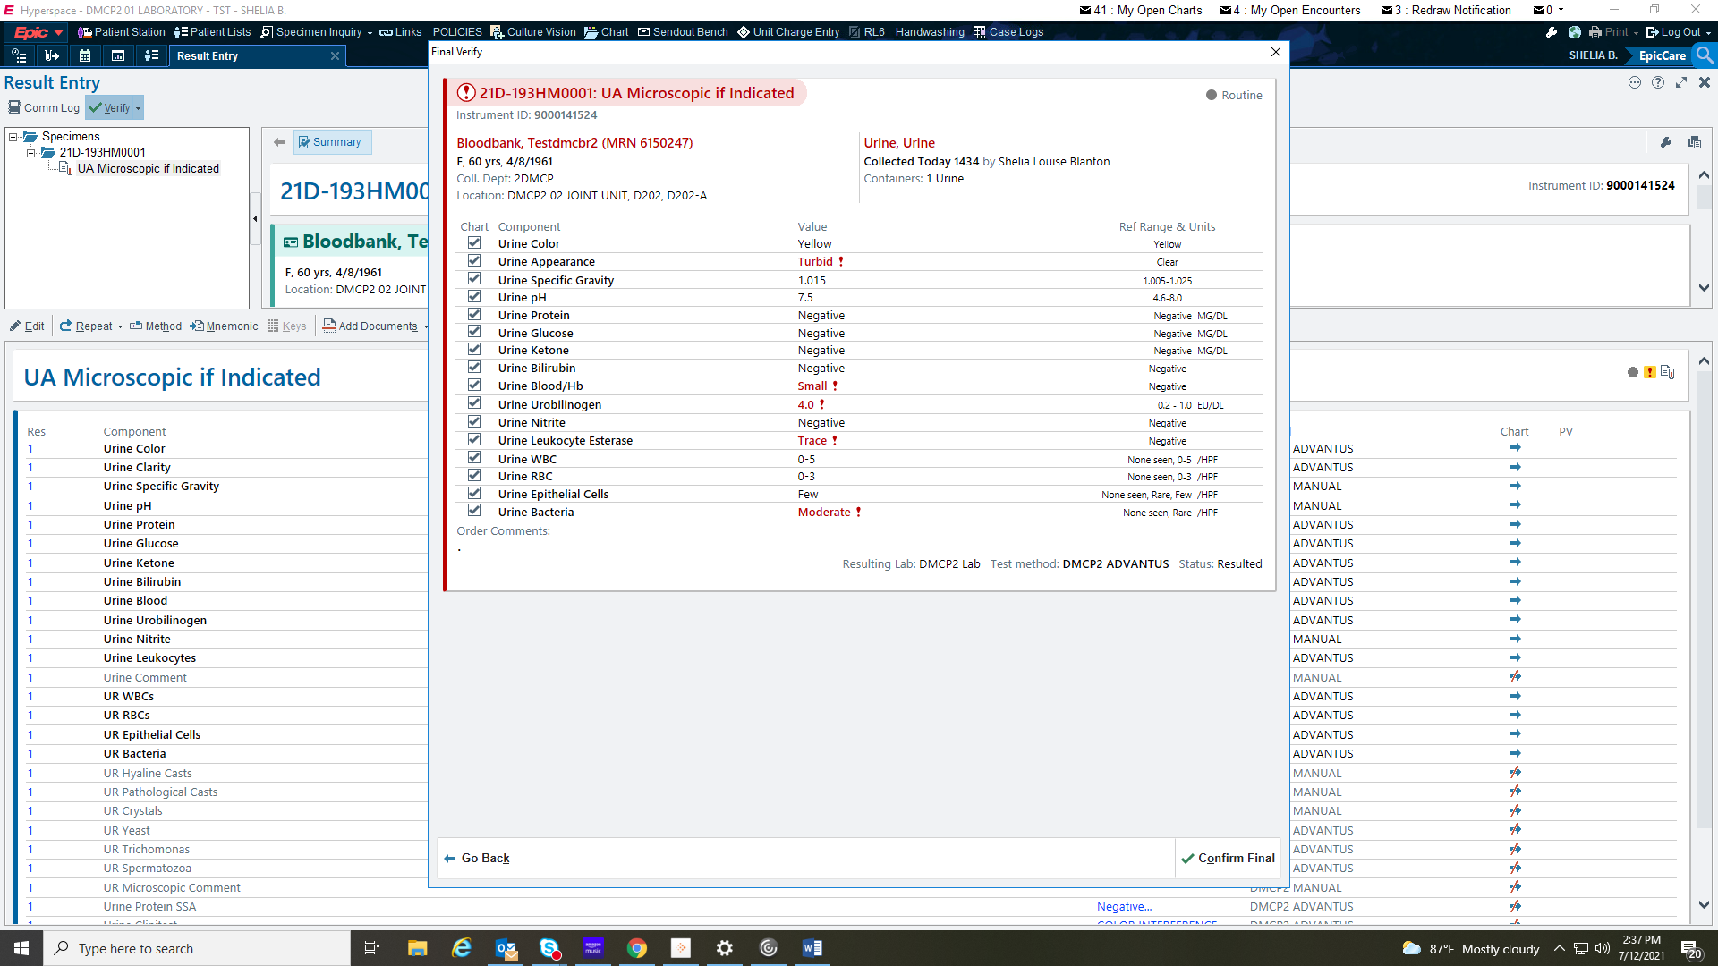

This urine will need a culture!

Beaker will order the culture for you based on the microscopic results ONLY.

REMEMBER: A culture is ONLY ordered with the microscopic WBC is ≥6.

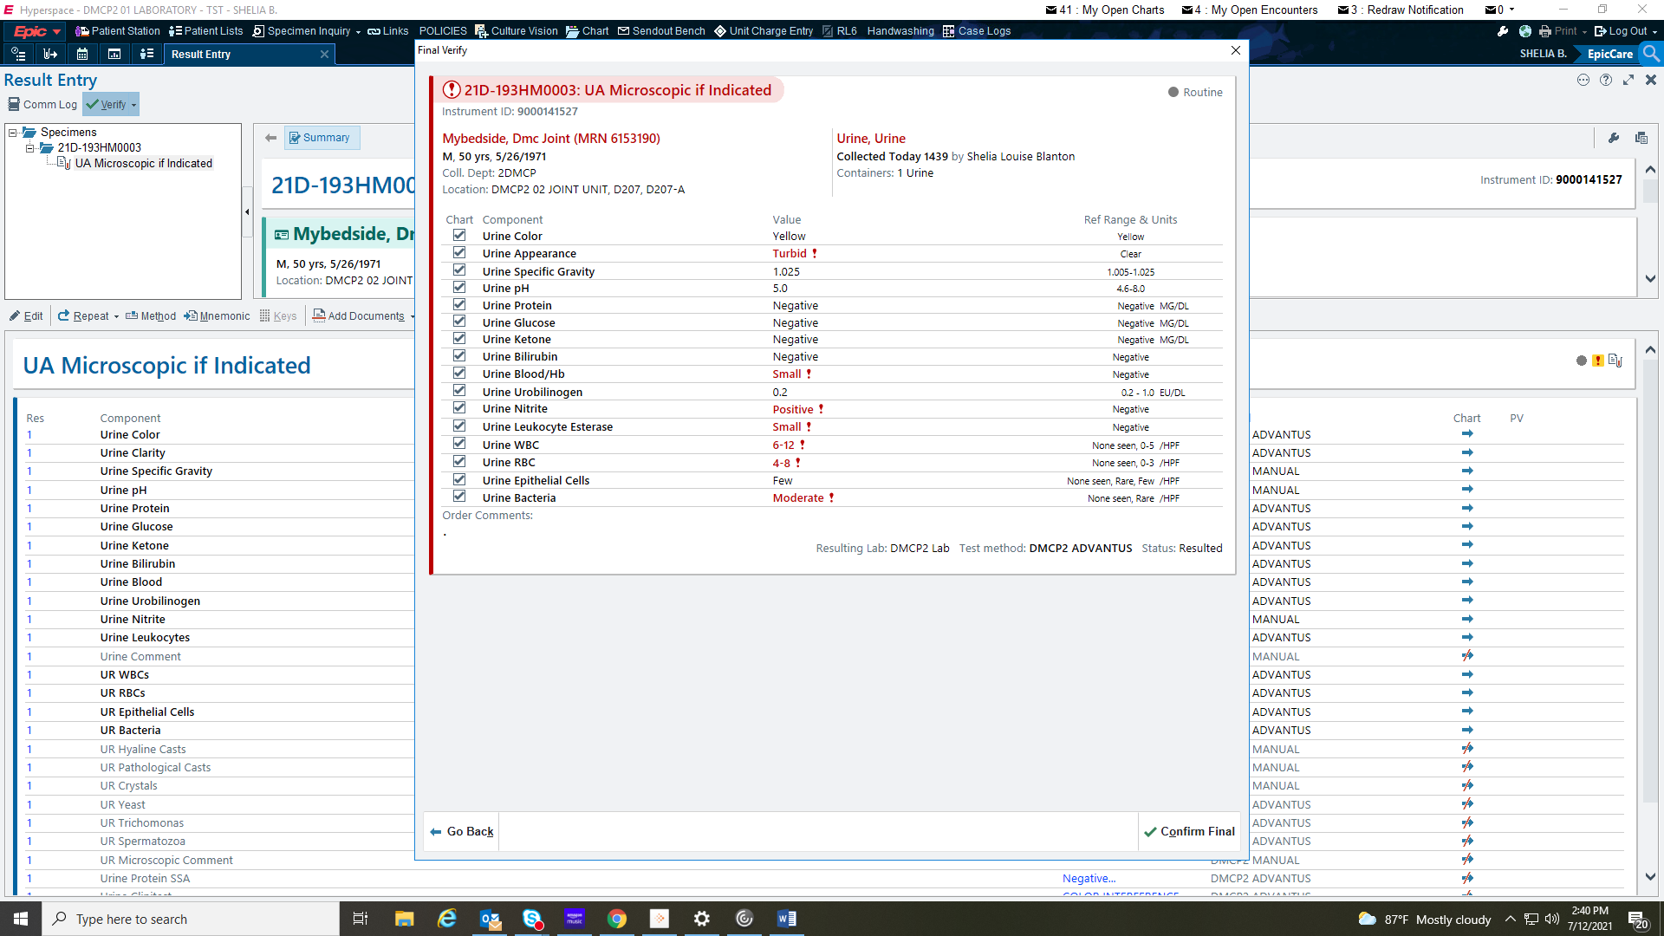

A pop-up will come up to remind you the culture was ordered.

At this point, a new order has been created for the culture and a label will print.

You will place the new culture order label on the Hold for culture urine tube.

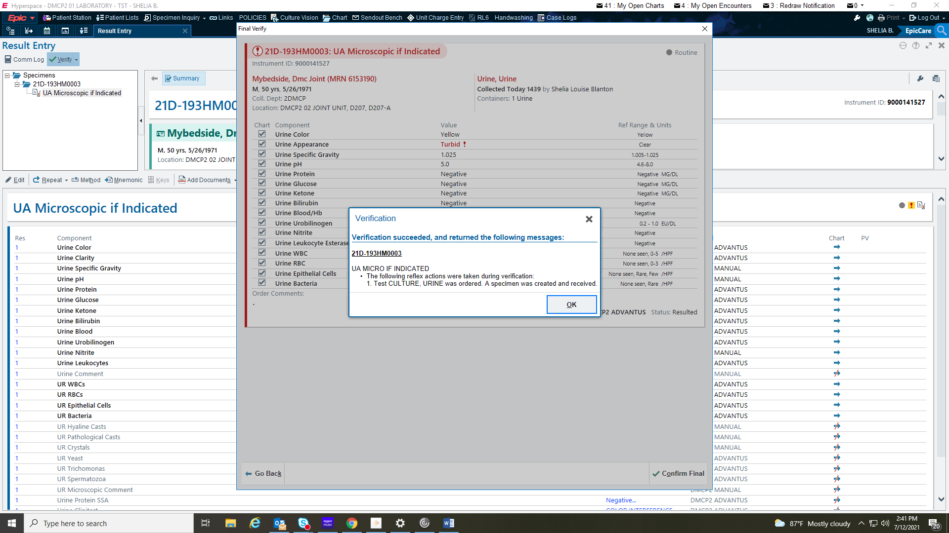

Notice: the Hold sample for Urine culture order is still available. This will go away and Beaker will automatically cancel it.

We will NOT be using this order for anything! That is why you need to change your views so you will not be seeing it in your outstanding list.

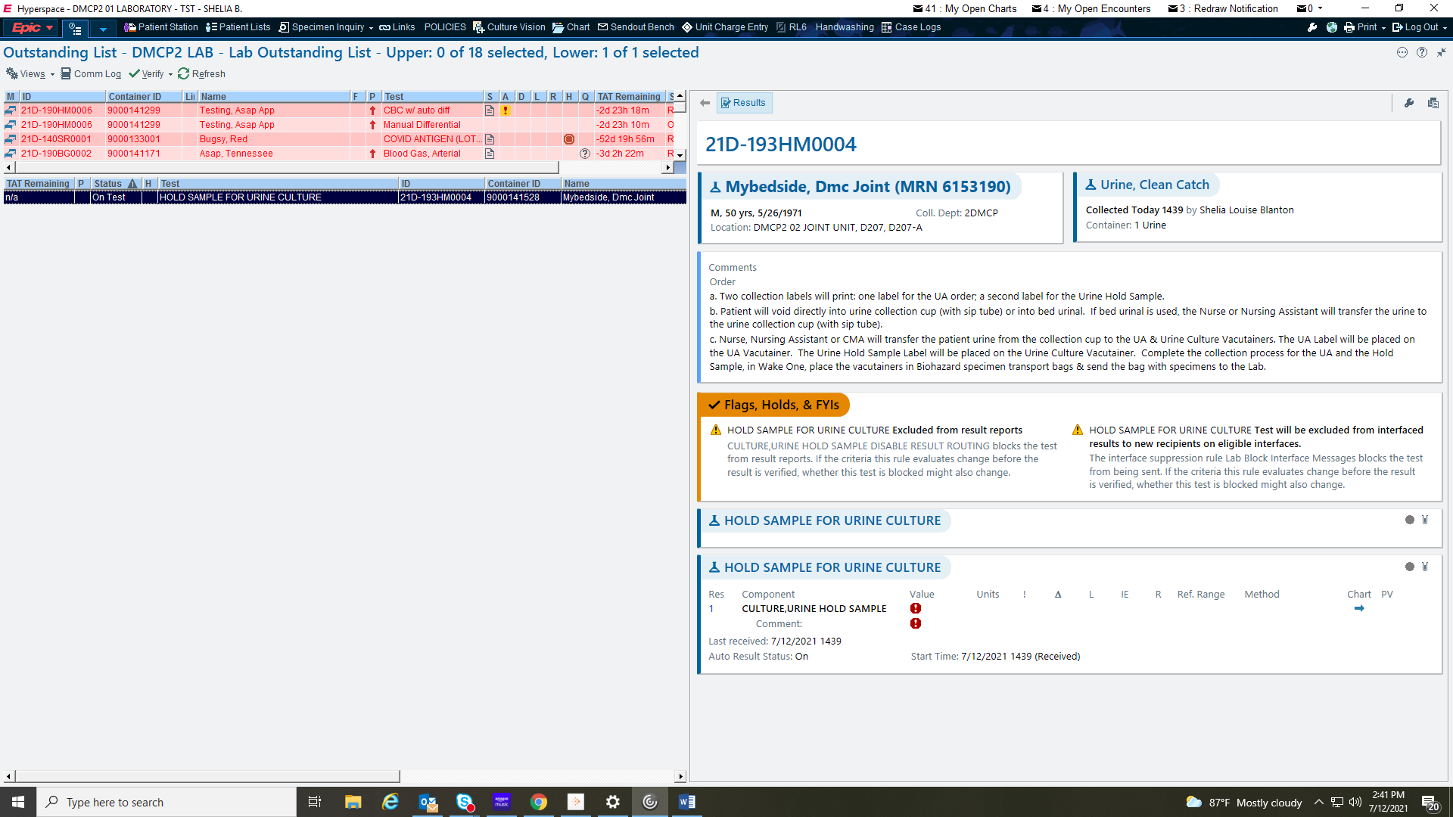

The culture was automatically received and placed on the send out bench for you!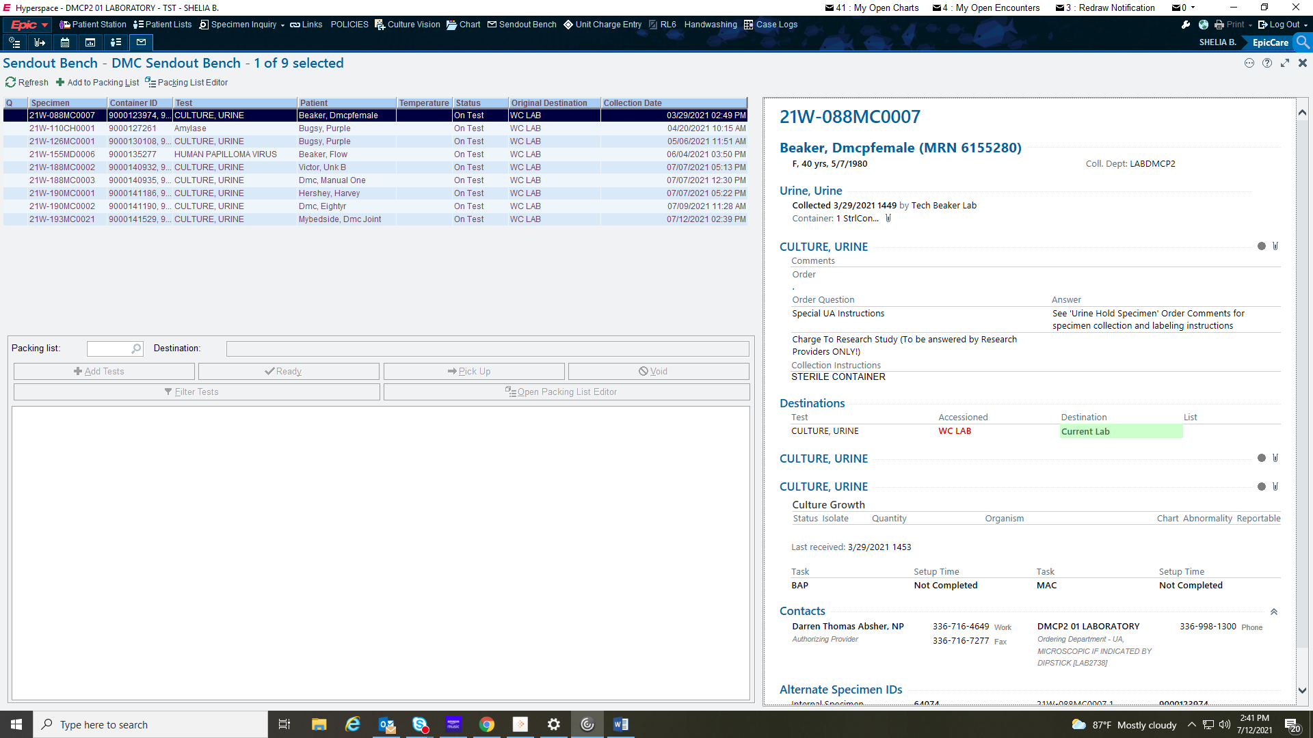

Ambulatory or Outpatient orders

You will NOT find the correct order without going into the Database Look Up!

You will need to type out the order partially to find it (UA, Urine etc will not

bring it up!

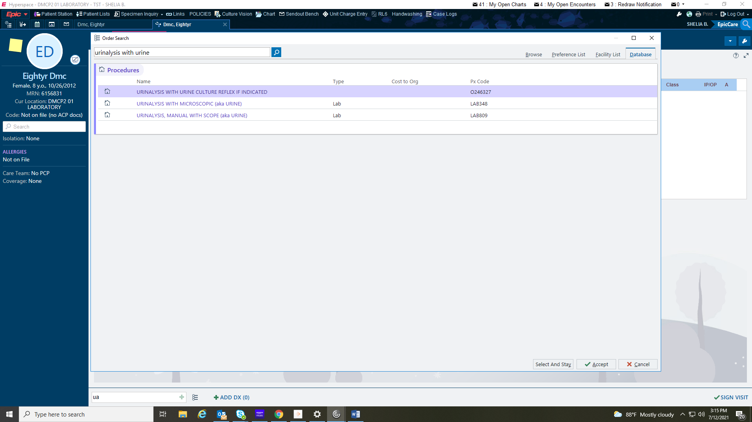

Once you select the order, the pop up box will come up in the corner. You will need to answer the questions and make the appropriate selections, much like demonstrated in the inpatient orders.

Click the new order in the pop-up box

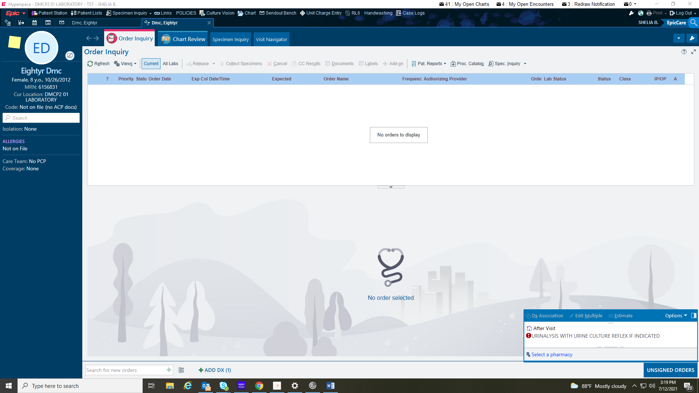

You will need to choose both tests

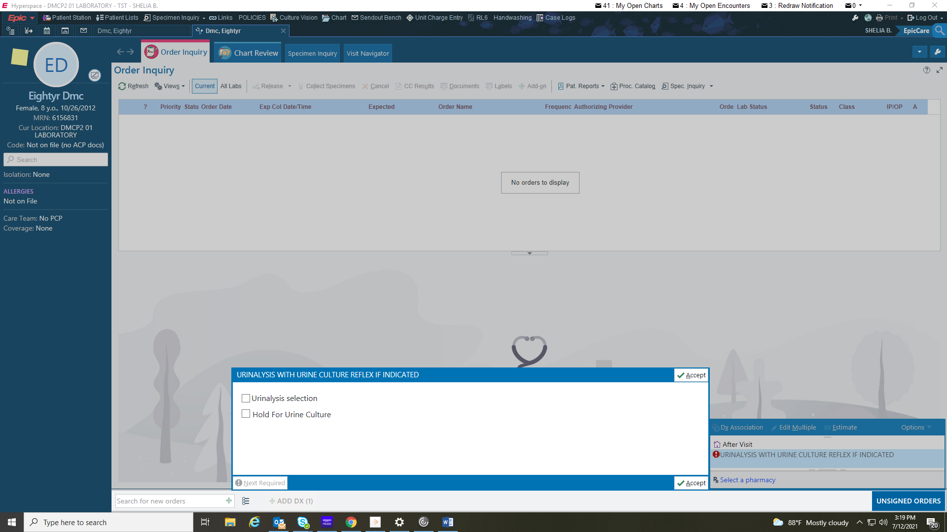

You will need to choose the correct UA order and complete the order as usual:

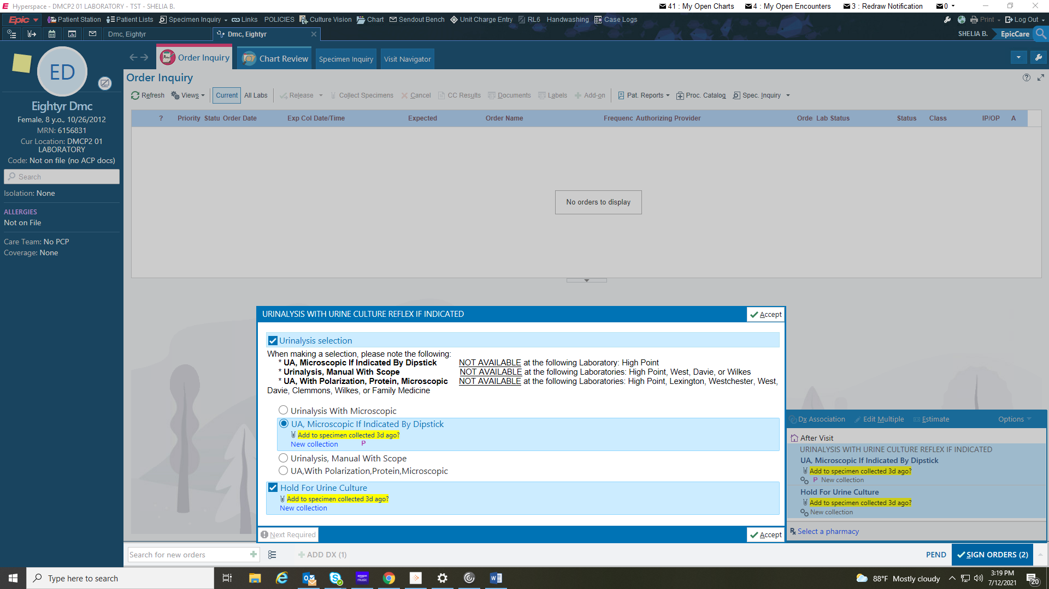

When indicated: the culture will automatically order.

You will process the same as demonstrated in the

Inpatient orders above.

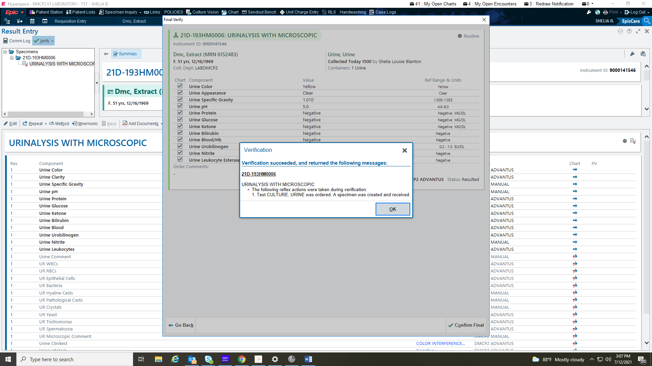

You can see all 3 orders in chart review:

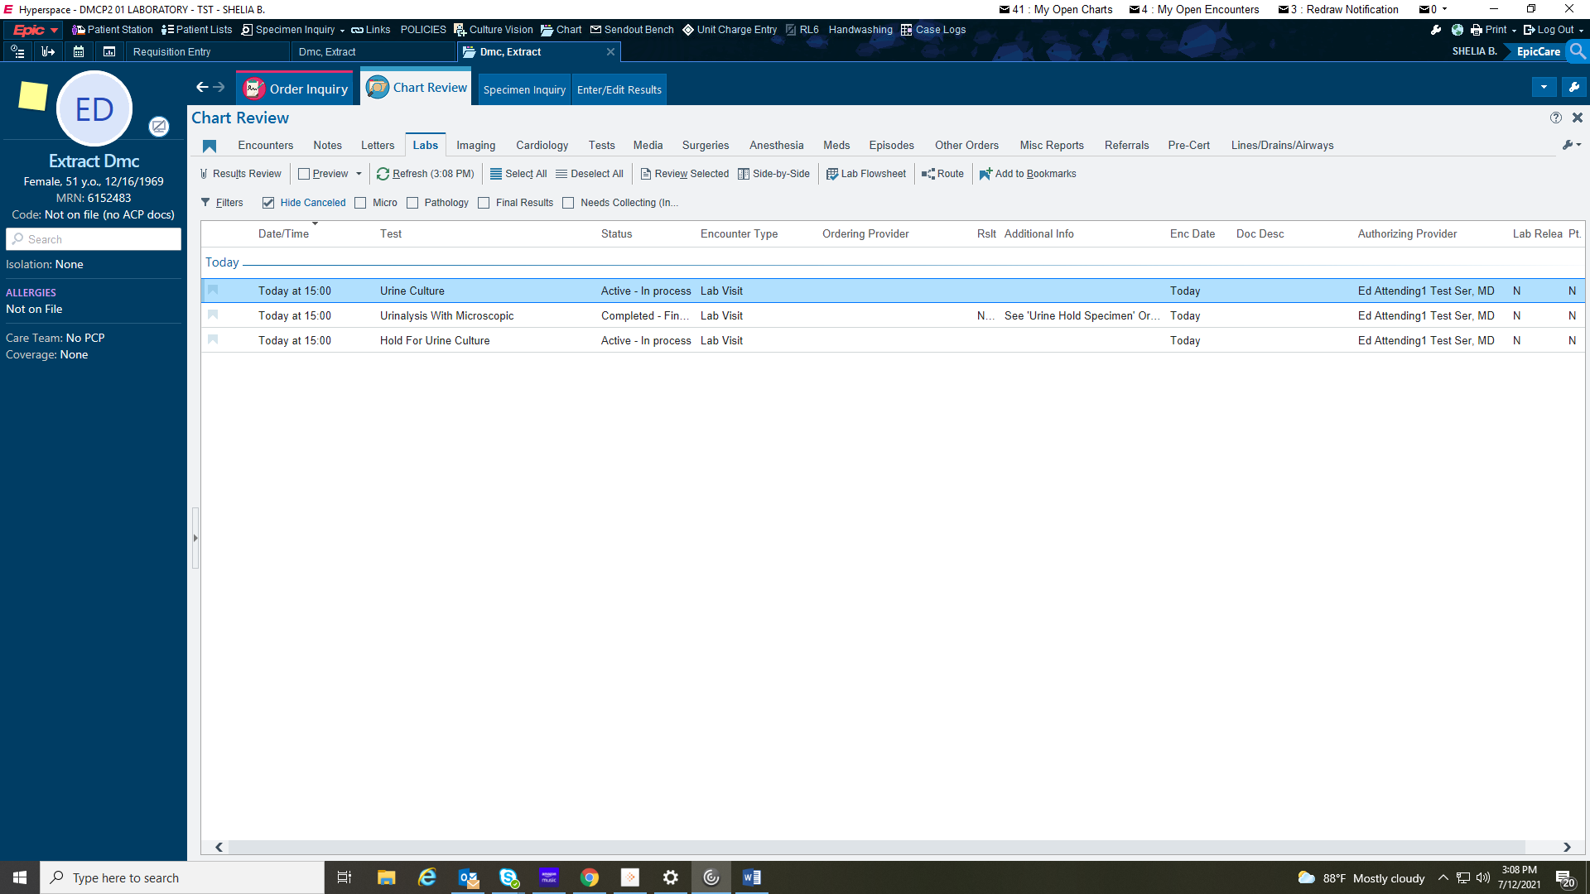

For Outpatients:

We will ONLY order the new order when the physician has indicated they want it.

If you receive an outpatient order for a UA and Culture, you can still order both as usual.

You can still order the UA orders without the culture.

This only applies if you get an order to reflex the culture.