Atrium Health Davie Medical Center

Blood Bank

**NEW ABO2 workflow**

**Situation:**

Second ABO specimens are routinely deemed unacceptable when they arrive in the Blood Bank.

**Background:**

Second ABOs are required on all patients with no blood bank history before blood other than type O can be released. Second ABOs must come from a separate collection from the original type and screen that includes another patient identification process.

**Assessment:**

Current samples are arriving to the Blood Bank with previously drawn labels under the ABO2 label indicating the specimens were collected at the same time as the TSX and held in the department until needed by Blood Bank. This practice seems to be widespread and puts patient safety at risk.

**Recommendation:**

Blood Bank will now send a tube to the department in which to collect the ABO2. Blood Bank staff will call the department and alert them that a second collection is needed, has been ordered, and that a tube is being sent to be used for the collection. The tubes will be 2mL pink top tubes only stocked by DMC blood bank. This item should NOT be ordered by any other department. Blood Bank will reject any sample not received in the correct tube. DMC Blood Bank will begin this new process starting on January 3rd, 2023.

Please note the differences between the current 6mL and new 2mL pink top tubes below:

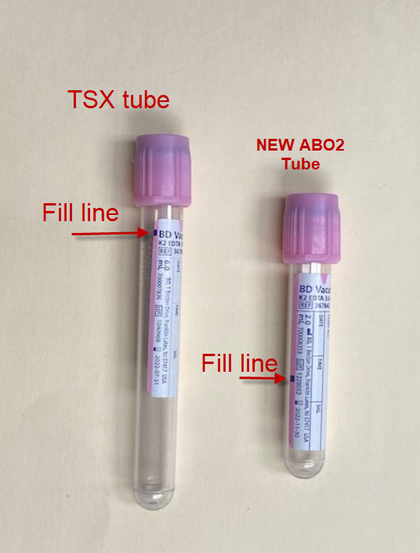

**Emmanuel Fadeyi, MD 12/22/2022**