**Table of Contents**

1. **How to access *Container Storage***
2. **How to find a storage rack**
3. ***Container Storage* buttons and menus**
4. **How to store a specimen**
5. **How to retrieve a stored specimen**
6. **How to locate and retrieve add-on tests**
7. **Best practices for *Container Storage***
8. **Generating Extra Containers**

# **I. How to Access Container Storage:**

**Method 1:** Find using the search function in EPIC

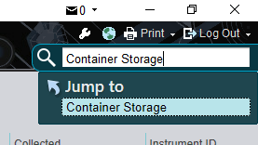

**Method 2:** How to add *Container Storage* the *Outstanding List* toolbar

* Press the *Epic* button at the top left to get
* Press *Modify This Menu* button
* Under *Lab* there is the *Container Storage* button
* Drag the *Container Storage* button to the toolbar on top
* Press *Accept* in the bottom right hand corner to finalize

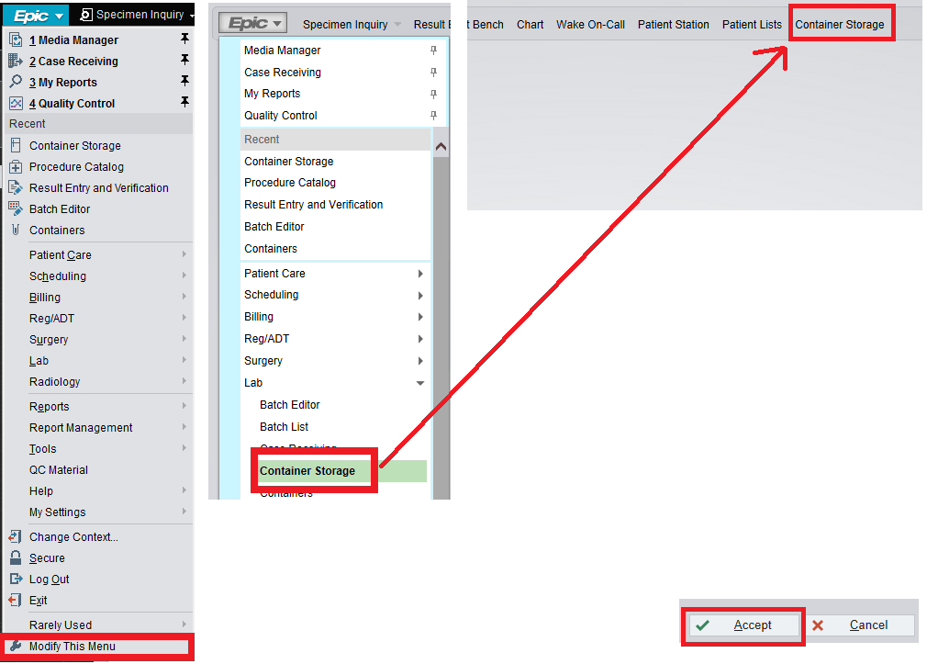

# **II. How to Find a Storage Rack:**

Enter *Container Storage*. Under the *Select* search bar search for the name of the storage rack

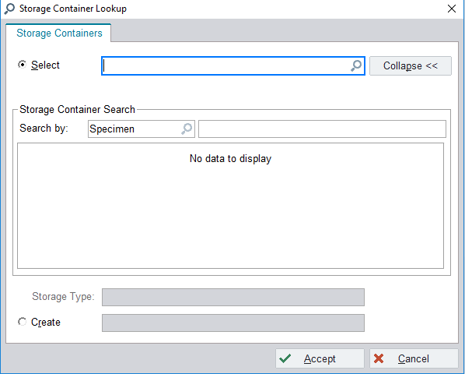

Searching the keyword *DMC* will bring up all the racks for Davie Medical Center

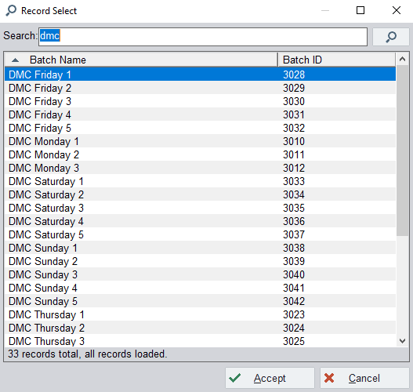

|  |
| --- |
| **Storage Racks Built for Davie** |
| DMC Monday 1 |
| DMC Monday 2 |
| DMC Monday 3 |
| DMC Monday 4 |
| DMC Monday 5 |
| DMC Tuesday 1 |
| DMC Tuesday 2 |
| DMC Tuesday 3 |
| DMC Tuesday 4 |
| DMC Tuesday 5 |
| DMC Wednesday 1 |
| DMC Wednesday 2 |
| DMC Wednesday 3 |
| DMC Wednesday 4 |
| DMC Wednesday 5 |
| DMC Thursday 1 |
| DMC Thursday 2 |
| DMC Thursday 3 |
| DMC Thursday 4 |
| DMC Thursday 5 |
| DMC Friday 1 |
| DMC Friday 2 |
| DMC Friday 3 |
| DMC Friday 4 |
| DMC Friday 5 |
| DMC Saturday 1 |
| DMC Saturday 2 |
| DMC Saturday 3 |
| DMC Saturday 4 |
| DMC Saturday 5 |
| DMC Sunday 1 |
| DMC Sunday 2 |
| DMC Sunday 3 |
| DMC Sunday 4 |
| DMC Sunday 5 |

# **III. Container Storage Buttons and Menus:**

**Example of how *Container Storage* appears:**

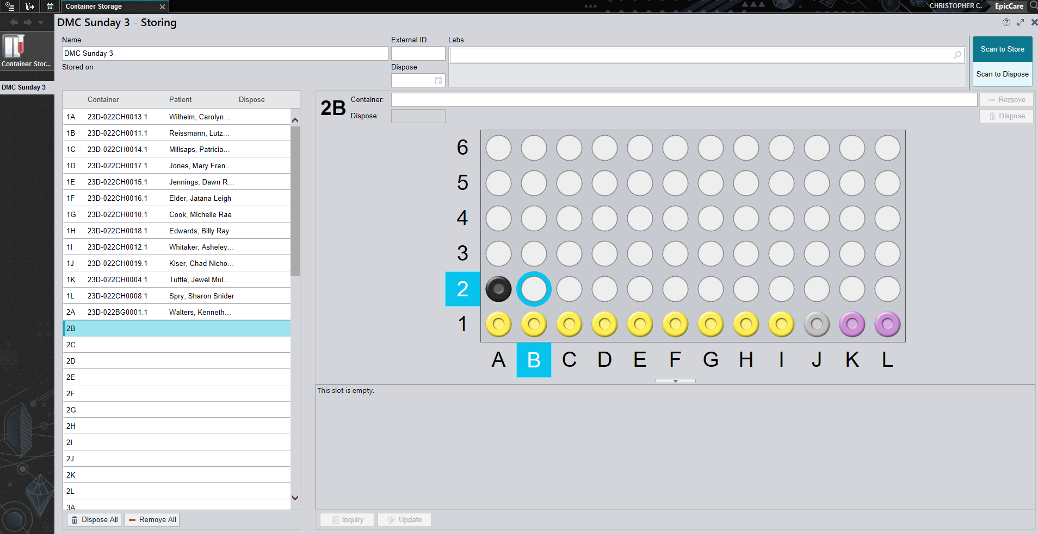

**Container Storage Button:**

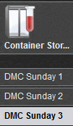

* Pressing this button will bring up *Storage Container Lookup*, which will let you open another storage rack
* All open storage racks will be available under the *Container Storage* button, and you can switch between them as needed by pressing on them.

**Rack content list:**

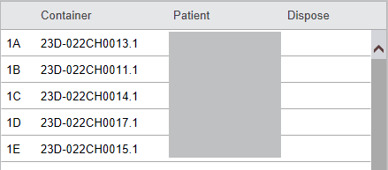

**…**

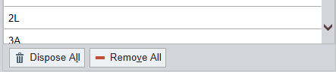

* The content list shows the names, container IDs, and storage location of all specimens stored in the rack
*  This button permanently disposes of specimens in the storage rack. Once disposed of, the specimens cannot be used for reruns, add-ons, or stored again. Only dispose of specimens when they will no longer be used.
*  This button removes all stored specimens from the storage rack. All specimens on the rack will still be marked as not stored, but still available for add-ons and storage.

***Scan to Dispose* and *Scan to Remove*:**

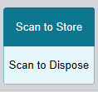

* *Scan to Dispose* – When selected, all specimens scanned in this mode will be added to the storage rack
* *Scan to Remove –* When selected, all specimens scanned in this mode will be removed from the storage rack
  + Removed racks can be stored again in the future

**Storage Rack:**

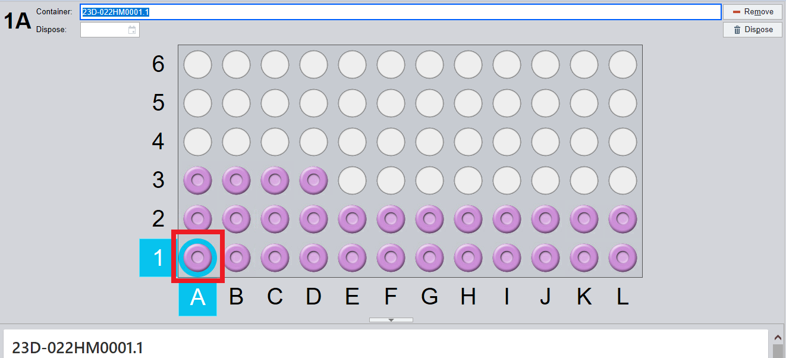

* See red box above: The light blue outline indicates which spot on the storage rack is currently being selected.
* Gives details of what is currently selected
* 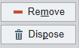Allows removal or disposal of the specimen currently selected

# **IV. How to Store a Specimen**

- Click the spot on the rack you want to store the specimen

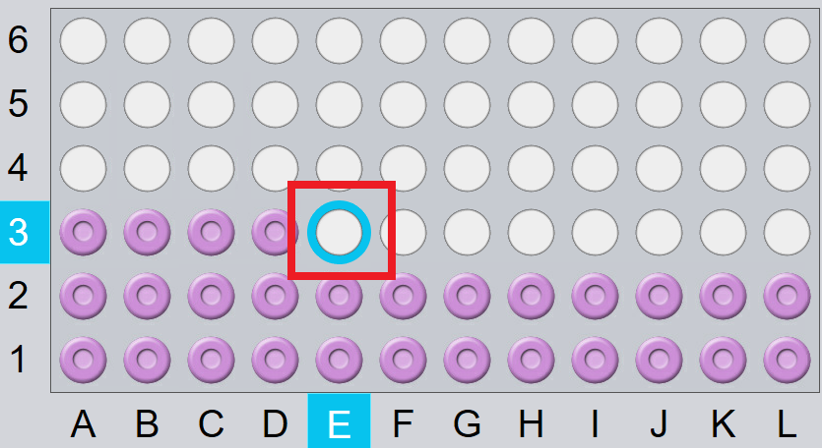

- Scan the specimen. The scanned specimen will be stored, and the next available empty spot will be selected.

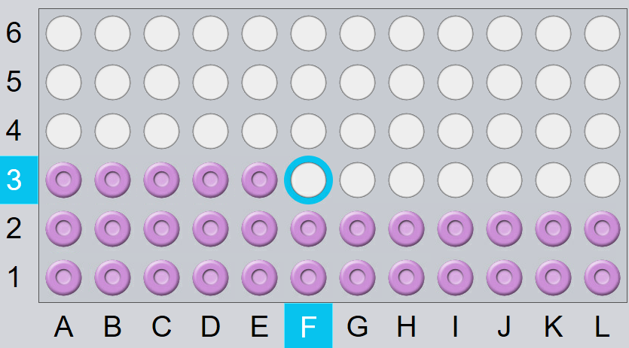

* If the tube is already stored in the rack the following error will pop up:

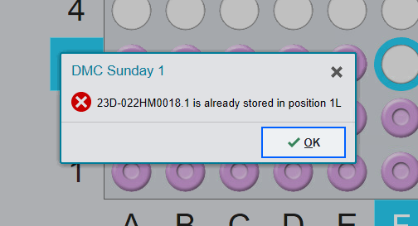

* This likely means that two of the same label were printed.

# **V. How to Retrieve Stored Specimens**

**Method 1:** Remove specimen using *Specimen Inquiry*

* Search for the specimen under *Specimen Inquiry*
* Under the *Specimen Tracking* section there will be the name of the storage rack the specimen is stored in, and the spot on the storage rack it is stored in.

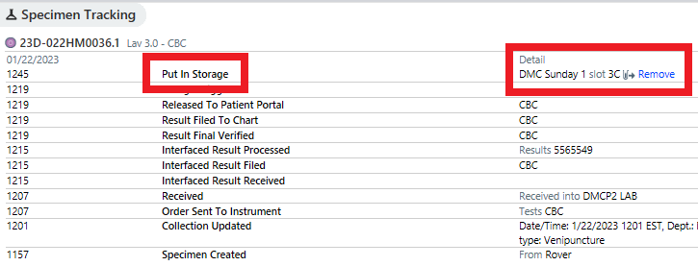

* To remove the specimen from the rack, click the blue *Remove* button
* The *Specimen Tracking* section will record the specimen as being removed



**Method 2:** Remove specimen using *Specimen Update*

* Search for the specimen under *Specimen Update*
* Under the *Specimen Tracking*section, on the right hand side, will be the name of the storage rack the specimen is stored in, and the spot on the storage rack it is stored in.

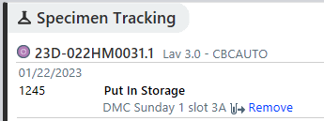

* To remove the specimen from the rack, click the blue *Remove* button
* The *Specimen Tracking* section will record the specimen as being removed

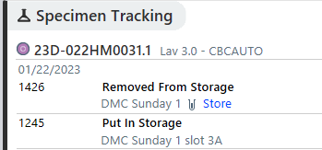

# **VI. How to Locate and Remove Add-on Tests**

* The add-on menu now shows the location where the specimens are stored:

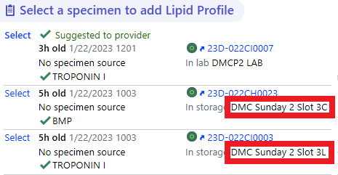

* If a specimen is *Selected* for an add-on, the specimen will be automatically *Removed* from its’ storage rack.

# **VII. Best Practices for Container Storage**

1. When storing containers, make sure the spot selected in *Container Storage* corresponds to where you intend to place the tube.
2. When storing multiple specimens, make sure to check the screen periodically to make sure you are storing in the correct spot.
3. Place a pipette in the last stored position in a storage rack to mark which specimens are stored, and which still need to be stored.
4. If a specimen is removed from a rack, always remember to also remove in Beaker.
5. For specimens that do not have barcodes, place them separate from the stored specimens to avoid confusion.
6. For duplicate specimens, two specimens that share the same label, place the specimen with the specimens that do not have barcodes.
7. Be careful to never *Dispose* of a tube until it is no longer need. Disposed tubes cannot be used for testing, add-ons, or future storage.