Case
Patient presents to the emergency department with failure to thrive, severe dehydration, and severe malnutrition with a history of ETOH misuse and Type 2 diabetes. The patent is alert and oriented, if a little confused, but is unable to ambulate in anyway. A CMP and CBC were performed with results as follows:
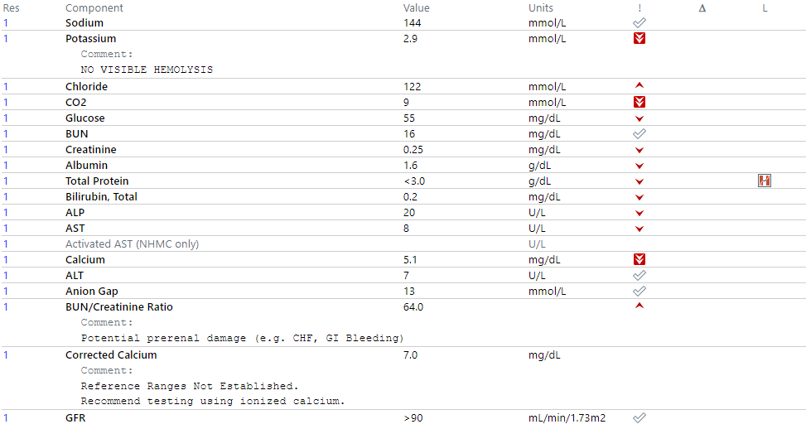

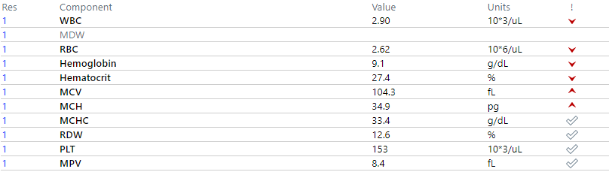
The patient is treated with electrolyte replacement and IV fluids overnight.
Repeat testing was performed the next morning. Results were as follows:
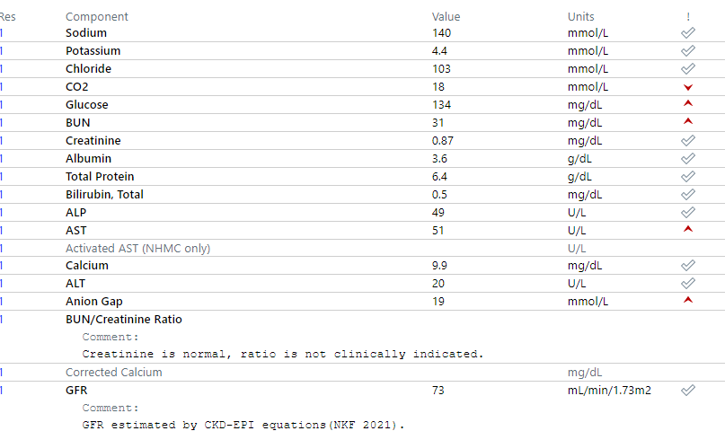

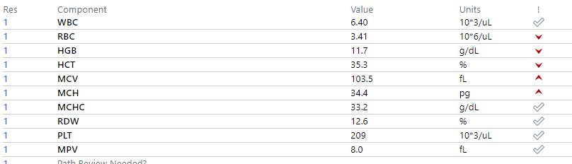

Interpretation
At first glance, the initial results are highly suspicious for IV contamination. The patient had markedly low values for most analytes in the CMP except for Na and Cl. This is expected with saline infusion because the solution contains Na and Cl while it does not contain the other analytes. Additionally, the CBC values were low. This is to be expected with saline dilution as the plasma volume to cellular ratio is skewed. The repeat testing shows a notable improvement in all values. However, due to an abnormal EKG the patient’s physician orders a troponin at this time as well that is found to be extremely elevated. Additionally, add-on testing to the initial specimen is low, most notably a decreased CK and Hgb A1C. CK testing was performed on the second specimen to compare values, and the number was found to be increased, but a repeat A1C was not possible.
Without the knowledge that the patient had been treated with electrolytes and IV fluids it would be easy to use these values to justify a diluted sample; however, this is not the case.
A patient with malnutrition so severe that they cannot move on their own is going to experience muscle loss as well as a generalized decrease in most laboratory values due to compensatory metabolic processes. This patient was in such a severe state that they developed hypovolemic and cardiogenic shock. The increase in values were a direct result of the treatment that the patient received.
FAQ
Why didn’t the physician run a troponin sooner? Is it because the CK was low?
No, the idea that troponin testing was not considered due to a low total CK (tCK) reflects a poor understanding of the tCK pathophysiology, in relationship with hs-Tp (troponin) and in relationship with the clinical presentation of this patient. CK has a very broad normal range and most of the CK in circulation comprise of CKMM isoform (muscle specific). As this patient has decreased muscle activity and severely low proteins, the decreased tCK reflected this clinical situation. Furthermore, the CKMB, which is the CK heart specific isoform, comprises of only 6% of the total circulating CK. Generally, elevation of rather CKMB and the calculated CKMB index, but not necessarily the tCK, correlate better with troponin levels and reflects CV events.
Surely a decreased Hgb A1C in a patient with diabetes would prove that this was diluted, right?
Not necessarily. In this case, the patient was in a major caloric deficit which better correlates with a decrease in average blood glucose levels. Additionally, alcohol intake decreases blood glucose levels in people with diabetes.
How are we supposed to know how the patient is being treated as lab techs?
We aren’t. The only way to know for sure whether or not the initial specimen was diluted would have been to talk to the patient’s nurse when it was collected. Lab technologists are not aware (especially in real time) of the decisions of the medical team and patient’s management or changes in the patient’s clinical status. We are not responsible for interpreting or correlating the laboratory results with the clinical correlation of every patient.
So, the next time I suspect a poor specimen I should just keep it to myself?
Absolutely not! If you are concerned about something, SPEAK UP to your direct leader and/or clinical team. Always take the time to Investigate what occurred at collection, recollect if possible, and ultimately document any communications you have regarding specimen validity.
The providers will take the appropriate actions if necessary.

