Manual temperature and humidity must be recorded every 24 hours for the Plaza 2 Outpatient Draw Room.
- Go to the Plaza 2 Outpatient Draw Room and locate the hygrometer:
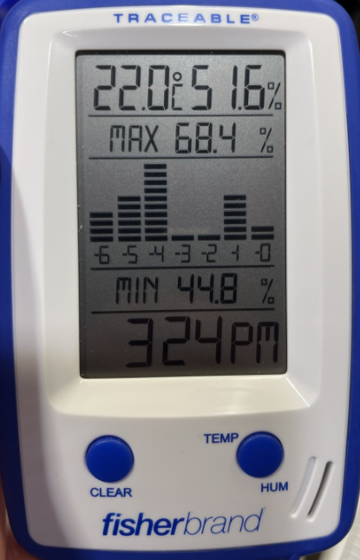

- The current temperature and humidity values will be located at the top of the screen on the hygrometer. Record these values on the Temperatures and Humidity Monitoring Form (Davie) found in Policy Tech: https://atrium.policytech.com/dotNet/documents/?docid=132623&app=pt&source=browse
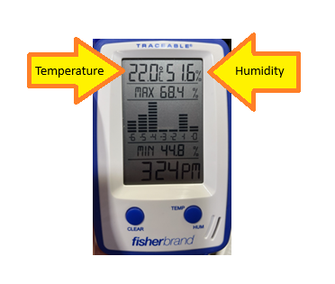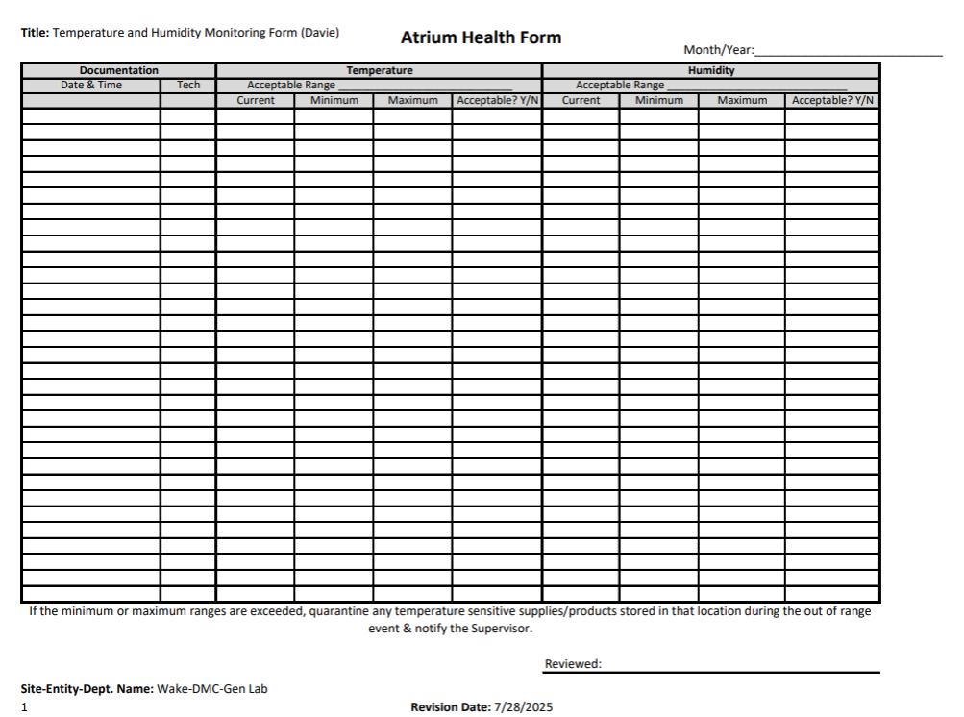

- Record the minimum and maximum values for the past 24 hours. These values can be found in the center of the screen.
​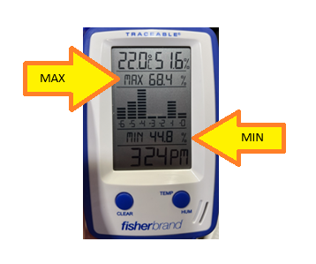
- To toggle between the Min/Max for temperature and humidity, click the TEMP/HUM button.
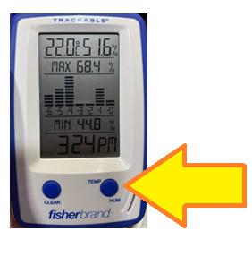
- Acceptable temperature values are 18-30°C. Acceptable humidity values are 20-80%. If any value falls outside of the acceptable range, report it to a tech immediately.

- Write legibly and only use blue or black ink when documenting on any handwritten forms/documents. If you make an error, strike through the error one time so that you can still see what was originally written, then date and initial the strike through. The correct information may be written beside it.

- This task must be performed every 24 hours, around the same time every day to ensure that it has been a full 24 hours since the last reading. Please perform this task at 2300 every day, and if you are unable to do it at this time, please ask someone else to do it. This cannot be missed.

