- PURPOSE
The purpose of this policy is to provide laboratory teammates with guidelines on how to manage and test redraws and cancellations for inpatient and ED retrievable specimens.

- SCOPE
This document applies to all laboratory teammates within Advocate Health entities in the North Carolina /Georgia Division.

- DEFINITIONS/ABBREVIATIONS
 | ROLE |  | RESPONSIBILITY
All NC/GA Teammates |  | Follows policy guidelines and escalates as appropriate
 | TERM/ABBREVIATION |  | DESCRIPTION/DEFINITION
 | Inpatient (IP) |  | A patient admitted to an inpatient Advocate Health facility
 | Emergency Department (ED) |  | A patient admitted to an Advocate Health ED
 | Cancel |  | An ordered test that is discontinued
 | Redraw |  | Function used in Epic to send the test back to a collection/task list for new collection. The ordered test is not discontinued.
 | Irretrievable Specimen |  | Any specimen deemed difficult to obtain, especially if requesting additional sampling. Examples are listed below.  - Amniotic fluid / Chorionic Villi Sampling  - Ascites  - Bone  - Bone marrow  - Bronchial alveolar lavage (BAL)  - Bronchial biopsy  - Bronchial brush  - Bronchial washing  - Cerebrospinal fluid (CSF)  - Corneal rim  - Meconium specimens  - Pancreatic cyst fluid  - Pericardial fluid  - Peritoneal dialysate  - Peritoneal dialysis fluid  - Peritoneal fluid  Alternate names:  Ascites  Peritoneal Effusion  Paracentesis Fluid  - Pleural fluid  Alternate names:  Thoracentesis Fluid  - Products of conception  - Suprapubic aspiration urine  - Synovial fluid  - Tissue  - Vitreous fluid
 | Retrievable Specimen |  | Anything not defined as an irretrievable specimen.

- POLICY
  - Specimens are evaluated at multiple steps within the laboratory workflow. This policy outlines when to use Redraw versus Cancel functions in Epic for Inpatient or ED retrievable specimens that do not meet testing criteria.
  - At specimen receipt in the laboratory, processing teammates visually evaluate acceptability of the specimen. If the specimen is inadequate at the receiving step:
    - Evaluate if the patient is an active IP or ED patient. If patient is active IP or ED, send test(s) for redraw with appropriate reason.
      - Note: Patients can easily be identified as IP/ED using column M. IP/ED will present with a bed, while OP will present a calendar.
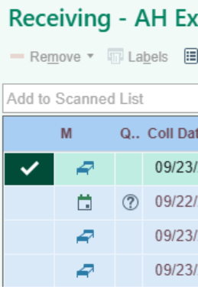
    - Specimen processing areas may not reject specimens due to hemolysis, lipemia, clotting, quantity not sufficient (QNS), or other reasons that require a technical assessment and decision.
      - Exceptions to QNS cancellations by processing departments include empty collection containers and containers not filled as per manufacture's guidelines and as per site specific practices.
  - In analytical departments, teammates evaluate specimen acceptability criteria for testing.
    - If the specimen does not meet acceptability criteria for testing, evaluate if the patient is an active IP or ED patient.
    - If the patient is an active IP or ED patient, evaluate if recollection would resolve the issue. Send for redraw with appropriate reason unless otherwise indicated by assay-specific SOP. If cancellation is indicated, cancel the test with an appropriate cancel reason.
  - Flow Chart
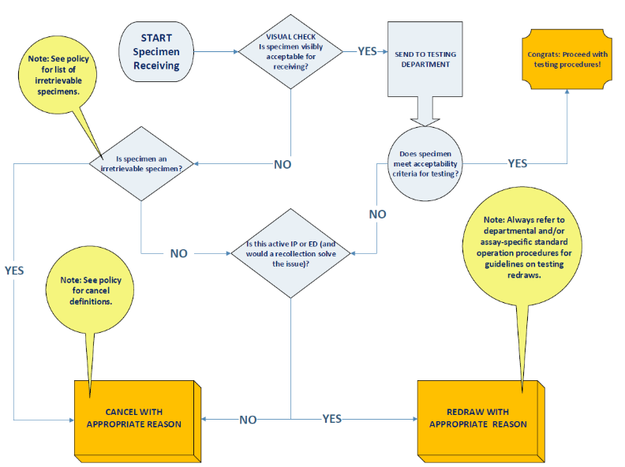
  - The definitions for Cancel and Redraw are provided below. Please note that clarification comments may be required. Even when not required, comments should be included where applicable to ensure clarity.
Redraw Only
Reason | Definition | Clarification Comment Required
Patient unable to void | No specimen collected.
Drawn from wrong patient | Order was for patient A and accidentally collected on patient B.
Patient Not Available | Patient not available during time of attempted collection.
Cancel & Redraw
Reason | Definition | Clarification Comment Required
Broken/Spilled in Transit | Arrived broken or spilled in bag.
Hold Tube Not Collected/Received | Unable to perform reflex and/or follow-up testing because hold tube associated with order was not collected and/or received.
Improper Collection - Excess Stool (CRE Surveillance PCR) | Defined by policy/CRE testing.
Improper Specimen Transport | Specimen transported that compromises integrity or improper delivery of the specimen (ex: Sent to wrong testing facility). | Explain what was done incorrectly (ex: put on frozen packing list, test not offered at testing lab).
Improper Time or Date for Requested Test | Collection falls outside of appropriate testing timeframe. | Clarify the timeframe specifics.
Improperly Preserved/Processed | Sample incorrectly handled after collection. | Explain what was done incorrectly (ex: whole blood was spun down).
LIS/Interface Error - See New Specimen ID | When results aren't able to file into chart and test will be reordered. | Why weren't results able to cross.
Patient Refused | Unable to collect on patient due to refusal.
Patient not fasting | Fasting required at time of collection.
PPID Not Followed | Proper patient identification per blood bank protocol not followed.
Quantity Not Sufficient | Required amount not provided for test.
Questionable Results | Results are unexpected. | Specific reason why the results are questionable.
Required Information and/or Requisition Not Provided | After contacting clinician, lab unable to obtain information required for testing. | Provide date of attempted contact or CRM #.
Specimen Clotted | Specimen too clotted for testing.
Specimen Contaminated | Contaminated during collection, by lab process or by outside source. | Explain issue (ex: EDTA contamination present, in bag with leaking specimen).
Specimen Unsuitable for Analysis | Interfering substances cause unreliable/unreportable test results by policy, improper collection. | Explain issue (Ex: sample overfilled).
Specimen Exceeds Holding Time | Specimen has exceeded given stability timeframe for test.
Specimen Hemolyzed | Specimen hemolyzed per policy.
Specimen Lost | Specimen lost at last receiving location.
Specimen Lost in Transit | Specimen lost when sending from one location to another (ex: pneumatic tube station, courier, etc.)
Specimen Mislabeled | Labeled with incorrect patient information or lacks required label information per policy.
Specimen Not Labeled | No label on specimen and/or collection container.
Specimen Not Received by Destination Lab | Performing lab did not receive specimen.
Specimen Received Not Centrifuged | Defined by policy.
Unable to Add On Tests to Existing Specimen | Used when current specimens are not sufficient for add on testing. | Provide reason why (too old, QNS, etc.).
Unable to Collect/Obtain Specimen | Cancellation used by collecting parties when collection is unsuccessful.
Unable to Obtain Results/Testing Method Failed | Used by testing departments when results are unsuccessful (ex: instrument malfunction). | Why you aren't able to obtain the results.
Update Performing Lab | Used for when the test cancellation will be followed by a new order to an alternate performing lab.
Wrong Collection Container or Specimen Type | Incorrect container or wrong specimen type sent. | What tube type or specimen type was received and what was needed (ex: sent Aptima, Cobas required).
Cancel Only
Reason | Definition | Clarification Comment Required
Autopsy Transfer | Autopsy was not performed before transfer. | Why it wasn't performed.
Canceled per Nurse/Nurse Practitioner | Received communication from nurse/nurse practitioner to cancel testing after received in lab. | Name of Nurse/Nurse Practitioner with date and time of communication.
Canceled per Pathologist | Received communication from pathologist to cancel testing after received in lab. Defined by pathology policy. | Name of Pathologist with date and time of communication.
Canceled per Physician/Resident | Received communication from Physician/Resident to cancel testing after received in lab. | Name of Physician/Resident with date and time of communication.
Duplicate | Multiple instances of the same tests from same source ordered within a short timeframe, or a single test ordered simultaneously with a panel that includes that test. | Reference specimen ID.
Formed Stool Not Acceptable | Defined by policy.
Improper Collection by Patient | Sample improperly collected/preserved/handled by patient. | Explain what was done incorrectly (ex: stool was frozen by patient).
Order Error - Incorrect Episode/Encounter/Provider | Applies to future orders activation, incorrect order selected at collection, collected at different location than ordering location, or wrong provider.
Test Not Available at Time of Request | Sample received during non-testing hours or testing temporarily not available. | Explain why (outside testing hours, test not available due to reagent, testing scheduled prior to collection, etc).
Test Currently Not Available. Lab will reorder appropriate alternative test | Temporary situation issue. Normal testing not available (i.e. instrument down, reagent out of stock, etc.) and needs to be sent out; need to order alternate in-house testing or send to referral lab. | Optional: Add specimen ID for alternate test.
Test Not Required | Defined by policy (Ex: Reflex test not needed, more optimal specimen in progress). | Explain why
The patient did not meet testing requirements for ME panel (>50 WBC in CSF or immunocompromised). Contact Infectious Disease to request testing if clinically indicated | Defined by policy.
Wrong Test Ordered | Ordered in error or incorrect test was ordered and will order correctly. | Reference correct order when applicable.
Reference Laboratory Not Currently Approved | Reference lab is not approved for use by Advocate Health. Defined by policy.

- CROSS REFERENCES
Not applicable.

- RESOURCES AND REFERENCES
Not applicable.

- ATTACHMENTS
See attachment with document.

