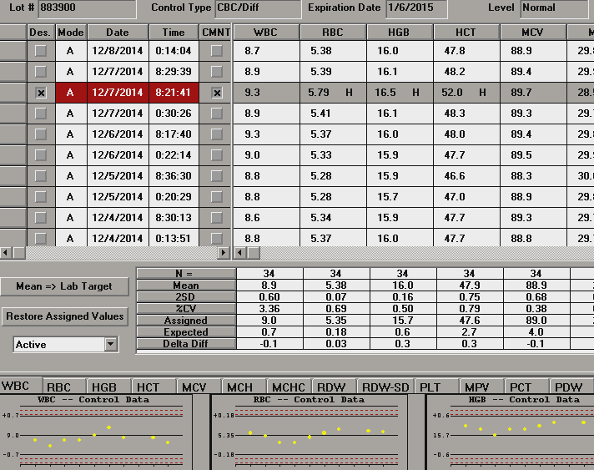

This is an LH780 QC file. Let’s look at the WBC data circled in blue.

**N** is the number of points run.

**Mean** is our lab average for that control.

**2SD** is our lab 2 standard deviations. This number is different than the “expected” value. The expected value is the Beckman Coulter assigned acceptable variation for that value. It is much like the mode to mode acceptable ranges. Our lab 2SD is generally much tighter than the expected value. This concept is the same for IL coagulation controls. IL assigns an expected variation; our lab runs a standard deviation that is generally much tighter than the expected variation.

**%CV** is our lab coefficient of variation.

**Assigned** is Beckman Coulter assigned value for that control. It is the target value.

**Expected** is Beckman Coulter assigned acceptable variation for that value.

**Delta Diff** is simply the assigned value minus our lab mean.

Let’s look at the Levy Jennings WBC graph circled in red:

The center of the graph is the assigned value. In this case it is 9.0. The limit lines are the expected values of +/- 0.7. This is the expected and acceptable variation set by Beckman Coulter. Each run is plotted. The 0.7 number is not equal to the lab 2SD value of 0.60.

Let’s move to the data points circled in purple:

A Levy Jennings trend is 6 consecutive points moving in one direction. The points circled in purple are 5 consecutive points moving up and across the mean, one shy of a trend.

A Levy Jennings shift is 6 consecutive points above or below the mean. The data points circled in orange show 5 consecutive points above the mean, again one shy of a shift.

**QC review** will be done each shift for the control run that shift. For example Nights runs Normal and Abnormal II, they would review those controls.

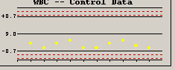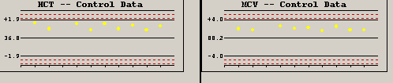

These graphs are examples of shifts in control values and must be noted on the QC review sheet.

We will not use the Westgard rules for noting QC.

Simply write WBC HCT MCV in the QC review box.