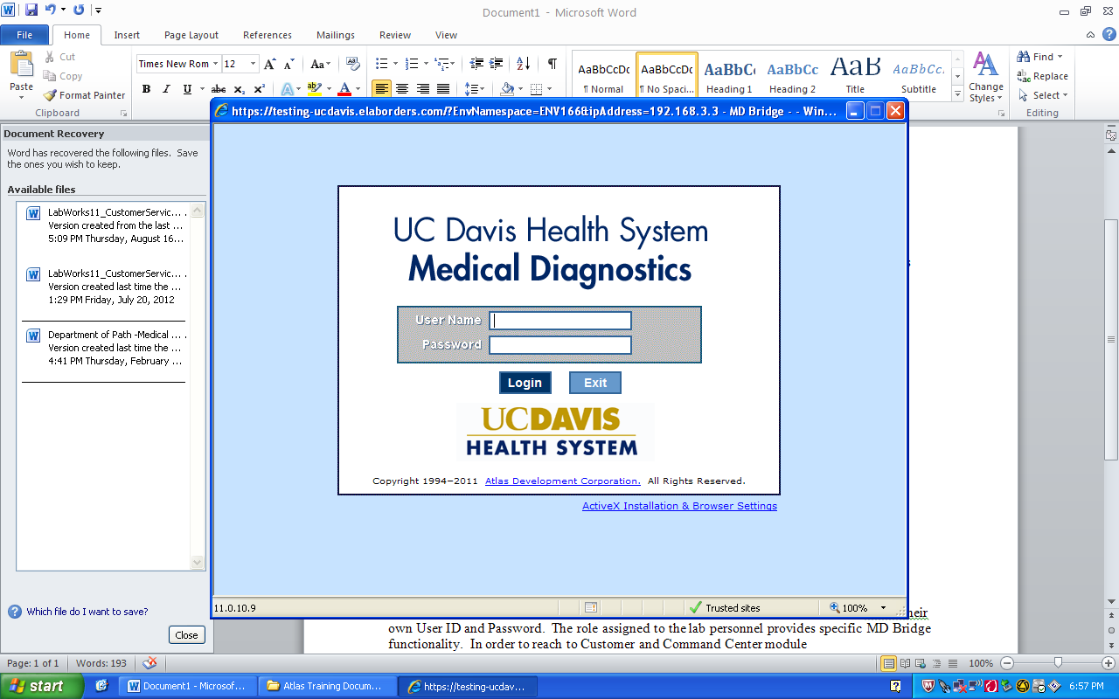 | Epic Quick Reference Guide # 3
EHS Patient with Requisition or Drop-off
Log in to EMR & make sure your logged into current location.  - Click on “New Specimen Reg”  Can also access under the chevron  arrows >> in header  - Key in patient MRN on EHS requisition  - Key the date of collection in the “Expected date” field then click “New”  - When prompted to choose an account ALWAYS choose  “Create a new hospital outpatient visit”  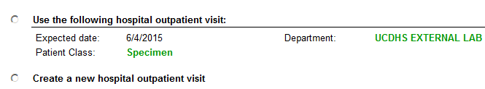  - At Interactive Facesheet, click on the  Encounter Folder  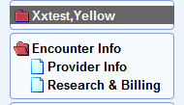  In Source Location: Key “Employee Health”  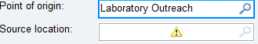  - Click on Reasearch & Billing folder  In Billing Flag field: Key “Employee Health”  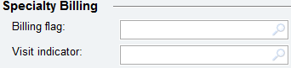  - Click “Create New Account”  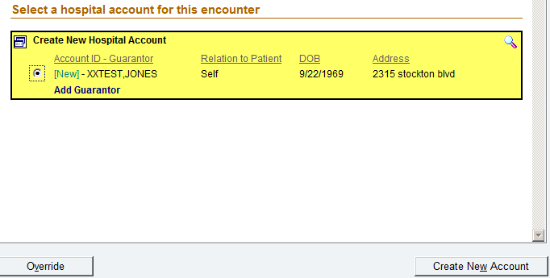 | - Verify Guarantor is Personal/Family :  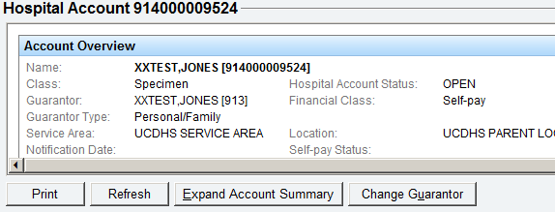  - Click Next  - Click “Self Pay  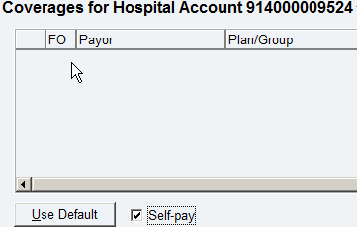  - Click on the “More” drop down menu to add the billing indicator  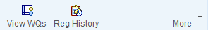  Scroll down and choose “Billing Indicator”  - Key: “Lab” to add Reg Self Pay-Lab Specimen as the  billing indicator  Click “Add Billing Indicator”  Click “Close”  - Click “Next” to Checklist Folder  Click on red links to verify or resolve issues.  - Click on “Confirm”  - Proceed to LIS under Enter/Edit Requisition and manually requisition order under the Employee Health account verify date and loc (EMPHLH) before proceeding.
When Creating a guarantor for EHS patient/specimen:
- Choose Personel/Family
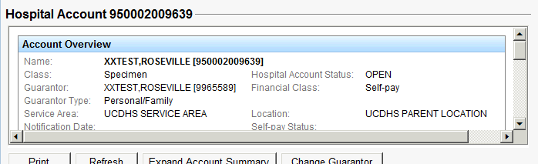

- Employee Health is no longer available to choose from

