|  |  |
| --- | --- |
|  | **Department of Pathology & Laboratory Medicine** |
| **Guidelines for Releasing Out-Patient Orders in EMR**  **Laboratory draw stations with MOSC check-in (PCN & HBC)** | |

1. **For laboratory draw stations with MOSC check-in (PCN & HBC)**
2. The MOSC will perform check-in including registration & scheduling
3. When the check-in is complete, the patient will populate on lab schedule

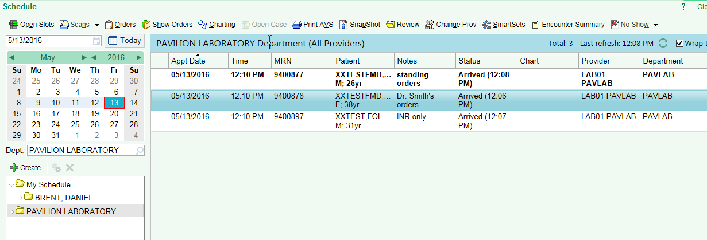

1. **DO NOT** release orders prior to making contact with the patient seated at your draw station. Click to the left of the “Appt date” and select a colored dot to indicate that you have assigned yourself to this patient

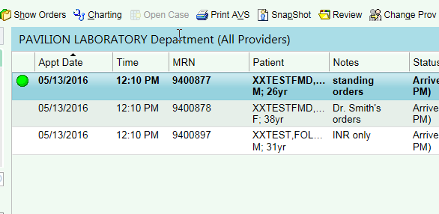

1. Call the patient from the waiting room/lobby to your draw station and verify their identity by asking them to state their name & DOB
2. Click on the patient in the lab schedule to highlight them, then click on “Show Orders” to review their orders

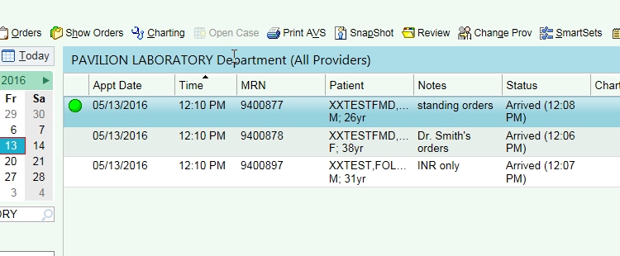

1. Review orders with patient: ***(Assuming today is 11/05/15)***
2. First set of orders in red box from Dr. Lucien have been ordered today – **Release these orders**
3. Second set of orders in blue box from Dr. Surapudi is a future order and cannot be released until at least 1 week prior to “Expected date” – **Do not release this order**
4. Last set of orders in green box from Dr. Cisneros is a standing order with directions for “Per Instructions in Full” – this indicates that this order is only to be released based off of the instructions that the physician and/or clinic instructed the patient. Please ask the patient what their instructions were to have this order performed and then document it in the appointment notes. – **Ask Patient**
5. For any order requiring the patient to collect a urine sample, do not release order until the patient has returned from the restroom with a sample. This will prevent multiple cancelations of urine source orders requiring MD’s to re-place orders. Place a demographic label on a specimen cup and ask the patient to collect sample. If adequate sample is collected, release order. Then, follow routine urine processing instructions per laboratory test directory.

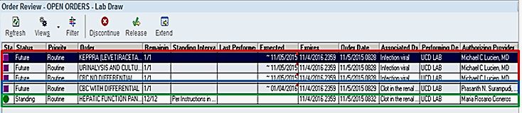

1. Prior to releasing orders, click on each order and scan to see if any comments are posted to the order that will impact whether or not you draw the sample.

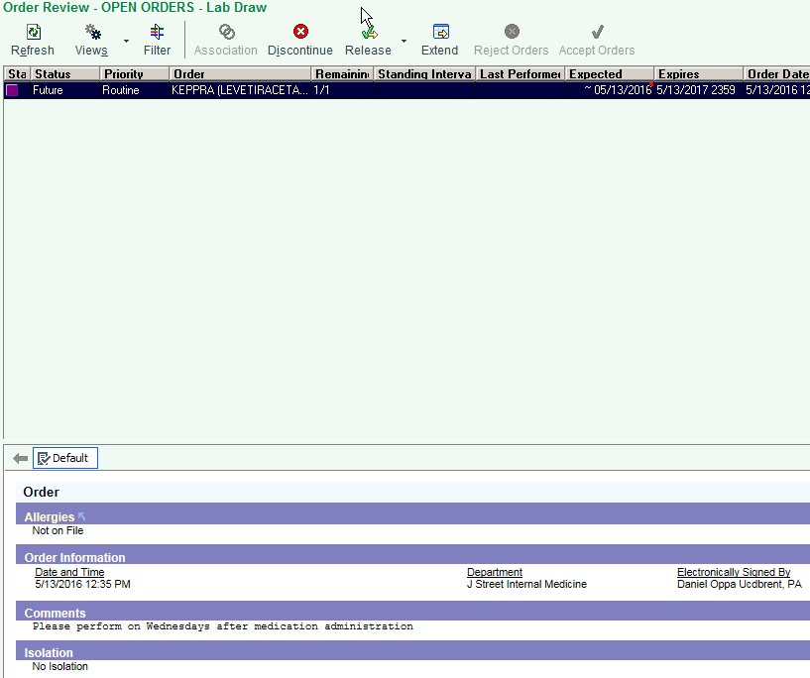

* 1. To view orders, click on the order highlighting it in blue

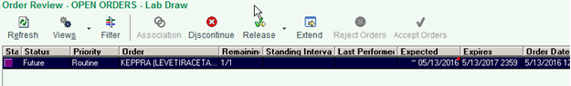

* 1. Click on the page separation line and drag the bottom page up to reveal the order that you’ve highlighted.

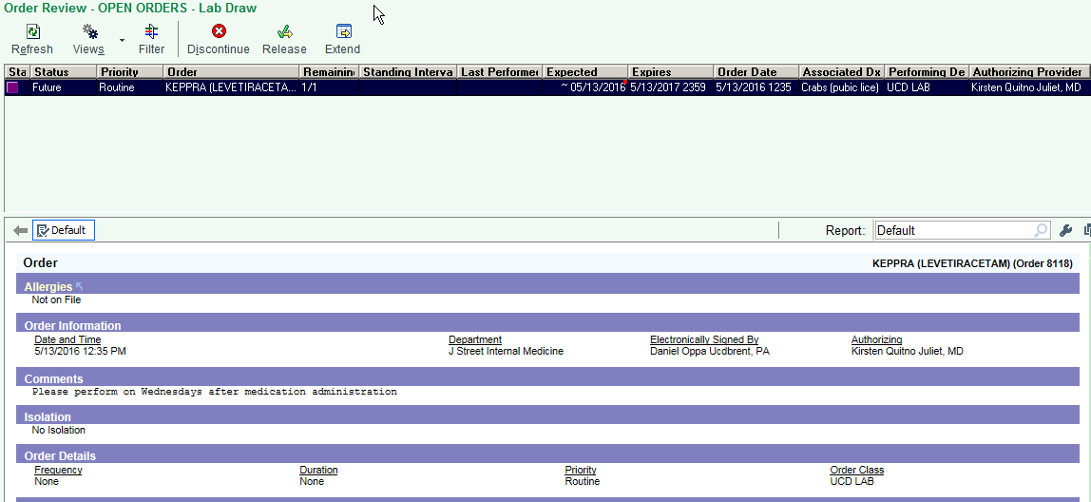

1. When releasing orders, click on each order and release one at a time to avoid releasing any orders in error

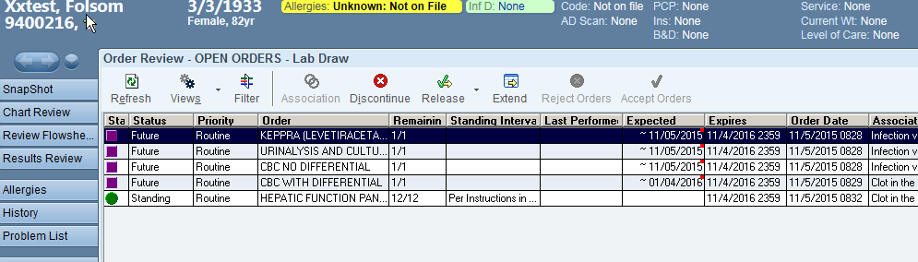

1. Proceed to in-basket and perform collect step
2. Occasionally, you will have patients present to your lab with standing orders. Pay attention to releasing the orders by the **Expected** by date, **Last Performed** and following the **Interval.**

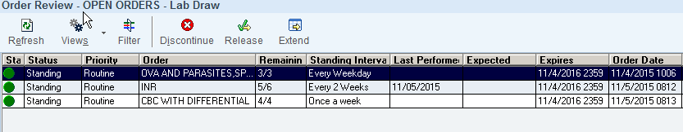

**Last Performed – Blue Box**

This column displays when the test was last performed for the patient. This information should help lab personnel determine when the next Standing Order should be performed (e.g. a CBC performed last week for a monthly interval should not be performed until next month).

**Expected – Green Box**

This column displays when a provider would like the test to be performed. This date needs to be evaluated by lab personnel to know when to perform the test. Future orders cannot be released until at least 1 week prior to “Expected date”.

* Standing order will not have an expected date, rather the Standing Interval box will specify how often to release orders.
* Future orders will have an empty Standing Interval box and will have a date in the expected box to guide user when to release orders.

**Interval – Yellow Box**

This column displays how often the standing order should be performed. Intervals will be set as one of the following:

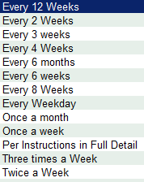

To calculate the interval, identify the “**Last Performed**” box and count on a calendar the amount of days since the test was performed last till the current day. If the current date exceeds the number of days in the interval, you can release the order.

**Last performed**: 1/02/XX **Interval:** Every 2 Weeks **Current Date**: 1/16/XX

If the current day falls within the interval set, you may not release the order.

**Last Performed**: 2/15/XX **Interval:** Once a month **Current Date:** 3/05/XX

“Per Instructions in Full” – this indicates that this order is only to be released based off of the instructions that the physician and/or clinic instructed the patient. Please ask the patient what their instructions were to have this order performed and then **document it in the appointment notes**. – **Ask Patient**

1. Patients will present and inform you that they are here for their “standing orders”. However, as depicted in the example above, the INR which is expected every 2 weeks was just performed and the patient is not technically due to have it performed again. Frequently, clinics or physicians will instruct their patients to return to the lab and have the orders performed outside of the standing order frequency. If the patient informs you of this, release the order however document in the appointment notes. This is most often on INR’s because the medication levels have to sometimes be adjusted and subsequent testing is required.

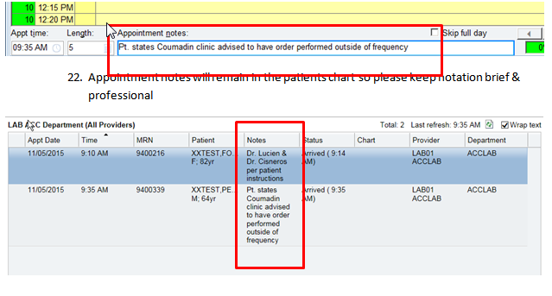

|  |  |
| --- | --- |
|  | **Department of Pathology & Laboratory Medicine** |
| **Guidelines for Releasing Out-Patient Orders in EMR**  **Laboratory draw stations without MOSC check-in (Primarily HBC’s)** | |

1. **For laboratory draw stations without MOSC check-in (Primarily HBC’s only however this will apply to PCN’s if MOSC is out or on lunch)**
2. When patient presents to your workstation, click on chart and key in patients MRN or perform a search using full last name, first name and DOB

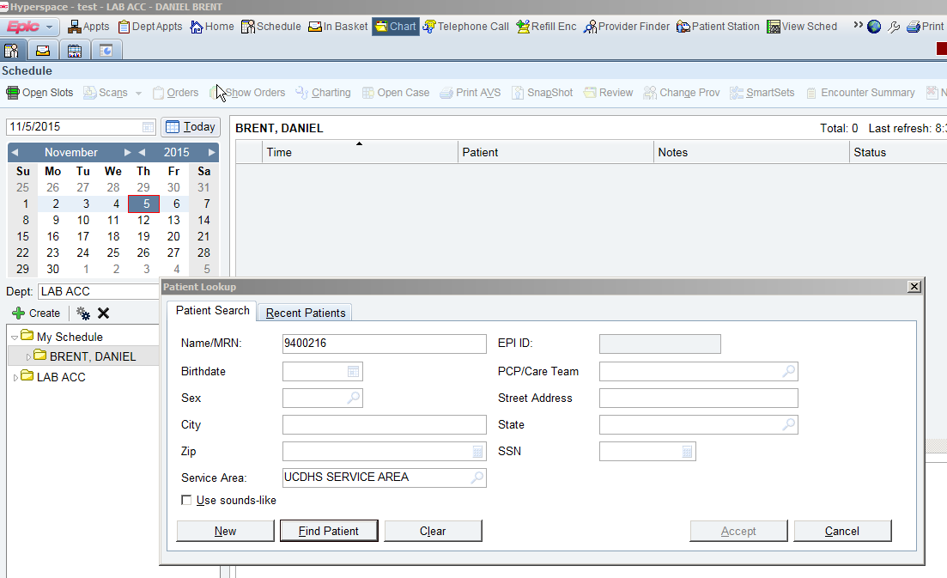

1. After verifying your patient, click on the **Open Orders** tab on the left hand column to view current orders.

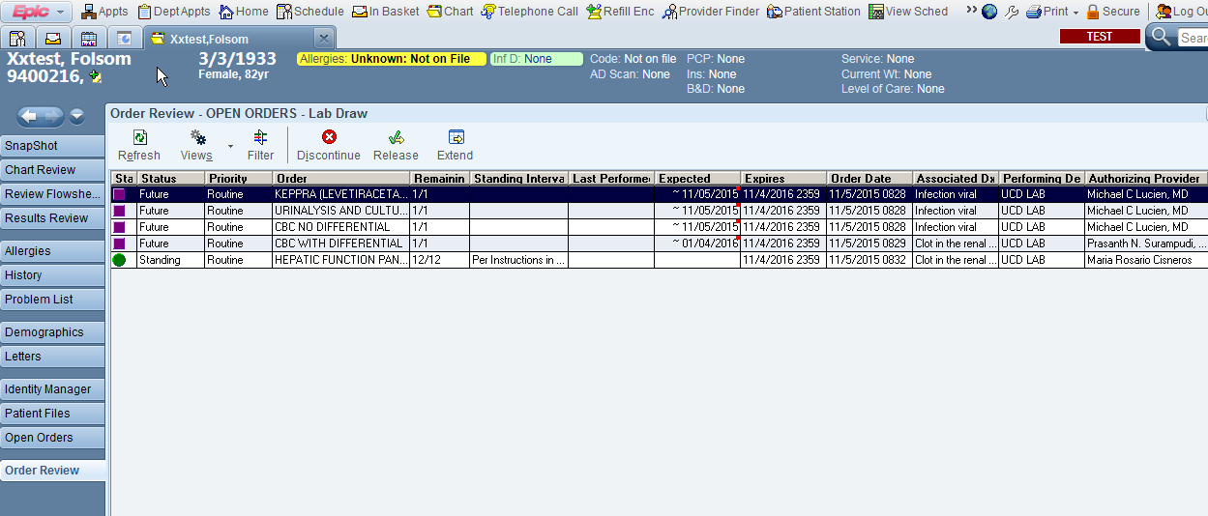

1. Review orders with patient: ***(Assuming today is 11/05/15)***
2. First set of orders in red box from Dr. Lucien have been ordered today – **Release these orders**
3. Second set of orders in blue box from Dr. Surapudi is a future order and cannot be released until at least 1 week prior to “Expected date” – **Do not release this order**
4. Last set of orders in green box from Dr. Cisneros is a standing order with directions for “Per Instructions in Full” – this indicates that this order is only to be released based off of the instructions that the physician and/or clinic instructed the patient. Please ask the patient what their instructions were to have this order performed and then document it in the appointment notes. – **Ask Patient**
5. For any order requiring the patient to collect a urine sample, do not release order until the patient has returned from the restroom with a sample. This will prevent multiple cancelations of urine source orders requiring MD’s to re-place orders. Place a demographic label on a specimen cup and ask the patient to collect sample. If adequate sample is collected, release order. Then, follow routine urine processing instructions per laboratory test directory.
6. After clarifying which orders will be released with your patient, close the chart and proceed to the out-patient appointment schedule to create your encounter for the lab visit. During the “Walk-in” registration process, notate which labs from what physician will be performed in the Appointment Notes.

*In the above scenario, the standing order with ”Per Instructions in Full” the patient advised you that he was instructed to have the lab performed one day after his medication in which he took yesterday.*

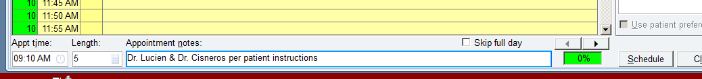

1. After the registration has been confirmed & your “walk-in” appt. is complete, click to the left of the “Appt date” and select a colored dot to indicate that you have assigned yourself to this patient
2. Prior to releasing orders, click on each order and scan to see if any comments are posted to the order that will impact whether or not you draw the sample.



1. To view orders, click on order to view highlighting the order in blue



1. Click on the page separation line and drag the bottom page up to reveal the order that you’ve highlighted.

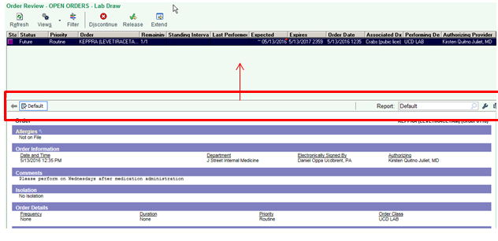

1. When releasing orders, click on each order and release one-at-a-time



1. Proceed to in-basket and perform collect step
2. Occasionally, you will have patients present to your lab with standing orders. Pay attention to releasing the orders by the **Expected** by date, **Last Performed** and following the **Interval.**

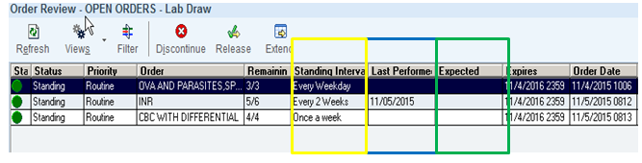

**Last Performed – Blue Box**

This column displays when the procedure was last performed for the patient. This information should help lab personnel determine when the next Standing Order should be performed (e.g. a CBC performed last week for a monthly interval should not be performed until next month).

**Expected – Green Box**

This column displays when a provider would like the test performed. This date needs to be evaluated by lab personnel to know when to perform the test. Future orders cannot be released until at least 1 week prior to “Expected date”.

* Standing order will not have an expected date, rather the Standing Interval box will specify how often to release orders.
* Future orders will have an empty Standing interval box and will have a date in the expected box to guide user when to release orders.

**Interval – Yellow Box**

This column displays how often the standing order should be performed. Intervals will be set as one of the following:



To calculate the interval, identify the Last Performed box and count on a calendar the amount of days since the test was performed last till the current day. If the current date exceeds the number of days in the interval, you can release the order.

**Last performed**: 1/02/XX **Interval:** Every 2 Weeks **Current Date**: 1/16/XX

If the current day falls within the interval set, you may not release the order.

**Last Performed**: 2/15/XX **Interval:** Once a month **Current Date:** 3/05/XX

“Per Instructions in Full” – this indicates that this order is only to be released based off of the instructions that the physician and/or clinic instructed the patient. Please ask the patient what their instructions were to have this order performed and then **document it in the appointment notes**. – **Ask Patient**

1. Patients will present and inform you that they are here for their “standing orders”. However, as depicted in the example above, the INR which is expected every 2 weeks was just performed and the patient is not technically due to have it performed again. Frequently, clinics or physicians will instruct their patients to return to the lab and have the orders performed outside of the standing order frequency. If the patient informs you of this, release the order however document in the appointment notes. This is most often on INR’s because the medication levels have to sometimes be adjusted and subsequent testing is required.

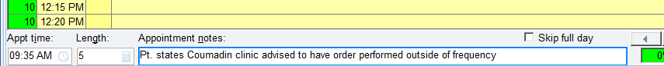

1. Appointment notes will remain in the patients chart so please keep notation brief & professional

