Registration of MED 7 Urgent Care Testing

**NOTE**: There are four (4) MED 7 Urgent Care locations; **these instructions apply to all four locations:**

**MED 7 URGENT CARE- NATOMAS, CARMICHAEL, FOLSOM, ROSEVILLE**

* **Click on “New Specimen Reg”**

**--If unable to find the patient, continue filling in the demographic information to create a new MRN for the patient: Use the patient’s demographic information on the requisition if it is available.**

**If not available use Default Address: 4860 Y St. #3100, Sacramento CA 95817**

**Default SSN#: 000000001**

* **Point of Origin: = Laboratory Outreach**
* **Source location: = MED 7 URGENT CARE- NATOMAS,CARMICHAEL, FOLSOM, ROSEVILLE**

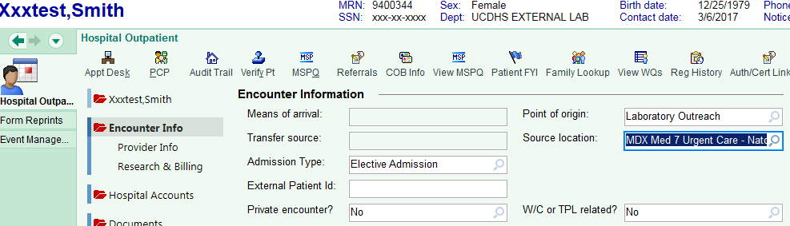

* If requisition is marked **“Insurance” or “Patient” bill** perform the following:

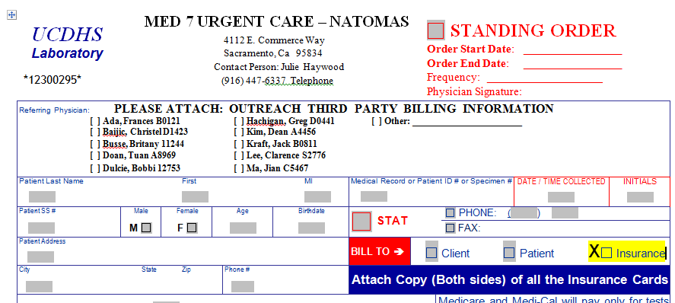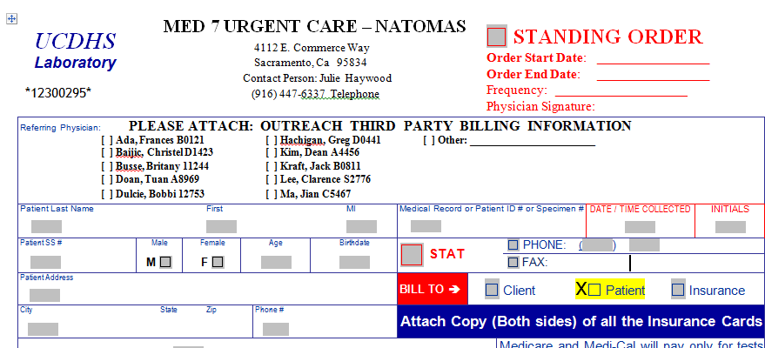

* **Billing Flag: = Blank DO NOT ADD A BILLING FLAG**

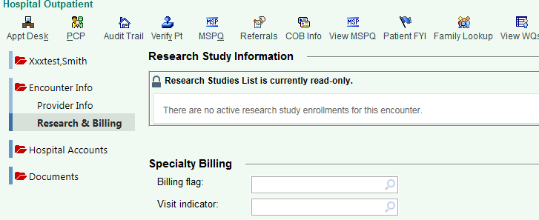

* **DO NOT REMOVE INSURANCE.**
* **DO NOT ADD BILLING INDICATOR.**

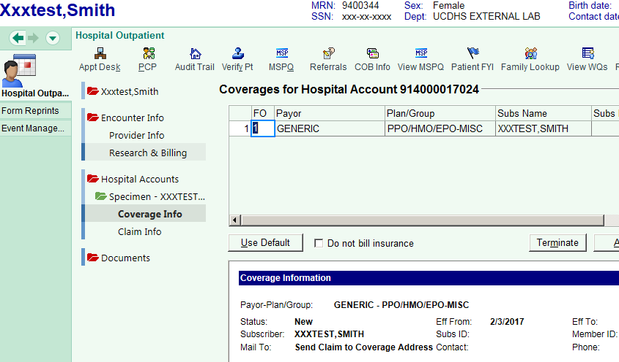

**If requisition is marked **“Client” bill**: Requisition under “New Specimen Reg” just like any other Bulk account i.e. DaVita, Mercy, etc.

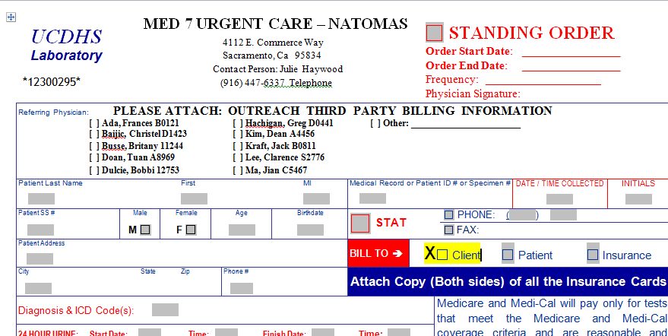

Created 03/03/17 (S):/APS/ClinLab/SARC/Training Folder/Epic Big Bang