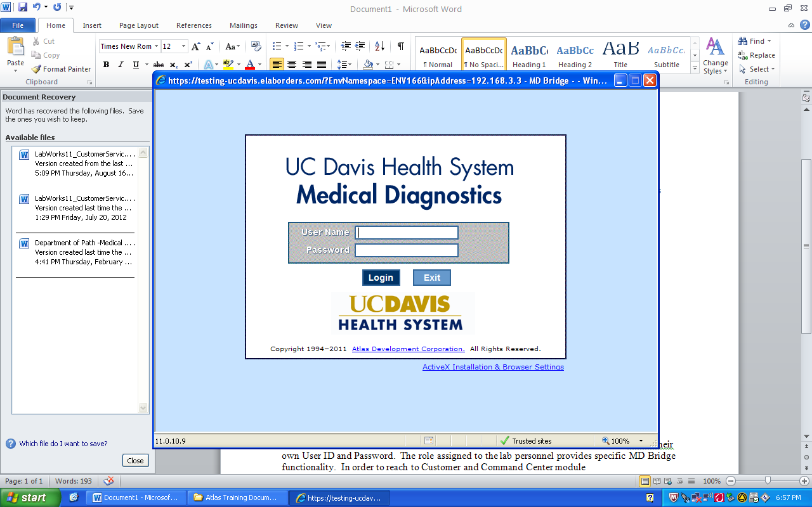 | Epic Quick Reference Guide #4
Bulk/Client Account Requisitioning
Log in to EMR & make sure you’re logged into your current location.  - Click on “New Specimen Reg”  Can also access under the chevron  arrows >> in Epic header  - Key in Patient Name/DOB/Sex and click “Find Patient”  --If unable to find the patient, continue filling in the demographic information to create a new MRN for the patient:  Use the patients demographic information on the requisition if it is available.  If not available use:  Default Address :  4860 Y St. #3100, Sacramento CA 95817  Default SSN#: 000000001  Once all fields are complete Click “New”  - Key the date of collection in the “Expected date” field then click “New” (reminder the expected date is the date of collection it  is not always “T” or today)  - Key the zip code(95817) into the City (or Zip) field to populate the county.  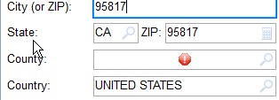  - Click “Next”  - Click “Add” to add Primary Care Provider using the Default information:  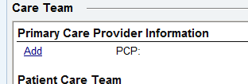  - Key “NO PCP” and click Add  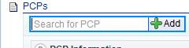 | - Under Search result click on the No Pcp No Pcp, MD that was just added.  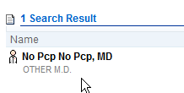  - Click “Accept”  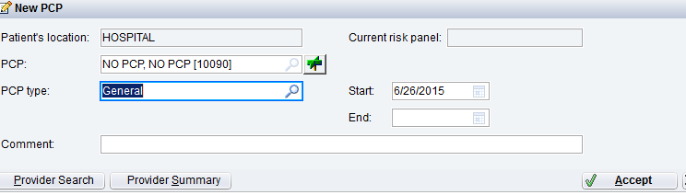  - Click “Close”  - Click “Add” to add Emergency Contacts using the default information:  Key “Contacts No” for the name.  Choose “Other” for the Relationship to the patient.  Key (916)555-5555 for the home phone number.  - Click Next  - At Add Guarantor Account Questionnaire  Click “Create New Account”  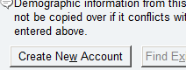  ***Only change guarantor info if the the Patient is a minor see FAQ’s for instructions  Minor Default:  Childs Name: Castaneda, Other (example)  Use patients last name  Rel to Patient field: enter “OTHER”  Date of Birth: 01/01/1978  - Key “Unknown” for Gurantor Emplyment  - Click Next  - When prompted to “Create a New Coverage” DO NOT add any information.  Click “Hosp Outpat”  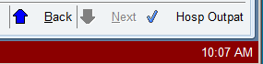  PAGE 1
- At Interactive Facesheet, click on the  Encounter Folder  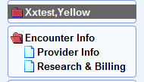  In Source Location: Key: “The client name on Req or Scan  the barcode to populate this field”  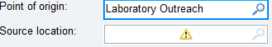  In External Patient ID: Key “External PT ID from req”  - Click on Reasearch & Billing folder  In Billing Flag field: Key: “The Client Name on Req or Scan  the barcode to populate this field”  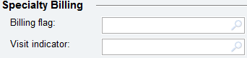  - Click “Create New Account”  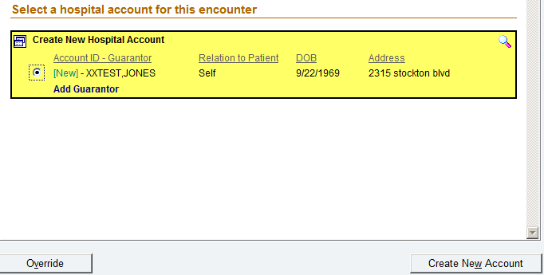  - Click “Next”  - Click “Self Pay” or “Do Not Bill Insurance”  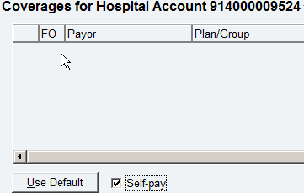  Updated 03/06/2017 | 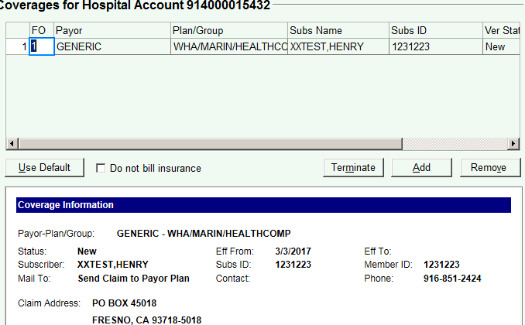  - Click on the “More” drop down menu to add the billing indicator    - Key: “Lab” to add Reg Self Pay-Lab Specimen as the  billing indicator  Click “Add Billing Indicator”  Click “Close”  - Click “Next” to Checklist Folder  Click on red links to verify or resolve issues.  - Click on “Confirm”  - Proceed to LIS under Enter/Edit Requisition and manually requisition order under the MDX client account that was just created in Epic.  **Guarantor Information for Minor/Pediatric Patient**  - Choose “Other” for Who is responsible  - Type name as: Patients Last Name, Other  (e.g. Meyers,Other)\  - Use default DOB: 01/01/1978  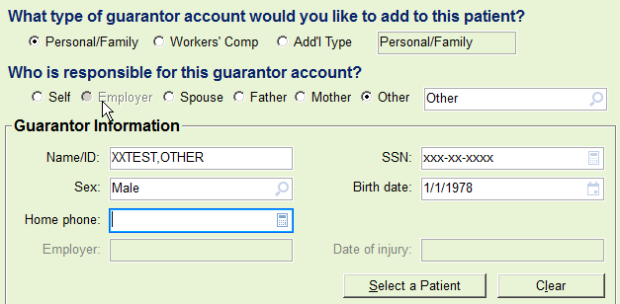  PAGE 2

