Meditech Beaker Overlap Requisition Workflow for Beaker (CP portion)

1. Log into EPIC and choose Pavilion Lab Context (under Department type in Pav and search for Pavilion Lab)
2. From patient Station choose the Patient to be requisitioned by MR search.
3. Under One Click choose pull down option followed by Specimen walk in

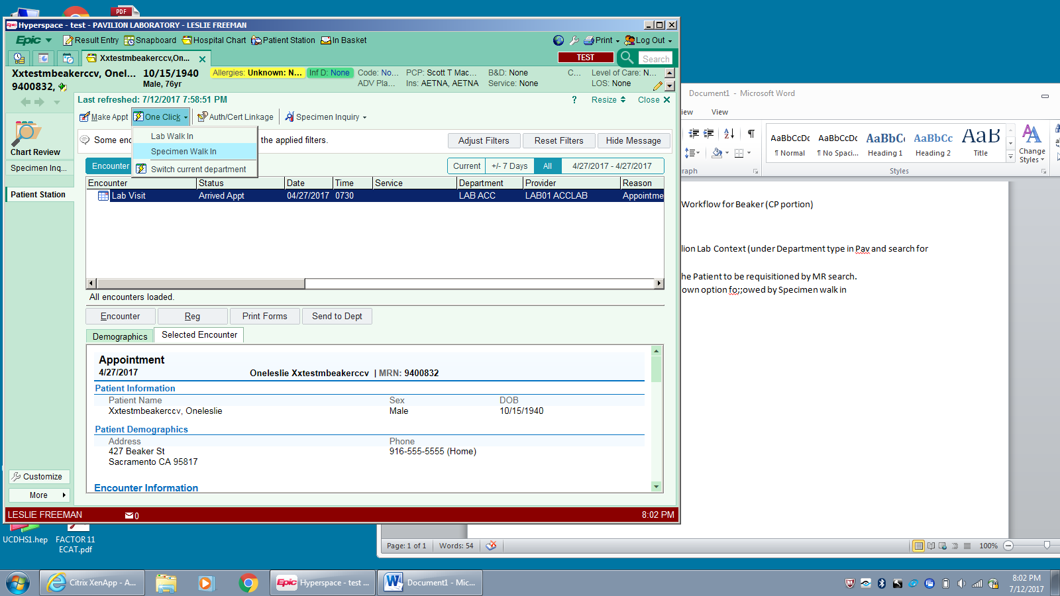

1. Choose a 10 minute appointment time at random.
2. Click encounter info on left side of screen:

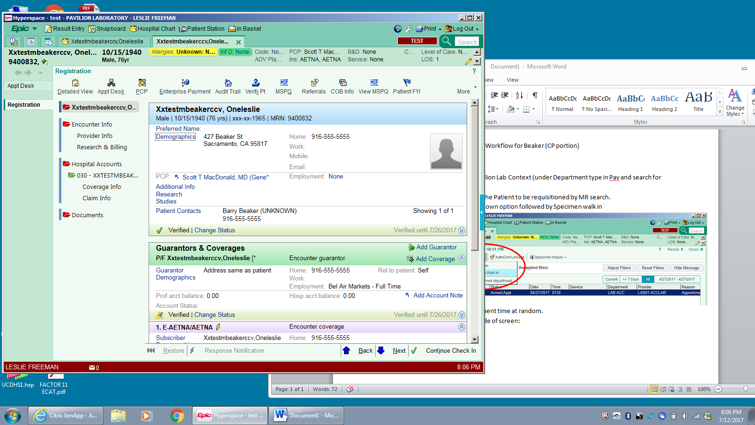

1. Under W/C or TPL related field answer No.

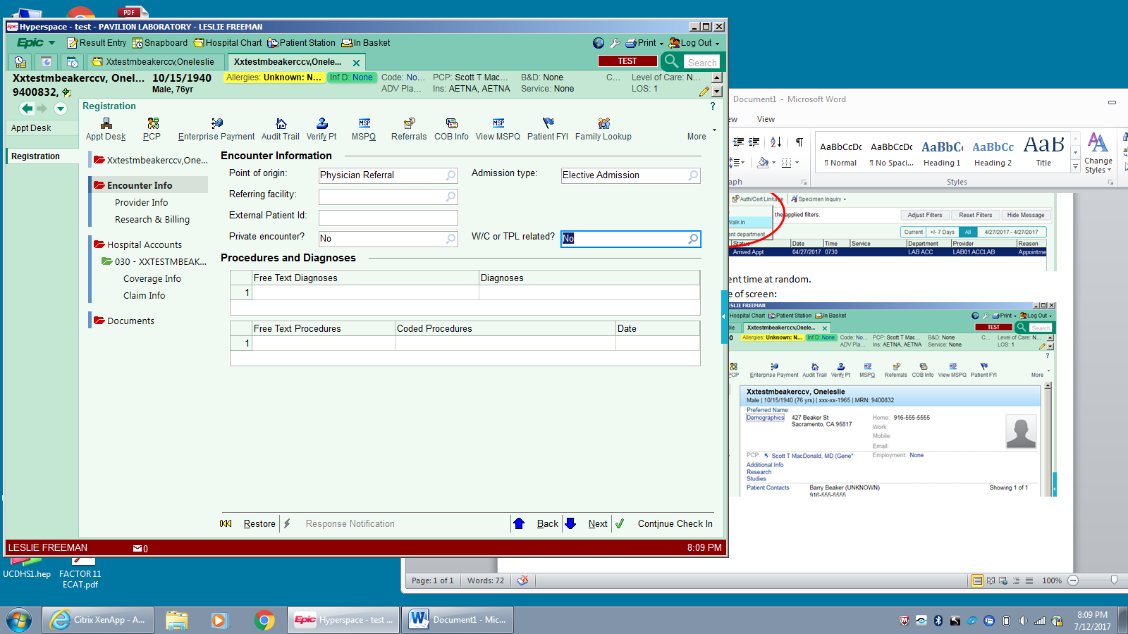

1. At the bottom right click the Continue Check In button with the green check mark. Any warnings and stops will appear in a pop up box on the left.
2. Click continue at the bottom of this pop up box followed by accept at the bottom right.
3. Double click on the encounter just created to open order inquiry.
4. Click on Order Entry on left side

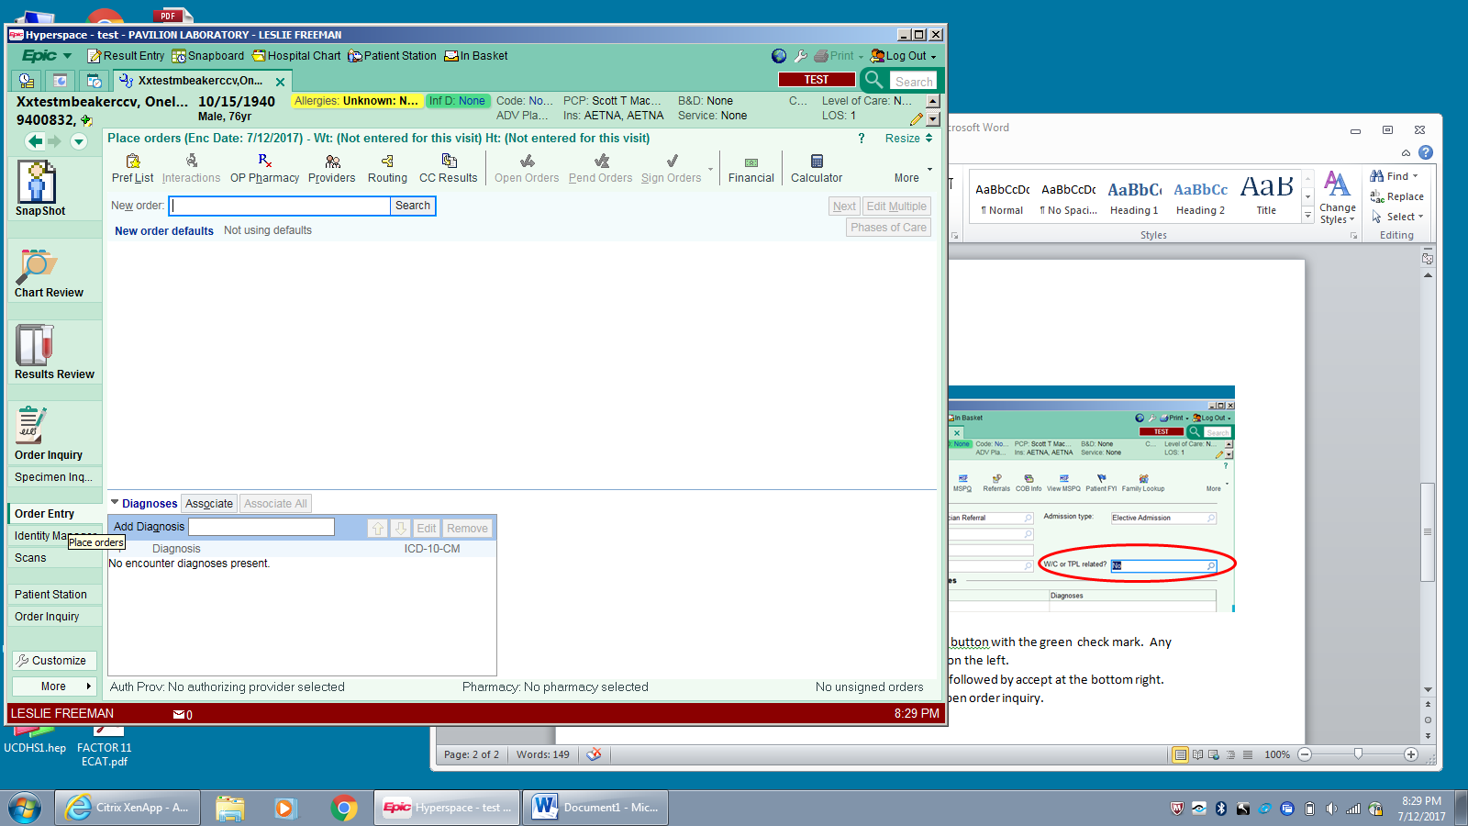

1. Under New Orders at upper left enter each test to be ordered for Clinical Pathology side (molecular, sendouts, micro) using mnemonics provided on the Bone Marrow requisition or partial mnemonic and search function).
2. For outpatients add ICD code from form into box next to add diagnosis. If more than one test and more than one code are used choose Associate All button after highlighting all diagnosis codes entered. (Red circle)

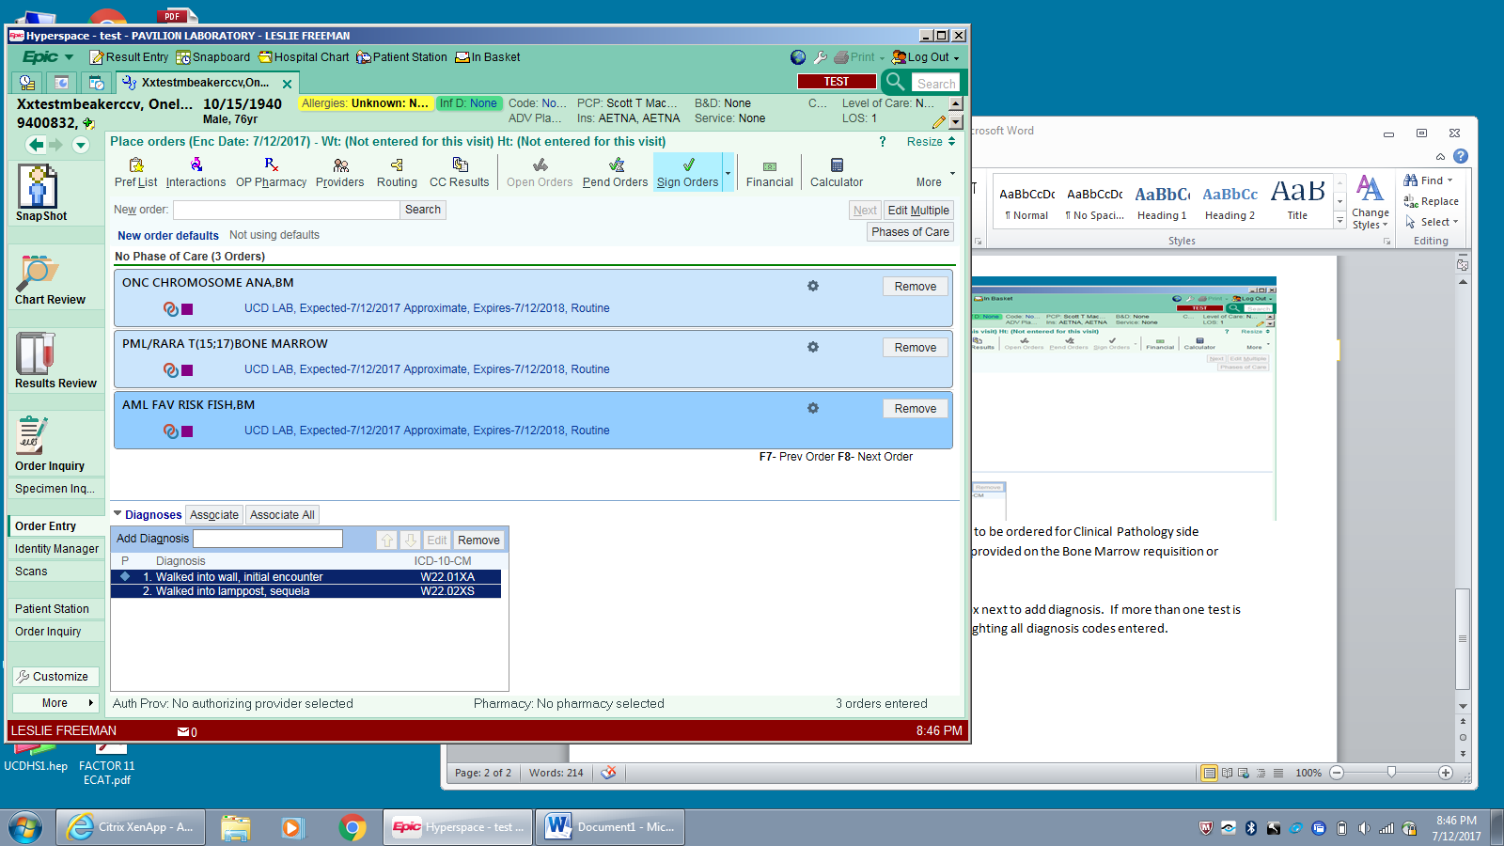

1. Add provider (Ordering Physician)by choosing Provider button (Green circle above) and searching for correct provider

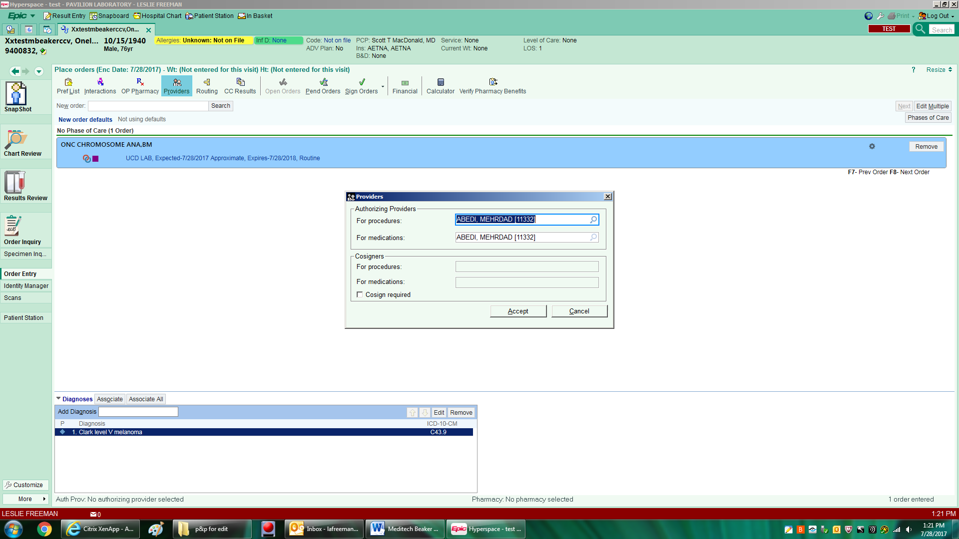

1. Sign Order by clicking on Sign Order button



1. Under Order Inquiry when using open orders link, highlight all Bone Marrow Orders. Be careful as all open orders will appear on this screen. Make sure you highlight only the orders just entered for Bone Marrow. Click on the Collect Specimen button above:

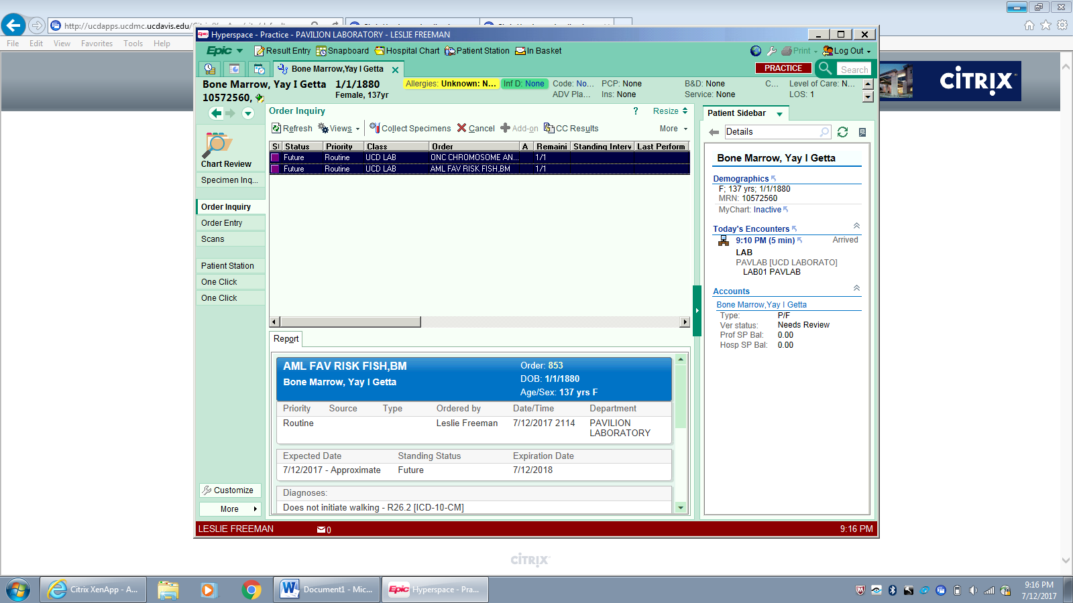

1. Click on Print Labels to assign a Beaker ID to each sample:

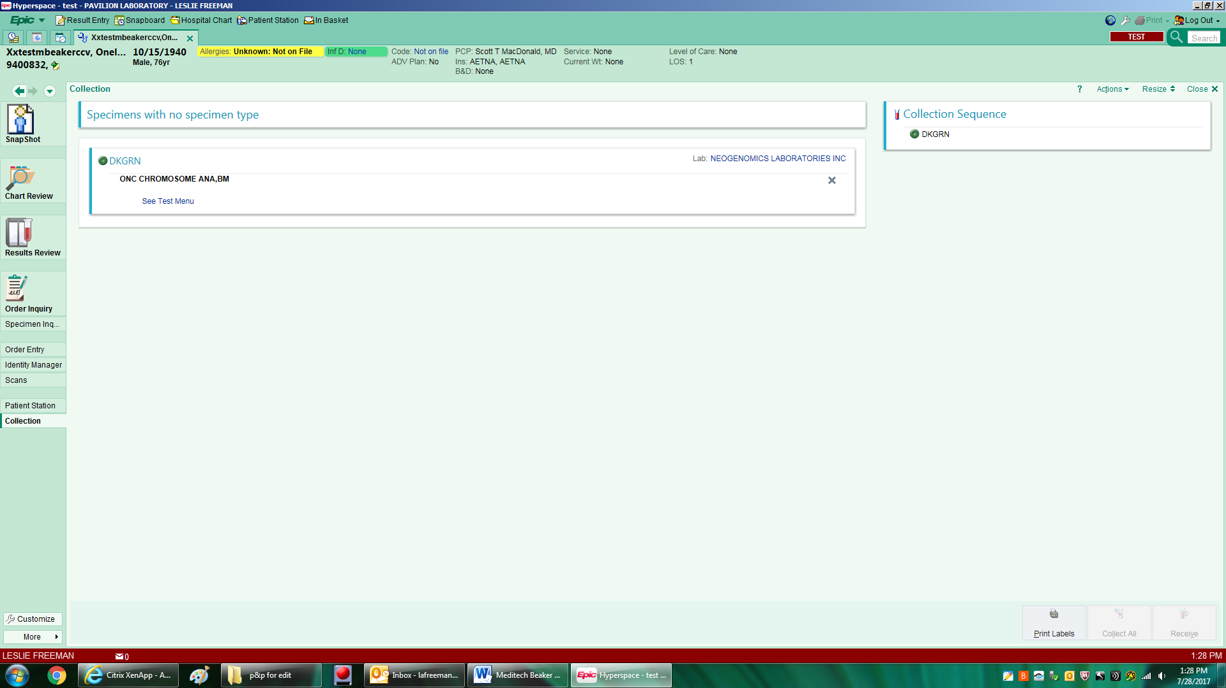

1. Click on specimen to update collection date and time by Clicking on Scan label or click to document the collection.

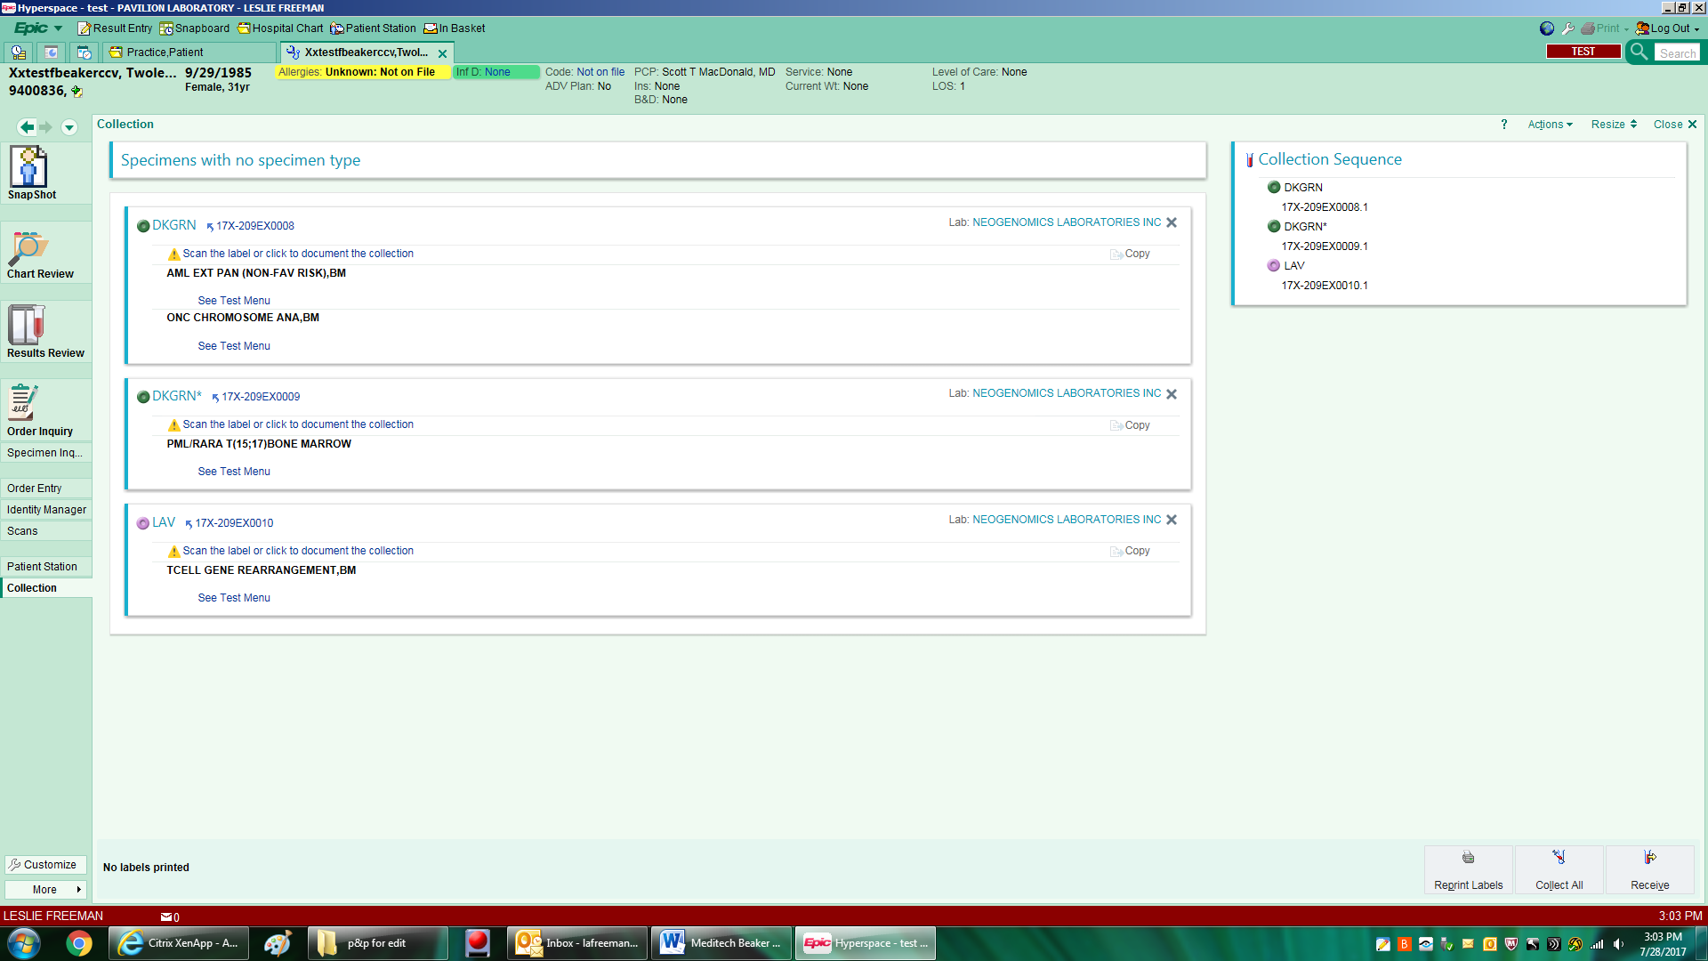

1. Fill in date and time of collection on first sample (Red) then click on Copy (Green)

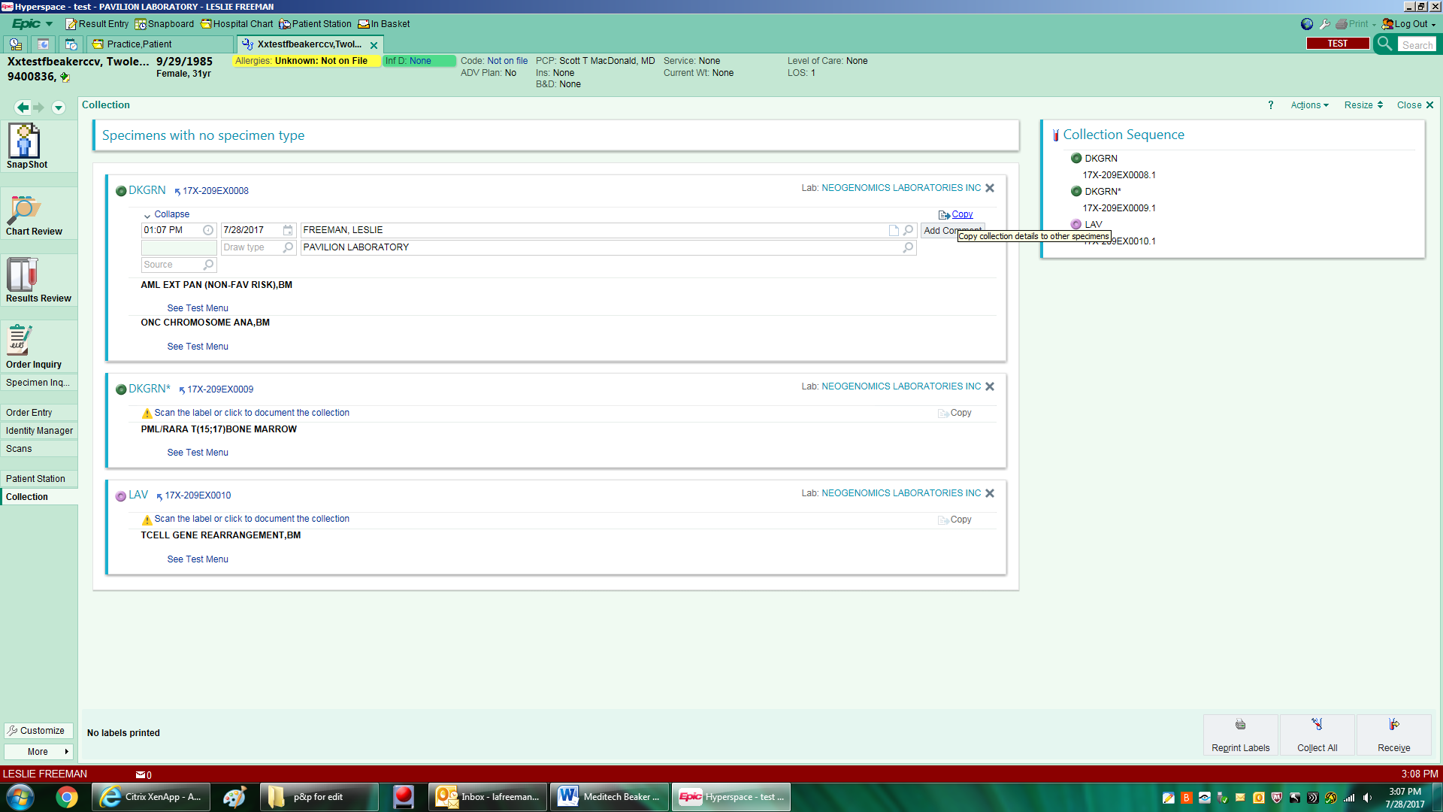

1. Click on Scan label line on click to document line on each sample to copy data over to all samples.
2. While in the collection data field (or you can click the Collected on line to re-open the collection information) click on add comments for Neogenomics samples to enter clinical information in comments field.

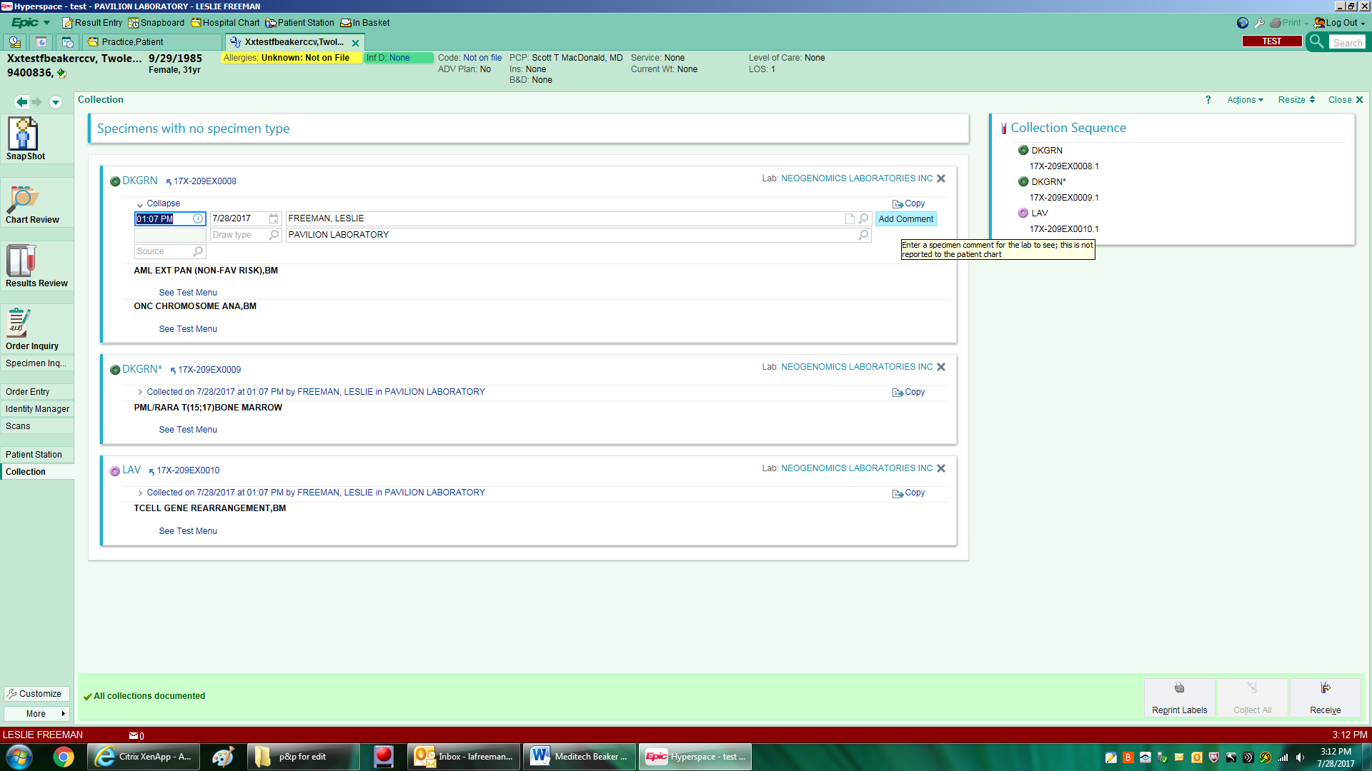

1. Type Clinical Information from form into comments box for use by Neogenomics.
2. Choose receive at the lower right side of the page to complete the process.

