# **ALL of Us Study updated registration workflow**

# **Out-patient ADD-ORDER Tip sheet**

**\*\*\*\*DO NOT order using Requesting Entry\*\*\*\*\***

“Venipuncture Only, Study” orders for the ALL Of Us Study will be on a UC Davis Client account paper requisition. The Clinical Research Coordinator will give the patient the lab requisition. When the patient presents to the lab, lab staff will need to create a One-Click walk in appt and associate the walk in appt and venipuncture charge to the research account. Summary of Steps:

* Phlebotomist will create a Lab Walk in appt for the patient
* Order for the Venipuncture only, Study will be transcribed via paper requisition, the order will be flagged as being associated to a Study **before** the order is signed
* From Order Inquiry, collect the venipuncture order along with any other orders needing collection

## Steps to requisition and collect “Venipuncture Only, Study” order(s) for All of Us Study research account

1. Create Lab Walk in appoint for patient
2. **If no patient exists, refer patient to CRC. CRC will pre enroll the patient into the study**
3. From Appt. desk, click on the One Click->Lab Walk In
4. For new patients to the university, leave insurance blank (DO NOT ADD INSURANCE)

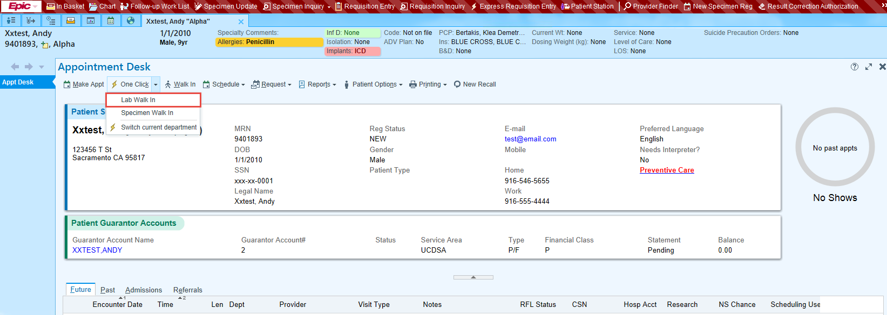

1. Place order for Venipuncture Only, Study
2. From order Inquiry, select ADD ORDER from the bottom of the screen

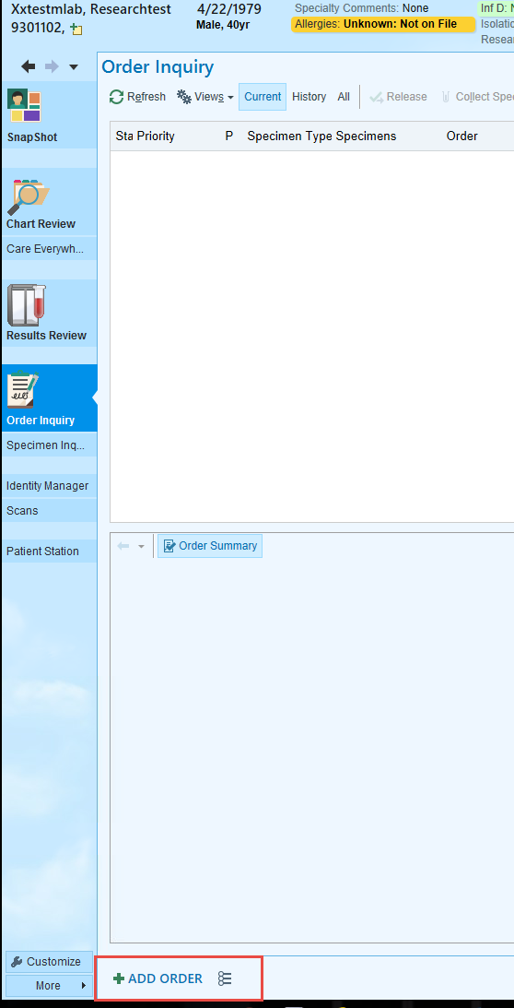

1. Type Venipuncture Only, Study in search box and select order

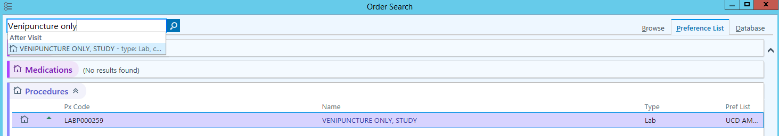

1. Type Skye Stewards contact details into the **(1)** Contact Phone # prompt: **Skye Stewart, 206 245 7578**
2. **(2)** Type **All of Us Study blood** Draw in comments (F6) field
3. **(3)** Associate DX

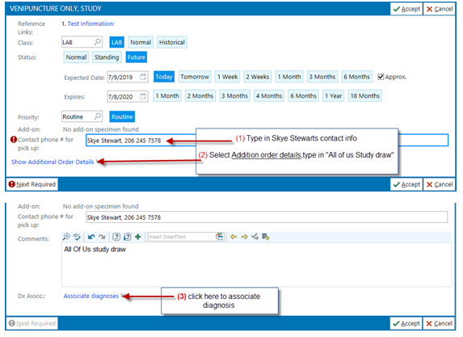

1. Enter Z006 (Z zero, zero, six)

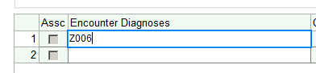

1. Then select “Research Subject”

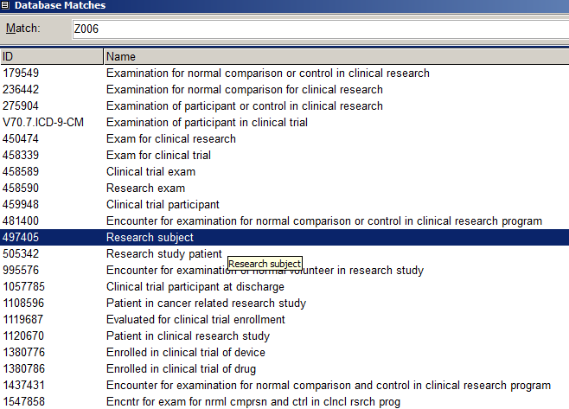

1. Click on ACCEPT
2. Click on Accept again once Research Subject appears in the Encounter Diagnoses box.

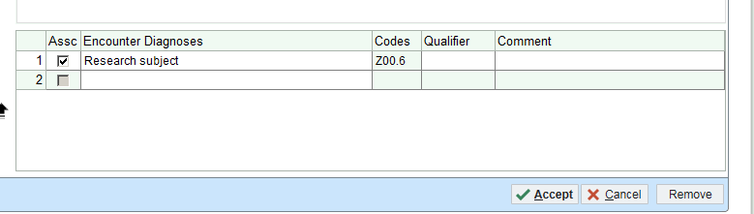

1. Now associate the ENCOUNTER to the STUDY-

From the Options button **(1)** click on Research Association **(2)**

NOTE: If “Research Association” is not available the patient has not be pre-enrolled

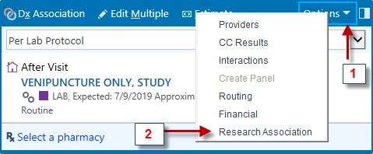

Click the appropriate research account:

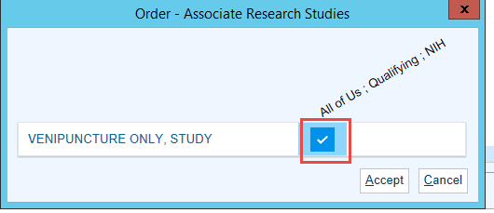

1. Click on ACCEPT
2. Confirm the Research Icon appears next to the order **(1) lab research flask icon**
3. Click Sign Order **(2)**

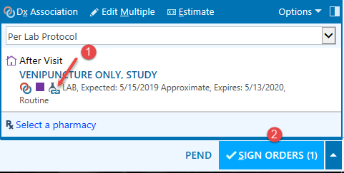

1. Enter BOROWSKY, ALEXANDER DAVID as the Ordering/Authorizing Provider

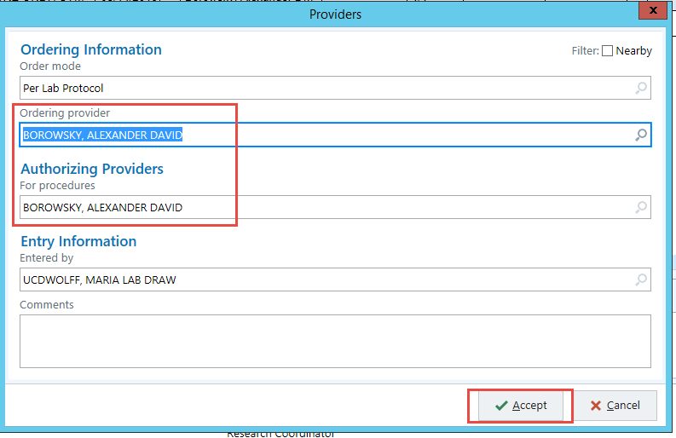

1. Click Accept
2. From Order Inquiry, you can then collect the Venipuncture Only, Study order and any other specimens needing collection:

