TABLE OF CONTENTS

Logging In.......................................................................................................................... 2

New Users......................................................................................................................... 2

Multi-Site Data Users........................................................................................................ 3

Home Screen..................................................................................................................... 3

**Controls and Reagents**

Cuvettes.................................................................................................................. 4

UA Strips................................................................................................................. 5

Pregnancy/Bacterial Vaginosis Kits...................................................................... 6-8

CoaguChek Strips…………………………………………………………………………………………….…. 9

HgbA1c.................................................................................................................. 10

Adenovirus…………………………………………………………….………………………………………….12

**Entering Test Data**

Not tested…………….….………..……………………………………………………………………………. 15

HgbA1C..................................................................................................................16

Hgb....................................................................................................................... 18

UA......................................................................................................................... 20

Refractometer…………………………………………………………………………………………………..21

Urine Drug Screen Kit………………………………………………………………………………………..23

Departmental Spot Check............................................................................................... 24

Troubleshooting.............................................................................................................. 26

**Logging In**

When you first launch the application, you will be presented with a login screen. Your username and password will be the same as your Citrix or Windows login.

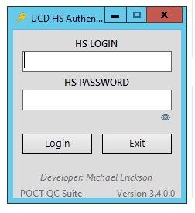

**New Users**

If you have not been added to the software as a user, you will be notified with a dialog box informing you that an e-mail has automatically been sent to the POCT unit requesting access. The e-mail will only be generated if you are logged into Outlook.

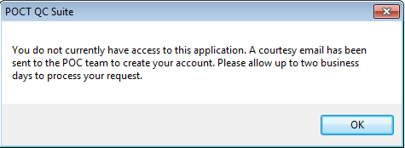

**MULTI-SITE USERS**

If you need to view and/or enter data from another area within your clinic, select by highlighting from the Current Location dropdown.

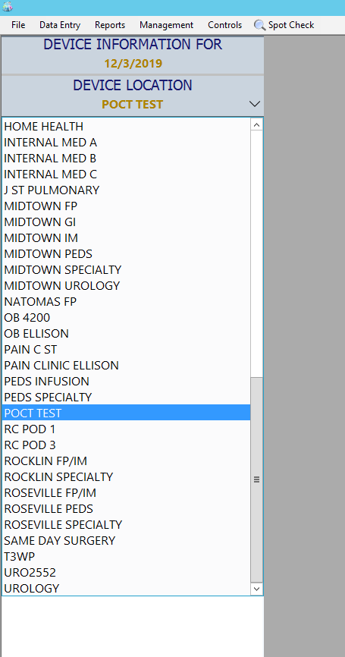

**HOMESCREEN**

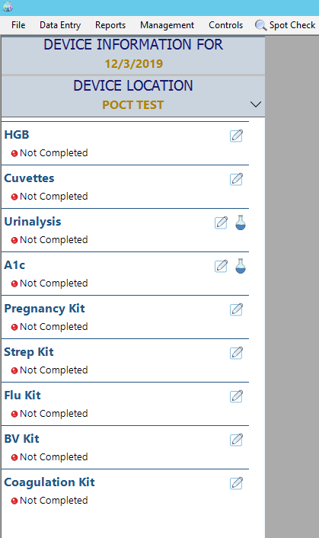If your role is “Data Entry”, you will start with a screen that displays your clinic location and department, along with the status of all tests at your location for the current day.

**CONTROLS AND REAGENTS**

Prior to entering daily test data, all controls and reagents must be entered and active. These include: cuvettes, UA strips and controls, pregnancy kits and controls, bacterial vaginosis kits and controls, and HgbA1c cartridges and controls.

# Cuvettes

On the Home Screen, select the enter data  icon next to Cuvette Data.

* **Active Cuvettes –** If your location has any cuvettes that have been entered but have not expired, you will see them on this list. Clicking the lot number will show the lot expiration date, the date opened, and the bottle expiration date.
* **Adding Cuvettes –**You **must** enter cuvettes when opening new bottles, *regardless* of lot number. Enter the lot number, expiration date **listed on the bottle**, and the date opened. Do not assign a letter designation at this time.

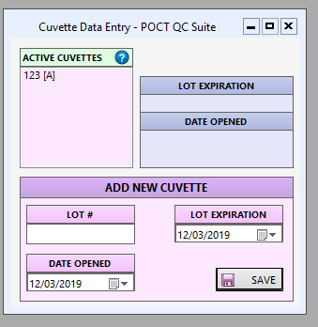Press the “Save” button. A prompt will appear, asking if you want to add a lettered designation to the bottle. Answering “Yes” will allow the newly entered cuvette to appear in the “Active Cuvettes” list. Remember: cuvettes are only usable for 3 months after opening, and this new bottle expiration will automatically be calculated.

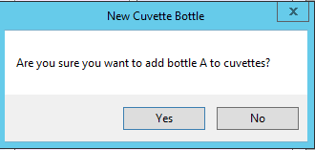

**Helpful Hint: Date the bottle when opened and mark the bottle with the assigned letter designation to avoid confusion.

**UA Strips**

On the home screen, select the enter data icon  next to UA Strips.

* **Active Strips –** If your location has any strips that have been entered but have not expired, you will see them on this list. Clicking the lot number will show the expiration date and date opened.
* **Adding Strips –**
  + You **must** enter strips when opening new bottles, *regardless* of lot number. Select the flask icon , select the type of strips your location uses. Enter a valid lot number, expiration date, and the date opened. Do not assign a letter designation at this time.
  + Press the “Save” button. A prompt will appear, asking if you want to add a lettered designation to the bottle. Answering “Yes” will allow the newly entered bottle to become active and you will be asked if you would like to QA the newly added bottle. Select Yes or No.

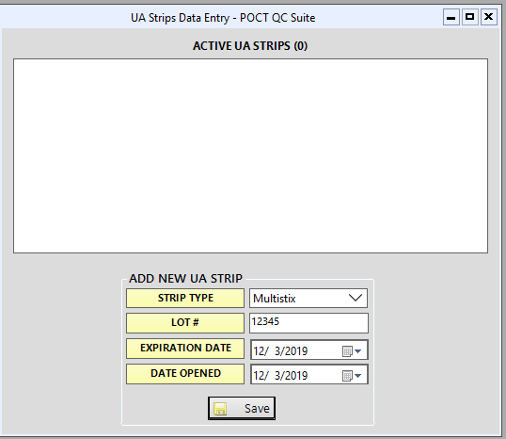**Helpful Hint: Date the bottle when opened and mark the bottle with the assigned letter designation to avoid confusion. 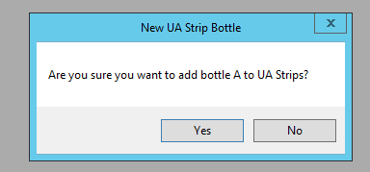

**Pregnancy/Bacterial Vaginosis Kits**

On the home screen, select the enter data  icon next to the Preg Kit or BV Kit.

* Enter a valid lot number, number of boxes (1, regardless of actual number) and the expiration date.
* Press the “Save Kit” button. A confirmatory prompt will appear.

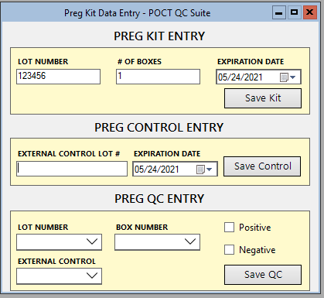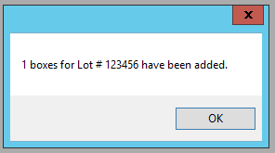

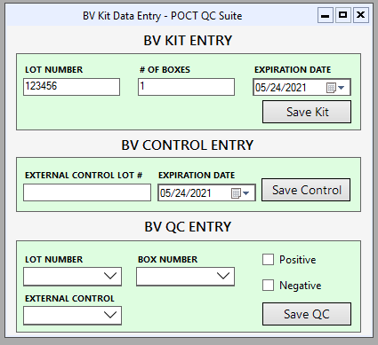

* Next Add the external control lot number and expiration.
* Select “Save Control” and a confirmatory Prompt Will Appear.

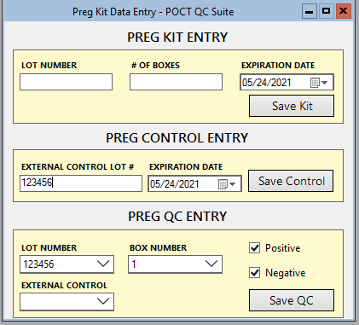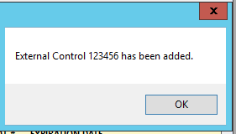

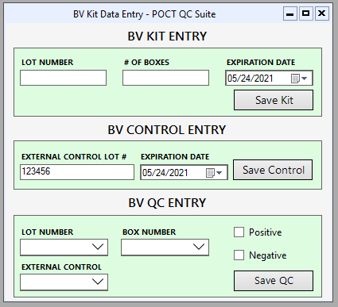

* To QC, select the lot number of the kit from the dropdown menu, select box number 1 from the dropdown menu and select the external control lot number.
* Check the Negative and Positive boxes if the controls react accordingly and press the “Save QC” button. A confirmatory prompt will appear. If QC is performed correctly, that box number will no longer appear in the dropdown menu and the lot is considered QC’d.

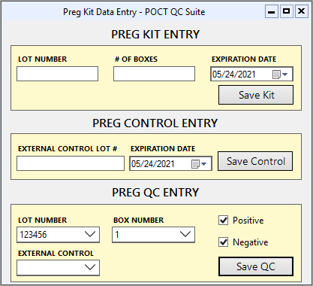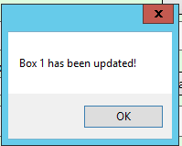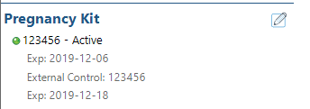

Note: if multiple boxes and lots are received, QC only one box at a time to avoid confusion. Only the most current lot passing quality control will appear on the Active list on your Home Screen.

**Helpful Hint: Label each box with the QC date

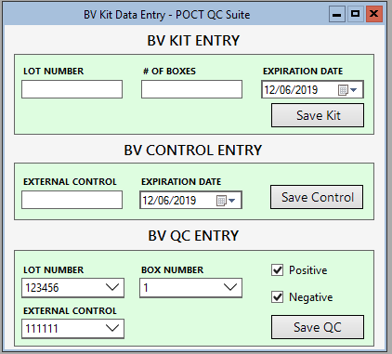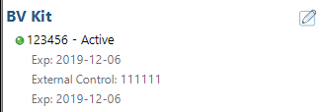

**CoaguChek Strips**

On the home screen, select the enter data icon  next to the Coagulation Kit.

* Enter a valid lot number, expiration date and press the “Save” button.
* Your new lot will appear in the “Active Coag Strips box.
* Select the Coag Strip lot to display lot expiration and date entered.
* The Home screen will now display “Active”

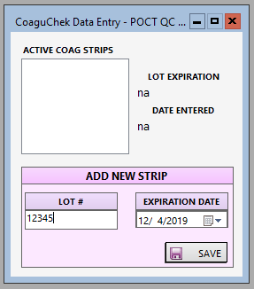 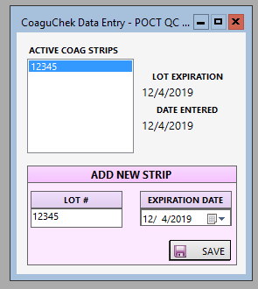

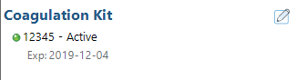

**HgbA1c**

**Adding New Cartridges**

You **must** enter reagents upon opening, *regardless* of lot number.



1. On the home screen, select the flask icon.
2. Enter the Lot number, open date and expiration date. Do not assign a letter designation at this time.
3. Select Save. A confirmatory prompt will appear.

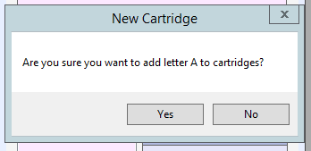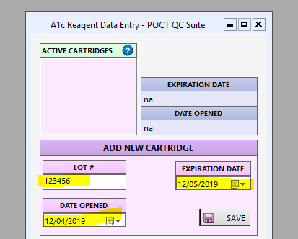

**Adding New Liquid Controls**

1. On the home screen, select the flask icon.
2. Enter the Lot number, open date, expiration date and normal and abnormal ranges. Do not assign a letter designation at this time.
3. Select Save. A confirmatory prompt will appear.

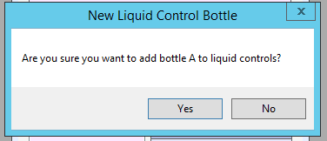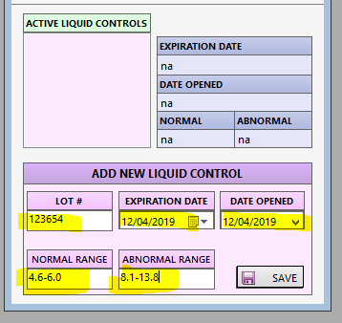

**Active Reagents –** If your location has reagents that have been entered but have not expired, you will see them on this list. Clicking the lot number will show the expiration date and date opened to the right. 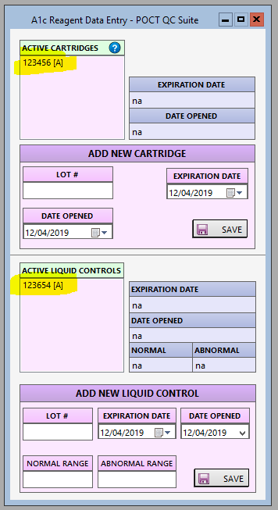

Helpful Hint: Date reagents when opened and mark them with assigned letter designations to avoid confusion

**Adenovirus Kit**

On the home screen, select the enter data  icon next to the Adenovirus Kit.

* Enter a valid lot number, number of boxes (1, regardless of actual number) and the expiration date.
* Press the “Save Kit” button. A confirmatory prompt will appear.

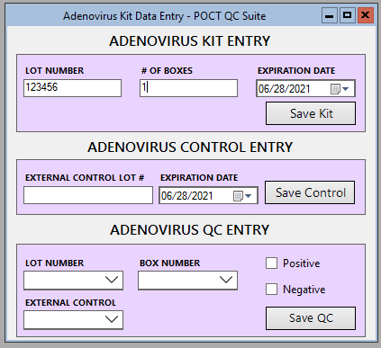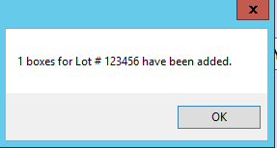

* Next Add the external control lot number and expiration.
* Select “Save Control” and a confirmatory Prompt Will Appear.

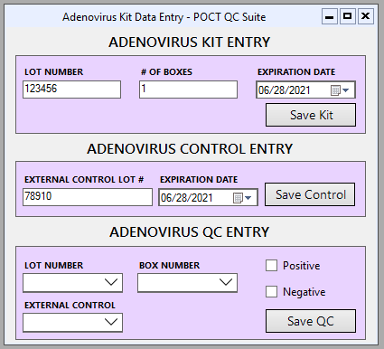 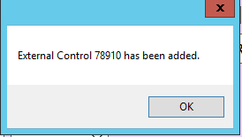

* To QC, select the lot number of the kit from the dropdown menu, select box number 1 from the dropdown menu and select the external control lot number.
* Check the Negative and Positive boxes if the controls react accordingly and press the “Save QC” button. A confirmatory prompt will appear. If QC is performed correctly, that box number will no longer appear in the dropdown menu and the lot is considered QC’d.

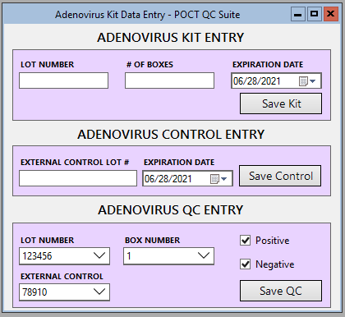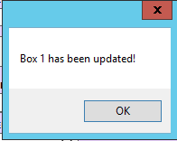

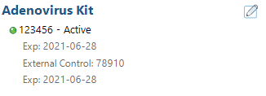

Note: if multiple boxes and lots are received, QC only one box at a time to avoid confusion. Only the most current lot passing quality control will appear on the Active list on your Home Screen.

**Helpful Hint: Label each box with the QC date

**Active Reagents –** If your location has reagents that have been entered but have not expired, you will see them on this list. Clicking the lot number will show the expiration date and date opened to the right. 

Helpful Hint: Date reagents when opened and mark them with assigned letter designations to avoid confusion

**ENTERING TEST DATA**

Your location is responsible for data entry everyday patient testing occurs. If QC is not performed, documentation is required.

**Marking test as “Not Tested”**

If QC patient testing is not performed on that test for the day. Make sure to document “Not tested” for that test.

1. From the home screen, select the “Data Entry” menu
2. Select Mark as “Not Tested” then select the test to be marked.
3. Enter comment, then select ok.
4. A confirmation prompt will appear. Select “Yes” or “No.”
5. This may be overridden, however, if QC is performed later that day.

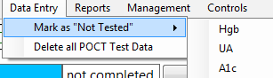 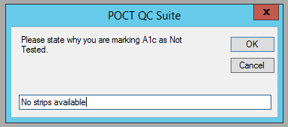

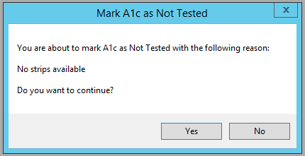

**HgbA1C**

On the home screen, select the enter data icon next to A1C.

* **Instrument ID**-Select the appropriate instrument from the dropdown list.
* **Cartridge**-Select the appropriate lot and box from the dropdown list.
* **Liquid Control**-Select the appropriate lot from the dropdown list.
* **Normal Result**-Enter your normal control result.
* **Abnormal Result**-Enter your abnormal control result.
* Select Save. A prompt will appear “All data has been recorded! QC Status: Passed or Failed.”

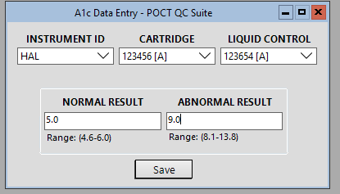 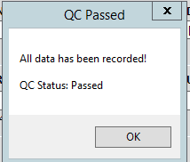 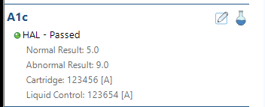

When entering QC results, if values fall outside of the acceptable range:

* Text box and normal values will change to red. If those values are saved a prompt will appear stating “QC failure, please document corrective action.”
* **Corrective action such as “will repeat test” or “Will contact POC for assistance” must be entered before proceeding.** Character limit is greater than 10 characters.
* The Home Screen will show that test as “Failed” in red, prompting the user to repeat and result **only** the QC that failed. A red notepad will also appear to review documented corrective action.

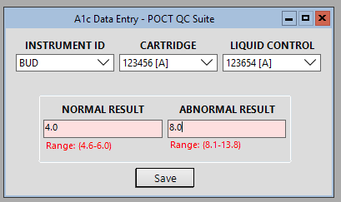

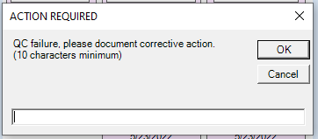

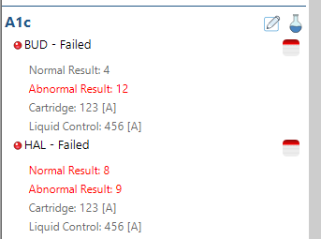

**Hgb**

On the home screen, select the enter data icon next to Hgb. 

* **Cuvette Lot**- Select the appropriate cuvette lot from the dropdown list.
* **Low Range Lot**-Select the appropriate lot and bottle from the dropdown list.
  + Enter a valid date opened, if necessary.
  + Enter the result.
* **High Range Lot**-Select the appropriate lot and bottle from the dropdown list.
* Enter a valid date opened, if necessary.
* Enter the result.

Press the “Save” button. A prompt will appear, stating either “QC Passed” or “QC Failed-Repeat Needed”.

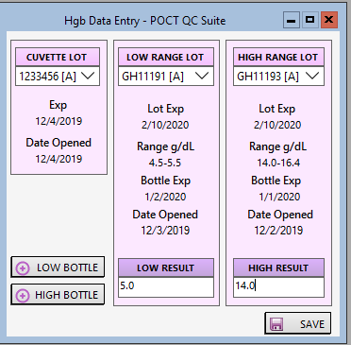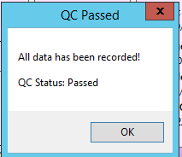

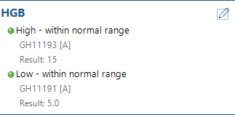

When entering QC results, if values fall outside of the acceptable range:

* Text box and normal values will change to red. If those values are saved a prompt will appear stating “QC failure, please document corrective action.”
* **Corrective action such as “will repeat test” or “Will contact POC for assistance” must be entered before proceeding.** Character limit is greater than 10 characters.
* The Home Screen will show that test as “Failed” in red, prompting the user to repeat and result **only** the QC that failed. A red notepad will also appear to review documented corrective action.

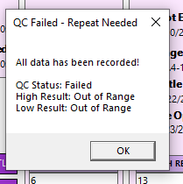 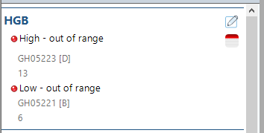

By default, each location will be given three bottles of low and high controls. If you require additional bottles, please click the corresponding button “Add Low Bottle” or “Add High Bottle”, but do not assign a letter designation. Remember: controls are viable for 30 days or lot expiration date (whatever comes first) at room temperature or refrigeration upon opening and this new bottle expiration will automatically be calculated.

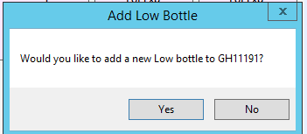

**Helpful Hint: Date the bottle when opened and label the control bottle(s) with the corresponding letter designation to avoid confusion.

**UA**

On the home screen, select the enter data icon next to Urinalysis.

* **Device ID**-Enter the 3-letter designation of urinalysis analyzer if automated.
* **UA Strips**-Select the appropriate UA strip lot from the dropdown list.
* **UA Controls**-Select the appropriate UA control lots from the dropdown list. If the lots do not appear on the list, please notify the Point of Care Department.
* **Reading Method**-Select the appropriate reading method for the strip chosen.
* Enter all test results from your printout or manual test. If a particular result is out of range, it will alert you by changing the corresponding field to red.

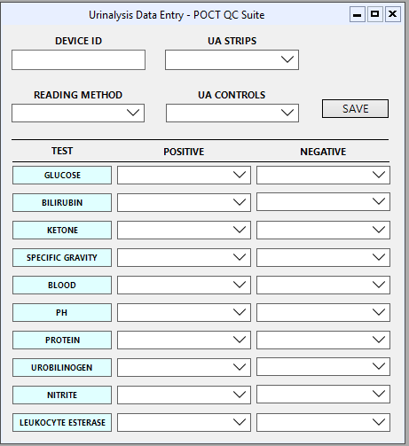

Press the “Save” button.

Repeat for remaining test strip types.

Those strip types passing QC will subsequently be removed from the dropdown.

**REFRACTOMETER**

On the home screen, select the enter data icon next to Refractometer.

* **MAS UA Controls**-Select the appropriate UA control lots from the dropdown list. If the lots do not appear on the list, please notify the Point of Care Department.
* **DEVICE ID**-Enter the designated device ID
* Enter all test results for Deionized water, MAS UA Negative Control and MAS UA Positive Control

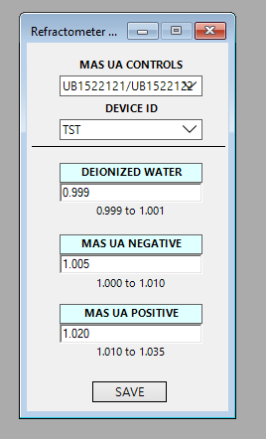 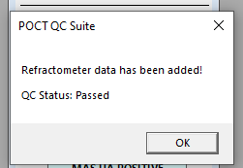

When entering QC results, if values fall outside of the acceptable range:

* Text box and normal values will change to red. If those values are saved a prompt will appear stating “QC failure, please document corrective action.”
* **Corrective action such as “will repeat test” or “contacting POC” must be entered before proceeding.** Character limit is greater than 10 characters.
* The Home Screen will show that test as “Failed” in red, prompting the user to repeat and result **only** the QC that failed. A red notepad will also appear to review documented corrective action.

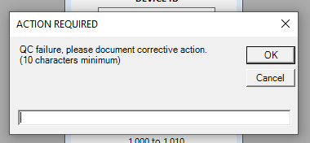

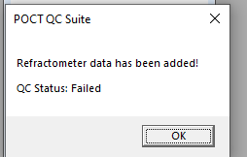

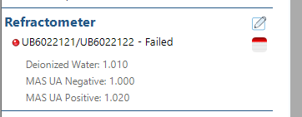 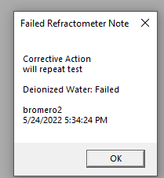

**Urine Drug Screen Kit**

On the home screen, select the enter data icon next to Urine Drug Screen Kit.

1. Enter the Kit Lot number and expiration date.
2. Enter the control lot number and expiration date.
3. Select the boxes for the controls that passed. If the control of one of the drugs did not pass, please repeat the test and document repeat results.
4. Graphical user interface, application

   Description automatically generatedSelect Save QC when done.

When entering QC results, if values fall outside of the acceptable range:

* Text box and normal values will change to red. If those values are saved a prompt will appear stating “QC failure, please document corrective action.”
* **Corrective action such as “will repeat test” or “contacting POC” must be entered before proceeding.** Character limit is greater than 10 characters.
* The Home Screen will show that test as “Failed” in red, prompting the user to repeat and result **only** the QC that failed. A red notepad will also appear to review documented corrective action.

**Departmental Spot Check**

Managers and their designees will have the ability to perform Departmental Spot Checks.

* From the home screen
* Select “Spot Check”.

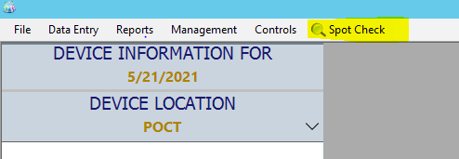

* Select your location from the dropdown, enter in a date, and hit “Search”.

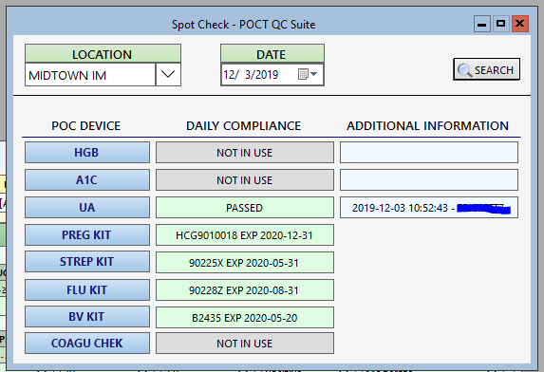

**Please contact our department to add or remove designees.**

**Troubleshooting**

If you experience any issues with the application, please contact the POCT team.

**Telephone:** 916-734-8050

**Vocera:** 916-734-0775 Point of Care

**Email:** [hs-Pointofcaretesting@ucdavis.edu](mailto:hs-Pointofcaretesting@ucdavis.edu)