Canceling a Specimen (LAB, MIC, [BBK-with no product]):
Canceling occurs when all the tests or procedures associated with a specific prefix will be deleted. Any tests canceled for inpatients or ER patients must be phoned. Save the contact information for future entry. Contact information includes: First and last name of the person notified and their job title. Cancellation of BBK orders must be performed by Blood Bank personnel.

In the module specific Cancel Specimen routine, enter the specimen number at the Spec # prompt.

The cursor will move to the Cancellation Comments field. You must select an appropriate canceled reason canned text. Press <F4>, type “CAN” and press <F9> to look up available canned texts.

NEVER FREE TEXT A CANCELED REASON. Doing so is incompatible with EMR results reporting and Quality Assurance monitoring.
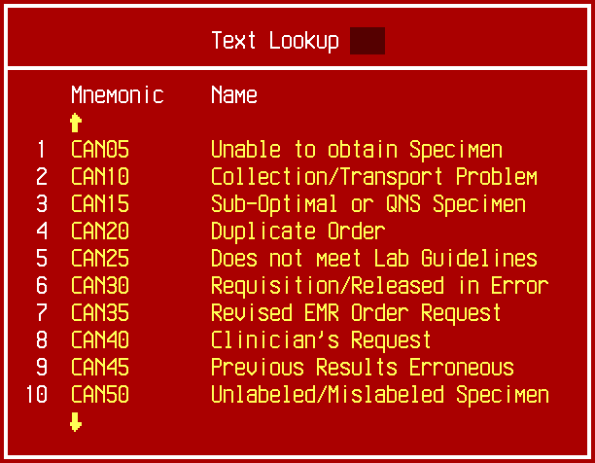

All frequently used canned texts are listed on the first lookup screen. These texts are general categories of cancellations, and more specific information will be requested after the general category text is chosen. Almost all cancellations fit into one of the above categories. Choose the most specific cancel reason available on this screen.

Choose Unable to obtain Specimen if, for any reason, a specimen could not be obtained. Reasons may include, but are not limited to:

Patient unavailable

Patient declined

Patient already drawn

No ID band on patient

IV/Heparin lock, both arms

Difficult stick

Choose Collection/Transport Problem whenever collection or transport conditions make cancellation necessary. Reasons may include, but are not limited to:

No specimen received

Too old upon receipt

Wrong container for test

Wrong source for test

Not on ice

Broken/leaking container

Choose Sub-optimal or QNS Specimen whenever a problem with the received specimen makes cancellation necessary. Reasons may include, but are not limited to:

Clotted

Hemolyzed

IV line contamination

QNS for testing

Choose Duplicate Order when a specimen should not be tested per laboratory duplicate specimen guidelines.

Choose Does not meet Lab Guidelines when an order does not comply with technical section testing guidelines.

Choose Requisitioned/Released in Error whenever a specimen is manually requisitioned or released from EMR in error.

Choose Revised EMR Order Request whenever you are modifying an EMR order. Reasons may include, but are not limited to:

Incorrect test ordered

Multiple barcodes received

Revised Microbiology procedure

Choose Clinician’s Request when a specimen should not be tested per the request of a responsible caregiver. This includes both phone requests and EMR initiated order cancellations.

Choose Previous Results Erroneous whenever a previously verified result must be removed.

This situation should be extremely rare. The following warning message will appear prior to filing:

If the previously verified result is discovered to be from a mislabeled/misidentified specimen, follow specific instructions contained in LIS Administrative Procedure #922: Handling Unlabeled and Mislabeled Specimens and Requisitions.

If the previously verified result needs to be cancelled for another reason, i.e. lab error or contaminated specimen, follow specific instructions contained in LIS Administrative Procedure #921: Editing Verified Results in the LIS.

If in doubt, do not file. Exit the requisition and consult a supervisor.

Choose Unlabeled/Mislabeled Specimen to cancel an unlabeled or mislabeled specimen that does NOT contain previously verified results.

Follow specific instructions contained in LIS Administrative Procedure #922: Handling Unlabeled and Mislabeled Specimens and Requisitions.

If NONE of the cancellation reasons on the first look-up screen are appropriate, press <Enter> to view additional screens containing cancellation canned text.

Choose Other Reason SHOULD BE RARE! only when NO OTHER CANCELLATION REASONS FIT THE CIRCUMSTANCE.

Cancellation reasons specific to Microbiology specimens begin with “CANM” and are also listed on the additional screens.

Once the appropriate canned text is selected, the cursor will automatically stop at fields that require an entry.

A response list may display which contains more specific cancellation reasons within the selected cancellation category. Choose the most specific response from the list.

The canned text will automatically fill in the date/time of entry and name of the person signed onto the system at the Date/Time and By prompts.

Specific cancellation reasons require notification to the submitter or designee. If a “Notified:” prompt displays, a response is required. Do not skip or delete this prompt.

Phone notification is required for current INPATIENTS and ER. Enter first initial, last name and title of the staff member who was notified.

All other notifications will be performed by Client Services as appropriate. If the cancellation was not phoned, enter CLIENT SERVICES at the “Notified:” prompt. A cancellation report prints to Client Services for follow-up.

Additional information may be added after the last line of the canned text.

Do not edit previous lines or insert text above or between lines. The position of these lines in the report ensures correct display in EMR.

All free text entries must be checked for grammar and spelling.

Press <F12> to continue.

If there are previous verified results, the following warning message will appear:

If the cancelled reason is not Previous Results Erroneous, do not cancel without supervisor approval.

At the Cancel? prompt enter “Y” to file or “N” to edit.

A cancel message will automatically generate to the EMR when the cancellation is filed.

Status of the EMR order changes to CANCELED.

A new message WILL NOT generate if a change is made to a cancellation comment after the cancellation has been filed.

A cancellation will automatically queue the specimen to generate a new printed chart copy at the next scheduled report print job for those locations/Clients that receive Meditech printed reports.

Canceling a Specimen (BBK with Product)

Follow all cancellation steps above with the following addition:

Before a specimen containing a product order can be canceled, the product must be at AVAILABLE status for non-crossmatched products, or READY status for crossmatched products.

If the product is not at an appropriate status, the following message will appear.
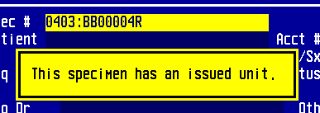

Use the Return to Prior Status routine to return the unit to an appropriate status before proceeding with cancellation.

Canceling a Specimen (Anatomic Pathology)

Follow all cancellation steps above with the following additions:

At the Renumber so this Spec# may be re-used? prompt, enter “N”.

Renumbering Pathology specimens is not compatible with the EMR and should never be performed.

If any data section has been resulted (the specimen is at any status past ENT), the following warning message will appear prior to filing. If in doubt, do not file. Exit the routine and consult a supervisor.
