8/20/24 TM
Recombiplastin 2G training aide
Introduction: UCDMC main lab is going live with a Werfen PT-INR reagent called Recombiplastin 2G (shorthand R2G) on the morning of Wednesday Sept. 4th 2024.
Resulting and reference range changes: On R2G go live INR result reporting is changing to one decimal place from current of two to be more consistent with other medical institutions. The new PT-INR reference range is changing to:
PT 10 - 12.8 sec
INR 0.9 - 1.1
New lab geometric mean time is 11.7 sec
R2G Lot N0249233 has an ISI of 1.01
About the reagent: R2G is a recombinant human tissue factor/thromboplastin that has been re-lipidated in a synthetic phospholipid blend and combined with calcium chloride, buffer and a preservative. It shows high sensitivity to deficiencies of Factors X, VII, V, and II and has been formulated to be insensitive to therapeutic levels of heparin. Compared to PT-INR’s with current Innovin, the overall change noted is that on average PT times will be a few seconds longer while INR’s will be lower.
R2G comes as a lyophilized reagent vial (white cap) and a vial of diluent (green cap).
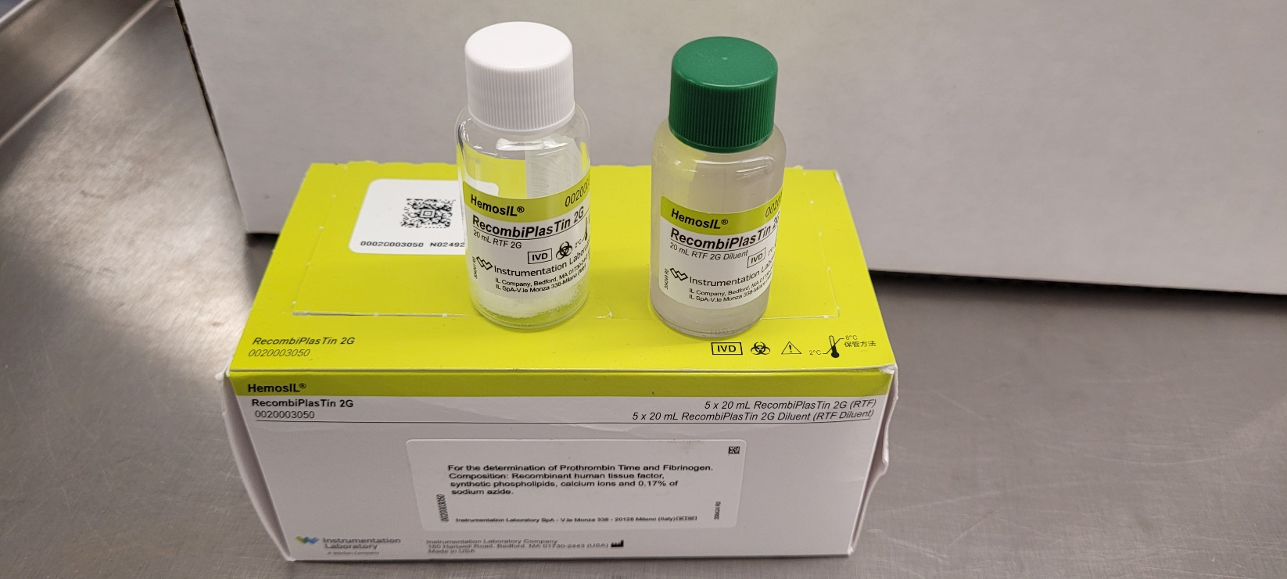

Reconstitution instructions: First take out reagent and buffer vial pair and let sit at least 15min on bench top to come to RT. Then reconstitute lyophilized reagent vial with exactly 20ml from the buffer vial. DO NOT just pour buffer vial into reagent vial as it has more than 20ml. You must tilt the buffer vial on 2nd 10ml pipette aspiration to avoid drawing up bubbles. Invert gently to mix then allow to sit another 15min. Invert again before loading.
Stability: 10 days onboard TOP’s or in 2-8C coag fridge. A fresh reagent vial has around 190 tests.
Loading: R2G loads on right side R lanes 4-6. As a Werfen reagent the TOP will automatically ID it so no more manual IDing of the PT-INR reagent.
QC: R2G uses the same current Normal C. Assayed and High Abn. C Assayed controls.
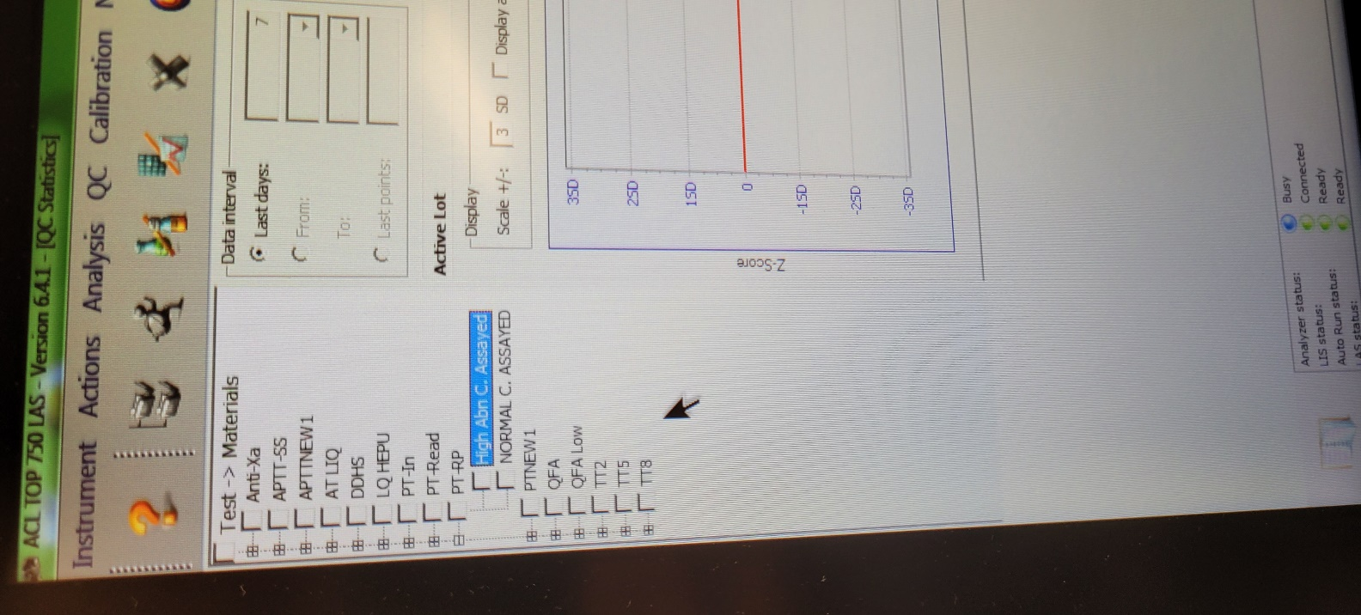
TOP test ordering: Onboard the TOP’s the test order ID button for it is PT-RP for both QC and patient samples. The extended test is PT-RP(E). They will move to the frontpage Routine orders tab and replace current PT-In on go-live. PT-RP runs data acquisition from 8-100 seconds and PT-RP from 8 – 320 seconds.
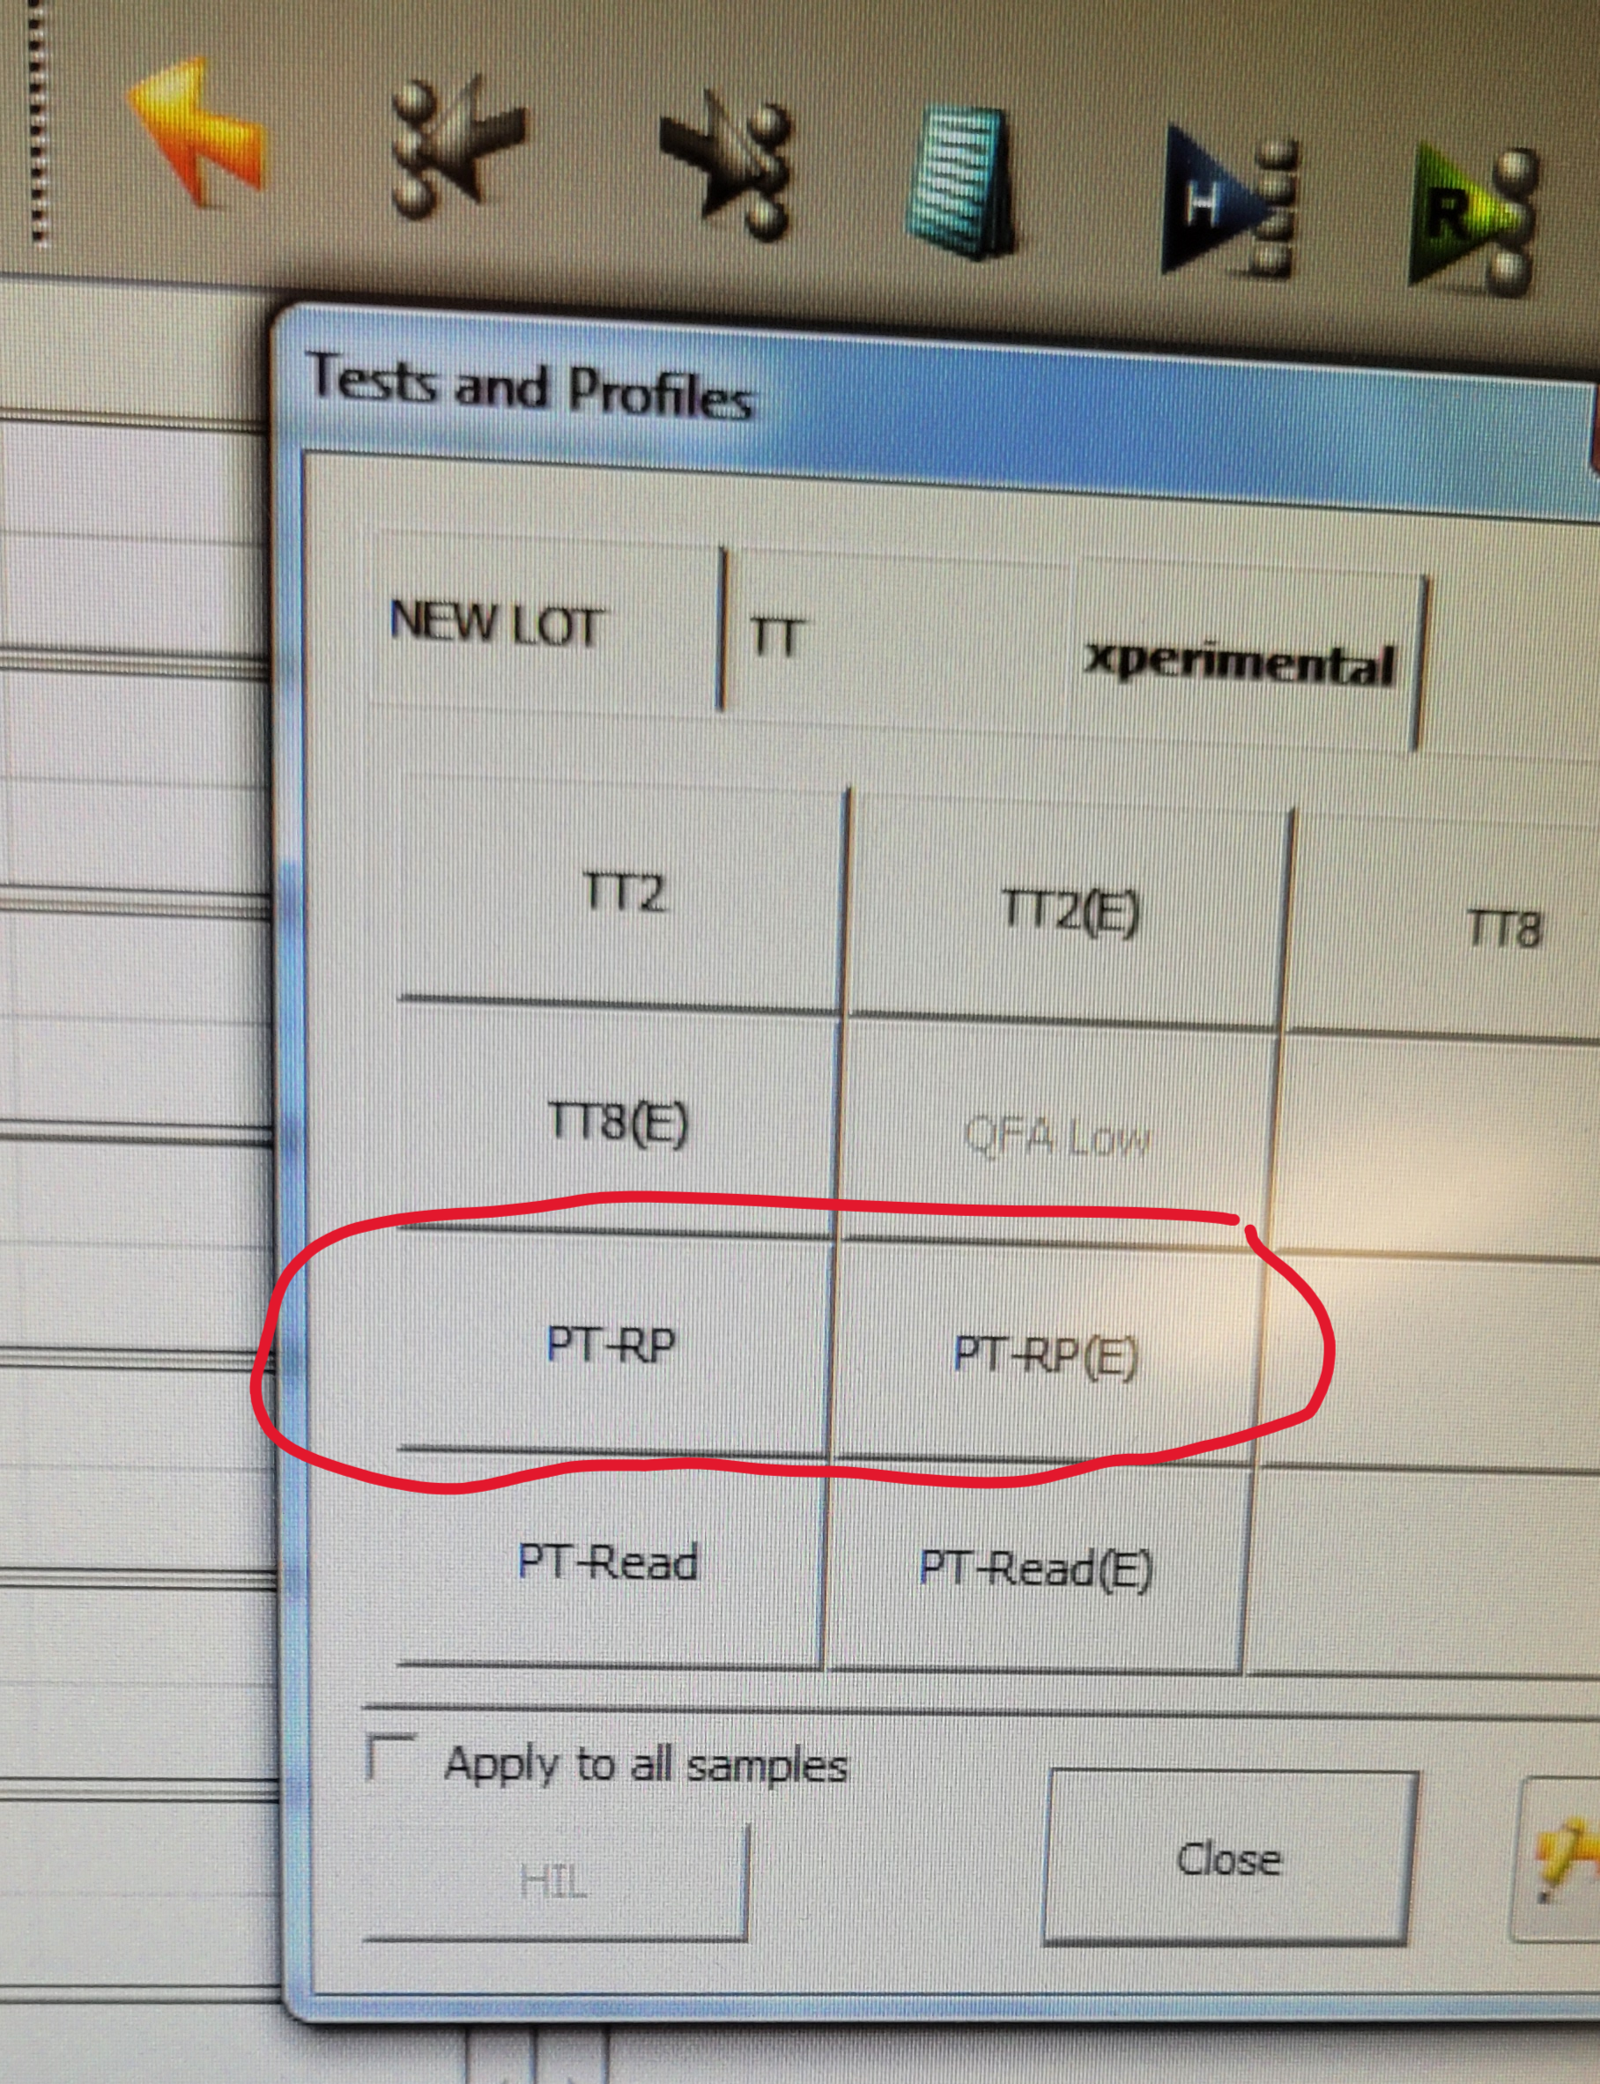
Hemohub/Beaker Autoverification and problem patients: Patient results will transmit to Hemohub. Current auto verification rules will carry over to R2G. If there are no result/rule flags the results should auto-verify. Troubleshoot problem patients/result curves per SOP practice of HIL review and clot curve analysis with manual INR calculation if needed.

