**Quality Assurance and Quality Control**

Quality control is designed to detect, reduce, and correct deficiencies in a laboratory’s internal analytical process prior to the release of patient results. Quality control samples are special specimens inserted into the testing process and treated as if they were patient samples by being exposed to the same operating conditions. The purpose of including quality control samples in analytical runs is to evaluate the reliability of a method by assaying a stable material that resembles patient samples. QC is a measure of precision or how well the measurement system reproduces the same result over time and under varying operating conditions.

As part of their license (and common sense) CLS/MLT can review current and historical QC and assess QC acceptability. Staff are also empowered to troubleshoot problems when encountered, call an instrument down and/or at minimum notify the Hemo Specialists of the problem if they can’t work on it or are unable to resolve it. Specialists and Supervisors review **ALL** QC’s on a monthly basis and investigate issues. Our monthly QC performance is compared to other institutional peers using the same equipment and reagents when possible. We further participate in national CAP proficiency testing twice a year for each of our reportable tests. All these steps are part of a quality assurance program to ensure our lab testing performance and released results are accurate, reliable and consistent. However, the Specialists are not working the bench regularly or aware of every situation as it is happening without communication from other staff. If you see a problematic new shift or trend developing when reviewing your daily QC then notify the Specialists.

Developing instrument/reagent/lot problems often start as shifts or trends in the QC performance. Many minor trends/shifts can occur which ultimately don’t require action but when problems persist and/or progressively get worse then action must be taken. When reviewing Coulter (or any other plotted) controls, it is important to be aware of what a shift or a trend can look like.

**Shift:** a shift occurs when there are control points that are on one side of the mean for 5 to 7 consecutive control runs.

**Trend:** a trend occurs when there are control points either decrease or increase consistently over a period of 5 to 7 days.

Repeating controls if results are out is a necessary practice, but what does it mean if controls are repeatedly out of control high or low? If after several repeats a control is finally barely “in” does that mean it’s okay? What should that be telling you? Scroll down and look at the RBC run history below of a recent lot of BF control level 1.

**This is not good QC performance!** If a control is riding an acceptability limit and requiring regular numerous repeats to just barely pass, your control is not valid and is not “in control”. This is telling you there is a problem with either the instrument or the control. In situations like this you **HAVE TO troubleshoot** and change variables in the situation. Note what troubleshooting action you are doing between your repeats. Try a new vial of well-mixed control or check the other instruments to see how this level is running. Are all instruments running the same pointing to a control lot issue or is it an issue with a specific instrument? Run instrument diagnostics and clean/prime/test relevant functions or components. Call company tech support for ideas/help. **Ultimately, if nothing you do corrects the problem and it persists then stop using the instrument. Notify the Specialists.**

In the above case of BF QC level 1, it was an issue with the QC lot. All DxH’s ran low but it was worst on DxH3. See below for the difference when we did a DxH S-cal calibration and switched to another lot of BF QC.

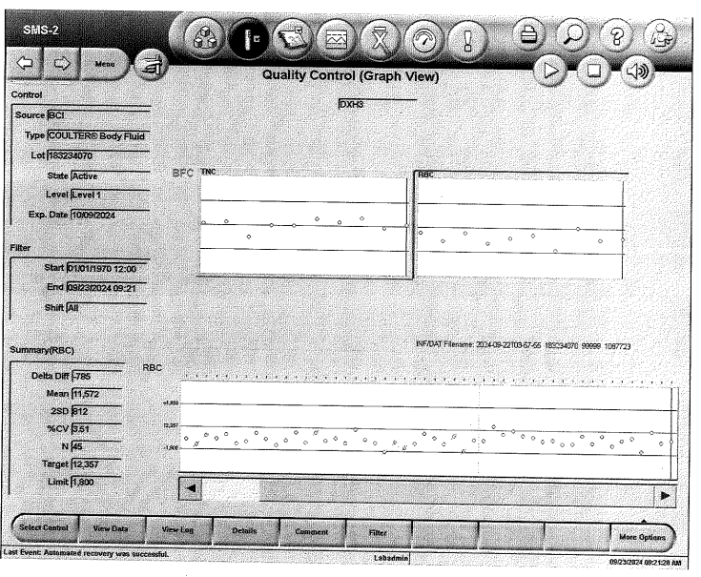

For additional education the Specialists have put together a quick primer from material on the web on Westgard rules and how they are used to help interpret Levey-Jennings QC charts.

Westgard rules:

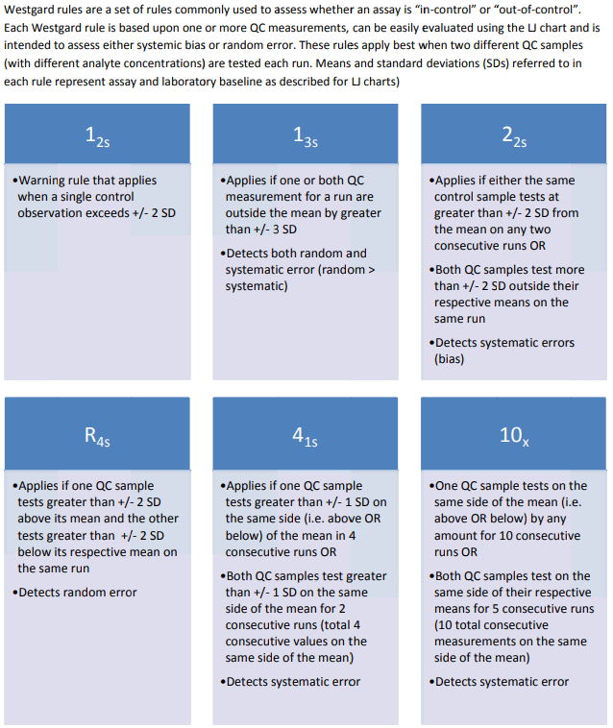

* **1:2s rule**

This is a warning rule that is violated when a single control observation is outside the ±2s limits. Remember that in the absence of added analytical error, about 4.5% of all quality control results will fall between the 2s and 3s limits. This rule merely warns that random error or systematic error may be present in the test system. The relationship between this value and other control results within the current and previous analytical runs must be examined. If no relationship can be found and no source of error can be identified, it must be assumed that a single control value outside the ±2s limits is an acceptable random error. Patient results can be reported.

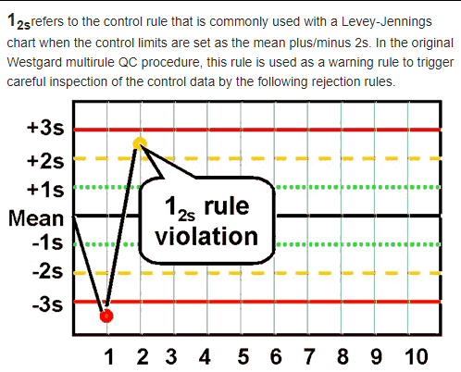

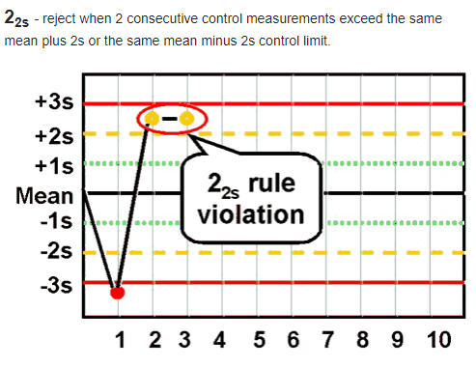

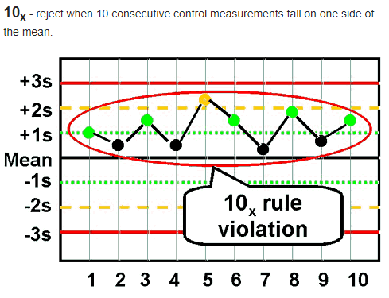

QC shifts are sometimes a fact of life. Not all control material batches and lots will be perfectly on target and there can be result variation from analyzer to analyzer without either one being wrong. This is why QC materials come with an acceptable result range from the manufacturer. A QC lot can be shifted but be stable and show good precision for the duration of its use. Nonetheless, we want to be aware of QC shifts and trends and investigate those that are alarming/close to limits and/or showing signs of getting worse.

Charts sourced from internet websites:

[Quality control is important measure of laboratory test precision (clinlabnavigator.com)](https://www.clinlabnavigator.com/quality-control.html)

["Westgard Rules" - Westgard](https://westgard.com/westgard-rules.html)

[Accu-Clinic - Westgard rules](https://www.accu-clinic.com.eg/index.php/blog/item/20-westgard-rules#:~:text=The%20elements%20of%20the%20Westgard%20system)

[Westgard+Rules.pdf](https://s3.amazonaws.com/ascpcdn/static/LMU/PDFs/Developing+Quality+Control+Systems/Westgard+Rules.pdf)