BB.Issue.18.0 Shockwatch Temp Indicators
STATEMENT OF PURPOSE
The purpose of this procedure is to outline the use of ShockWatch WarmMark® Temperature Indicators.
SCOPE
The procedure applies to all MACL blood banks that use the ShockWatch WarmMark ® Temperature Indicators.
RELATED DOCUMENTS
BB.Issue.2.0 Dispensing of Blood Components
BB.QC.11.0 Blood Bank Cooler Validation

MATERIALS
ShockWatch WarmMark® Temperature Indicators
Cool Packs (1-6⁰C)

STORAGE
- ShockWatch WarmMark® must be stored in a cool, dark place, at room temperature.
- ShockWatch WarmMark® may be kept in the blood bank for 2 years from the date of manufacture.
PROCEDURE
NOTE: In a busy blood bank environment, the use of a cold pack will help maintain the temperature of blood during the dispensing process. It is recommended that multiple cold packs be kept in the refrigerator, and place on the surface under the blood bag during the application process and dispensing.

Step | Action | Notes
1 | Remove the blood from refrigerator.
 | 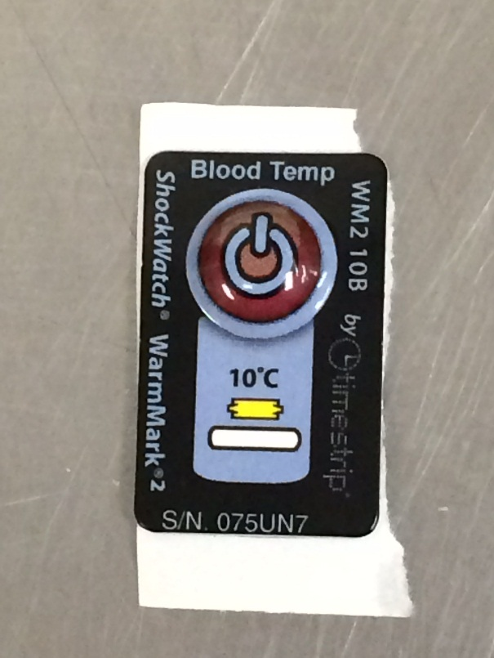
2 | Press the Red Product Blister firmly on the ShockWatch WarmMark® to arm the temperature indicator system.
3 | Verify that the arming window changes from yellow to green.
 | 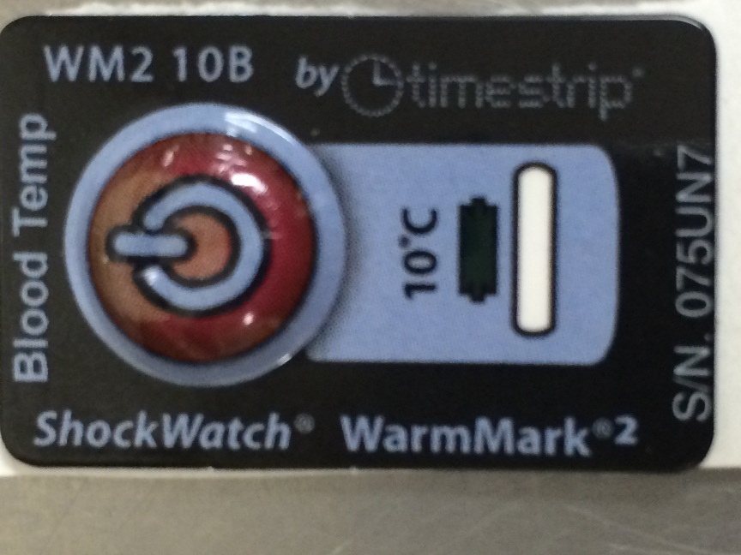
4 | Remove the ShockWatch WarmMark® from the adhesive liner and attach it directly to the blood bag.  It is recommended to apply it to the lower third of the bag, where there is a large volume of blood product.
5 | Be certain that the ShockWatch WarmMark® Indicator is completely in contact with the blood bag.
6. | The temperature sensitive liquid will move from the arming window and into the breach window when the blood bag core temperature reaches 10ºC.
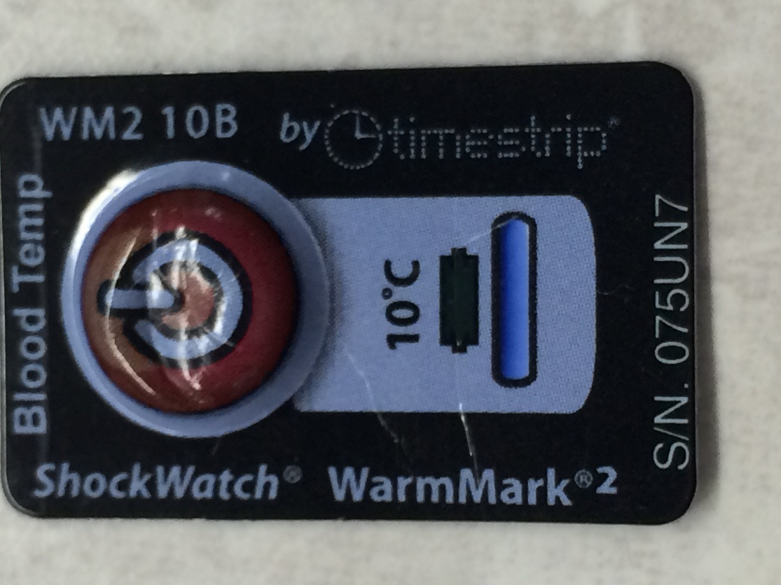

COLOR CHANGE TEMPERATURE INDICATION
- The ShockWatch WarmMark® system is valid to use when the red Product Blister is not pressed, the arming window is yellow, and the breached window is white.
- The ShockWatch WarmMark® system is armed when the red Product Blister is pressed allowing the temperature sensitive liquid to move into the arming window, changing the color from yellow to green. The breached window is still white.
- The temperature sensitive liquid will move from the arming window and into the breach window when the blood bag core temperature reaches 10ºC.

REFERENCES
Package insert, ShockWatch WarmMark,® Smart Solutions for Safe Transit. 2014

