MICRO.STAIN.1.0 GRAM STAIN

PRINCIPLE
The Gram Stain is used to classify bacteria on the basis of their forms, sizes, cellular morphologies, and Gram reaction. It is also a critical test for the rapid presumptive diagnosis of infectious organisms and serves to assess the quality of clinical specimens.

Bacteria vary in their ability to retain crystal violet after treatment with Grams iodine which acts as a mordant fixing the crystal violet to the cell wall and then an organic solvent (either alcohol or acetone). Those organisms that retain crystal violet are considered Gram positive; those that do not retain the crystal violet and are stained pink or red by the counter-stain are considered Gram negative. The difference in the staining reaction can be directly related to the cell wall structure of Gram negative and Gram positive organisms, the Gram positive cells having a thick peptidoglycan structure.

The recommended diagnostic test for Bacterial Vaginosis (BV) is a Gram stained smear, using a scoring system based on the relative amounts of bacterial morphotypes that are present. BV is defined as a shift in vaginal flora from predominantly lactobacilli to a mixture of anaerobic organisms.

OWNERS
Manager, Regional Microbiology
Microbiology & Molecular Best Practice Team

TABLE OF CONTENTS

Associated Documents…………………………………………………………………………………………………. | Page 2
Test Information…………………………………………………………………………………………………………… | Page 2
Equipment and Supplies…………………..…………………………………………………..……………………… | Page 2
Specimen Requirements…………………………………………………………………………………..………….. | Page 3
Reagents…………………………………………………………………………..………………………………………….. | Page 5
Quality Control…………………..…………………………………………………..……………………………………. | Page 6
Procedure—General Staining Procedure.....………………..…………………………..…………………… | Page 6
Procedure—Repeated Staining Procedure…………………………………………………………………… | Page 7
Interpretation—Gram Reactions and Morphologies…………………………………………………….. | Page 7
Interpretation—Units of Measure………………..…………………………..…………………………..…….. | Page 13
Interpretation—Assessment Criteria for Sputum and Tracheal Aspirate for Culture…….. | Page 13
Interpretation—Evaluation of Vaginal Specimens for Bacterial Vagionosis (BV) Smear—Hay/Ison Classification………………..…………………………..…………………………..………… | Page 17
Reporting Results & Result Entry………………..…………………………..…………………………..………. | Page 18
Reporting Results & Result Entry—Sunquest (GUI) Result Entry…………..………………………. | Page 19
Reporting Results & Result Entry—QLS…………..…………………………………..……………………….. | Page 22
Procedure Notes…………..…………………………………..…………………………………..…………………….. | Page 23
Limitations…………..…………………………………..…………………………………..……………………………… | Page 24
Reference…………..…………………………………..…………………………………..……………………………….. | Page 25

ASSOCIATED DOCUMENTS
MICRO.STAIN.1.1 Slides for Acridine Orange Stain
MICRO.STAIN.1.2 Manual Gram Stain QC Patient Result Log
MICRO.STAIN.1.3 Manual Gram stain QC Log
MICRO.STAIN.3.0 Polymorphonuclear Leukocytes in Stool Specimens
MICRO.PROC.6.0 Previ Color Gram Slide Stainer for Automated Gram Stains
MICRO.CULT.2.0 Blood Culture
MICRO.FORM.3.0 Automated Gram stain QC log (Regional Microbiology)
MICRO.FORM.3.1 Acridine Orange QC log (Regional and Evansville Microbiology)

TEST INFORMATION

Assay | Gram Stain
Methods | Manual (all sites)  Automated (Regional Microbiology only)
Instrument | Previ Color Gram stainer (Regional Microbiology only)
Associated Test Codes | Sunquest  - GS = Gram stain  - RESPC = Respiratory Culture with Gram Stain  - AERGS = Aerobic Culture with Gram Stain  - ANAGS = Aerobic and Anaerobic Culture with Gram Stain  QLS  - 497 (i.e., 497YJI=, see QLS Location Suffix below) = Gram Stain  - 4556YJI = Sputum/Lower Respiratory Culture with Gram Stain  - 4446YJI = Aerobic and Anaerobic Culture with Gram Stain  - 4469YJI = Anaerobic Culture with Gram Stain
QLS Location Suffix  Note: A QLS Gram Stain with a specific location suffix indicates the Gram Stain performing laboratory. | - YASV = St. Vincent Carmel Laboratory  - YCYH = Community North Laboratory  - YCYS = Community South Laboratory  - YGO7 = Community Westview Laboratory  - YHW8 = St. Vincent Anderson Laboratory  - YJI = Regional Laboratory  - YMCS = Community East Laboratory  - YRES = St. Vincent Fishers Laboratory  - YVCT = St. Vincent Indianapolis Laboratory

EQUIPMENT & SUPPLIES
- Glass slides
- Sterile disposable pipets
- Sterile swabs
- Sterile sticks
- Wax pencil
- Immersion oil
- Sterile scalpel, forceps
- Tissue grinder
- Sterile saline, sterile broth
- 95% Methanol
- Cytocentrifuge (cytospin) or centrifuge
- Vortex mixer
- Bacti-cinerator or alcohol swab
- Biosafety cabinet
- Timer
- Microscope

SPECIMEN REQUIREMENTS
- Specimen Types & Handling
Body Fluids (including CSF), Bronchial Alveolar Lavage (BAL), and Bronchial Washing (BW) or Brushings (BB) | Specimens should be processed either by a cytospin or regular centrifuge at 2000 g for 10 minutes and sediment used to prepare a Gram smear. Using a wax pencil to mark the specimen location on the smear may help locate the inoculated area, as well as indicate that concentration process is used to prepare this smear. Allow the slide to air dry.  Note: Re-suspend the centrifuged sample tube to Regional Microbiology for additional cultures or tests if applicable.  Note: As centrifuge manufacturer’s will have different radial arm specifications, each performing site should ensure that the centrifuge/cytospin in use is programed to deliver the appropriate relative centrifical force (RCF) required (2000 g).
Body fluid or CSF is viscous, cloudy, quantity is not sufficient (≤ 1mL) for cyto- or regular- centrifugation | Prepare a direct smear by placing one to two drops of well-mixed, un-centrifuged specimen on a slide with a sterile pipette. Do not spread the drop. Allow the slide to air dry.
Urine Specimens | Place one to two drops of well-mixed, un-centrifuged specimen on a slide with a sterile pipette. Do not spread the drop. Allow the slide to air dry.
Sputum Specimens | Select the most purulent or most blood-tinged portion of the sample. Use sterile loops, sterile swabs, sticks, or a pipette to inoculate a smear. Allow the slide to air dry.
Swab Specimens | Roll the swab thoroughly over the slide surface to transfer a representative amount of material. Note: If only one swab is submitted for culture and gram stain, hold back of slide to Bacti-cinerator for 3-4 seconds. Allow slide to cool and roll swab over the surface of the slide. Place swab in culturette and send to Microbiology for culture. Alternatively, the slide may be sterilized by thoroughly cleansing with an alcohol swab and allowing to dry prior to preparing the smear.
Tissue Specimens | - For HBL, send all tissue specimens to Microbiology for Gram stain no matter the priority status.  - For Microbiology, transfer tissue sample to a sterile Petri dish and mince tissue with a sterile scalpel, selecting purulent, necrotic, or bloody portions. Grind portions of the minced tissue in small quantity of culture broth or sterile saline with a sterile tissue grinder. Prepare a thin smear from the ground up fluid.
Stool Specimens | Prepare a direct smear by placing one to two drops of well-mixed stool sample from a Total-Fix or PVA vial on a slide with a sterile swab, stick or pipette. Note: Stool sample in an unpreserved container has ≤ 1 hour stability. The smear should be prepared promptly. See MICRO.STAIN.3.0 for more details.

The following Gram stain specimens & handlings apply to Microbiology only.
Specimens from a Liquid Medium (e.g., THIO broth) | Place one to two drops of well-mixed, un-centrifuged specimen on a slide with a sterile pipette. Do not spread the drop. Allow the slide to air dry.
Colonies growing on Solid Medium | Mix enough organisms from an isolated colony with a drop of sterile saline on a slide to obtain a barely visible turbidity.
Blood Culture Bottles | Prepare smear using a venting needle (to avoid manipulating a needle and syringe) and transfer 1 to 2 drops to the slide. Blood culture Gram smears must be prepared in a biosafety cabinet (BSC). See MICRO.CULT.2.0 Blood Culture, for more details.

- Collection Container
- Liquid Aimes, Liquid Stuart, gel swab transport system, or equivalent culturette swab
- Sterile container
- Air-dried smears in a plastic or cardboard slide holder
- Stool samples in Total-Fix vial (black cap) or PVA preservative vial (gray cap)
Note: Inform clinicians not to submit syringe with needle attached. If a syringe with needle is received, carefully remove the needle and discard the needle in a sharp container. Notify supervisor/manager or lead tech. Process the fluid according to A. Specimen Types & Handling.

- Volume
- Optimum: 2 to 3 mL of fluid or 1 to 2 grams of tissue
- Minimum: any amount of material or one properly prepared slide (air-dried and heat or methanol fixed)

- Transport Temperature, Stability & Storage Requirements
- Swabs: Specimens on swabs in transport media are stable for 48 hours in room temperature or refrigerated temperature.
- Sputum in a sterile container: Transport sputum sample in room temperature. For gram stain purpose, sputum is stable for 48 hours in room temperature or refrigerated temperature. Note: For culture purpose, sputum sample is stable for 24 hours in room temperature only. Therefore, always transport sputum sample in room temperature.
- Body fluid in a sterile container is stable for 48 hours in room temperature or refrigerated temperature.
- Urine in a sterile container is stable for 24 hours in room temperature or refrigerated temperature.
- Urine in a boric acid tube is stable for 72 hours in room temperature or refrigerated temperature.
- Air dried smears in a slide holder are stable for 10 days in room temperature or refrigerated temperature.
- Stool sample in a total-fixed vial (black cap) or a PVA vial (gray cap) is stable for 10 days in room temperature or refrigerated temperature. Stool sample in an unpreserved container has ≤ 1 hour stability. The smear should be prepared promptly.

- Unacceptable Specimens
- Any frozen samples
- Any sample outside specimen stability or transported in improper container and/or environment
- Broken slides or smears too thick to read
- Smears fixed with Cytology fixative
- Slides previously stained by cytology and cover slipped
- Dry swabs

REAGENTS
- Gram’s Crystal Violet, stored at room temperature (15-30ºC). Stable until the expiration date on bottle.
- Gram’s Safranin Stain, stored at room temperature (15-30ºC). Stable until the expiration date on bottle.
- Gram’s Iodine Solution, stored at room temperature (15-30ºC). If using a commercially prepared bottle, Iodine Solution is stable until the expiration date on the bottle. If using the Iodine solution in a 4 liter container, add one bottle Iodine Concentrate to one Gram Iodine Diluent container and mix well. Solution is stable for three months from date of preparation.
- Decolorizer: If using a commercially prepared bottle, the reagent is stable until the expiration date on the bottle. Pure acetone can be used as alternative decolorizer. Store decolorizer or acetone at room temperature (15-30ºC). Stable until the expiration date on bottle.
- Methanol, absolute, stored at room temperature (15-30°C) in brown bottles or plastic containers. Stable for one week in a secondary container.

CAUTION:
All reagents are extremely flammable, and with the exception of working quantities, should be stored in the flammables cabinet at room temperature (15-30ºC). Reagents should be used in a well-ventilated room and kept away from sources of heat and flame.

QUALITY CONTROL
- Control Used
Control Organisms | Expected Results
Staphylococcus aureus ATCC25923 or equivalent strain | Deep purple (Gram positive) cocci must be observed
Escherichia coli ATCC 25922 or equivalent strain | Pink or red (Gram negative) rods must be observed

- Frequency: A known Gram positive organism and a known Gram negative organism will be stained at least weekly and with each new lot number and shipment of reagents. At each manager’s discretion, more Gram stain Quality Control (QC) may be necessary for each site.
- QC results will be recorded on the appropriate log sheet. At each manager’s discretion, a site can use MICRO.STAIN.1.2 or MICRO.STAIN.1.3 to record Gram stain QC results.
- Do not perform quality control on the same slide as a patient specimen.
- Do not use the reagents or release results from runs with unacceptable controls.
- Corrective action must be taken and documented when QC results do not meet expected results.

PROCEDURE
- General Staining Procedure
Step | Action
1. | Obtain one clean glass slide. Make one smear from each specimen, labeling the slides with patient’s last name, source, accession number, and date.  Note: Clinical specimens should be processed and handled in a biosafety cabinet (BSC), including the preparation of Gram stain slides. When working in a BSC 2 cabinet, personal protective equipment should be used, including gowns and gloves.
2. | Follow section, Sample Types & Handlings, for smear inoculation and preparation.
3. | Allow slide to air dry.
4. | Fix slide by placing a few drops of 95% methanol on the air dried slide for 1 minute. Alternatively, heat-fixing is also acceptable.  Note: Fixing with 95% methanol is preferred as it prevents the lysis of RBCs, avoids damage to the host cells, as well as bacteria and results in a clear background.
5. | Drain off remaining methanol without rinsing and allow slide to air dry again. Note: If methanol is used to fix slide, do not use heat before staining.
6. | Flood the fixed smear with crystal violet solution. Allow the stain to remain for 30-60 seconds, and then rinse slide gently with running tap water. Note: Excessive rinsing in this step could cause crystal violet to be washed from gram-positive cells. Vigorous rinsing in in any rinsing step could cause the specimen on the fixed smear to be washed off.
7. | Flood with iodine solution. Allow iodine to remain for 30-60 seconds, and then rinse slide gently with running tap water.
8. | Decolorize by letting the reagent flow over the smear while the slide is held at an angle. Stop when the runoff becomes clear. Adjust decolorization time to thickness of the smear. Immediately rinse slide gently with running tap water.
9. | Cover smear with Safranin counterstain and allow to remain for 30-60 seconds. Rinse slide with a gentle flow of tap water and air dry or blot on absorbent paper.
10. | Scan the smear microscopically under 10X objective (LPF, low power field) to evaluate polys and cells when applicable. Then, examine smear under 100x objective (OIF, oil immersion field). Once completed, the oil should be carefully blotted off and the slides can be saved for one week.

- Repeat Staining: If after preliminary review of a Gram stain, the smear does not appear adequately stained, re-staining may be performed.
Step | Action
1. | Gently blot off any immersion oil left on the smear.
2. | Flood smear with decolorizer. Rinse gently with running tap water.
3. | Repeat General Staining procedure steps 6 to 10.

INTERPRETATION
- Gram Reactions and Morphologies
Gram Reaction Result | Interpretation
Purple or deep blue staining   | Gram positive  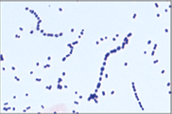  Morphologically, Gram positive organisms may be yeast, rods or cocci. The cocci may occur singly or in pairs, chains or clusters. Yeast cells are larger than cocci and characteristically demonstrate budding. Pseudohyphae may also be observed. Gram positive rods vary in size and shape. Some can be quite large while others will stain irregularly and have a beaded appearance. They may occur widely scattered or stacked. Lancet-shaped Gram positive diplococci, often observed with capsules, are representative of Streptococcus pneumoniae.
Pink or light red staining   | Gram negative  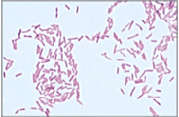  Morphologically, Gram negative organisms may be rods, coccobacilli or diplococci. Gram negative rods are usually easily observed. Enteric Gram negative rods may exhibit bi-polar staining (stain darker at each end). Coccobacilli are fine, small forms which are often stained lightly. "Gram negative diplococci" is a term reserved for the characteristic kidney bean shape of the Neisseriaceae and Moraxella catarrhalis. True Gram negative cocci in configurations other than kidney bean shaped diplococci are rare.
Both purple and pink staining | Considered gram variable when seen in smears of culture isolates. This is often seen with Bacillus, Clostridium, anaerobic cocci, Moraxella and Gardnerella vaginalis.  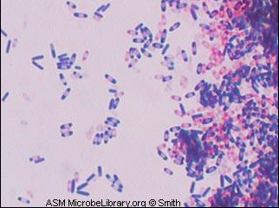

Morphology Observation | Interpretation
Small round or oval forms | Cocci
Two Gram positive cocci elongated end-to-end   | “Gram positive cocci in pairs”. These forms are suggestive of Streptococcus pneumoniae. The most common specimen sources include respiratory and CSF.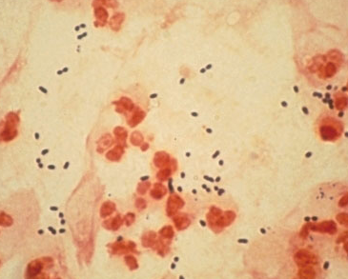
Two Gram negative cocci round “kidney bean” shape   | “Gram negative diplococci”. These forms are suggestive of Neisseria spp or Moraxella spp.  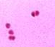
Rod shape | Rods or Bacilli  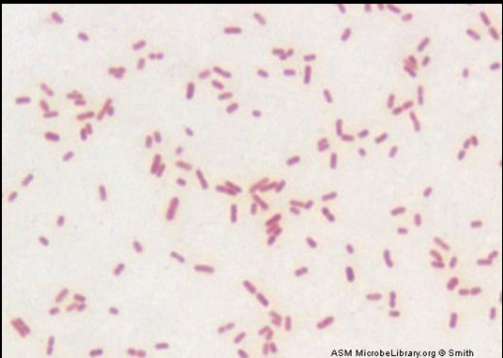
Gram negative coccobacilli, difficult to determine if they are rods or cocci (may be pleomorphic) | These forms are suggestive of Haemophilus species when seen in respiratory specimens  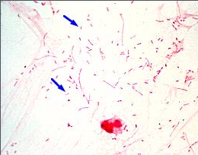
Yeasts or Pseudohyphae | Yeasts or pseudohyphae are usually stained gram positively. Some may have thick cell wall layer that can be difficult for crystal violet stain to penetrate. Therefore, some may be stained as gram variable or gram negative. Yeast cells can clump together like Gram positive cocci. However, yeast cells are larger than Gram positive cocci. Usually, it is not hard to find budding yeast off a yeast cell.
Epithelial cells (Epis), a.k.a. Squamous Epithelial cells  (Low Power Field) | Epithelial cells are large with a darker pink central nucleus. The presence of Epis usually indicates skin or oral contamination to the sample.
Columnar Epithelial Cells  (Low Power Field) | Ciliated columnar epithelial cells line the bronchi. When present on a Gram stain they indicate that the specimen contains lower respiratory tract secretions.  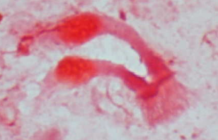
Clue cells  (Low Power Field) | Clue cells are epithelial cells completely covered by tiny, gram variable bacilli and coccobacilli, suggestive of bacterial vaginosis.  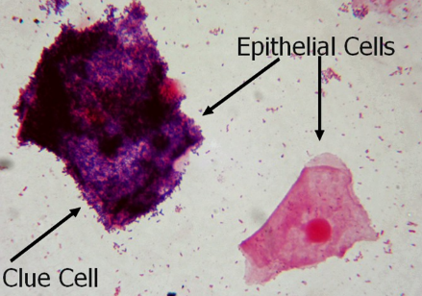
Bacterial Vaginosis  (Low Power Field) | A large clue cell with edges covered by bacteria is visible to the right of the slide. The Lactobacillus morphotypes have been replaced by small gram variable rods (Gardnerella vaginallis).  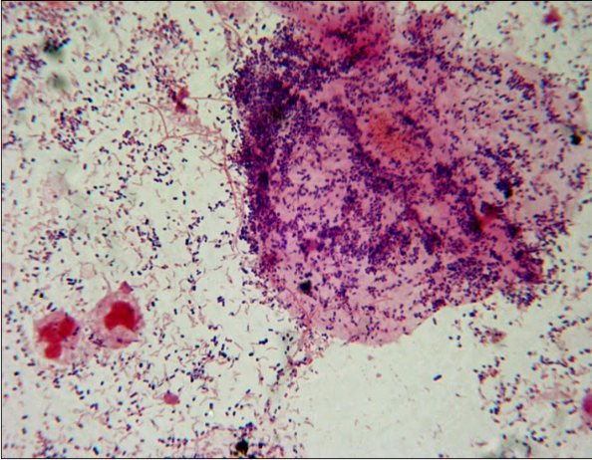
Lactobacillus spp. | Lactobacillus morphotypes (long, Gram positive bacillus in chains). The slide below represent normal vaginal gram smear.  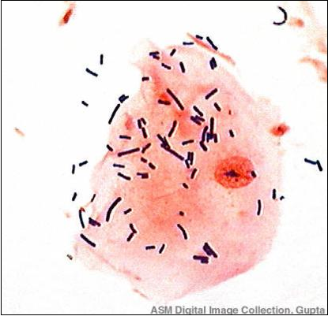
Polymorphonuclear white blood cells (Polys) | Polys have two or more segments to their nucleus and should be called as polys only if segmentation is visible. The nuclei can be stained purple or pink. However, the cytoplasm should always be pink. If the cytoplasm is purple, it indicates under-decolorization of the smear.

- Units of Measure
- Determine the average number of cells and bacteria in 20 to 40 fields of the smear. Skip fields where there are no cells or bacteria, and do not average these fields in the count if there are fields where cells and/or bacteria are present.
- If cells and organisms are observed, use the following guidelines for quantitation.
- Examine smears prepared from clinical specimens under low power for evidence of inflammation. Enumerate host cells in a Gram smear using low-power objective (10x objectives) and report relative number accordingly. Use the following guidelines for quantitation:

For cells (polys, epithelial cells, or RBCs) under Low Power Field (LPF)
Average Quantity Observed 10X LPF | Report As
< 1 per LPF | RARE
1-9 per LPF | FEW
10-24 per LPF | Moderate
≥ 25 per LPF | Many

- Count bacteria, yeast and/or hyphal elements under oil immersion (100x objective) and report relative numbers from areas with cells. Use the following guidelines for quantitation:

For bacteria or organisms under oil immersion field (OIF):
Average Quantity Observed 100X OIF | Report As
< 1 per OIF | RARE
1-5 per OIF | FEW
6-24 per OIF | Moderate
≥ 25 per OIF | Many

- Assessment Criteria for Sputum and Tracheal Aspirate for Culture
Note: Do not reject sputum and tracheal aspirates for culture for Legionella or Acid Fast, collected in the Lueken’s trap, or specimens from cystic fibrosis patients for any tests.

Step | Action
1. | Scan sputum or tracheal aspirate Gram smear under 10X objective (LPF) to evaluate epithelial cells polys, or other host cells. Then examine the slide under 100x objective (OIF).
2. | Based on the evaluation, reject the followings for culture, as poorly collected or not consistent with a bacterial infectious process.  Sputum Sputum sample has ≥ 10 epithelial cells per low power field. Exception: If the number of Polys is 10 times the number of epithelial cells AND there is Moderate to Many of a single morphotype of bacteria.  Tracheal Aspirates Tracheal aspirates from adults have ≥ 10 epithelial cells per low power field OR No Organisms Seen (NOS).
3. | If the specimen is rejected for culture, do not examine the smear for organisms. Call rejection to submitting location and request for a recollection. If patient is no longer in hospital, fill out a recollection form and follow local department process for approval before submitting to Client Services. Record call information in GUI Sunquest as steps described below.  Sunquest Sunquest (Cont’d) Sunquest (Cont’d) Sunquest (Cont’d) - In GUI Microbiology Result Entry, enter the accession number to access test code RESPC. - At “Observation” under “Direct Exam” tab, enter ;UNSPU (for sputum) or ;UNTRA (for tracheal aspirate) at observation #1. Press [TAB] key. (See an example on the next page.) Note: When you type the first semi-colon in GUI, it is not visible. It indicates that the operator is about to enter a message code. In this case, the message code is UNSPU or UNTRA. - Go to “Observation” under “Culture Entry” tab. Enter ;SR1 (for sputum) or ;SR2 (for tracheal aspirate) in the result field for observation #1. Press [TAB] key. (See an example on the next page.) - Go to the “Composed Text” area under “Culture Entry” tab by clicking the “Composed Text” green button. At “Composed Text” field, record call documentation by free text. - Return to the “Observations” portion by clicking the “Observations” green button. Highlight the observation #2 field by pressing the [Down Arrow] key. - Finalize RESPC test by pressing both [Shift] key and [ ~ ] key at the same time. A message, as an example shown below, will appear on the screen. Click on “OK”. (See an example on the next page.) - Click “Save” button once at the bottom right corner on the screen. This will bring you to the “Billing” tab. - At the “Code” field under “Billing” tab, Enter CDRES, then press [TAB] key. This will credit the respiratory culture portion of the culture/GS combination test code. - Finally, press the “Save” button again to close out the test.  QLS Note: QLS process applies to Regional Microbiology only since test code 4556YJI= can only be accessed at Regional Microbiology. - At the result entry field, enter “TNP/378*” and press the [Enter] key. The screen will bring to the free-text field. - Free text the following message, “The Gram stain result indicates that the specimen is unsatisfactory for routine culture. Specimen recollection is suggested.” Press [Enter] key. - Move on the next empty field and enter “DNR+”. Press [Enter] key. This allows DNR to be auto-populated in every empty field. - Enter “ // ”. At the prompt “Release Result?”, enter “ Y “ for yes. - Fill out a recollection form and send it to manager/supervisor and leads.

- Evaluation of Vaginal Specimens for Bacterial Vagionosis (BV) Smear—Hay/Ison Classification (Note: This section, the BV smear by Hay/Ison Classification, will not be effective until after 9/1/15)
- For SVAN, SVEV, SVJO, and CHW, perform vaginal Gram stain on site.
- For other sites, send all vaginal Gram stains to Regional Microbiology.
Step | Action
1. | Scan vaginal Gram smear under 10X objective (LPF) to evaluate epithelial cell and polys.
2. | Scan smear under 100X objective (OIF) and evaluate for the presence of Lactobacillus morphotypes (thin-long, Gram positive rods in chains). See a slide example of Lactobacillus under “Interpretations, A. Gram Reactions and Morphologies”.
3. | Evaluate the relative quantity of Lactobacillus to other bacteria.  If BV Interpretation  Lactobacillus morphotype is predominant. Normal Vaginal Flora Observed on Gram Stain. (Sunquest code: NBV)  Mixed bacteria with reduced Lactobacillus present. Relative numbers and type of bacteria observed on Gram Stain does not completely rule in or rule out Bacterial Vaginosis. (Sunquest code: INBV)  Predominately other bacterial morphotypes. Few or absent Lactobacillus. Consistent with Bacterial Vaginosis based on relative numbers and type of bacteria observed on Gram Stain. (Sunquest code: CBV)
3. | Report the presence or absence of the followings:  - Polys  - Yeast  - Gram negative diplococci (GNDC)  - Clue cells
4. | Report the presence or absence of polys, yeast, GNDC, clue cells, as well as BV interpretation code. See “Reporting Results & Result Entry” for more details on result entry and reporting.

Examples on Reporting Vaginal Specimens for BV Smear:
Normal Example | Intermediate Example | BV Example
No polys  No yeasts  No GNDC  No clue cells  NBV (translate to “Normal Vaginal Flora Observed on Gram Stain”.) | Rare polys  No yeasts  No GNDC  Rare clue cells  INBV (translate to “Relative numbers and type of bacteria observed on Gram Stain does not completely rule in or rule out Bacterial Vaginosis.”) | Moderate polys  Few yeasts  No GNDC  No clue cells  CBV (translate to “Consistent with Bacterial Vaginosis based on relative numbers and type of bacteria observed on Gram Stain.”)

REPORTING RESULTS & RESULT ENTRY
- For all sources, except sputum, tracheal aspirate, and vaginal smear for BV, always report the presence or absence of polys and organisms. If present, always report with quantitation. Refer to “Interpretations, Units of Measure” for quantitation reference.
- If polys and organisms are absent, report “NO POLYS, NO ORGANISMS SEEN”. Note: Use keyboard key “Y” or result code “XX” for “NO POLYS, NO ORGANISMS SEEN.”

- For sputum or tracheal aspirate, always assess the specimen’s acceptability for culture. Refer to “Interpretations, Assessment Criteria for Sputum and Tracheal Aspirate for Culture” for more details. Always report the presence or absence of polys, epithelial cells and organisms. If present, always report with quantitation. Refer to “Interpretations, Units of Measure” for quantitation reference.

- For vaginal smear for BV, always report the presence or absence of polys, yeasts, GNDC, and clue cells. If present, always report with quantitation. Refer to “Interpretations, Units of Measure” for quantitation reference. Refer to “Interpretations, Evaluation of Vaginal Specimens for Bacterial Vagionosis (BV) Smear” for smear interpretation and additional BV interpretation code.

- Report detailed observations such as Gram positive cocci in clusters (code: STAF) and Gram positive cocci in pairs and/or chains (code: STRP) if possible.

- Sunquest (GUI) Result Entry
Step | Action
1. | In GUI Microbiology Result Entry, enter the accession number to access test code (GS, AERGS, ANAGS, or RESPC).
2. | At “Observations” button under “Direct Exam” tab. Hit [F8] key to bring up result keyboard.
3. | Click on the result field for observation #1. Use the mouse or the manual keys to select or enter a quantity and observation morphology from the keyboard.
4. | Arrow down or click to # 2. Continue to enter the second observation and so forth until the entire report has been entered.  Note: Positive CSF are called to the unit or physician. Document calls in “Composed Text” area by clicking the “Composed Text” button.
5. | If the test code is GS, proceed to step 6. If the test code is RESPC, AERGS, or ANAGS, proceed to step 7.
6. | For test code GS, finalize GS test by pressing both [Shift] key and [ ~ ] key at the same time. A final window, as an example shown below, will appear on the screen. Click “OK”.  Then, click the “Save” button once at the bottom right corner. Proceed to step 8.
7. | For AERGS, ANAGS, or RESPC,  - If the smear is not prepared by cyto- or regular-centrifugation, save the result by click the “Save” button once at the bottom right corner to close out the test. And the result entry is done. (See an example on the next page.)  - If cyto- or regular-centrifugation is used to prepare the smear, click “Billing” tab. Proceed to step 8.
8. | GUI will continue to the “Billing” tab.
9. | If concentration method is used to prepare the Gram stain (Cytospin or centrifugation), proceed to step 10. If no concentration method is used to prepare the Gram stain, proceed to step 11.
10. | If concentration method is used to prepare the Gram stain (Cytospin or centrifugation), type “CONCT” at the code field.
11. | Finally, press the “Save” button again to close out the test.
Note: GUI Sunquest does not allow GS test code being finalized if all result fields are not answered. The most commonly seen situation is either the SDES or SREQ field left empty. To resolve this situation, go to “Misc. Updates” tab. If SDES field (source) is left empty, click the magnify glass icon on the right corner of the field and look up source code. If SREQ field (special request) is left empty, type “NONE” at the field and press [TAB] key.

- QLS Result Entry
For test code 497 performed at HBL only
Step | Action
1. | Pathway: 3,3,1
2. | Allow release? Press [Enter] for default response.
3. | Worklist: enter site specific worklist
4. | Accession: enter JI number
5. | SRC_______ This field should already have a source code in it. If not, enter the  source using the code from the Micro Source List.
6. | GST________ In this field hit shift+8 (*) to go to the result screen. In the result  screen, free text Gram stain results. Enter each observation on  separate line.
7. | Press [ENTER] key twice to go back to the main screen.
8. | Release all? Y

For test code 497YJI=, 4556YJI=, 446YJI=, 4469YJI= (Regional Microbiology only)
Step | Action
1. | Pathway: 6,3,1
2. | Allow release? Press [Enter] for default response.
3. | Worklist: Press [Enter] for default response.
4. | Accession: enter JI number
5. | SOURCE: Enter # following proper QLS source code.
6. | STATUS: For individual GS, enter “F” for final.  For GS/Anaerobic culture/Sputum culture, enter “P” for preliminary.
7. | GRAM ST: In this field hit shift+8 (*) to go to the result screen. In the result screen, free text Gram stain results. Enter each observation on a separate line.
8. | For individual GS, “DNR+” the rest of the fields.  For GS/Anaerobic culture/Sputum culture, enter“#CPR” at Result field. Then, “DNR+” the rest of the fields.
9. | Release all? Y

PROCEDURE NOTES
- STAT Gram stains, sputum or tracheal aspirates, and all spinal fluid Gram stains are stained and read immediately. Positive CSF are called to the unit or physician. Document calls by clicking on the Composed Text button within the Microbiology Result Entry window in GUI Sunquest or under “Area of Call” or “Comment” field in QLS.

Note: Positive CSF Gram stains containing gram negative diplococci must also be telephoned to Infection Control.

- If “moderate” to “many” polys seen on CSF Gram stain or any organism seen on CSF Gram stain, the following items MUST be prepared and sent to Microbiology lab by the next courier for acridine orange stain review or confirmation: 1) an unstained CSF slide (methanol or heat-fixed), 2) the original Gram stain, and 3) additional CSF specimen (if any left). The acridine orange stain request form (see MICRO.STAIN.1.1) must be sent with the specimen. For this situation, follow the additional steps below to release Gram stain result.
- Enter the preliminary Gram stain result in GUI Sunquest along with the “;GSPR” comment code (Preliminary result. Forwarded to Regional Microbiology for review). Call the physician and inform them that a special final review stain will be performed at Microbiology lab.
- Once Microbiology lab completes the final review, a final Gram stain result will be reported in GUI Sunquest along with the “;GSFR” comment code (This result has been reviewed by Regional Microbiology).

Note: The presence of bacteria in CSF should also correlate with an increased CSF protein and decreased CSF glucose.

- For HBL, once the Gram stain has been read and reported, the technologist should indicate the completion by marking “done” on the Sunquest label before sending the specimen on to the Regional lab for the culture.

- When the Sunquest system is down, the Gram stain results should be written on the temporary requisition. The technologist reading the smear should initial the requisition and document the initials or name the person to whom the result was called. Once the laboratory computer is back up, the results can be entered. File temporary requisition.

- When Hospital Based Labs associates are in doubt, report the preliminary Gram stain result in GUI Sunquest along with the “;GSPR” comment code. Send the Gram stain smear to Microbiology for final review. Once Microbiology completes the final review, a final Gram stain result will be reported in GUI Sunquest along with the “;GSFR” comment code. See item B above for specific result process.

- The automated stainer can also be used for preparation of gram stains. Refer to MICRO.PROC.6.0 “Previ Color Gram Slide Stainer for Automated Gram Stains” for detailed instructions.

- Microbiology lab must correlate direct Gram stain results with final culture results.

LIMITATIONS
- Gram stain reactivity in a clinical specimen may be altered by prior antibiotic therapy.

- If a smear is very thick or the material is very viscous, decolorization may be incomplete, rendering Gram negative organisms as Gram positive.

- Use results of Gram stains in conjunction with other clinical and laboratory findings.

- Careful adherence to procedure and interpretive criteria is required for accurate results. Accuracy is highly dependent on the training and skill of the microscopist.

- Gram stain positive, culture negative specimens may be the result of contamination of reagents and other supplies, presence of antibiotics, or a failure of organisms to grow under usual culture conditions (medium, atmosphere, etc.).

- False negative Gram stains may be related to inadequately collected specimens.

- Gram positive cocci in pairs, such as Streptococcus pneumoniae, are easily over decolorized and Gram negative diplococci resist decolorizing. In these circumstances, morphology can be useful in Gram stain interpretation.

REFERENCE
- Garcia, L.S., ed, Clinical Microbiology Procedures Handbook, American Society for Microbiology, 3rd edition, 2010.
- Saa, E. & Cromien, J., Gram Stain, Quest Diagnostics Incorporated, version 3

