**DOCCTR.SOP.1.0 DOCUMENT MANAGEMENT**

**PURPOSE**

Document control ensures that information used by staff is available, current and authentic. CAP identifies five specific elements that are required to demonstrate document control:

(1) Document versions are current;

(2) There should be evidence that personnel have read documents relevant to their job activities;

(3) Documents are properly authorized before being placed in service;

(4) Documents are to be reviewed by the laboratory Medical Director or designee at least biannually; and

(5) Discontinued documents are to be retained for a minimum of 2 years after the date of discontinuation (5 years for Transfusion Medicine).

Technical procedures should be described in complete, simple sentences in the present tense. Words with ambiguous or obscure meanings should be avoided and sentence structure should be simple but correct. There should be no ambiguities and no details left to individual discretion. The instructions should be detailed enough so that each technologist using the method will perform the test in exactly the same way each time. An experienced person should be able to perform the test properly from the information given without further instruction.

Technical procedures should be typed in a standard format, either CLSI or another approved format. All policies and procedures will be maintained in the MACL SharePoint system to ensure documents are secured to prevent unauthorized changes.

**SCOPE**

This policy applies to all MACL policies, procedures and derivative documents such as forms, charts, and quick reference sheets.

**OWNERS**

Compliance Officer

Quality Assurance and Safety Officer

**RELATED DOCUMENTS**

DOCCTR.SOP.1.2 Document Review and Approval Guidelines

DOCCTR.SOP.1.3 Policy and Procedure Review Template

DOCCTR.SOP.3.0 Record/Specimen Retention Requirements

DOCCTR.SOP.2.0 Emergency Procedure Changes

QA.GEN.7.0 Documentation Technique for Technical Records

**DEFINITIONS**

1. Affected Supervisor or Designee—Supervisor or designee whose department will adopt specific SOP being written or revised.
2. Alternate Implementation Date—Date policy or procedure is put into use at specific sites/locations if after the original implementation date. A record of alternate dates of implementation is documented in SharePoint’s Version History by indicating in the version comments that a particular location was added at that time. This process will increment the version, so that this change will require updates of backup discs and the paper copy of the MACL Safety Manual for each location.
3. Approval Authority—Medical Directors or qualified designees who have the CLIA-designated authority to approve a particular document. Details on these requirements are provided elsewhere in this document.
4. Attachment—“Related documents” should not be specifically called attachments and the terms appendix and addendum should not to be used. Related documents are used to illustrate or support information in a policy or procedure or are documents required to follow the written policy or to complete the procedure. Each related document should be identified by using the document numbering system and sequentially numbering related documents after the decimal (eg, primary document 1.0; related documents would be 1.1, 1.2, 1.3, etc).
5. Authoring Authority—Individuals who have been given the security access within the electronic document control system to create and edit documents.
6. Derivative Documents—Forms, charts, quick reference sheets, and ‘cheat sheets’ posted independently from the policy or procedure. Example: Keyboard Guide, Incident Report Form. These documents should be included as either part of the parent policy or procedure or should be listed under and treated as Related Documents.
7. Educational documents—Reference guides used for general reference and are not specific to the procedure or process.
8. Effective Date—Date policy or procedure is to be in use or becomes policy.
9. Format Revision—Any change to a policy or procedure that does not affect the existing content or intent of the information. Examples include typos, punctuation corrections, grammar corrections, and procedure number changes. A signature review is not required for these revisions, but should be noted in the revision record. Format revisions should be scheduled for next annual or biannual review or for next major/minor revision, whichever occurs first.
10. Implementation Date—Date policy or procedure is initially available as an Official Document to associates for review. The Implementation Date should be prior to the Effective Date and allow enough time for review and training, as applicable. The initial date of medical director approval and signature should be on or before the implementation date.
11. Job Aids and Quick Reference Materials—Documents created for quick reference in the support of daily work (eg, lists of reference ranges or method codes and worksheets). These documents are required to be kept within the document control system and are subject to the applicable review and approval requirements. If printed for workstation use, they require regular, documented review to ensure they are current versions (see Guidelines, J.3 in this document).
12. Major Revision—Any change to an policy or procedure that has the potential to directly affect patient results, including but not limited to changes to critical limits, technical limits, reporting format, units, new or changed procedural notes, limitations, clinical applications, interfering substances, and significant changes to specimen requirements. Requires medical director and affected associates’ review.
13. Master Document List—Spreadsheet or report listing all active policies and procedures cross referenced with all departments actively using them. This report/spreadsheet may be generated within a SharePoint function.
14. Minor Revision—Any change to a policy or procedure that does not have the potential to directly affect patient results, but does not include grammar, typos, and other formatting changes. These changes may include changes in computer steps, reagent stability, updated references, etc. Requires affected associate’s review.

**Procedure Discipline Categories and Acronyms**

Administration ADMIN

Blood Bank BB

Chemistry CHEM

Client Services CS

Coagulation COAG

Community Cancer Center CCC

Community Heart and Vascular Hospital CHVH

Community Hospital East CHE

Community Hospital North CHN

Community Hospital South CHS

Community Howard Regional Health CHWD

Community Westview Hospital CWH

Compliance COMP

Cytology CYTO

Document Control DOCCTR

Facility Management FACMAN

Finance FINANCE

Frozen Section/Ameripath AMERIPATH

Hematology HEM

Hospital Based Labs HBL

Human Resources HR

Immunology IMM

Indiana Orthopaedic Hospital IOH

Information Technology IT

General Laboratory LAB

Laboratory Service Centers LSC

LIS (Operations) LIS

Logistics LOGISTICS

Marketing MARKET

Materials Management MATMAN

Microbiology MICRO

Molecular MOL

Patient Care Centers PCC

Point of Care POC

Privacy PRIV

Regional Laboratory REG

Regulatory REGU

Quality QA

Safety SAFE

Sales SALES

Specimen Management SPECMAN

St Mary’s SVEV

St Vincent Anderson SVAN

St Vincent Carmel SVCR

St Vincent Clay SVCL

St Vincent Dunn SVDN

St Vincent Fishers SVFI

St Vincent Frankfort SVFR

St Vincent Heart Center SVHC

St Vincent Indianapolis SVIN

St Vincent Jennings SVJN

St Vincent Kokomo SVJO

St Vincent Mercy SVMR

St Vincent Randolph SVRA

St Vincent Salem SVSA

St Vincent Williamsport SVWP

St Vincent Women’s SVW

1. New Procedure—New or merging of existing procedures. Requires Medical Director review and affected associates review.
2. Official Document—Documents made available to all associates in the SharePoint system as a pdf. These documents will be in effect or in the implementation process.
3. Owner—Specific individuals responsible for approving new and changed processes/procedures in each of their areas within the network. The policy or procedure in progress will be directed to the owner(s) at specific times in the process for approvals. Ownership may be delegated.
4. Related Documents—Related documents are used to illustrate or support information in a policy or procedure or are documents required to follow the written policy or to complete the procedure. Examples include forms, illustrative charts, quick reference sheets and other derivative documents. Derivative documents are a special type of related document. Each related document will be identified by using the document numbering system and sequentially numbering related documents after the decimal (eg, primary document 1.0; related documents would be 1.1, 1.2, 1.3, etc).
5. Requestor—Associate requesting a new procedure or a revision to an existing procedure
6. Retired—Term used for documents removed from use or discontinued due to version revision.
7. Revision Record—Record of revisions that include revision number, date of revision, revision description, review type and revised by. Note: the Medical Director or Designee approval and signature must be documented on or before the Revision/Effective date.
8. SOP—Standard Operating Procedure
9. Typist—Specific associate(s) within network with responsibility and electronic security to create, modify, or save SharePoint SOP documents. These associates primarily serve this role for entry of new documents rather than the maintenance of existing documents. Document owners are responsible for the maintenance of their documents.
10. Working Document—Documents available in SharePoint that may be edited/revised and reviewed by associates with authoring privileges.

**GUIDELINES FOR DOCUMENTS**

1. Title—Searches for specific documents are more likely to be successful when document titles are predictable. Titles should allow for easy search and identification of desired document. Therefore, document titles should follow specific nomenclature guidelines.

1. For automated instruments, list the instrument first with a colon, then the analyte(s), or calibration, or maintenance, etc., for example, “Vitros 950: Calibration” or “Advia 120: Complete Blood Count.”

2. For manual testing procedures such as kit tests, list the actual analyte first, with qualifiers next, followed by a colon and the method/kit, for example, “HCG, Qualitative: Stanbio.”

3. Manual processes should start with a noun that identifies the main topic of the document followed by qualifiers, for example, “Proficiency Testing: Inappropriate Referrals” or “Nasopharyngeal Collection, RSV”

4. File naming practices should follow this same protocol

1. Procedure Number—Procedure numbers are unique identifiers for each MACL policy, procedure or other document. These numbers are selected by the Compliance Officer upon consultation with the document owner(s) and take the following format: Discipline or Department identifier, subdiscipline or instrument identifier, document number (eg, SAFE.BIOHAZ.1.0 for the safety document covering MACL’s bloodborne pathogen and infection control policy). The acronyms have been previously agreed upon to help associates find their desired documents during a search. The following guidelines are to be used:
   1. Part one, Department or Discipline acronym—Generally, these acronyms are department or larger discipline based. For example, SAFE is used for all MACL safety policies, HR for all MACL human resources policies, and HEME for all MACL hematology procedures. (see sidebar, Procedure Discipline Categories and Acronyms, for examples)
   2. Part two, Subcategory acronym—Select a subcategory that further defines the document’s content. Examples include: HAND, for specimen handling; OP, for order processing; CHEMHYG, for chemical hygiene; ARCH, for an Architect chemistry analyzer. Review past acronyms to determine whether similar terms are already in use.
   3. Part three, second subcategory acronym (optional)—If necessary for clarification, select a second subcategory acronym. The most common use for a second subcategory is to clarify that a policy or procedure is limited to the hospital based laboratories (HBL). For example, PCC.OP.HBL.1.0 indicates that this is an order processing SOP that is specific to the hospital based PCCs.
   4. Part four, document number—This number is selected sequentially, with whole numbers indicating a primary document and numbers after the decimal indicating related documents (usually forms). For example, SAFE.GEN.2.0 is the number assigned to *Workplace Injury, Illness and Incidents*, while SAFE.GEN.2.1 is assigned to the related *Incident Report Form*. Note: “0.0” is reserved for discipline-specific Table of Contents (eg, SAFE.0.0 is the Safety Manual Table of Contents).
2. Implementation Date—Select the date that the policy or procedure is to be accessible for associates to review. This should be prior to the effective date and should allow adequate time for affected associates to review the procedure prior to or during training. An approved document will not appear on the official document list prior to the implementation date.
3. Effective Date—Select the date that the policy or procedure is to be in actual use. Take into consideration the time required to have affected associates review the procedure, for associates to complete any required training, and the desired date that the process should be in use.
4. Next Review Date— The SharePoint system will send an email reminder to the owner based upon the date chosen for the Next Review Date. Review dates should be scheduled throughout the year to lessen the burden of this review. The date that should be selected here varies based upon the location where the policy or procedure is used. Technical procedures and policies should be reviewed at least biannually; safety, annually. As an additional consideration, ***non-emergency document changes should be implemented on a quarterly basis.*** Owners should consider spacing review based on this implementation schedule.
5. Department(s)—Select the department that holds primary responsibility for the process or the technical discipline that is most appropriate for the process. For example, a safety policy applies to all departments but the most appropriate department to select is Safety. Another example of how to select a department is a Osmolality test procedure performed on a piece of equipment only in use at SVIN. This document would be assigned to Chemistry, while the location (a department in this scenario) will be indicated in the Locations field.
6. Location(s)—Select all of the locations where the policy, procedure or form will apply.
7. Author—Select the author from the contact list. If associate is no longer with MACL (eg, document created prior to SharePoint), select the primary owner as the author and indicate the original author by using the section header at the end of the policy or procedure.
8. Owner(s)—Owners are best selected from associates directly responsible for the process addressed by the policy or procedure. Only one owner can be designated in the SharePoint system. If more than one owner is desired, select one associate to have primary responsibility and use the Owners section within the document to indicate others who should be consulted for review and revision.
9. Document Types—
   1. Derivative Documents
10. Any document with specific manufacturer requirements or specialized steps should be included in the document control process. When possible, documents should be included and stored with the associated SOP and include the appropriate SOP or attachment designation on the form, chart or quick reference sheet.
11. Generic documents such as temperature charts should be.
12. Periodically, and at a minimum annually, supervisors are responsible to review all derivative documents in the work areas to identify and remove outdated or unapproved documents.
    1. Forms and Instrument/Process Charts or Flowcharts
13. Forms and charts should include fields with prompts for all critical or specialized steps, the date performed and the initials of the performing associate. The frequency of the requirement should be noted. Example: Maintenance – clean probes daily, check diluent periodically.
14. Fields should be available for supervisory review signature and date reviewed. Frequency of review should be preprinted on form for use as a prompt.
    1. Quick Reference Materials
15. Should contain a reference to the root or related policy or procedure.
16. Medical Director/ designee must review and approve each document prior to posting and annually thereafter. The approval and date posted must be documented on the actual document.
    1. Educational Documents
17. Educational documents are used as general references and should be labeled ‘Educational Use’. Example: Poster from Hematology analyzer vendor of the maturation phases of RBCs.

**POLICY**

1. Applicability—All new policies and procedures within Mid America Clinical Laboratories should adhere to the requirements of this policy.
2. Document Access—All approved policies and procedures should be maintained in the MACL SharePoint system and be accessible to all applicable associates. In the event SharePoint is not accessible, copies of all official MACL documents should be retained on CD at each location; a paper copy of the Safety Manual should be retained at all laboratory facilities.
3. Versioning—Draft copies are indicated by versioning within the SharePoint system. Fully implemented versions of a document are indicated by whole number versions (found electronically or indicated in the document footer); draft documents have a non-zero number after the decimal in the version number (eg, 2.1 rather than 2.0). The versioning of documents is performed automatically by the SharePoint system.
4. Adoption of Documents by Multiple Departments—Documents shared by departments or locations should not be duplicated for use by different departments; the same document is to be used by all departments or locations. Adoption of a document by a department is indicated by the Departments and Locations properties assigned to each SharePoint SOP document.
5. Document Review by Associates—All associates must document review of policies and procedures that are relevant to their job activities upon initial training for the related task and as assigned. Review is required prior to initial performance of related job duties.
6. Implementation—
   1. Following policy or procedure revision, all affected associates should be informed of the revision and document their review and understanding.
   2. Distribution of documents should be accomplished via supervisor notification of changes.
7. Document Authorization and Approval—
   1. Policies and procedures must be authorized by the Medical Director before implementation.
   2. Policies and procedures must be reviewed at least or biannually by the Medical Director or designee. Individuals qualified to perform review include technical supervisors for all areas ***with the exceptions of Blood Bank/Central Transfusion Services and Cytology***. Documents for these two technical areas must be approved and reviewed by the Medical Director. Procedures should be re-approved within a reasonable time frame if the directorship of the laboratory changes.
   3. Documentation of approval and review is recorded by SharePoint through Workflows. The history of these actions is maintained by the system and the document version connected to that review can be retrieved through the SharePoint system.
8. Downtime Precautions— Backup copies ensure document availability during SharePoint or internet failure. On a weekly basis, Information Systems will back up the most recent versions of the Official SOPs to the QA Resources folder on the public drive. The SOPs will be stored in a folder labeled ‘Official SOP Backups’. At least once a month, Supervisors from each laboratory will copy this folder to the Desktop of at least one of their local computers. This folder should not be copied to the Desktop of a computer connected to a VDI, as this Desktop will not be available during internet failure. Official SOP backup copies should only be maintained electronically. Only the Safety Manual should be maintained in paper copy within the laboratories in case of electrical failure. Supervisors are responsible to ensure backup copies of manuals contain the most recent document versions.
9. Table of Contents—It is recommended that each department or discipline maintain a Table of Contents for their policies and procedures. This document should be included in SharePoint and numbered with the category and “0.0”. See numbering guidelines for more information.
10. Numeric Identifiers—Procedure numbers should be unique and are assigned by the Compliance Officer.
11. Document Retirement—Discontinued policies and procedures are retired within the SharePoint system. Information included in the retirement includes date of retirement, the name of associate retiring document, and the document version as it existed at retirement.
12. Emergency Procedure Changes—For required immediate changes, follow DOCCTR.SOP.2.0 *Emergency Procedure Changes*.
13. Procedures may include the sections below, and others, as applicable. Additional sections may be required or appropriate in some instances; other sections may be irrelevant.
    1. Title—Procedure number and descriptive title (in capital letters)
    2. Principle/Purpose—General description of the principle involved
    3. Scope—General list of affected groups of associates or processes
    4. Owners—Associate(s) responsible for the content, implementation and review of document
    5. Related Documents—Includes related policies and procedures, along with related forms and other documents required or referred to by this policy or procedure
    6. Definitions
    7. Specimen—Specimen required, special considerations, limitations
    8. Reagents—Reagents required, preparation, storage conditions
    9. Equipment—Equipment and supplies required
    10. Calibration—Standards utilized, preparation, supplier, tolerances, frequency
    11. Quality Control—Preparation, frequency, corrective action, documentation or process to validate adherence to policy or procedure
    12. Procedure—Simple step by step description, problem resolution, known hazards
    13. Calculations—Required formulas
    14. Reporting Results—Normal range, interfering substances, reporting format
    15. Procedure Notes—Clinical application, special precautions
    16. Limitations—Linearity and detection limits, interfering substances
    17. References—Documents or other information used to create the policy or procedure. This includes books, journals, manufacturer’s package inserts, personal communication
    18. Written By—Original Author (only include in document if effective prior to SharePoint implementation, otherwise this information is part of the document properties)
    19. Implementation Date—Initial date policy or procedure is placed in use within network (only include in document if effective prior to SharePoint implementation, otherwise this information is part of the document properties)
    20. Information Sidebars and Checklists—Sidebars can highlight important information and allow users to quickly find answers to common questions. Checklists serve as reminders of general steps involved in a process without requiring readers to search through details of the process.

**PROCEDURE**

1. *STEP 1—*Requestor (if different from Owner)

1. Obtains a Document Management Change Form

2. Completes page 1 of Document Management Change Form when a new or revised procedure is needed including

a. Document title

b. Procedure number (unless new document)

c. Requestor name

d. Phone number to be used to contact requestor, when necessary

3. Gives Change Form to document’s primary owner, along with any related documents such as justification for new or changed SOP

1. *STEP 2—*Owner

1. Reviews information and determines if new or changed SOP is needed

2. Completes remaining page 1 sections of Document Management Change Form including

a. Procedure number for new document (obtain new number from QA)

b. Implementation date

c. Effective date

d. Revision type

e. Department

f. Location(s)

3. Sends notification/email to all other owners and affected managers/supervisors/leads/review committees (e.g., Best Practice Team) as determined by an evaluation of the scope of requested change, alerting them of new or changed document request

a. Note: Notification/email should ask for concerns and objections and if any additional owners, locations or departments need to be included

4. Approves or denies change

a. Any concern or objection must be resolved before Owner approves

b. If modifications are required, Owner must include clarification as part of the related documents

5. Communicates with the Requestor if changes denied

6. Decides whether to make change(s) to document personally or to forward necessary materials to Typist if new document or extensive changes required

7. Writes new procedure, makes edits to document or prints current document adding a handwritten DRAFT mark and marks desired changes

8. Sends necessary materials to Typist

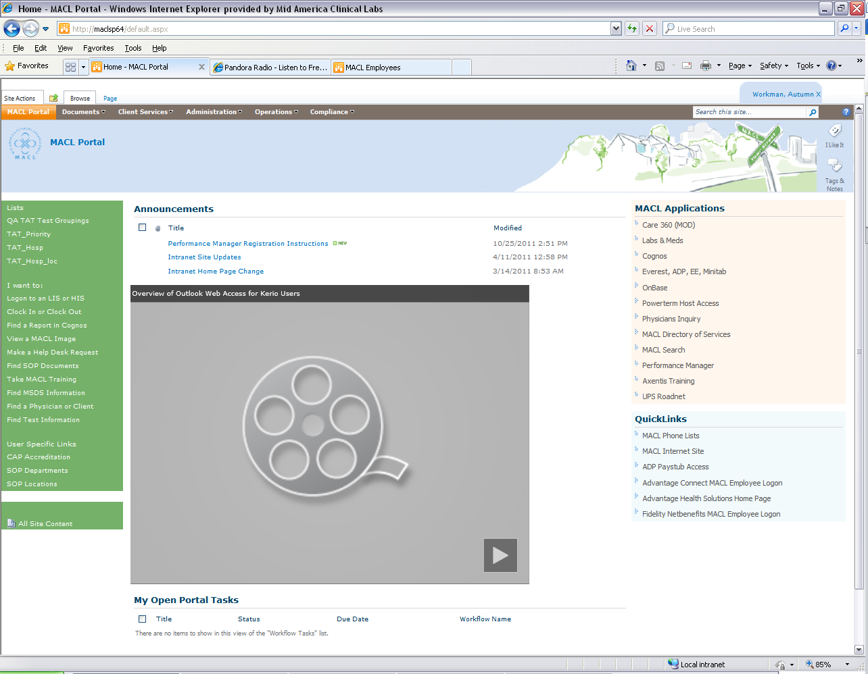

1. *STEP 3—*Typist or Owner

1. Types draft of new procedure into SharePoint SOP document or makes requested changes to existing SharePoint SOP document. This step may also be performed by Owner or designee with SharePoint authoring rights

a. To create a new document, click on “Find SOP Documents” link on the left side navigation bar found on the MACL Intranet page

b. Select “Working Documents” from the left side navigation bar on the SOP Documents page

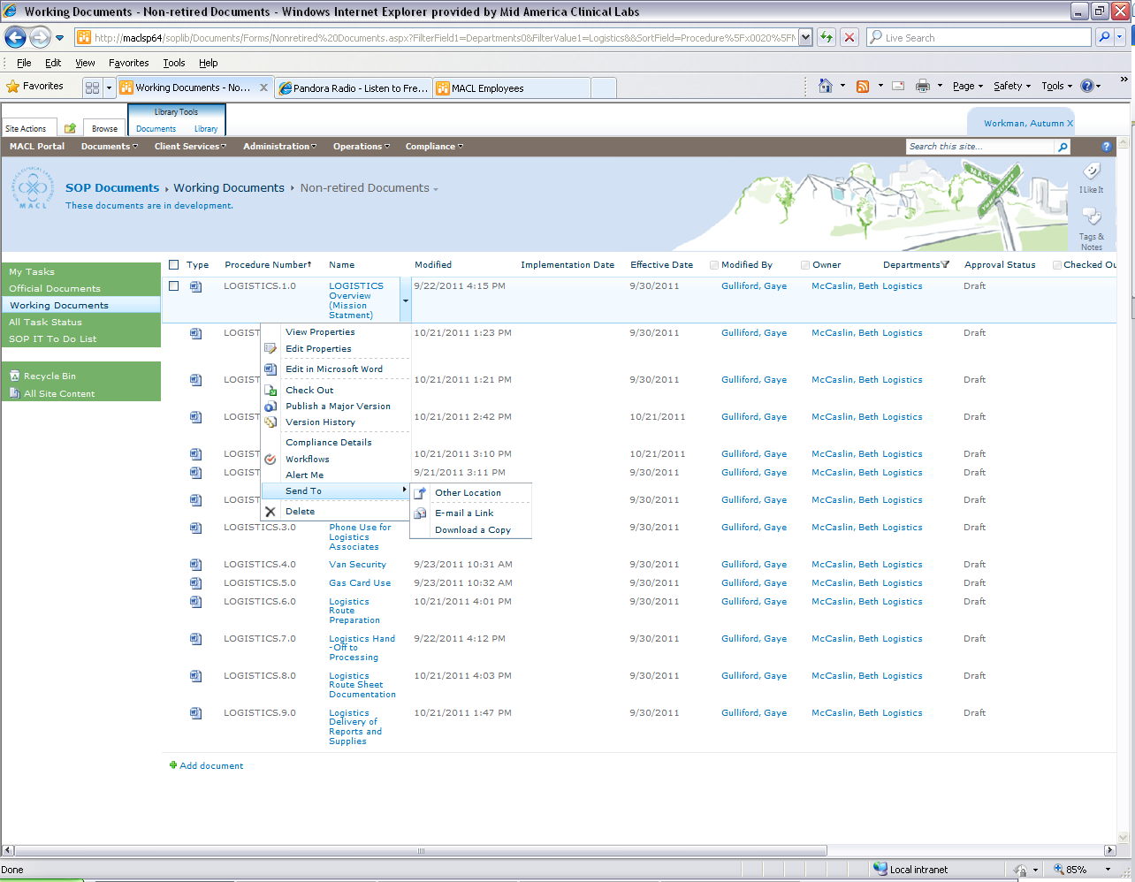

c. Click on a procedure number to bring up the SharePoint editing toolbar/ribbon

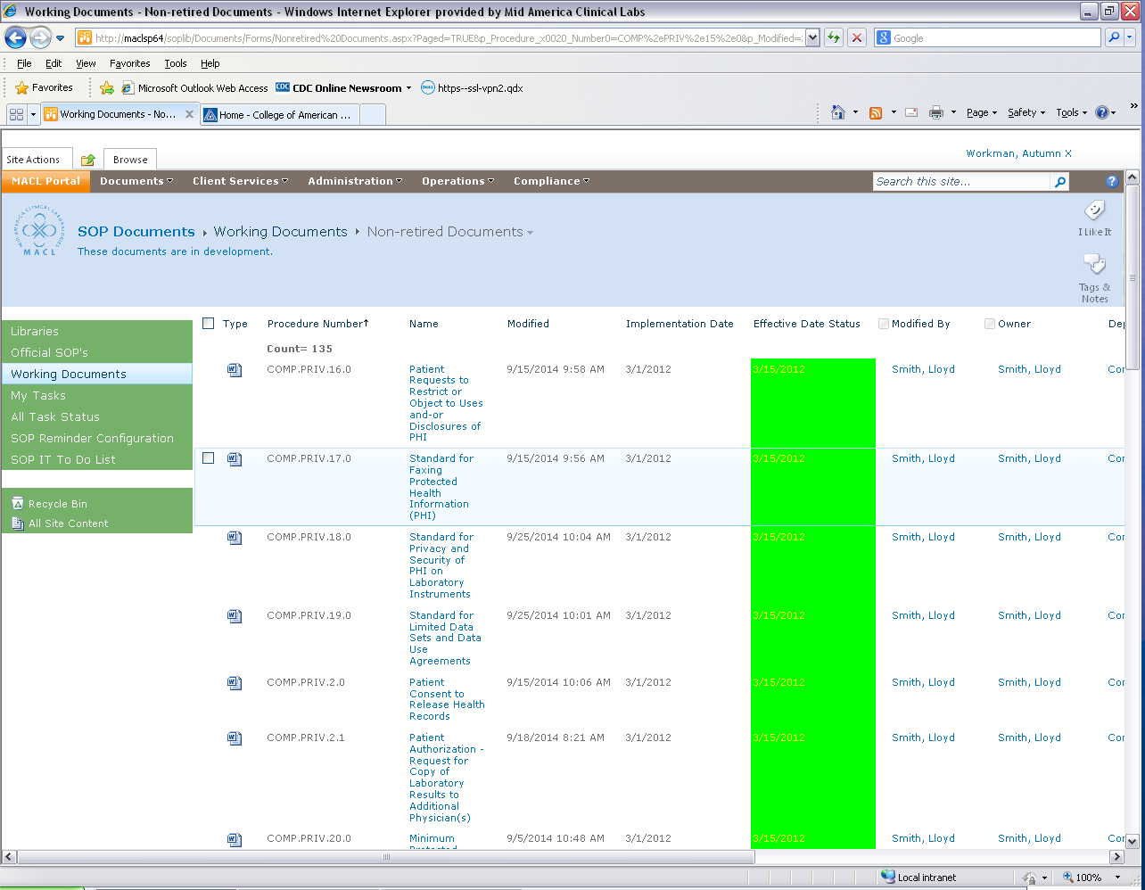

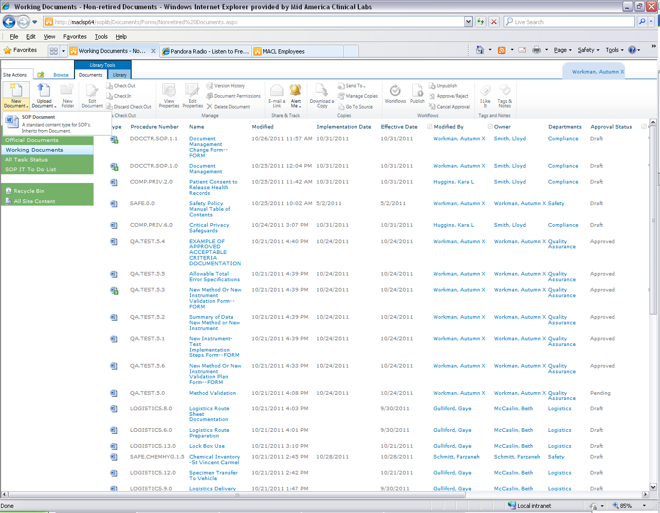

d. Use the SOP document template. To access the template click on the arrow under “New Document” and select the SOP Document choice. Although the system allow for the uploading of existing files, use of this template is recommended because it automatically provides the user with required fields within the document (eg, version number, title, logo)

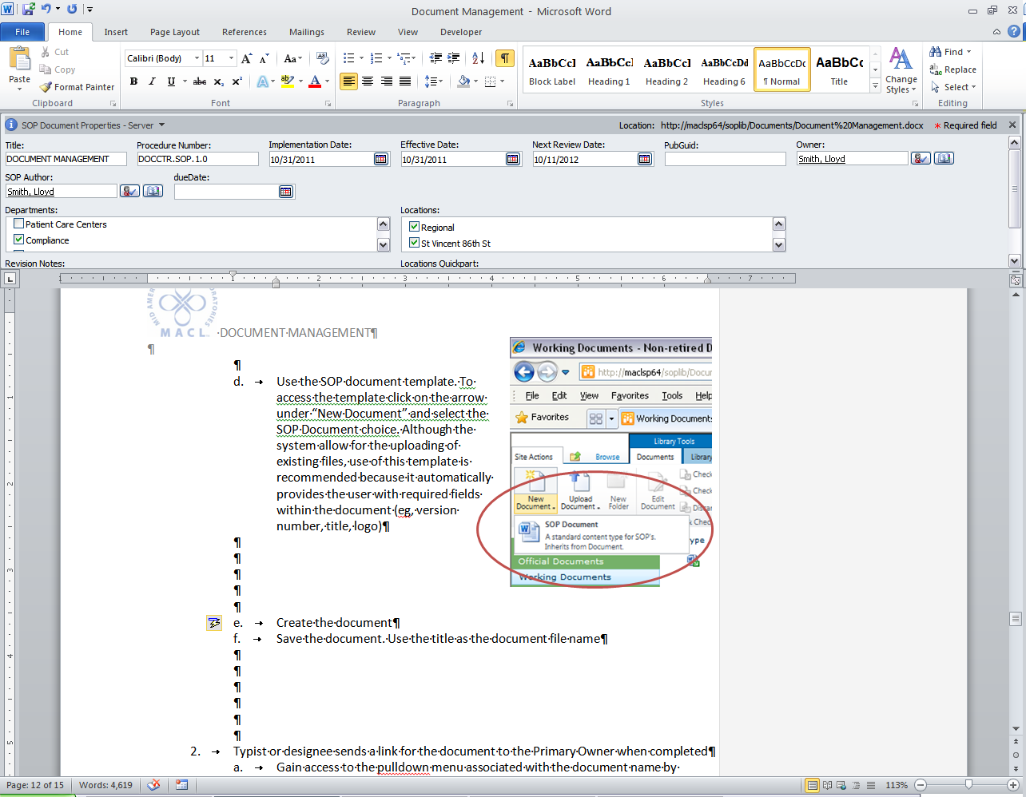e. Create the document. During this process, enter the file data in the properties panel at the top of the document

f. Save the document. Use the title as the document file name

g. When done working on a document, it should be Checked In. When you close a document you have changed, SharePoint will ask if you want to check it back in. Say yes and select the appropriate version. For a Draft version, when you are not finished working on a document, select the next decimal up. For example, if a document is new, the version will be 0.1; if the first round of changes is being made to version 3.0 of a document, then select 3.1. Prior to checking the document back in, enter information about the changes made in this document version (eg, New Document; Updated incubation times per manufacturer changes). **This is a required field**; you will not be able to successfully start an approval workflow if version comments are not entered, even though SharePoint will allow you to check in the document.

NOTE: Overwriting the current minor (draft) version will remove the previous version from the SharePoint system; only use if a record of these changes are nonessential.

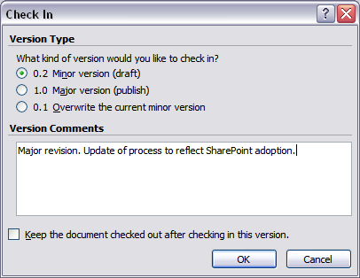

2. If applicable, the Typist or designee sends a link for the document to the Primary Owner when completed

a. Gain access to the pulldown menu associated with the document name by hovering over the name and clicking on the arrow

b. Select “Send To”

c. Complete the email request as directed

1. *STEP 4—*Owner

1. Reviews draft and makes needed changes. Note: A second review by another associate is strongly recommended.

2. Forwards final draft to co-owners as appropriate

3. Once all owners approve the document, finalizes Implementation and Effective Dates and edits as necessary in SharePoint document properties

a. Refer to DOCCTR.SOP.2.0, *Emergency Procedure Changes*, for the emergency change policy.

4. Forwards to respective Medical Director(s) for approval through a SharePoint Workflow

a. Gain access to the pulldown menu associated with the document name by hovering over the name and clicking on the arrow

b. Select “Workflows”



c. Select “Document Approval” under the “Start a New Workflow” section.

d. Complete the Document Approval form

i. Select each of the Medical Director(s) or other designated associate(s) who must review and approve the document prior to implementation (see *Document Approval and Review Guidelines* DOCCTR.SOP.1.2). Either enter the username and select the check button or use the address book to search and select

ii. Enter a description of the changes made to the document in the message section

v. Click on the Start button at the bottom right of the page when the form is completed

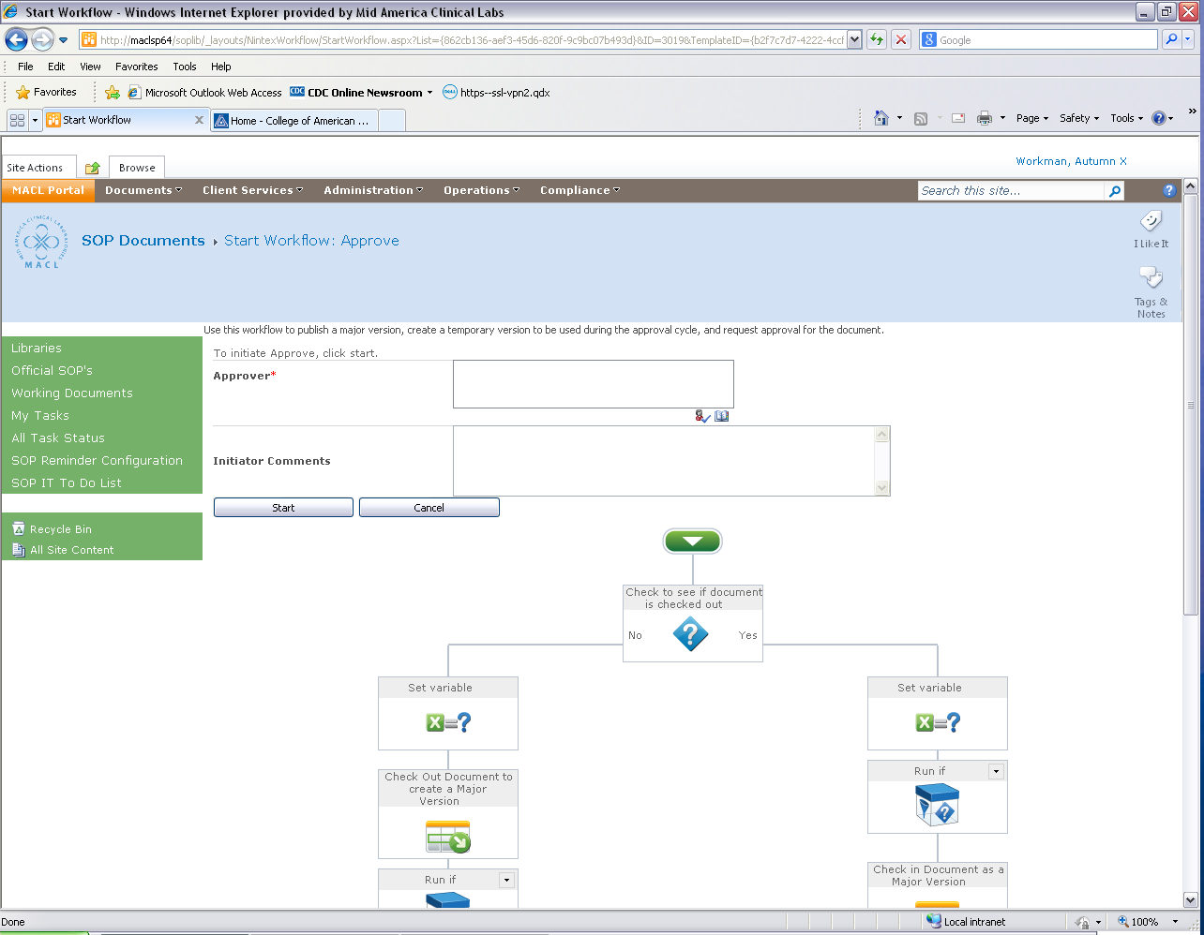

1. *STEP 5—*Owner

1. Once document approved by the Medical Director(s), sends notification email to all affected managers/supervisors. This email should include

a. Description of the document and/or changes made document during revision

b. The link to the procedure

c. Implementation/rollout instructions, including need for associate review

d. Implementation date and effective date

e. Training modules/materials, as applicable

2. Updates table of contents or notifies table of contents’ owner of need to update, as applicable

1. *STEP 6—*Affected Supervisors/Designees

1. Ensures that site specific medical director signature was obtained. Note: If alternate implementation date, the site medical director review and signature must be prior to the implementation date.

2. Ensures that appropriate associates have been assigned and complete document review in SharePoint Document review is to be assigned by the document owner with input from affected departments as to which associates are responsible for the content and process related to the document.

1. *STEP 7—*Associate

1. Reviews document and attests to the document review as requested.

H. *STEP 8*—Quality Assurance/Safety Department

1. Ensures a backup of SharePoint documents is available to all laboratory locations.

I. *STEP 9—*Retiring a Document

1. Retire is only used to formally take a document out of use. It is not used when revising an existing document, as it will remove the document from active status.

2. Use the procedure outlined above for selecting a Workflow. Select Retire Document, the owner as approver, and indicate a date for the document to be retired

**PROCEDURE NOTES**

A. Read, acknowledge, and put into practice the contents of all documents assigned to you in a timely manner. Frequently monitor email, SharePoint notices, and Laboratory Memos for notifications of new/ expired documents

B. Go to the procedure in SharePoint first when you are unsure of a step or direction or need more information. Asking a coworker to recall a detail may lead to error. If the document does not have the information you need, notify your supervisor or team leader.

C. Notify your manager if more than one version of a document is found in the work area. Do not use old versions of documents, forms, labels or tags that have been replaced by a more current version or keep them in the work areas. Remove and give these to your supervisor or team leader.

D. Notify your immediate supervisor or team leader when a change to a document is required. Critical changes that affect the comprehension of any type of document or performance of a procedure will be made immediately. Typos that do not affect comprehension or performance may be held until the next version is released.

E. Do not alter, write on, or white out controlled hard copies of documents.

F. Be suspicious of paper or cd copies of controlled documents—they could be outdated because the primary documents are kept electronically in SharePoint. Copies of controlled documents should not be made unless needed for a revision submission. Copies are no longer controlled and should be considered outdated as soon as they are printed. If a copy is required for rewriting purposes, “Copy” should be handwritten on document.

G. Uncontrolled/draft copies of documents should not be made for prolonged use at the workstation. Draft copies are meant to be transient or temporary in nature.

H. Do not release documents outside the Laboratory Department without approval of the Compliance Officer, QA and Safety Officer, or Medical Director. Do not share copies of approved documents with other laboratories without approval.

**REFERENCES**

1. Clinical and Laboratory Standards Institute. *Laboratory Documents: Development and Control: Approved Guideline—Fifth Edition*. CLSI document CLSI GP2-A5. Clinical and Laboratory Standards Institute: Wayne, PA. 2006
2. College of American Pathologists. *Laboratory General Checklist*. College of American Pathologists: Northfield, IL. [www.cap.org; Accessed January 27, 2015]