

Create a Learner Account

(If you already have an account at cdc.train.org, access the site and skip to step 6.)

1. Go to <https://cdc.train.org>.
2. Select the **Create Account** button.
3. Complete the online registration form to set up your account.
4. You will then be directed to your **Local Train** learning page. From this page you can check announcements, schedule training, and manage your account.
5. Follow the link in the **Notifications** box to complete your account profile. This should only take 1 – 2 minutes to complete.

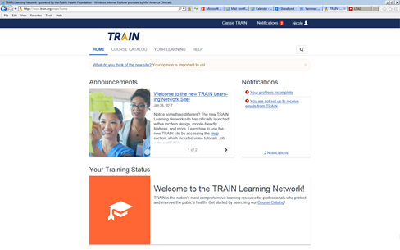

**6.**0

**5.**

1. Select the **Course Catalog** link for the TRAIN Learning Network.
2. Search **Shipping** … The course title you will be looking for is: **Packaging and Shipping Division 6.2 Materials: What the Laboratorian Should Know 2016**
3. Click the link for the course to be directed to the registration page. Select **Register**.

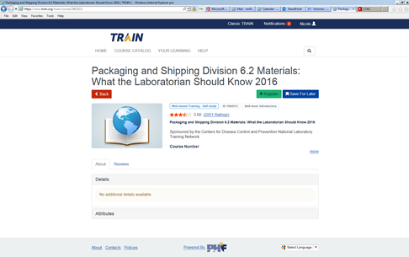

1. As part of the registration you will be directed to select a Credit Type. Select **PACE** credits.
2. You are now registered for the course. A **Pre-Assessment** is required. Follow the green link to start the assessment. (The pre-assessment questions are designed for the CDC to gauge the effectiveness of their training course, these assessments will not be collected or seen by MACL)
3. After completion of the Pre-Assessment, you can **Launch** the course using the displayed green button. If you do not wish to take the course at this time, or you need exit the course during the training period, the course will be displayed on your home page in **Your Recent Courses and Status** section.

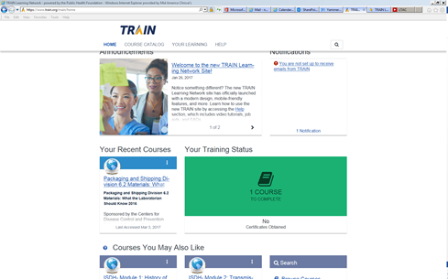

1. After completing the course, you will need to print your certificate and send a copy to the QA/Safety Department. Access your certificate under the **Your Learning** heading. Earned certificates are displayed under the **Your Certificates** tab.

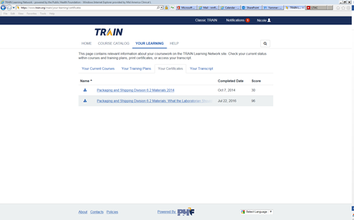

1. Click the link and then the **Print Certificate** button.

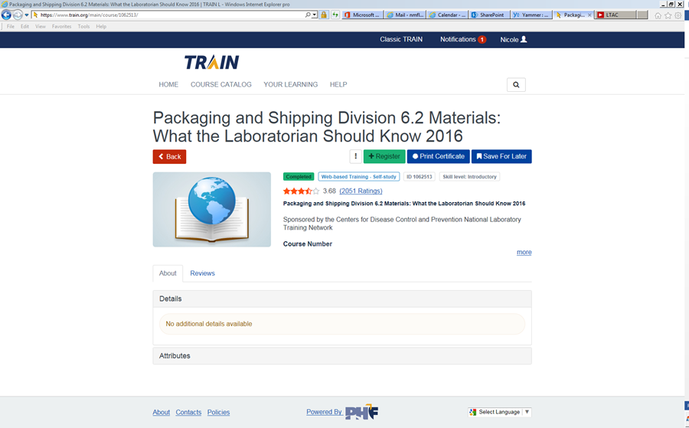

**Course completion Suggestions:**

* Access the **Tool Box** within the course and either print or have available on your computer the individual reference sheets. These will help with course completion and the post-test assessment.

