Stop and Start Instrument connection on DI (Data Innovations)

**STATEMENT OF PURPOSE**

To establish the procedure for stopping and starting an instrument connection on DI

**SCOPE**

This procedure applies to all personnel performing testing on an instrument

**OWNERS**

Mid America Clinical Laboratory IT Department

**RESPONSIBILITIES**

It is the responsibility of the IT Department to provide a way for a user to stop and start an instrument connection on the Mid America Clinical Lab Instrument Manager (DI Data Innovations)

**PROCEDURE**

1. After logging into DI on the menu bar choose System and under System choose Status

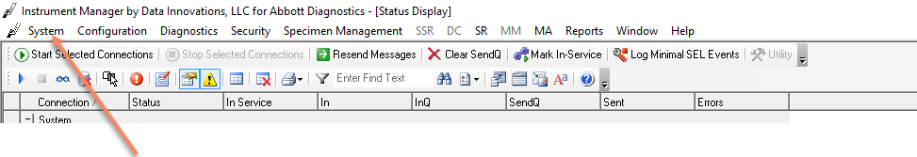

1. Locate your instrument connection and right click

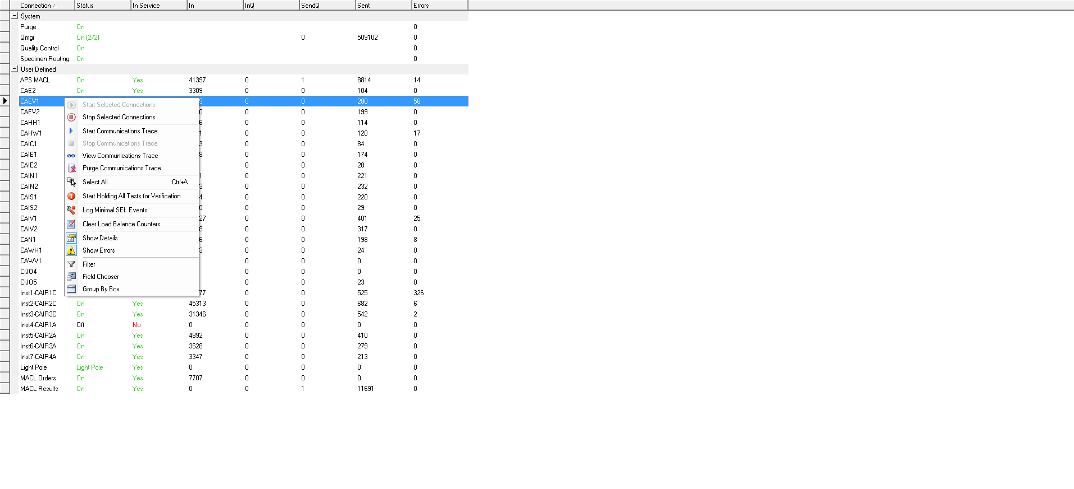

1. Choose Stop Selected Connection
2. Once the connection has stopped right click on the connection and choose Start selected connection

