**IT.GEN.17 Suspend Autoverification and Hold All Results for Manual Verification**

**STATEMENT OF PURPOSE:** To establish the procedure for turning off Auto Verification at the Instrument Level

**SCOPE:** This procedure applies to all personnel using auto verification on an instrument

**OWNERS**

Mid America Clinical Laboratory IT Department

**RELATED DOCUMENTS**

**RESPONSIBILITIES:** It is the responsibility of the IT Department to provide a way for auto verification to be disabled on any instrument as needed

**PROCEDURE**

1. Associate logs into Data Innovations Instrument Manager and under the system menu chooses system

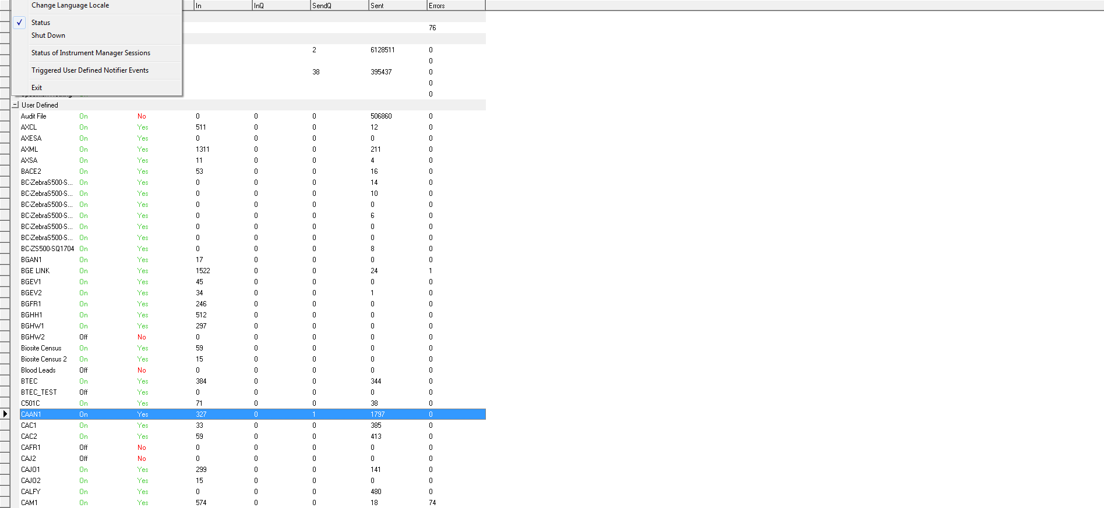

1. Associate locates Instrument connection on the status screen and right clicks on it

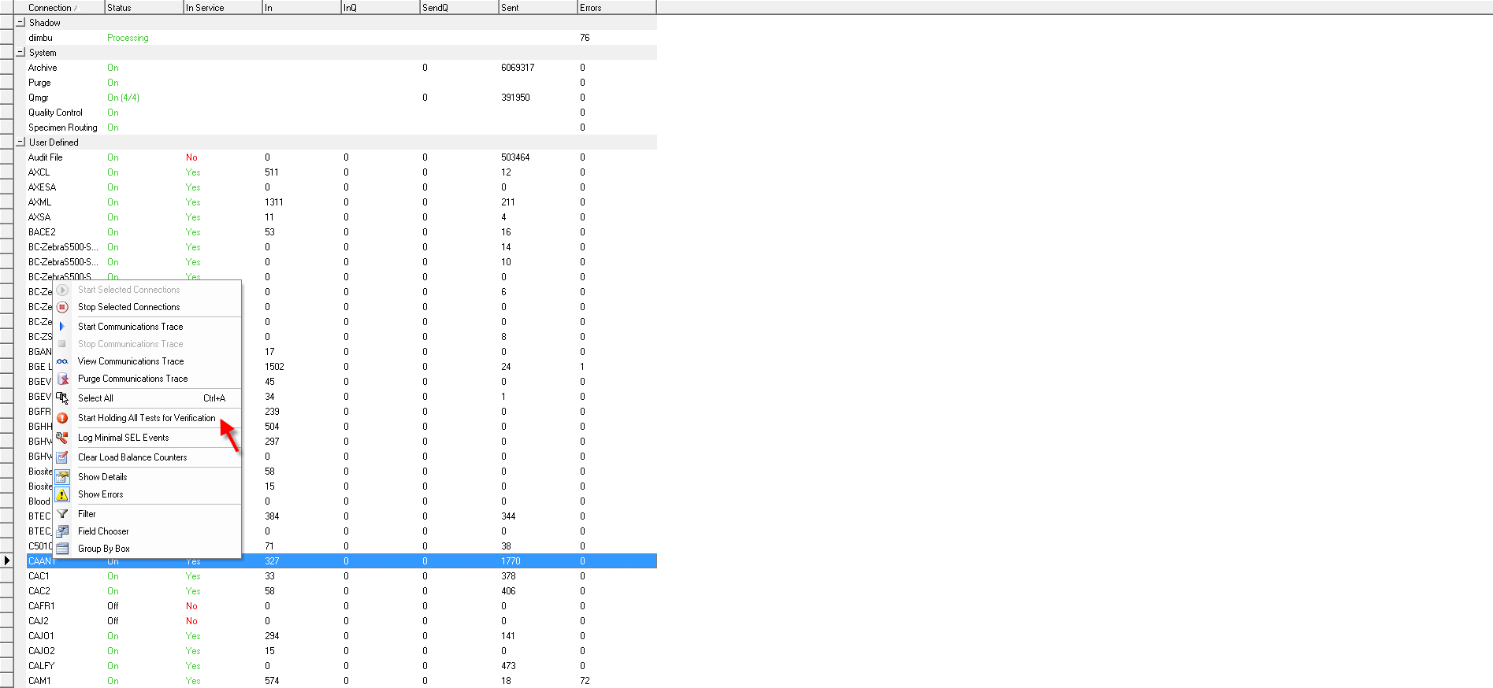

1. Associate chooses Start Holding All Tests for Verification
2. Associate is prompted to verify that all results for selected connection should be held.

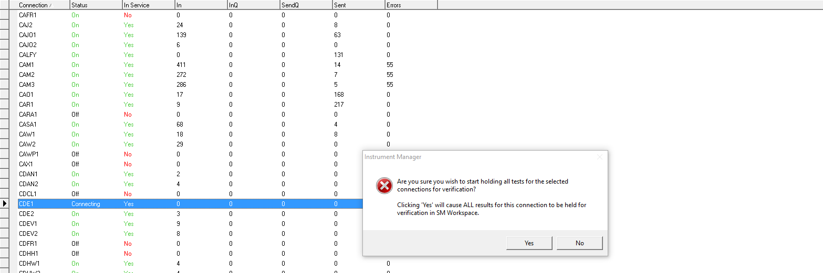

1. Associate should contact the MACL helpdesk for assistance, once issue is resolved the IT associate will enable autoverify.

**PROCEDURE NOTES**

**LIMITATIONS: Techs do not have access by default. Access has to be updated by IT to include this functionality.**