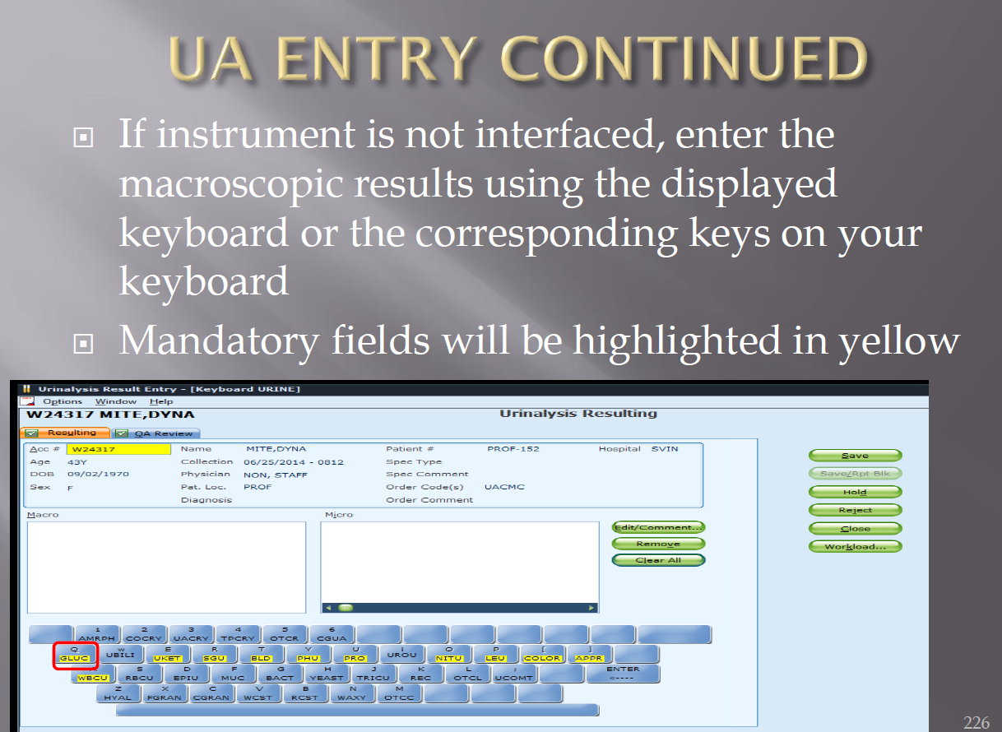

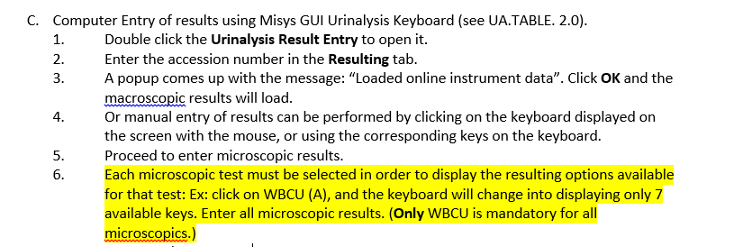

Also, See procedure UA.MICRO.2.0

This is referenced from the SQ training power point provided by MACL. Note that the RBC field is **NOT** highlighted.

Note!

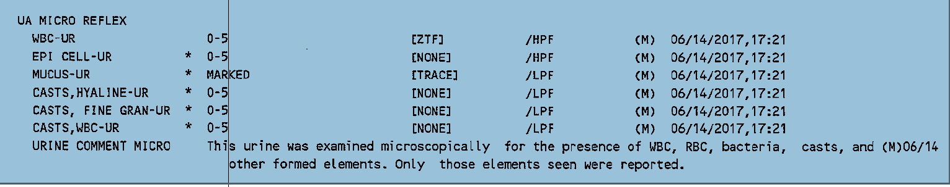

Above is from an IRA. Note the urine comment. “Only those elements seen were reported”. This comment was created so that we did not need to report none seen for every urine microscopic parameter.