Effective August 15th, 2017 the RBCU normal range will be moving from 0-5/HPF to 0-3/HPF due to updated guidelines so the new ranges will 0-3/HPF and 3-10/HPF. I have attached the keyboard aids below for review.

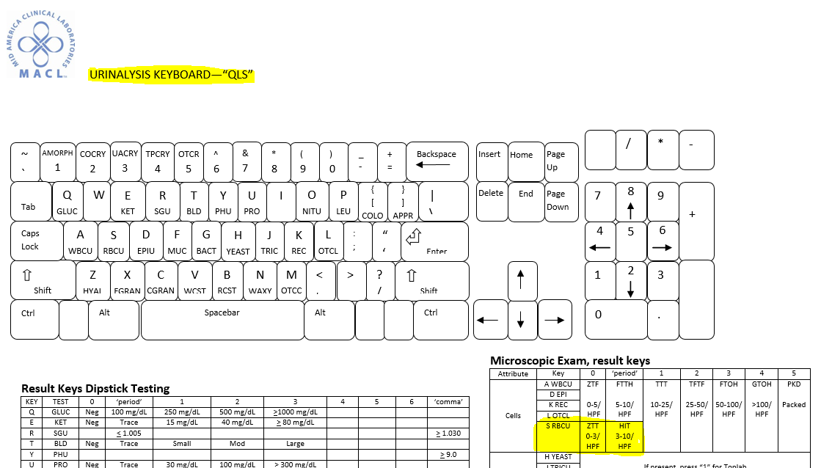

UA.TABLE.1.0

