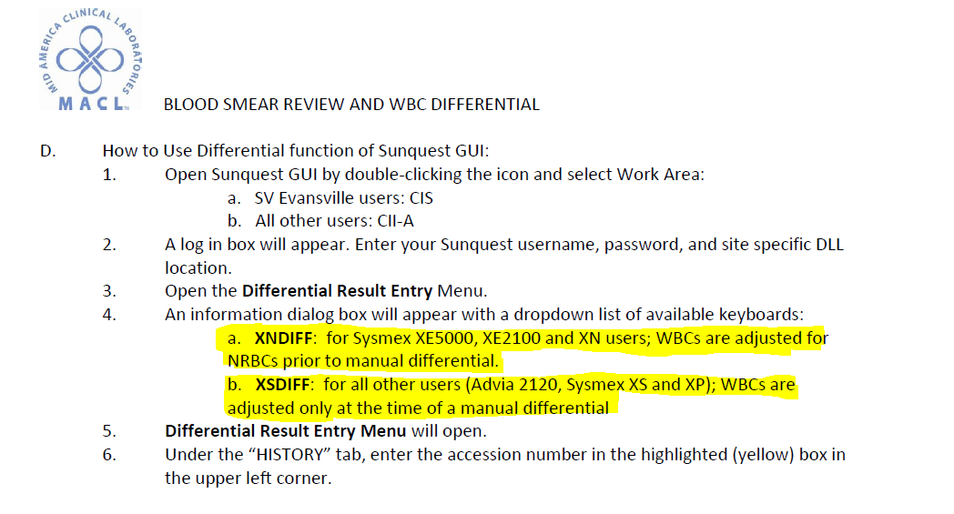Effective August 14th, 2017 there will be no default differential keyboard when signing into CII or CIS. Instead, techs will be required to select a keyboard from the drop down box rather than just hitting the ok button and selecting the incorrect keyboard. Below I have attached part of the HEM.SMEARS.4.0 procedure that has been updated to reflect this change.

XNDIFF = All Sysmex XN and Sysmex XE users only!

XSDIFF = All other users (Advia 2120, Sysmex XS and XP)!