**QLS Path Review**

1. Ordering path review (ONLY IF ONE HAS NOT BEEN ORDERED ALREADY)
   1. 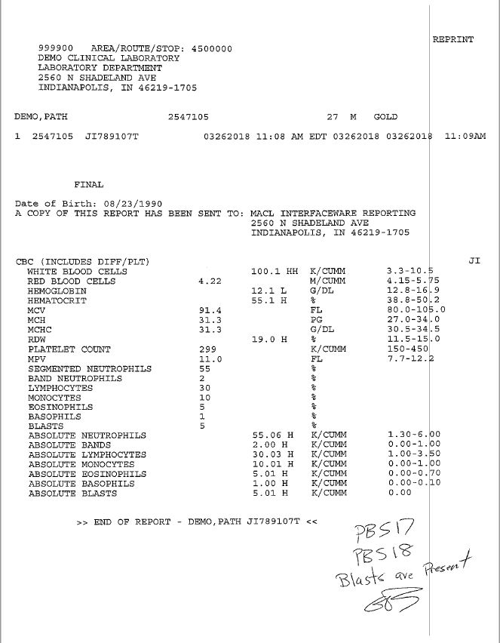Pathway 1,7
   2. Enter Default Suffix
      1. YJI
   3. Enter Accession Number
   4. Go to result field 19
      1. /19
   5. 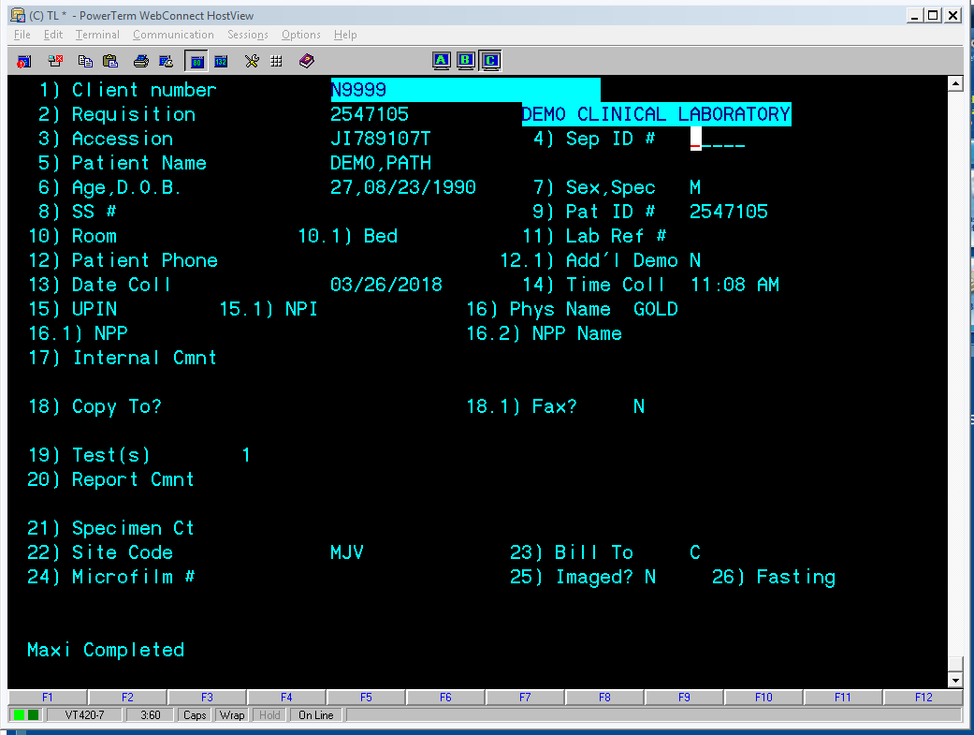Enter Path Review Order code
      1. 833
      2. Enter

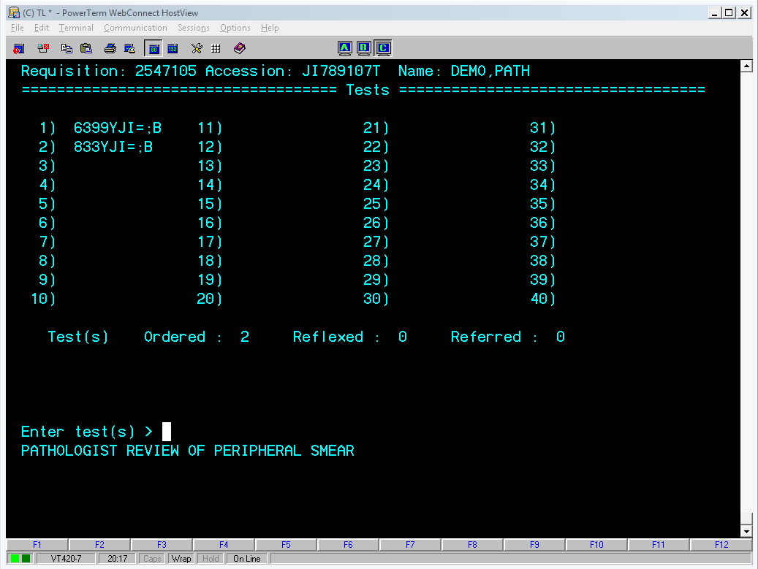

* 1. Double backslash to get back to patient screen
  2. Double backslash
  3. File?
     1. Yes
  4. Reason for adding 833YJI:
     1. 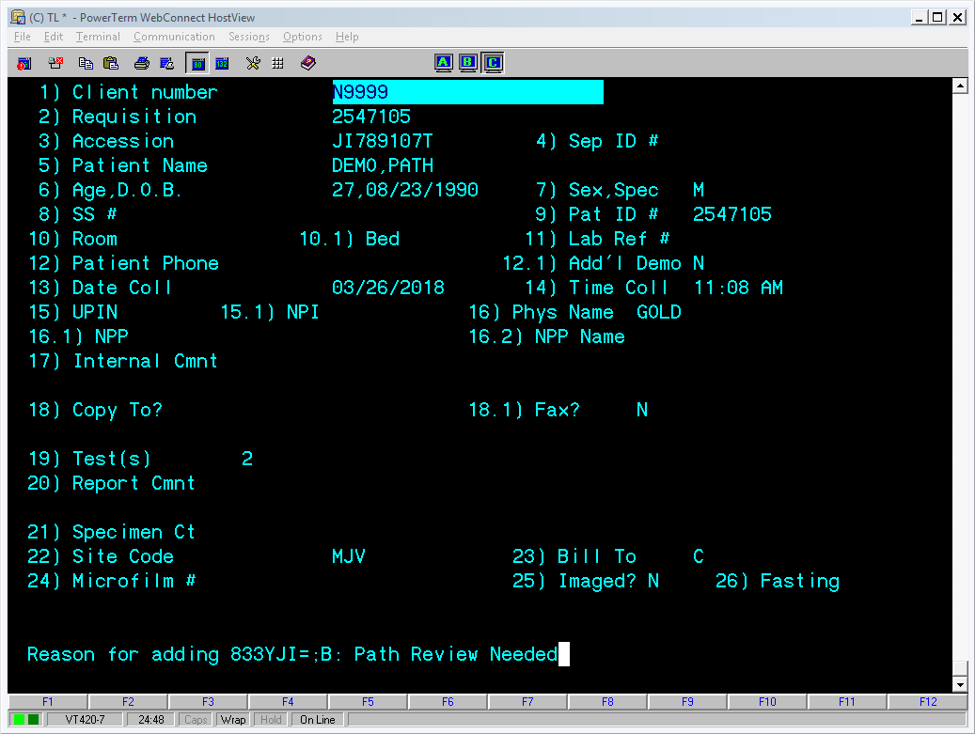Path Review Needed

1. Entering Path Review Notes
   1. Pathway: 3,3,1
   2. Worklist: HMMB
   3. Enter canned comments into result field PCOM1
      1. For this example there are two canned comments. The first will need to begin with a #JI followed by the canned comment.
         1. #JIPBS17
            1. If this was the only canned comment, you would skip to step “d”.
      2. Since we have two canned comments, you will put a comma after the first canned comment followed by JI and the next canned comment. There is no space behind the comma.
         1. #JIPBS17,JIPBS18
            1. If you had more canned comments, you would continue by using a comma followed by JI, then the canned comment. The pound symbol is only needed for the first canned comment.
            2. 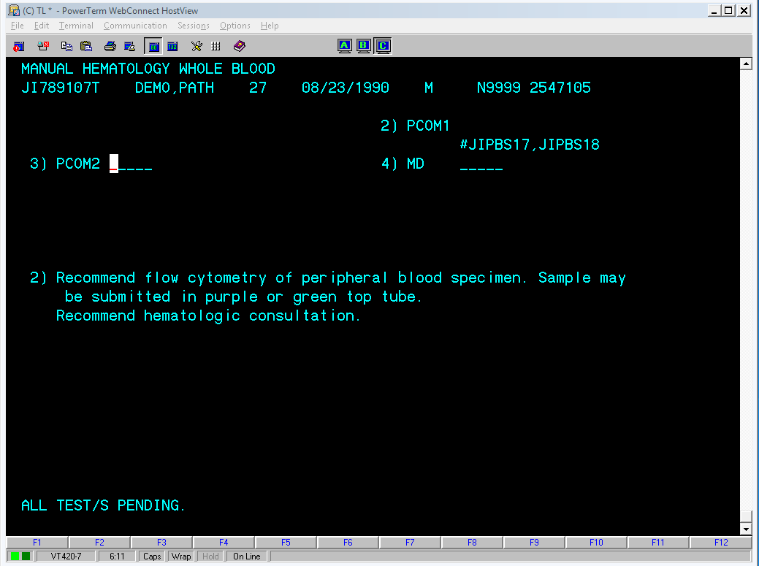You should see your canned comment propagate the actual comment
   4. Enter any free text comments into PCOM2
      1. Type an asterisk (*)
      2. Enter your free text as you would any comment
         1. Hit enter when you’re done
      3. If there is no free text to enter, enter DNR into PCOM2

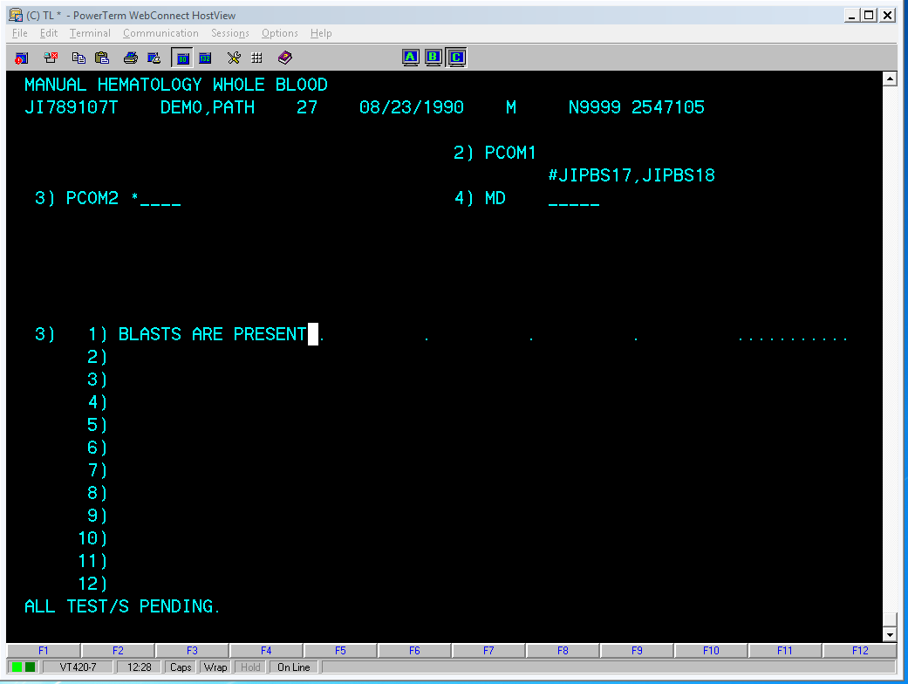

* 1. Enter pathologist name into MD field
     1. For Dr. Lanting Liu, enter:
        1. #JILLMD
     2. For Dr David Wilson, enter:
        1. #JIDBW
     3. Dr Andrew Schubeck
        1. #JIATS
  2. When you are done entering everything, print out a screenshot of what you entered so it can be manually reviewed.
     1. If you type /3 you can get your free text comment to show on the screen. Screenshot this so we can review everything at once.

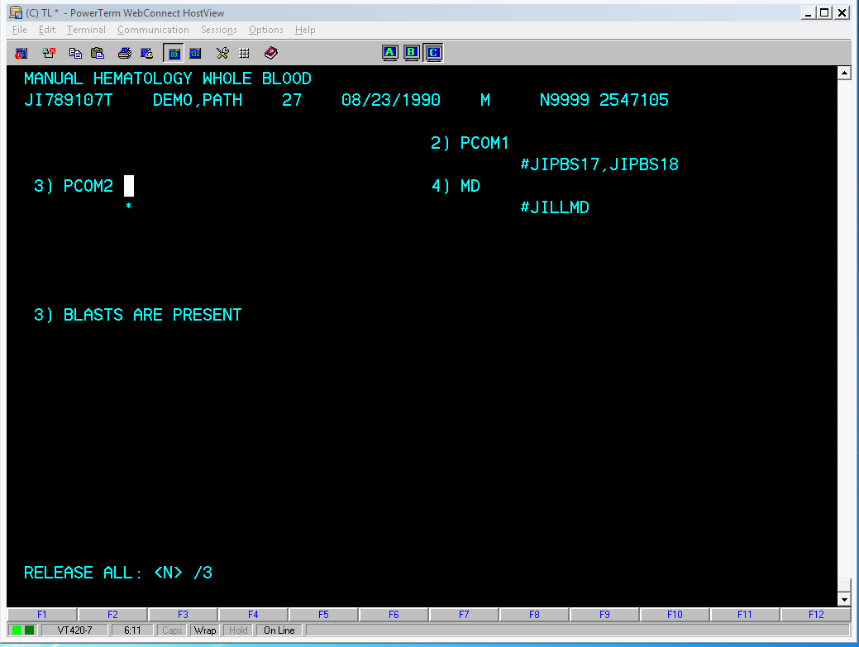

* 1. Staple screen shot to the original paper and place in manual review basket for later review.

**Sunquest Path Review**

1. Ordering Path Review (ONLY IF ONE HAS NOT ALREADY BEEN ORDERED)
   1. Go into Order Entry in SQ GUI
   2. 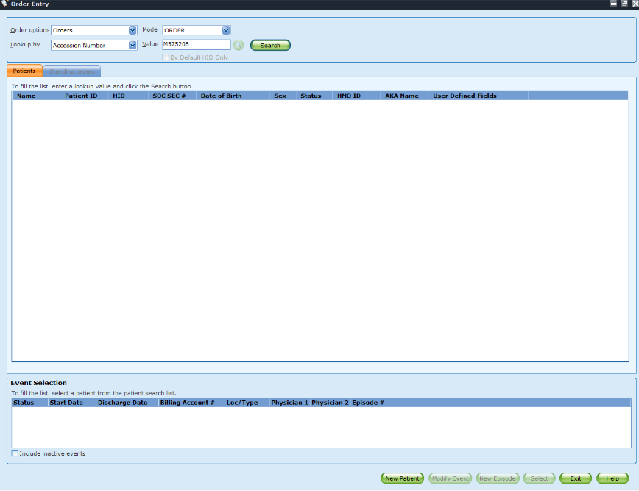Order it under the same accession number as the CBC

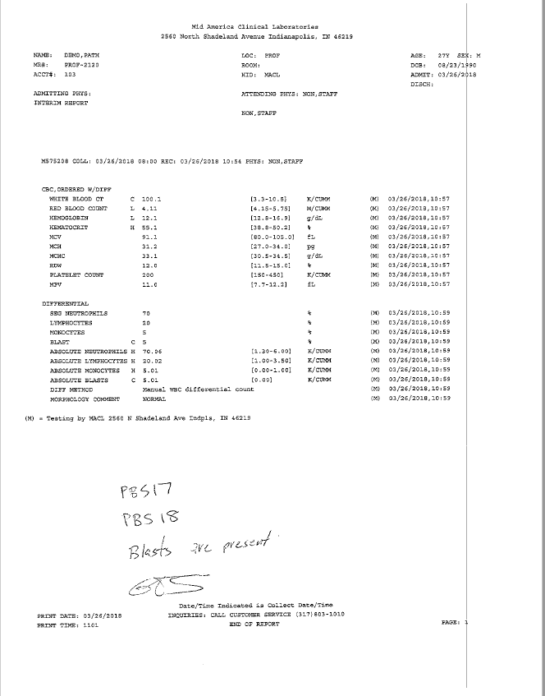

* 1. 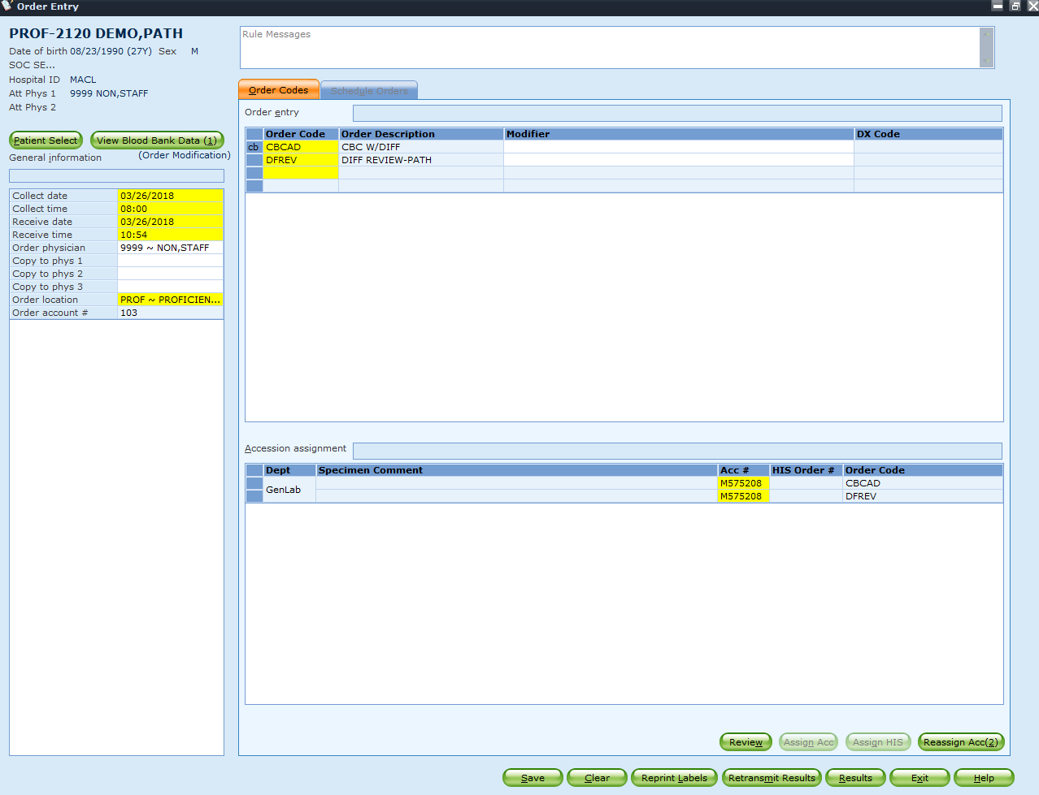Once in patient record, order the DFREV
  2. Hit save to finalize the order

1. Entering path review
   1. Use roll and scroll Sunquest.
      1. Function: MEM
   2. Enter through Worksheet and enter DFREV into Test-1

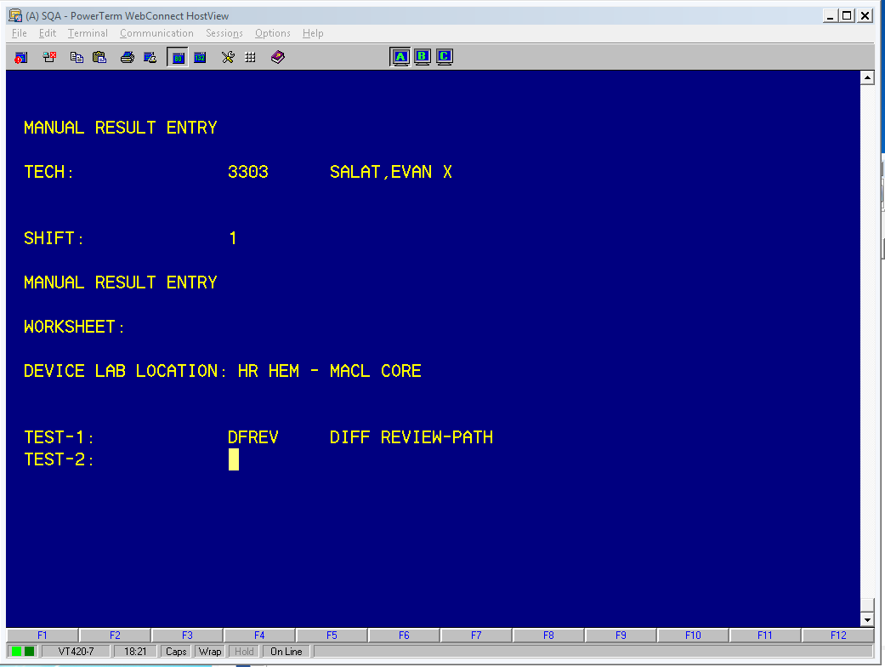

* 1. The same concept applies for Sunquest, your canned comments will be inputted into PCOM1 and your free text comments will go under PCOM2
  2. To enter canned comments in SQ, just enter what you see (ie PBS17)
     1. If there are multiple canned comments, enter your first canned comment, followed by the “|” (shift, forward slash) and then the next canned comment.
        1. PBS17|PBS18
        2. Once you hit enter, you should see your canned comments propagate

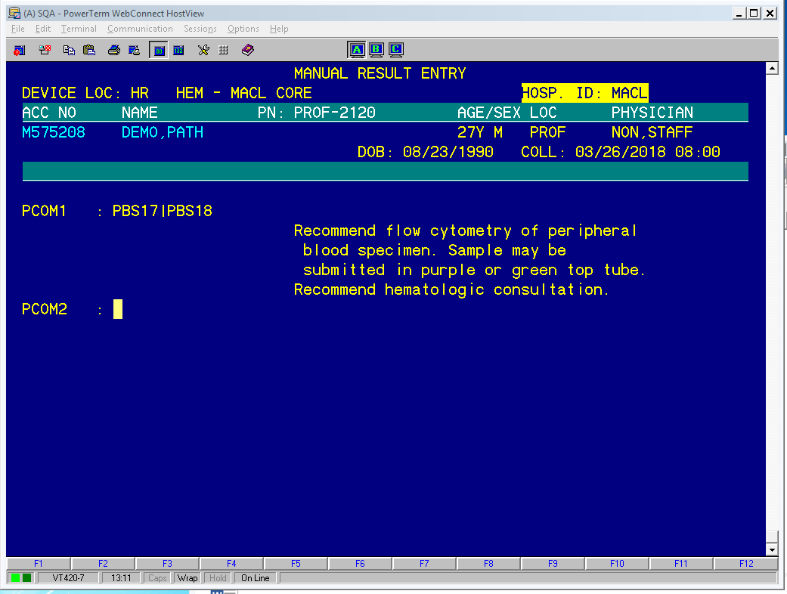

* + - 1. Screenshot this for manual review
    1. Enter your free text comments into PCOM2. You must enter a semicolon before you begin typing or else SQ will not accept it.
       1. 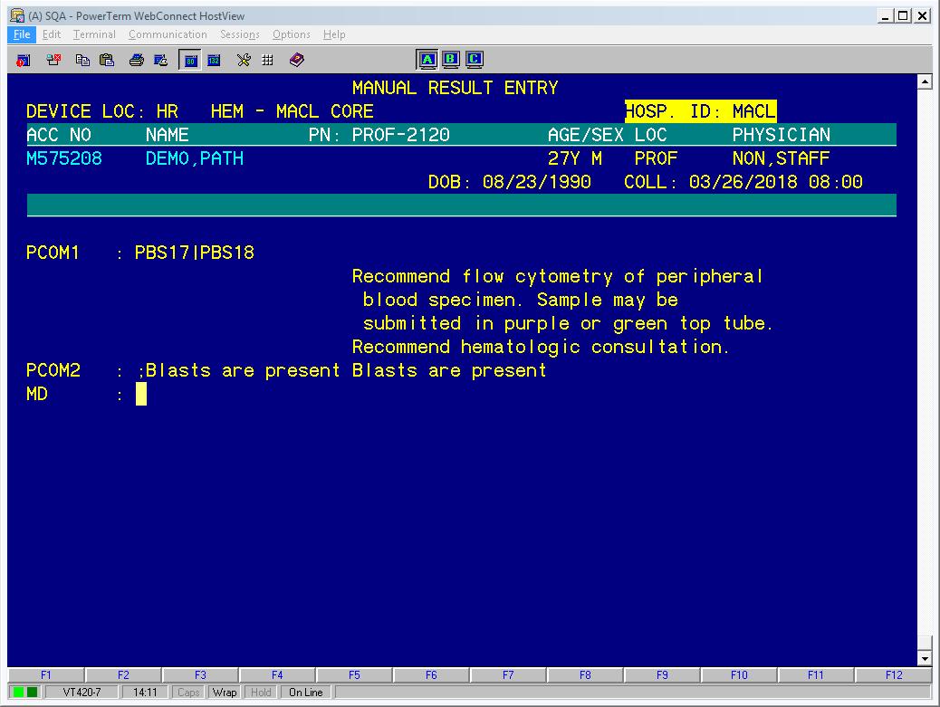;Blasts are present
       2. If no free text is required, type HIDE
    2. Enter your pathologist into the MD result field.
       1. Dr Lanting Liu
          1. LLMD
       2. Dr David Wilson
          1. DBW
       3. Dr Andrew Schubeck
          1. ATS
    3. Make sure to take a screenshot once everything is completed so we can review.
    4. Staple your screenshots to the original and leave in the manual review basket.

1. 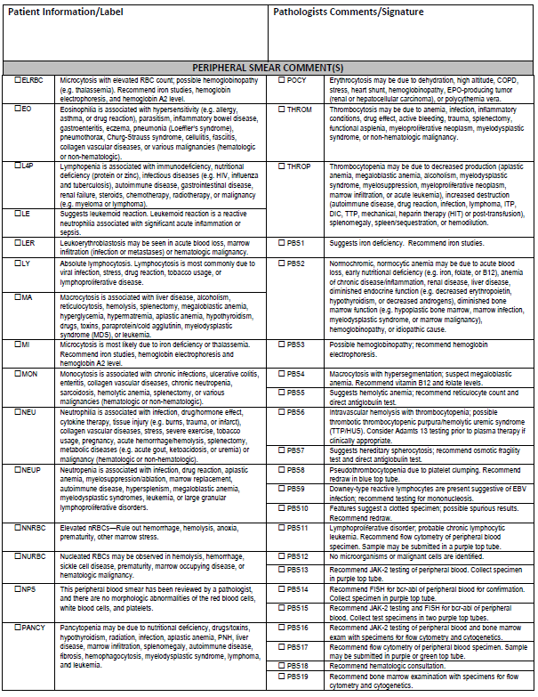Attached is a list of the canned comments and what their translated text is. This is also a procedure (HEM.SMEARS.8.1)