QC Failure in SM Workspace, will trigger ALL patients with the same test code as the failure to start holding in DI.

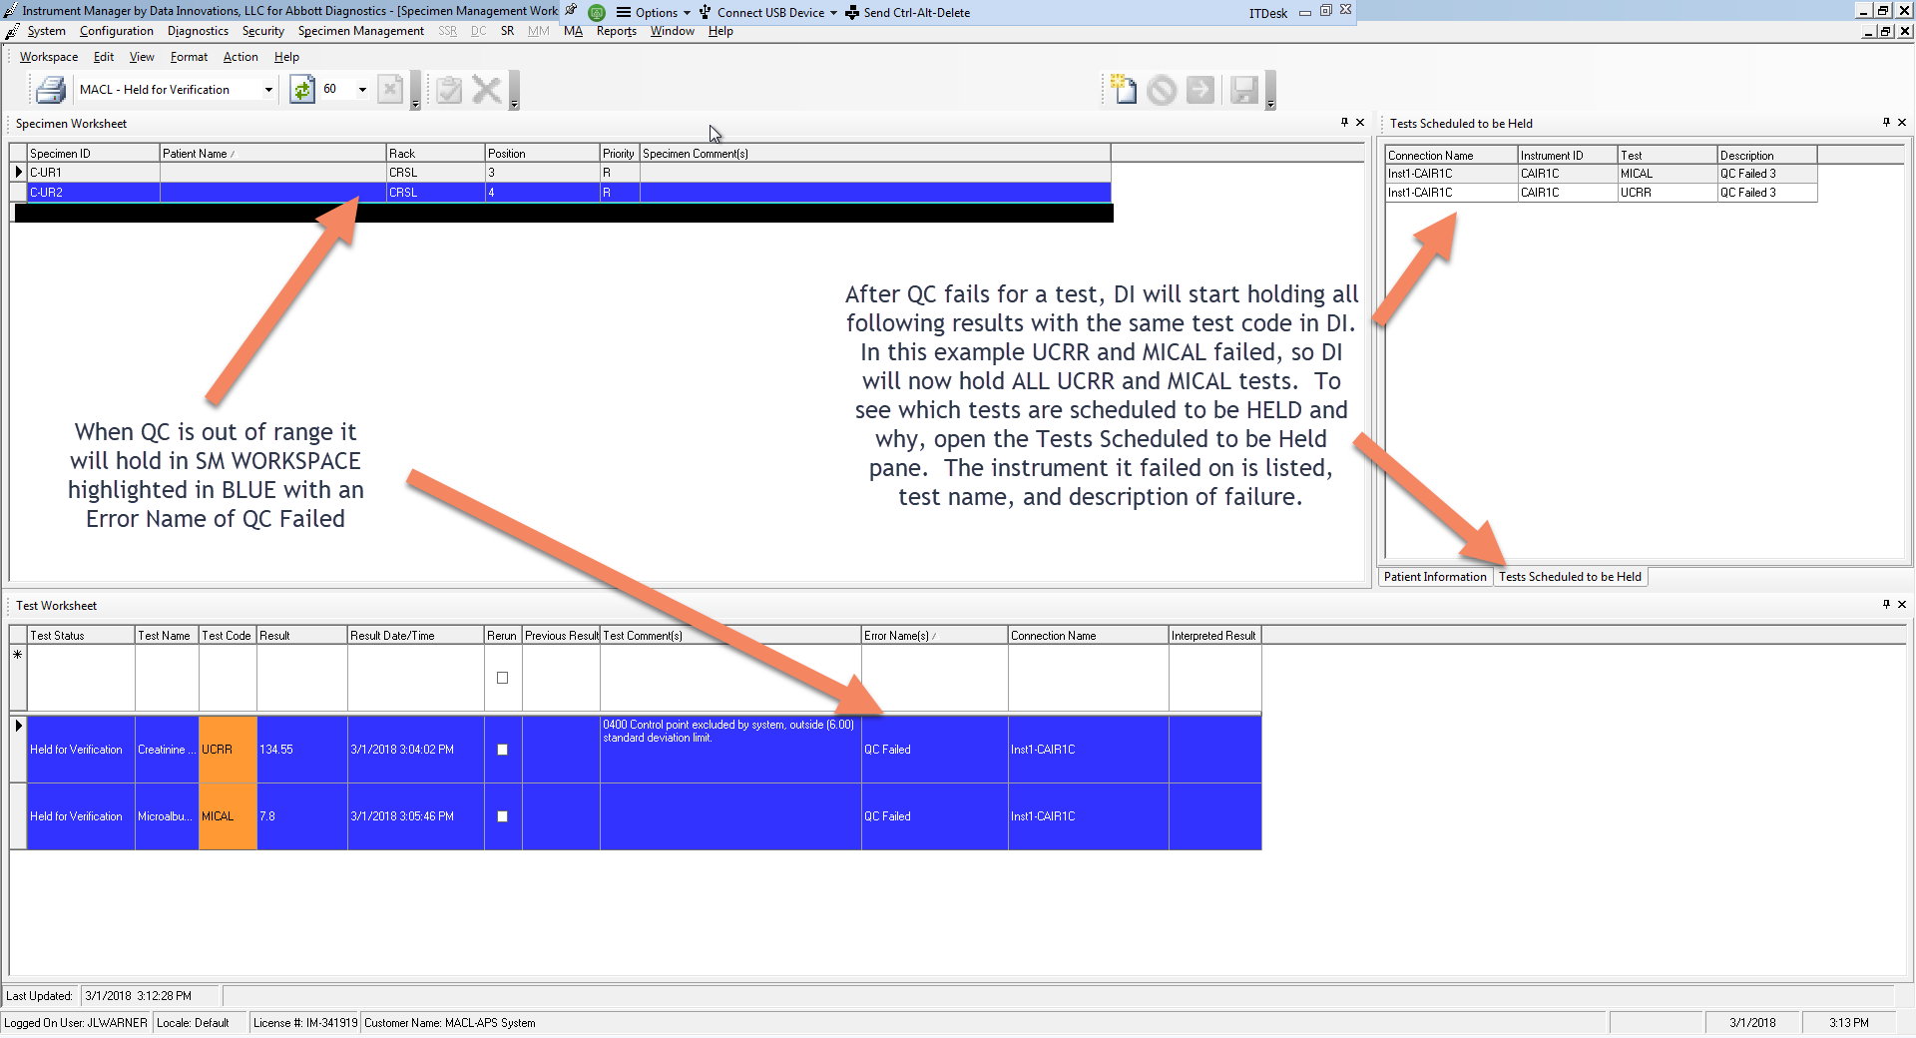

Once the QC issue is resolved, to Stop Holding All Testing for Verification…

