Mid-Columbia Medical Center
Laboratory
Competency Exam
for the
Instrumentation Laboratory
ACL Elite Pro
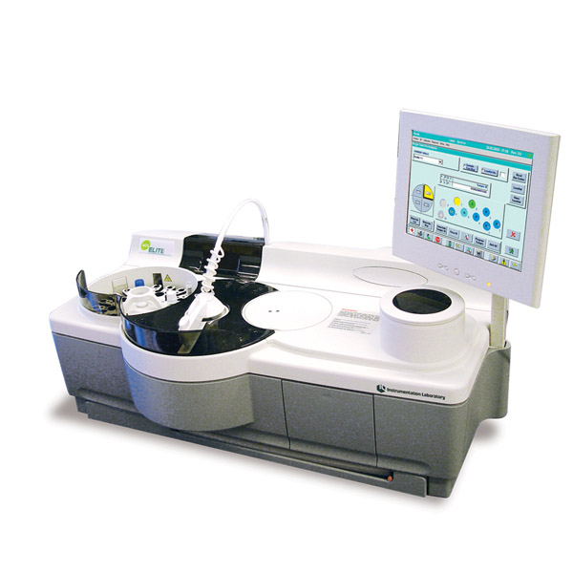

1. Describe the preparation instructions for the PT reagent used on the Elite Pro
(RecombiPlastin-R2G)?
__________________________________________________________________
__________________________________________________________________
__________________________________________________________________
2. How long is this PT reagent (RecombiPlastin-R2G) stable on the ACL Elite/ElitePro?
_______________________________________________________________
3. What is the ISI for this PT reagent? __________ Where is the value found?
__________________________________________________________________
4. What are the Limitations/Interfering Substances? What are the units of measure for the Limitations/Interfering Substances?
________________________________ ________________
________________________________ ________________
________________________________ ________________
5. What is the calibration target value for the D-Dimer reagent? _____________
Where is the value found?
______________________________________________________________
6. What is the linearity of the D-Dimer test?
______________________________________
7. Identify recommendation for a D-Dimer test exceeding linearity?
_________________________________________________
_________________________________________________________________

8. What is the target value for the PT based Fibrinogen for this instrument and the
reagent used? (RecombiPlastin-R2G) ________
Where is the value found? _________________________
9. Barcode Reader detects the presence of a cup or a tube in the sample tray.
True / False (Do not forget the sensor)

10. What causes a materials map position to turn Red? Orange?
Red-________________________________________________________
Orange-______________________________________________________

11. What would be some advantages of using the load list configuration?
_________________________________________________________________
_________________________________________________________________
_________________________________________________________________
12. When would manual entry be beneficial?
_______________________________________________________________

13. What are the options defined for Reflex Status in system setup?
__________________________________
__________________________________
__________________________________

14. Which Reflex Status setup selections eliminates operator from removing a
sample if a reflex test needs completed?
__________________________________
15. Under what liquid definition is the ISI value entered?___________________
16. Where is the Fibrinogen Calibration value entered?
_________________________________________________________
17. How is the Warning Volume determined?
_________________________________________________________
_________________________________________________________
18. Do you have to enter the ISI value into all associated PT tests (ie.extended or
duplicate tests)?_________

19. After running samples, some tests ordered on a sample were not run. What
would you check?
__________________________________________________________
__________________________________________________________
_________________________________________________________
20. What is the default cycle for the needles cleaning cycle? ____________
How often is this procedure performed? __________

21. State the recommendations for the following maintenance procedures.
Maintenance Procedure Interval
a. Check Wash R-Emulsion
b. Clean Waste Line
c. Clean Needle Procedure
d. Clean Air Filter
e. Align Needles
f. Verify the Needles Alignment

22. Can you omit an individual replicate from the calibration? Can you restore
omitted replicates?
_______________________________________________________________
23. What is the total number of QC results in each statistic file?
___________________________________________________
Hint: Operator’s Manual Chapter 7 Assay and Instrument Specification: page 7.47
24. How many days of results are viewable on the Levy Jennings chart in MediTech?
___________________________________________________
25. What does QC invalid mean when printed on a cumulative report or in the
cumulative data in a QC file?_______________________________
26. When you are in a Multi-Test / Profile Mode, not connected to an LIS, and
with no Default tests enabled; are tests automatically ordered? Yes / No

27. Can you re-start a session after adding a reagent liquid to the instrument?
Yes / No
28. What action(s) can be taken for a sample/reagent using the Pause Session
icon?
a) ___________________________
b) ___________________________
c) ___________________________
29. Can you add a control using the Stat/ Pause icon? Yes / No
30. If the D-Dimer controls recovery is not acceptable, what can you check?

31. Do not reflex to a D-Dimer High test (DDH) if results of the D-Dimer test is
under 1035ng/ml. Please explain Why?
__________________________________________________________
__________________________________________________________
32. What can cause the Peltier Temperature to be out of range?
______________________________________________________
______________________________________________________
33. What happens if you leave the cover to the rotor stack or holder area open?
______________________________________________________
______________________________________________________
34. Define an error code 7, and what action do you take, if encountered?
______________________________________________________
35. Explain the following
a. What type of error is error code 14 and 30 when received for the D-Dimer
test?
b. Will a result be reported?
c. What action can be taken, if encountered?
- ________________________________________________
- ___________________________________________________
- __________________________________________________

36. Define the following messages: warning, alarm or failure and whether you can
continue operating your instrument.
Warning__________________________________________________
Alarm____________________________________________________
Failure____________________________________________________

37. Does a failure status prevent you from using the instrument? Yes / No
38. What does a “Flush warning” error message indicate and what corrective
action should be taken?
_______________________________________________________________
_______________________________________________________________
_______________________________________________________________
39. How many rotors will the rotor stack accommodate? ______________
40. On the ACL ELITE PRO, where can find “rotors OK” message
displayed?________________________________________________
41. What message is displayed when cuvette waste is full on an ACL ELIE PRO?
_________________________________________________________
42. How do you obtain a MNR (Mean of the Normal Range) based on your
regulating agency?
___________________________________________________________
43. When looking at a Clot Curve what does the following represent?
a. X-Axis: ___________________________________________
b. Y-Axis: ___________________________________________

