33 year old Korean woman.

Presented on the 2nd of May with a 3 month history of amenorrhoea.

Pregnancy test (quantitative hCG) was negative (<3 U/L).

Due to the unexpected hypokalaemia, biochemistry was repeated on the 3rd of May with urine chemistry.

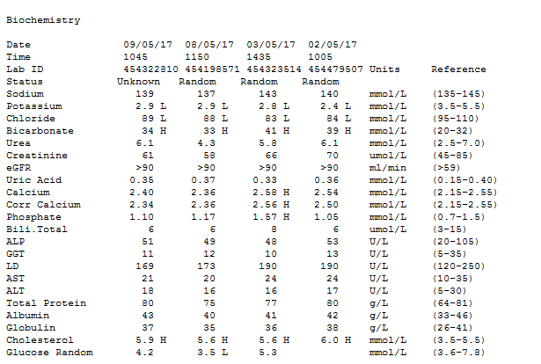

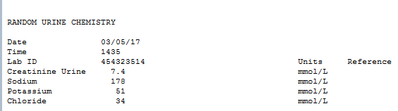

1. How would you describe the acid-base disorder described by the electrolytes on the 2nd, 3rd and 8th of May 2017?
2. What are the causes of metabolic alkalosis?
3. How does hypokalaemia lead to metabolic alkalosis?
4. Can you comment on the urine chemistry?
5. What other biochemistry tests could be suggested?
6. How does mineralocortitcoid excess lead to hypokalaemia?
7. The Renin aldosterone results were as follows:

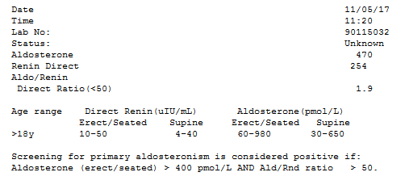

The marked rise in renin may be secondary to hypokalaemia.

1. Further discussion with the GP – After all these investigations, the GP decides to tell me that the patient’s BMI is 16!! How does this affect the diagnosis?