Encompass Tool Tip
Title: | Point of Care Testing – Ordering and Resulting
Affected: | OB/Birthplace and ED Inpatient Nurses and Providers
Effective Date: | February 15, 2011 | Modified Date: | February 16, 2015/NRG/MB
Content Owner: | Orders Application Analysts

Objective: Placing and resulting Point of Care (Fern/Nitrizine/Limited Urinalysis) tests.

- From the Order Entry type POCT in the New Order search field.

- Select the Point of Care Test you would like to order and click Accept.

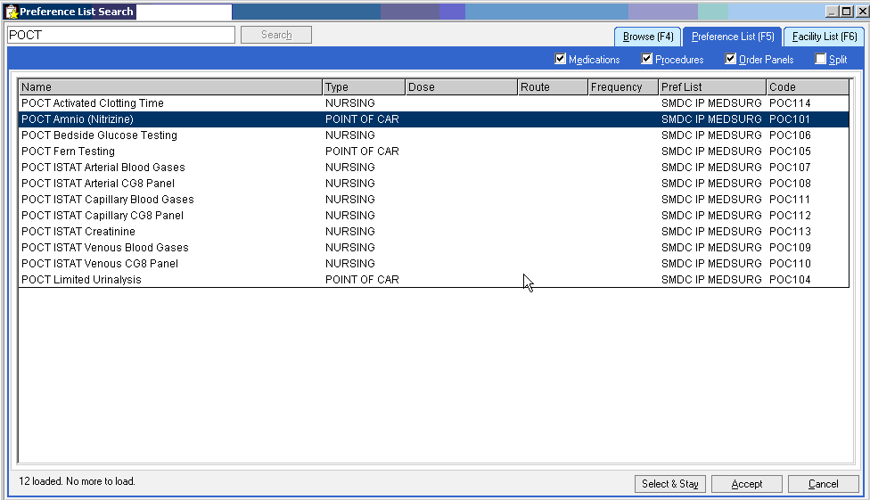

- If you are going to dip the urine more than once, be sure to change the frequency to PRN.
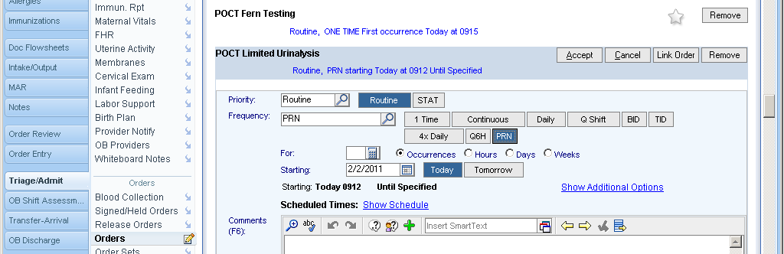
- Select the Order Mode of Protocol for cosign (if appropriate), then click Sign Orders.

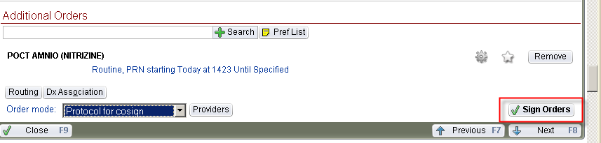

- Click on More Activities, and select Enter/Edit Results. Orders with a ONE TIME frequency, such as the Fern & Nitrazine above, will automatically be available in Enter/Edit Results.

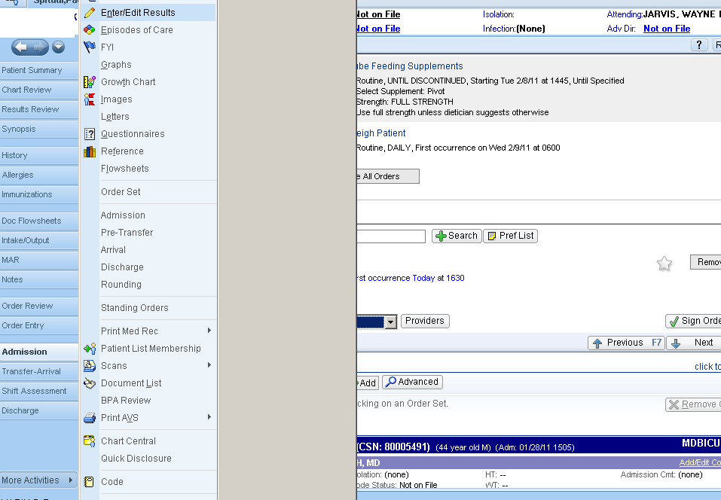

- Single click on the test you want to result and click Edit.

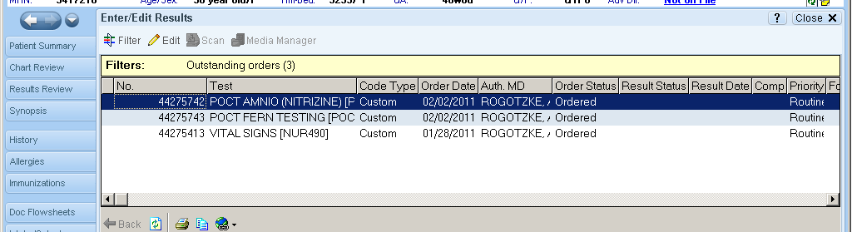

- The lower half of the screen will populate with fields to enter results. Enter all of the following:
  - Resulting Provider (usually the resident in OB) – This is VERY important!
  - Value
  - Date
  - Time
  - Abnormal
  - Status = Final

- Click Accept.

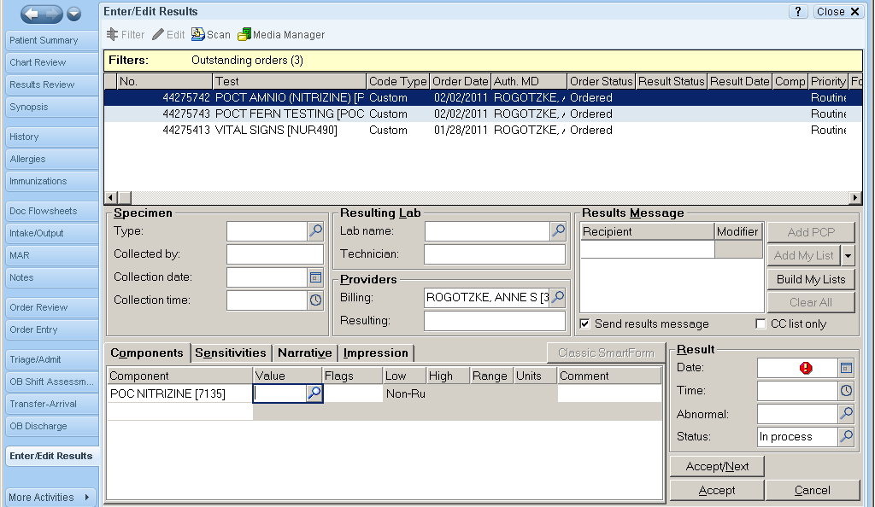
a
b
c
d
e
f

- These results are available now in Results Review.

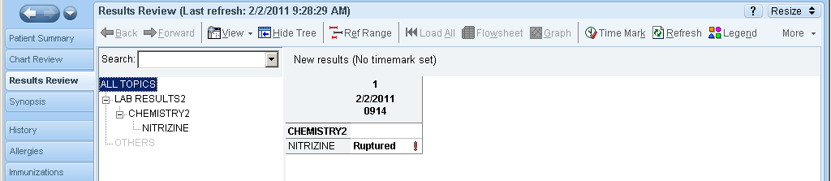

- Orders with a PRN frequency (such as the POCT Limited Urinalysis) must be released in order to Enter/Edit Results.

- Go to Order Review. If you do not have a Release button, try changing your view (try Last 72 Hours).

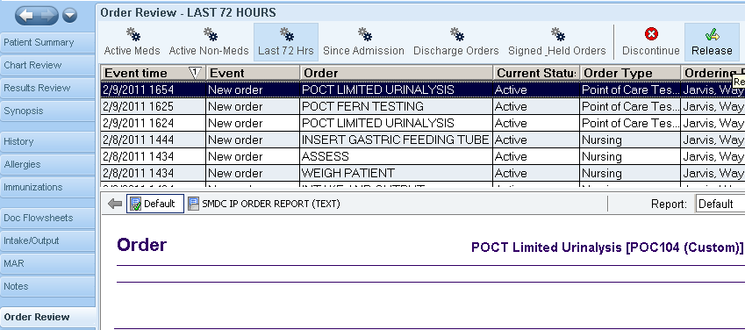

- Single-click to highlight POCT Limited Urinalysis, and click Release.

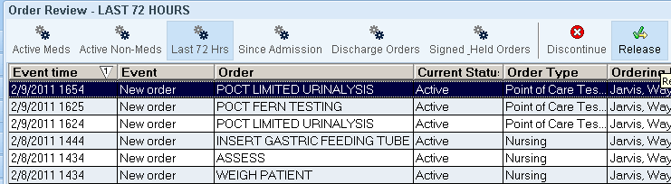

- Complete Steps 5-9 to enter/edit the results.

