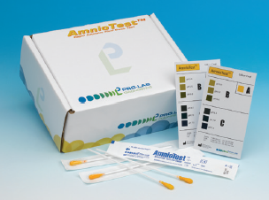

Principle:

Amniotest swab is used to detect the pH in fluid from a pH of 5.0-7.5. A pH of 6.5 or higher in the upper vagina is consistent with leakage of amniotic fluid.

Sample Collection:

Vaginal secretions are collected from the posterior vaginal pool obtained by a speculum that has not been lubricated with petroleum jelly (water based Lubricants are O.K. – “Surgilube, and K-Y”).

Saturate the amniotest swab with the Specimen.

