Wilmington, Ohio

TITLE: β – Ketone (whole blood) Waived Testing  By Abbott Precision Xceed Pro Point of Care System | POLICY NO: LAB-POC.0102
DEPARTMENT(S):  Laboratory | PAGE 1 OF  8 PAGES
APPROVED BY: Walter W. Timperman, Jr., M.D.  Laboratory Medical Director  DATE: | EFFECTIVE DATE:10/01/2013  REVIEWED:  REVIEWED:
ORIGINATOR:  Amy Richards, MLT (ASCP) | REVIEWED:
ORIGINATOR:  Amy Richards, MLT (ASCP) | REVIEWED:
COLLABORATORS:  Deanne Thatcher, MT(ASCP) POC Coordinator | REVIEWED:
COLLABORATORS:  Deanne Thatcher, MT(ASCP) POC Coordinator | REVIEWED:
DISTRIBUTION: Laboratory | REVISED:
DISTRIBUTION: Laboratory | SUPERCEDES:

Principle:
Blood ketones are primarily used to screen for, detect, and monitor diabetic ketoacidosis (DKA) in people with type 1 and sometimes type 2 diabetes. DKA can occur when a diabetic’s blood sugar is significantly increased, with illness, severe infection, pregnancy, and a variety of other conditions. DKA is associated with acute hyperglycemia, a severe insulin deficiency, and a disruption of the body’s acid-base balance. Excess ketones and glucose are dumped into the urine by the kidneys in an effort to flush them from the body. This causes increased urination, thirst, dehydration, and a loss of electrolytes. The affected person may also experience symptoms such as rapid breathing, shortness of breath, a fruit-scent to the breath, nausea, vomiting, fatigue, confusion, and eventually coma.

The Precision Xceed Blood β-Ketone test strips have chemistry to specifically measure
β-hydroxubutyrate, the primary ketone body developed when a patient is developing ketoacidosis.

Specimen Collection and Preparation:
POC testing:
Precision test strips are designed for use with fresh whole blood samples. The minimum sample volume is 1.5 µL.
Before obtaining a fingertip blood sample, clean and dry the sample site completely. If possible, hang the arm down before lancing the finger to increase the blood flow. Use the sample immediately.

Laboratory specimen:
Collect venous whole blood samples in tubes containing lithium/ sodium heparin and use the sample within 30 minutes.
*Do not use tubes containing fluoride or oxalate.

Reagents:

Quality Control:

QC will be performed at least once per 24 hours per monitor.
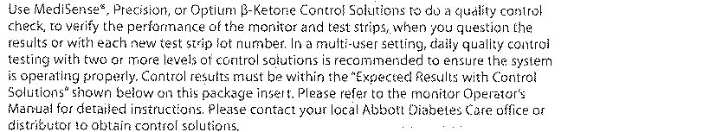

Reporting Results:

Procedure :

References:

