Copy and paste the link below to watch the CoaguChek XS System operation.

<http://www.coaguchek.com/coaguchek_patient/en/home/products/xs-system.html>

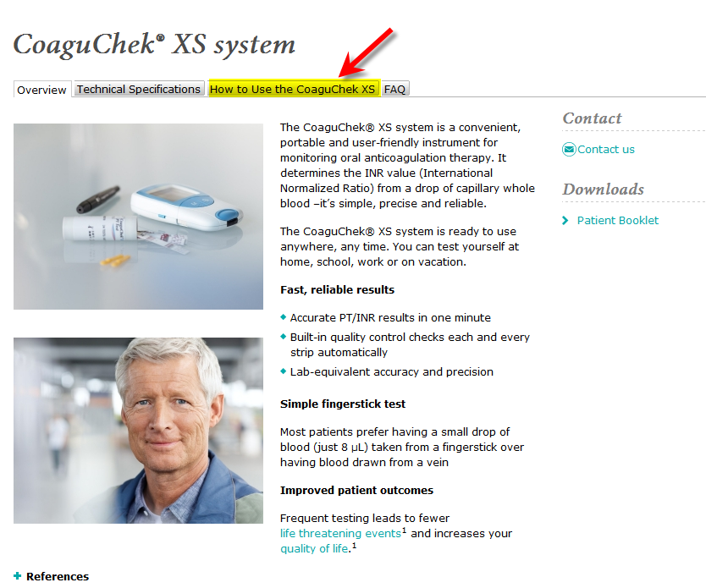

Scroll to the bottom of the web page and press play.

