**Creating Custom Patient Lists in EPIC**

Sign into EPIC  and make sure the “Patient Lists” is showing 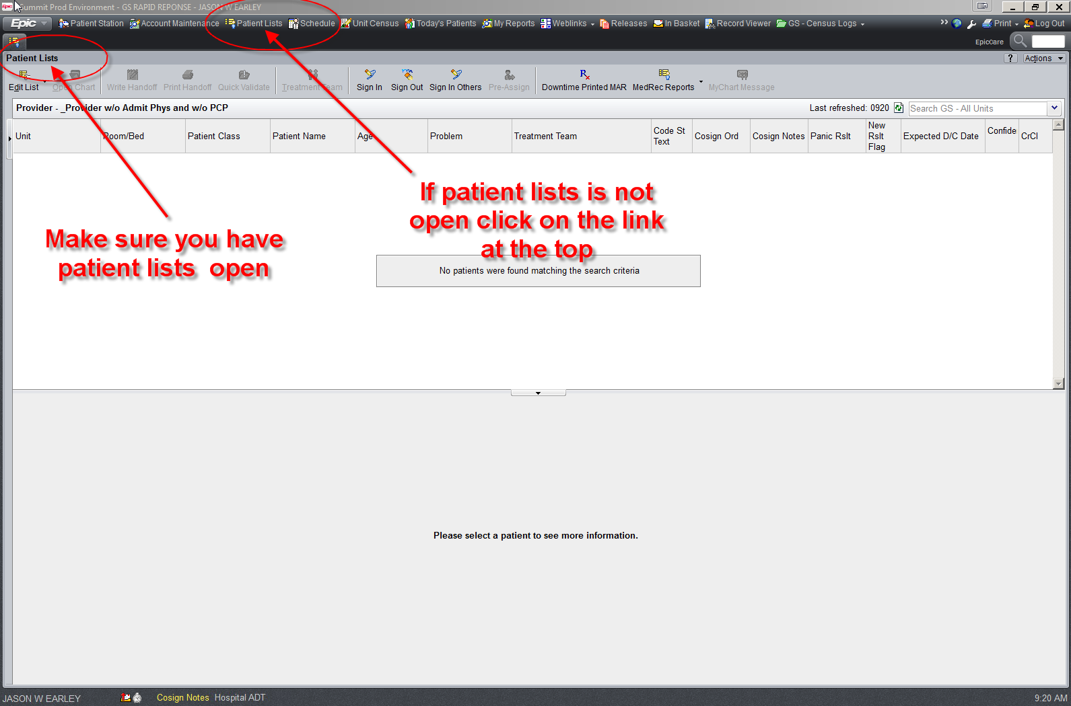

Click on the small arrow on left if the column of lists is not showing.

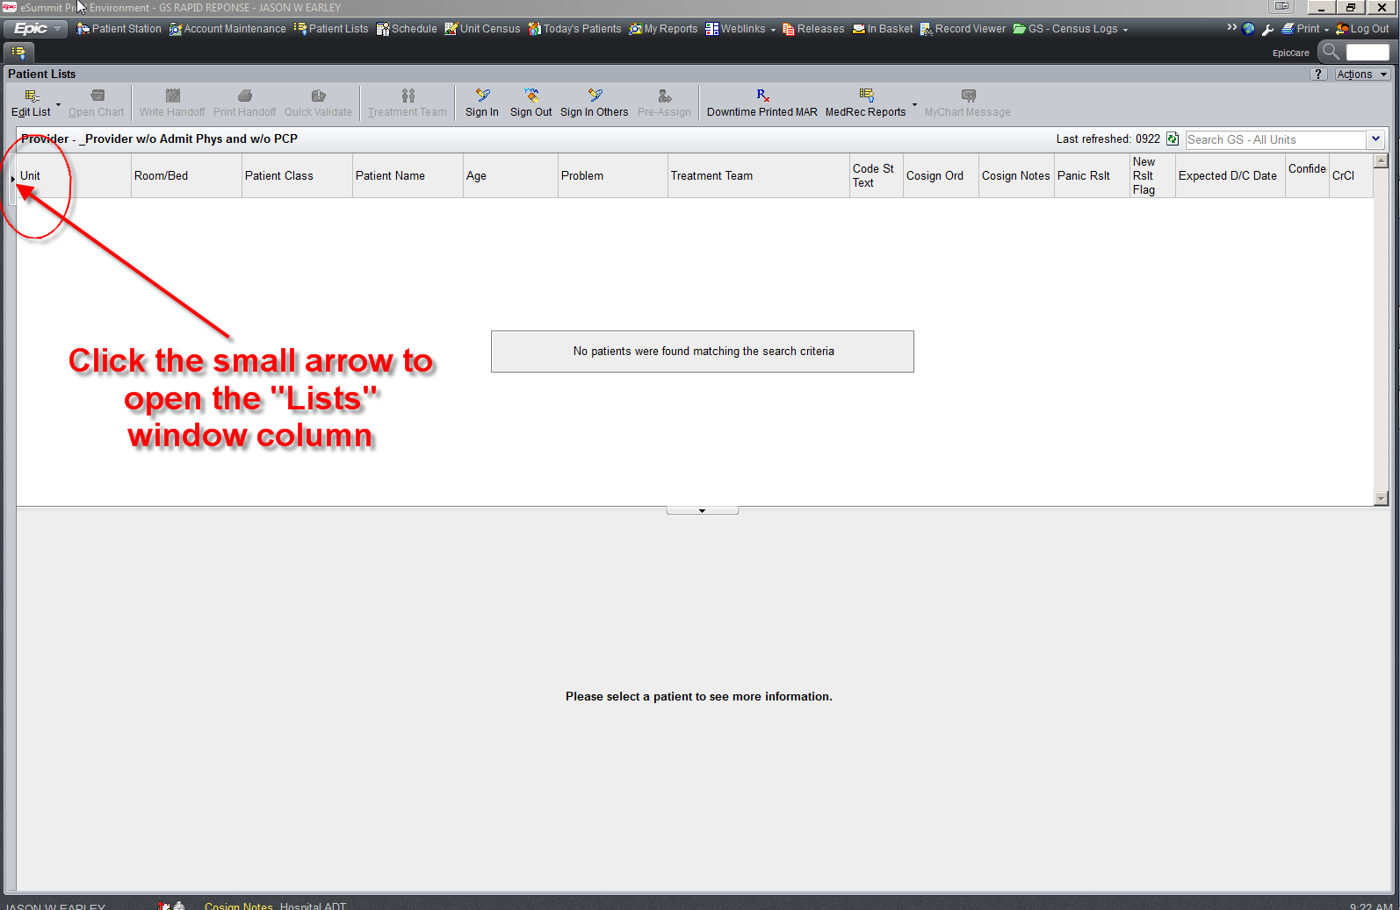

Now that the column is open, click on **Lutheran** then **LM** ALL Units then **LM** All Units again.

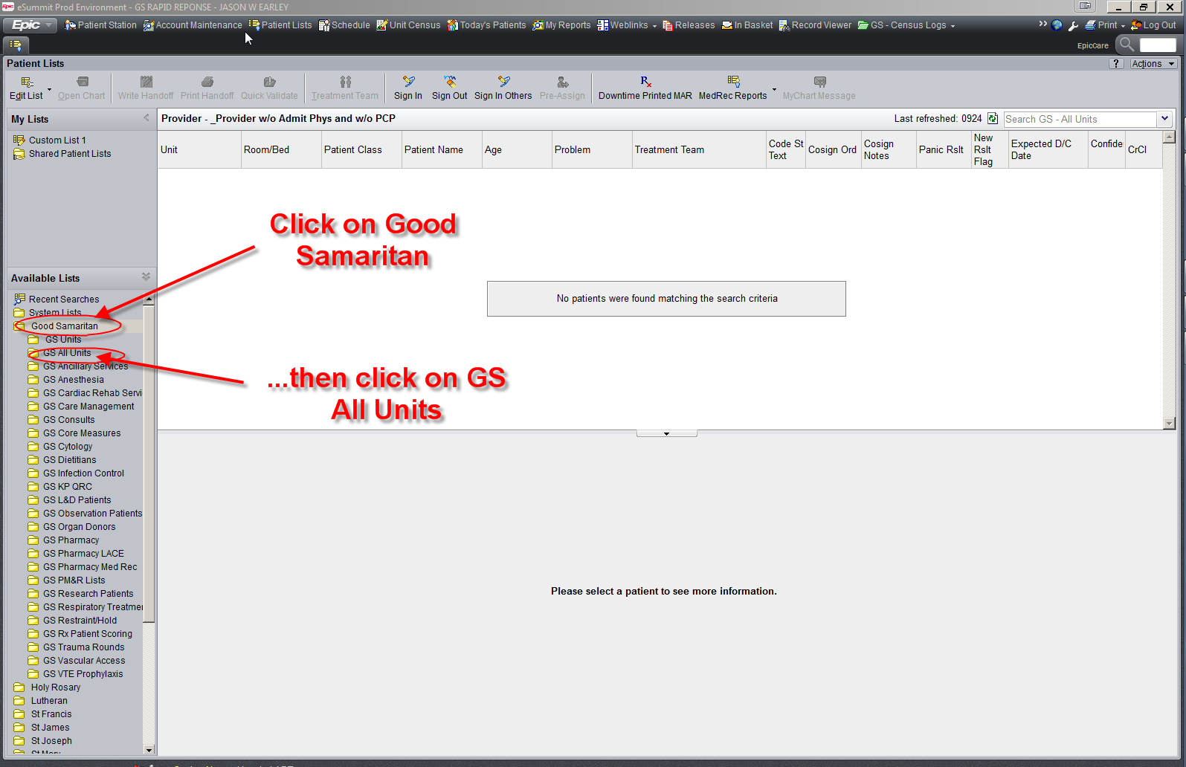

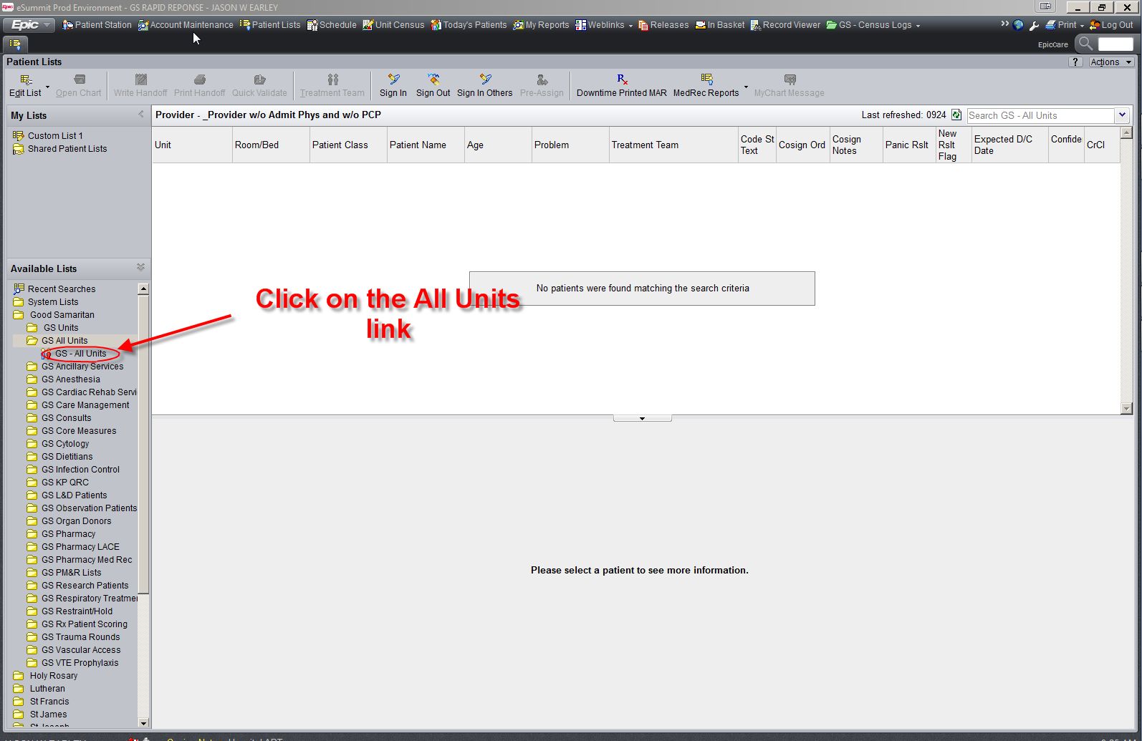

Now you’ll get a list of all the units at Lutheran, click the drop down arrow to expand it.

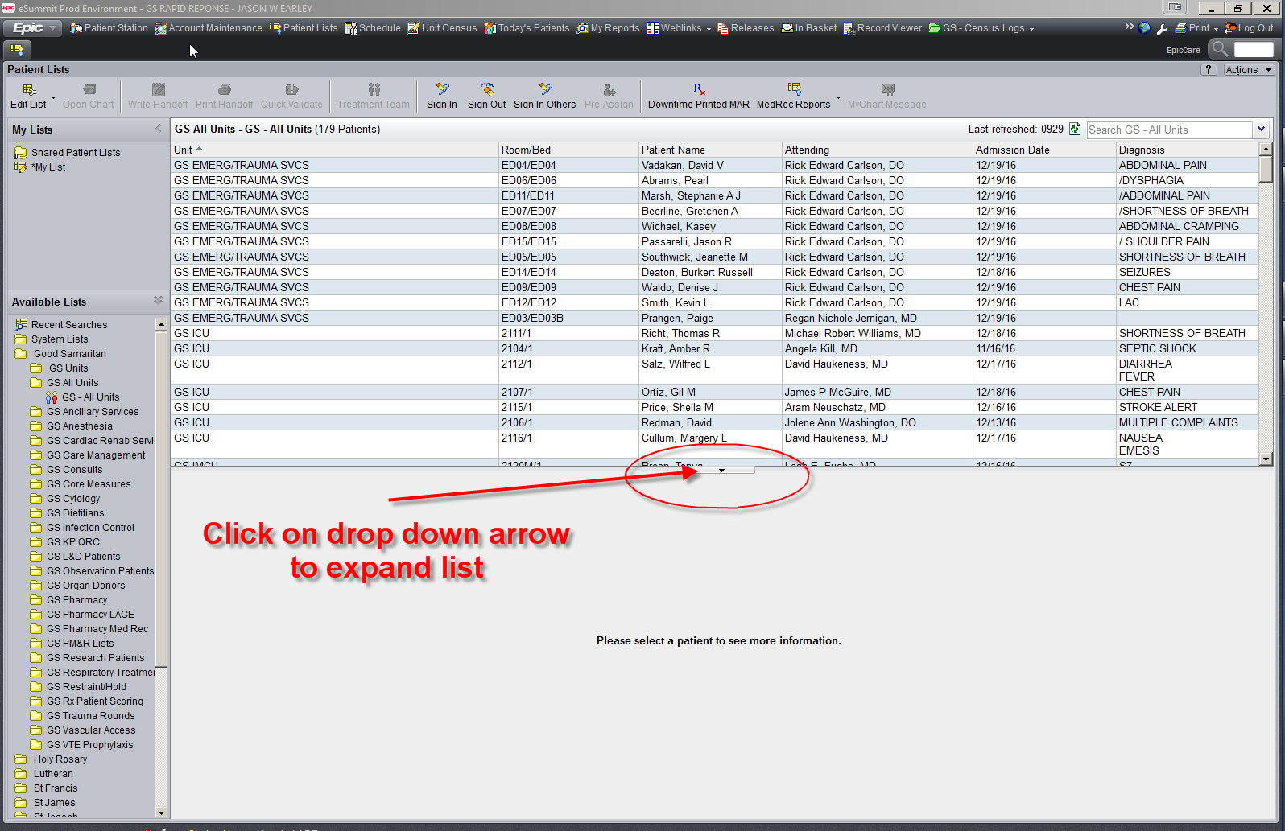

Now right click on the LM – All Units link, hover the mouse over “Send To” then click on My List. This will add this link to the link named My Link above available lists.

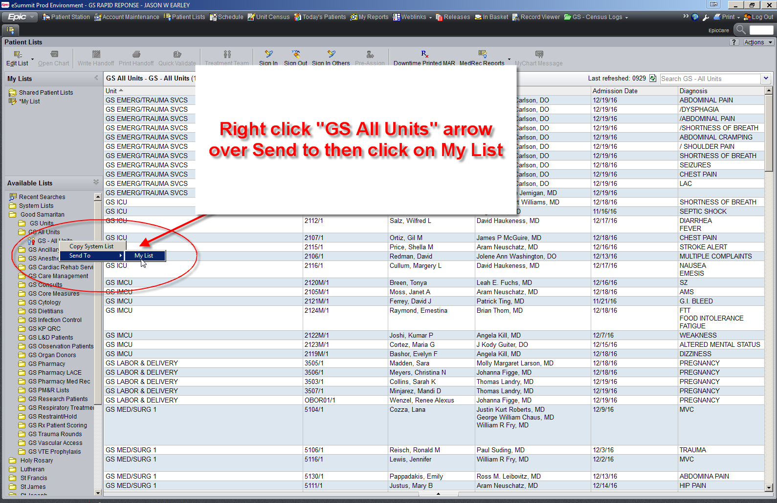

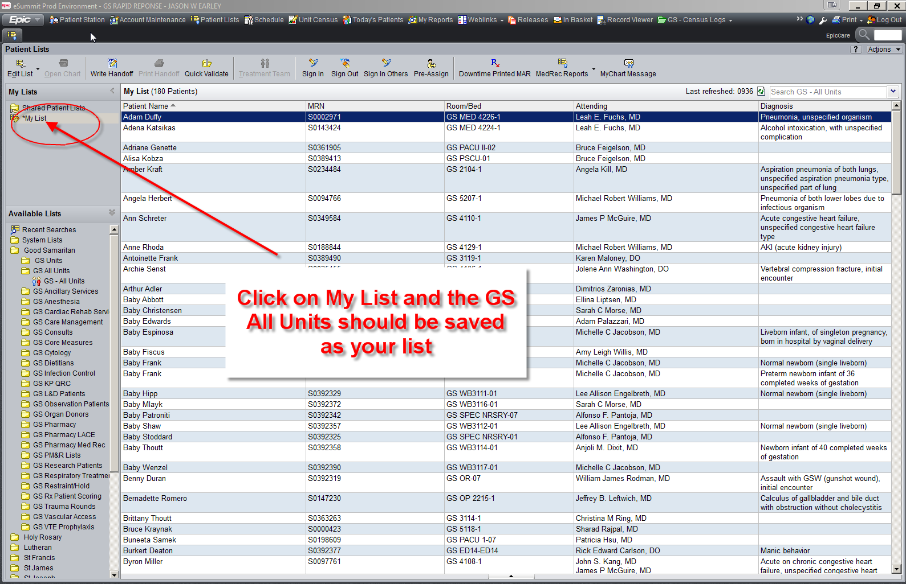

Now let’s customize the list. Right click on “My List” and select Properties.

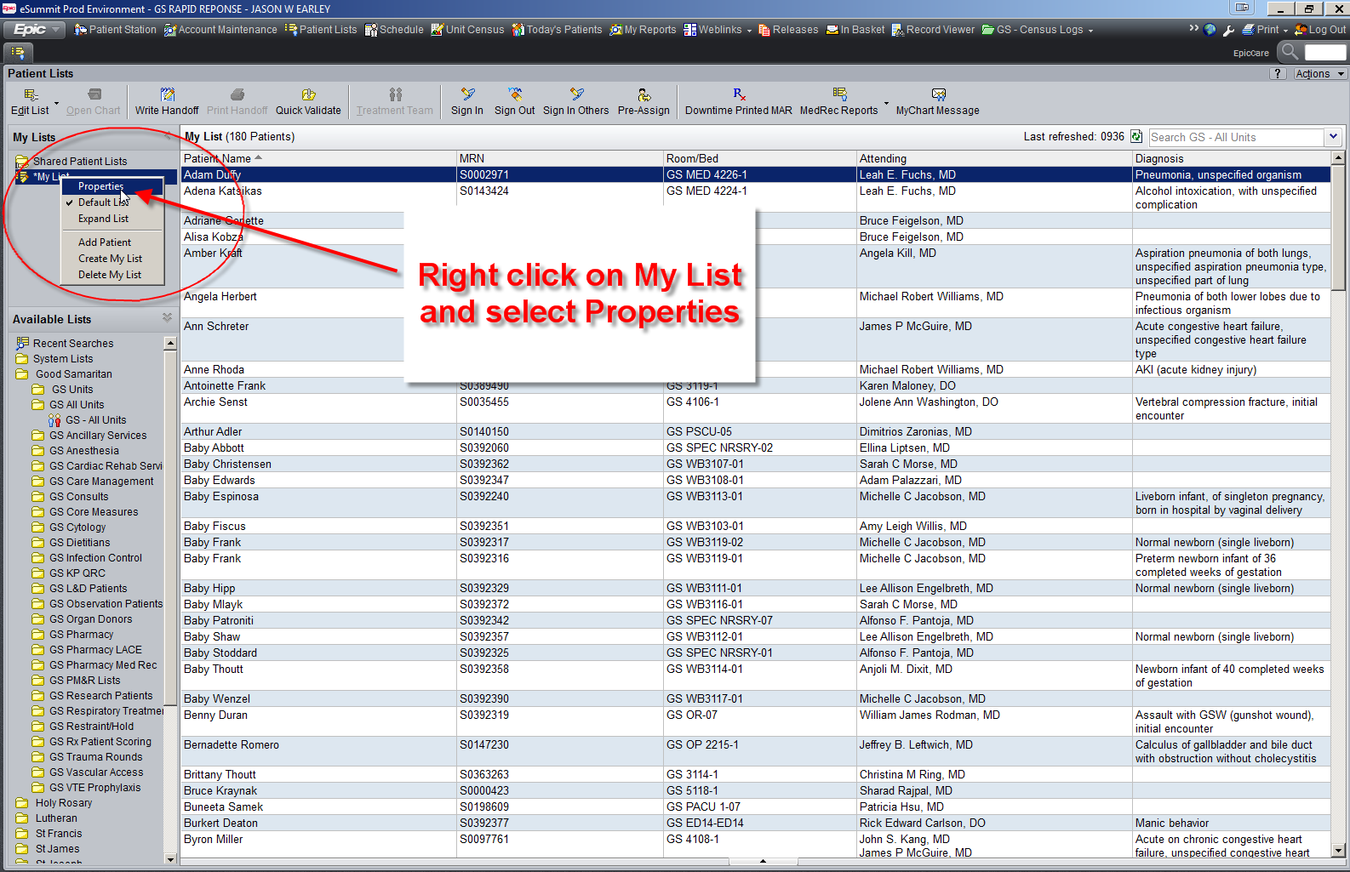

This will upon a customization tool. You can select from the list on the left, click add, and it will be put on your “My List” in the right column. My advice is to keep it simple. There are MANY available items to choose on the left and most are useless. You can also adjust where the column displays on My List by using the up and down arrows to the right of the column. When you are done hit Accept at the bottom.

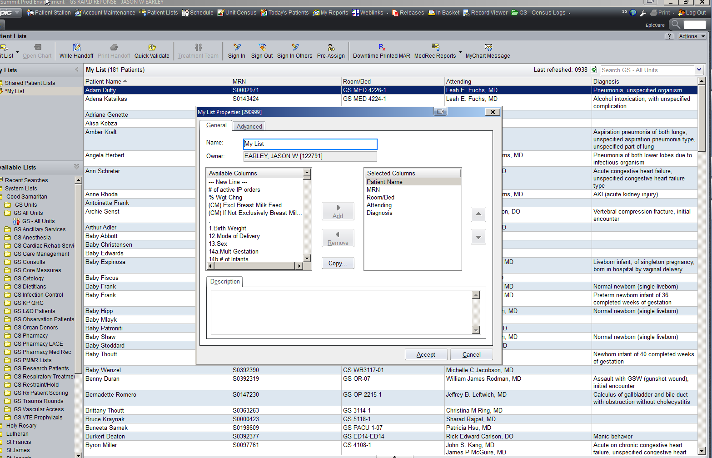

Now click on a patient and make sure the PER is showing.

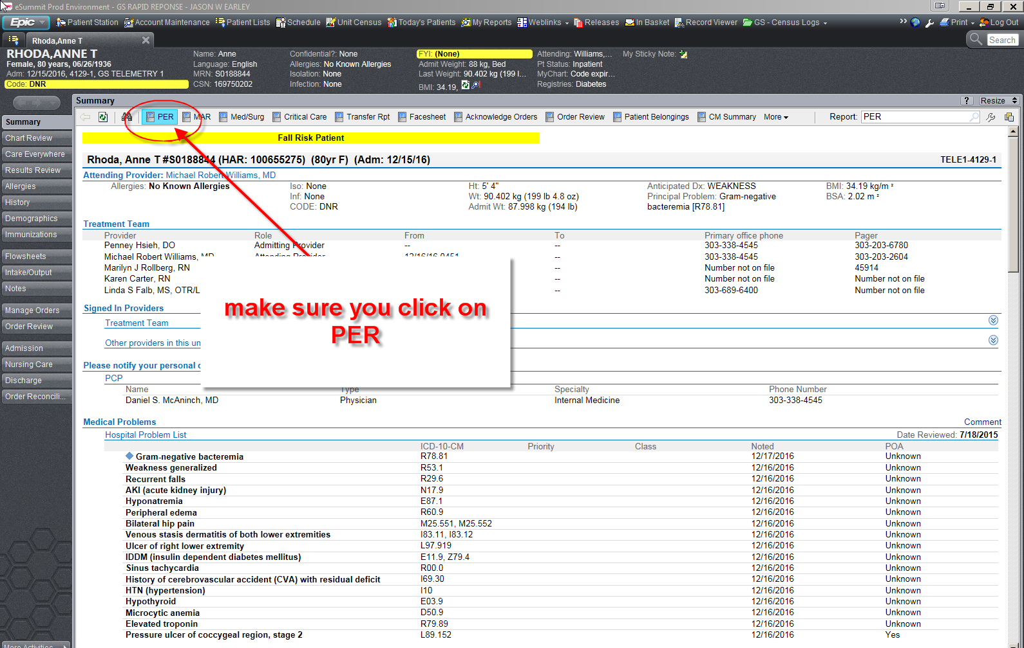

There should be arrows on the right below Signed in Providers which will open the list where you should be able to find the MD, RN and phone numbers for that patient.

